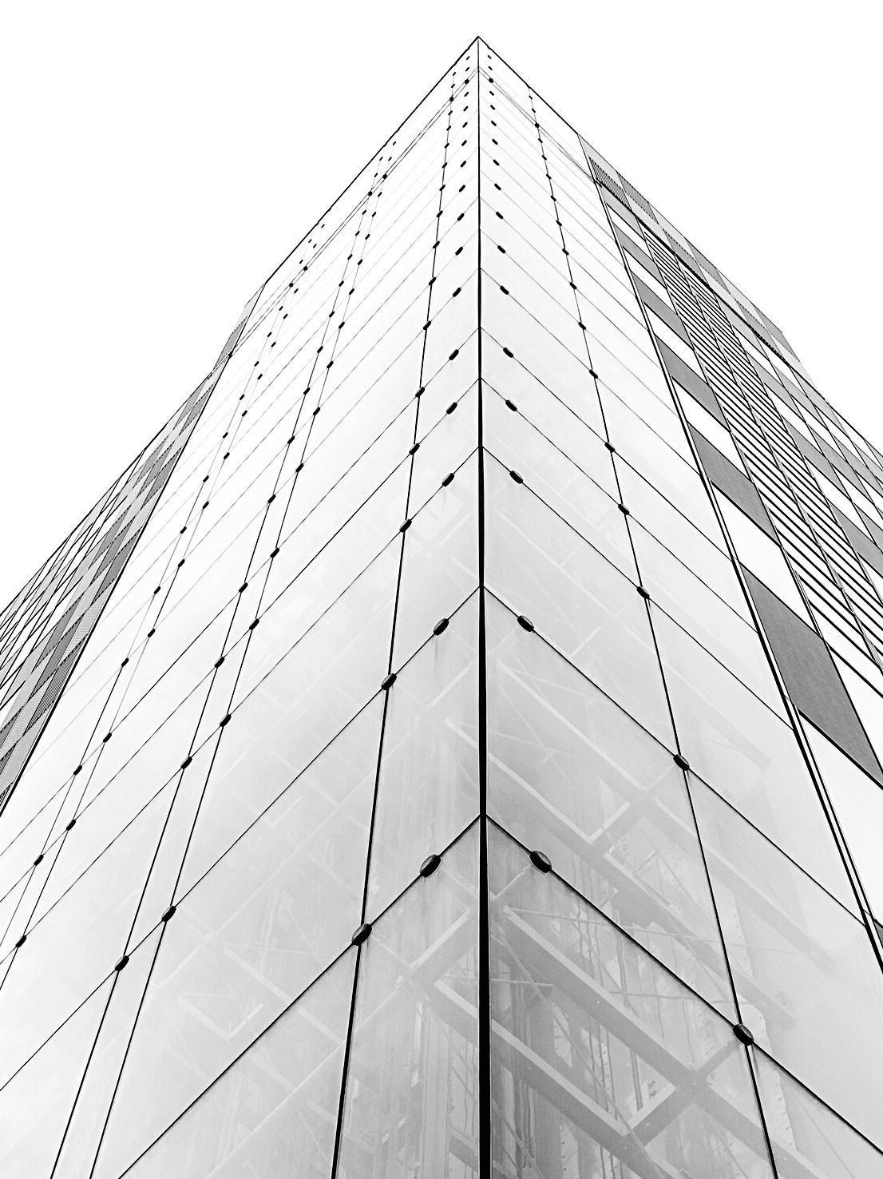

APRIL
2022

FINTECH

SOLUTIONS
F
O
R

AFRICA

M
LM
B

usinessesss

MLM Business

Development
using

Emmedue

technology



FINANCIAL
S
O
L
U
T
I
O
N
S

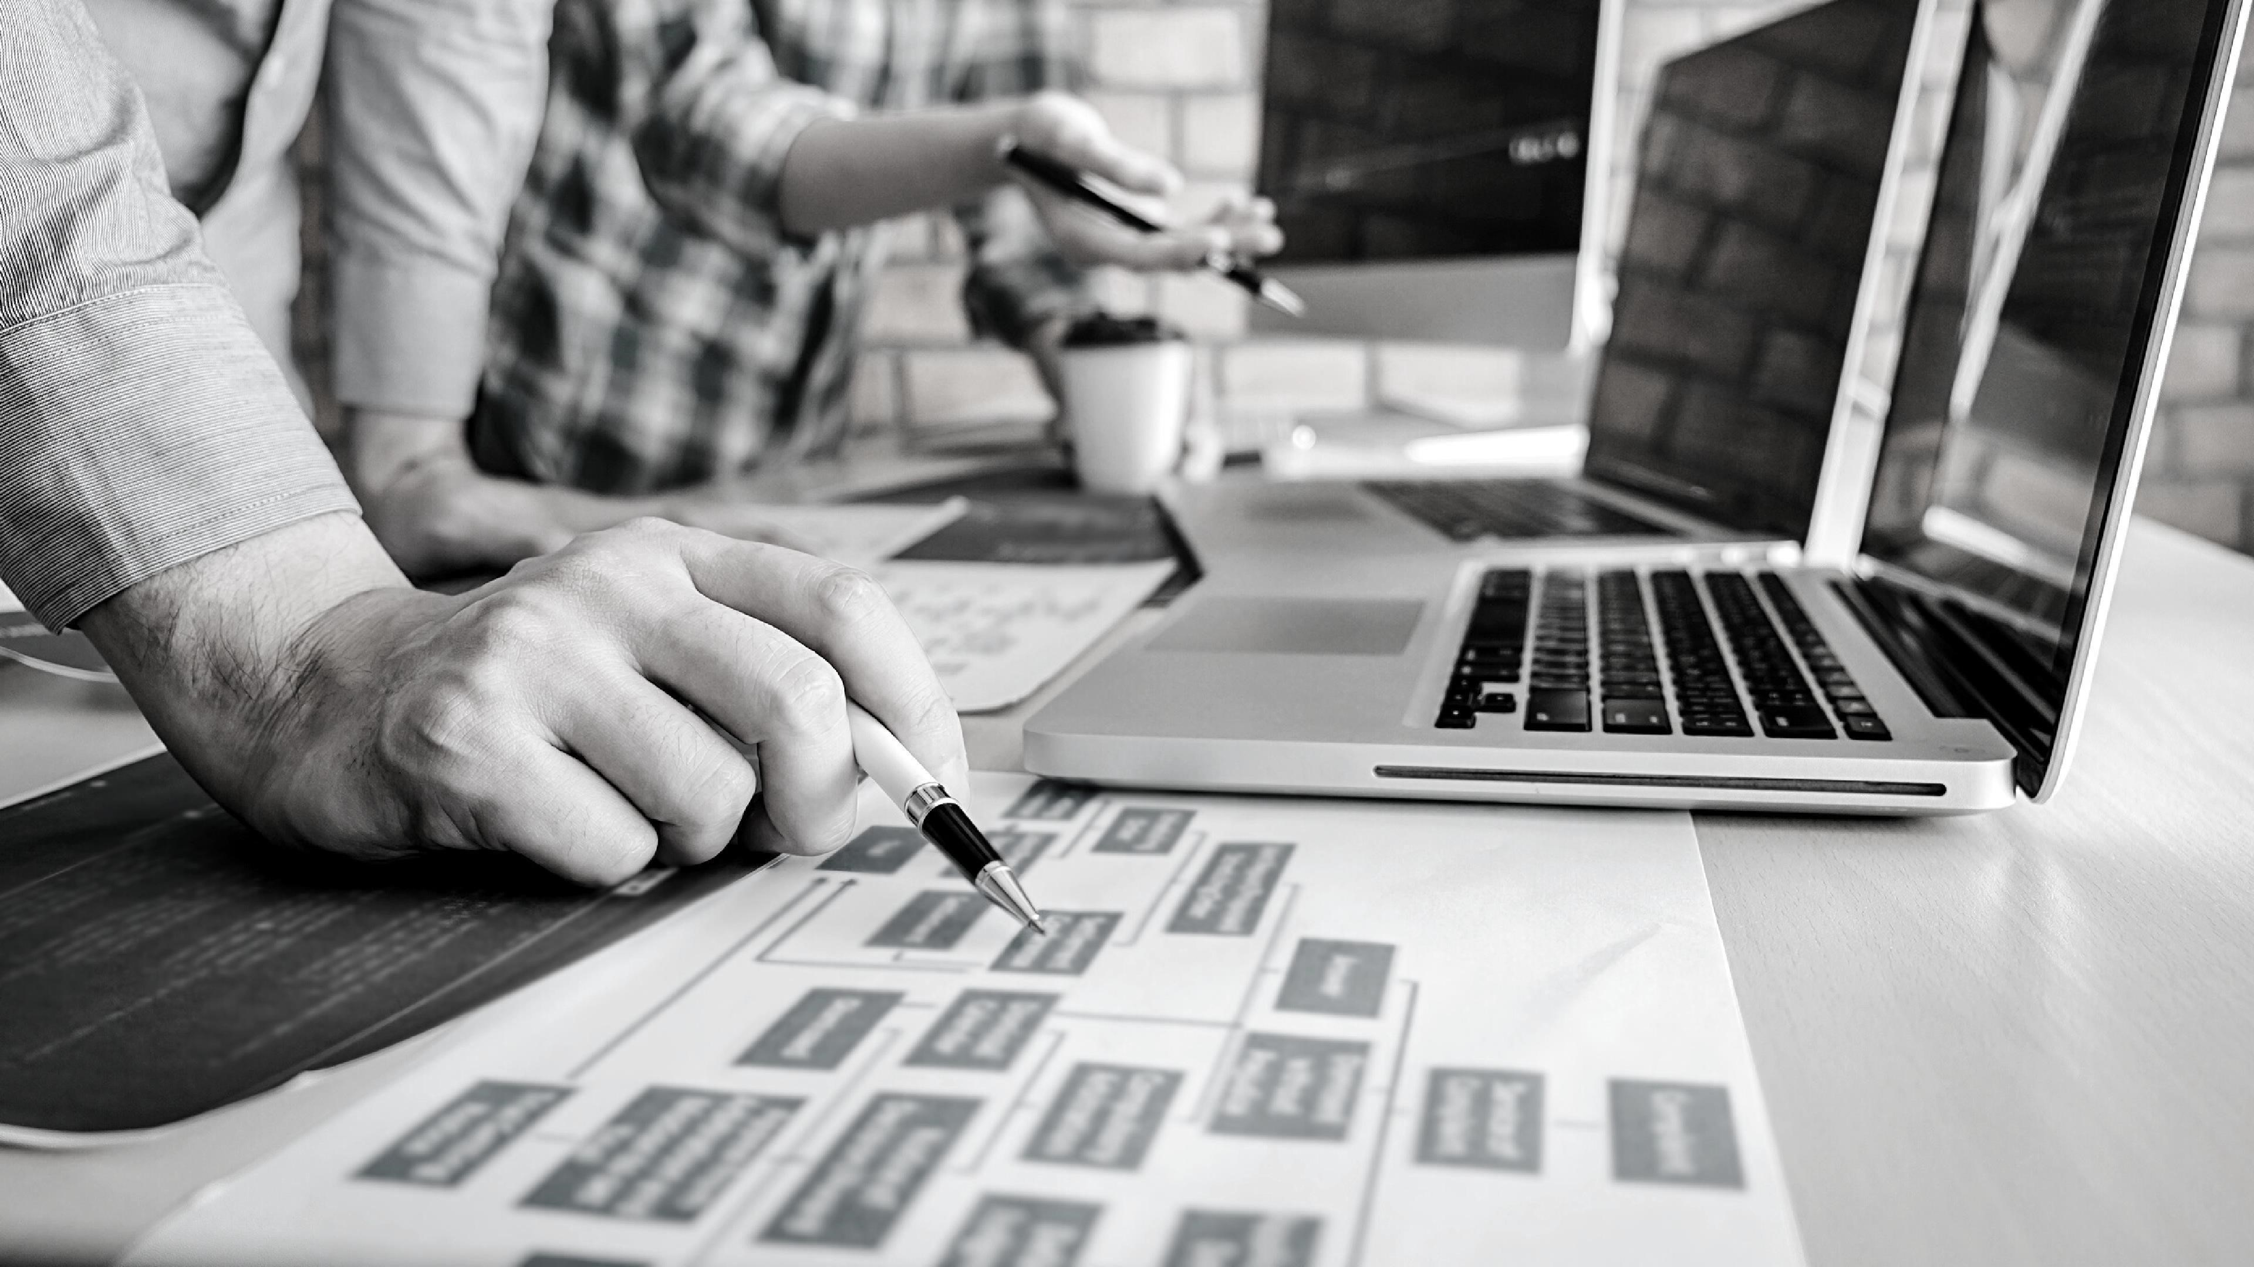
D
E
V
E
L
O
P
M
E
N
T

MLM

BUSINESS

FINANCIAL

MECHANISMS

MLM
Business

Development

LTD (herein

referred to a

s
“MLMBD”)

ha

s

secured

partnerships
with
International
Funders
/

Investors

and

is
in a

position

to
offer

potential
Client's

a

ccess
to
various
project

funding.

MLMBD’s
services
offer
potential
Clients
the
opportunity
to

receive
tailor
-
made
f

inancing
solutions
with
favorable
terms
and
conditions
engineered
for
success.

MLMBD
facilitates

the
Clients
funding
request
by
submitting

a

“Client

Information

Pack”

on
behalf

of
the

Client

to
its
Funders
/

Investors

that

ha

s
been
designed
to
both
save
time
and
money.

MLM BUSINESS DEVELOPMENT’S FUNDERS / INVESTOR offer a recapitalization of the banking sector.
MLMBD’s International Funder has presented an opportunity for the local banks to obtain a credit line for project finance based on the following terms and conditions:

- The local banks must apply for a credit line for a minimum amount of US$ 100,000,000.00 (One Hundred Million United States Dollars).

- The local banks must be able to provide a Bank Guarantee with a minimum value of 35% of the proposed project. Alternatively the government can issue a bond on behalf of the banks.
- The Guarantee must be valid for one year and be transmitted by Swift to the Funders Bank (the Bank Guarantee does not need to be renewable).
- The annual interest rate will be between 1-3%.
- Repayment period is between 10 to 25 years.
- The local banks will benefit from a four or five-year grace period during which it will not be subject to any repayment obligation. MLMBD believe this is a unique opportunity for the local banks to finance projects at a preferential interest rate. This will then enable the local bank to make further loans to various projects that will be submitted to them while ensuring that their funding commitment is honoured. This will allow the local banks to increase their lending capacity and generate more income from interested rates charged to their clients.
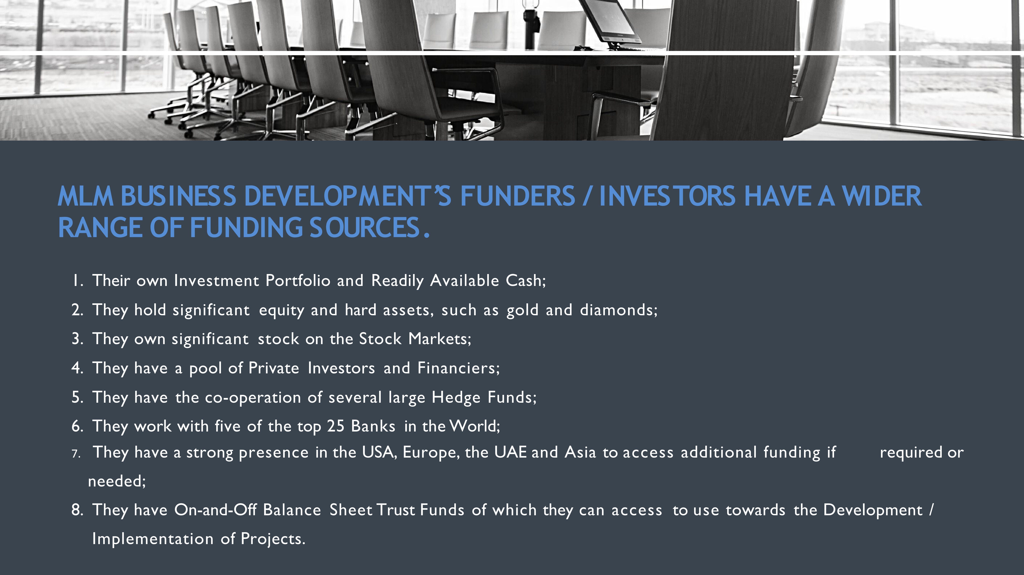
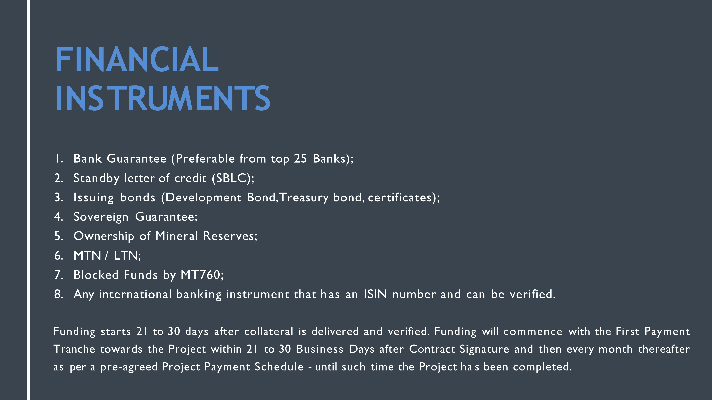


Government

Funding

As most of

the international

investment

platform

require

to
mitigate
the risk of any project funding

by providing

a bank guarantee. It is
important to acknowledge

that it can be very challenging

for the
African continent.

MLMBD is able to provide

and

structure a

great

funding

mechanism
utilizing

some of the
government

asset or income

for example
(
pension

fund).Those assets will

allow to provide

a bank

guarantee

in
order to receive

necessary funding for all projects.

MLMBD believe

the preferential

interest rate or various

benefits
provided

by our funder

will

be

a breath

of fresh

air

into the economy
and will impact positively the current national debt.

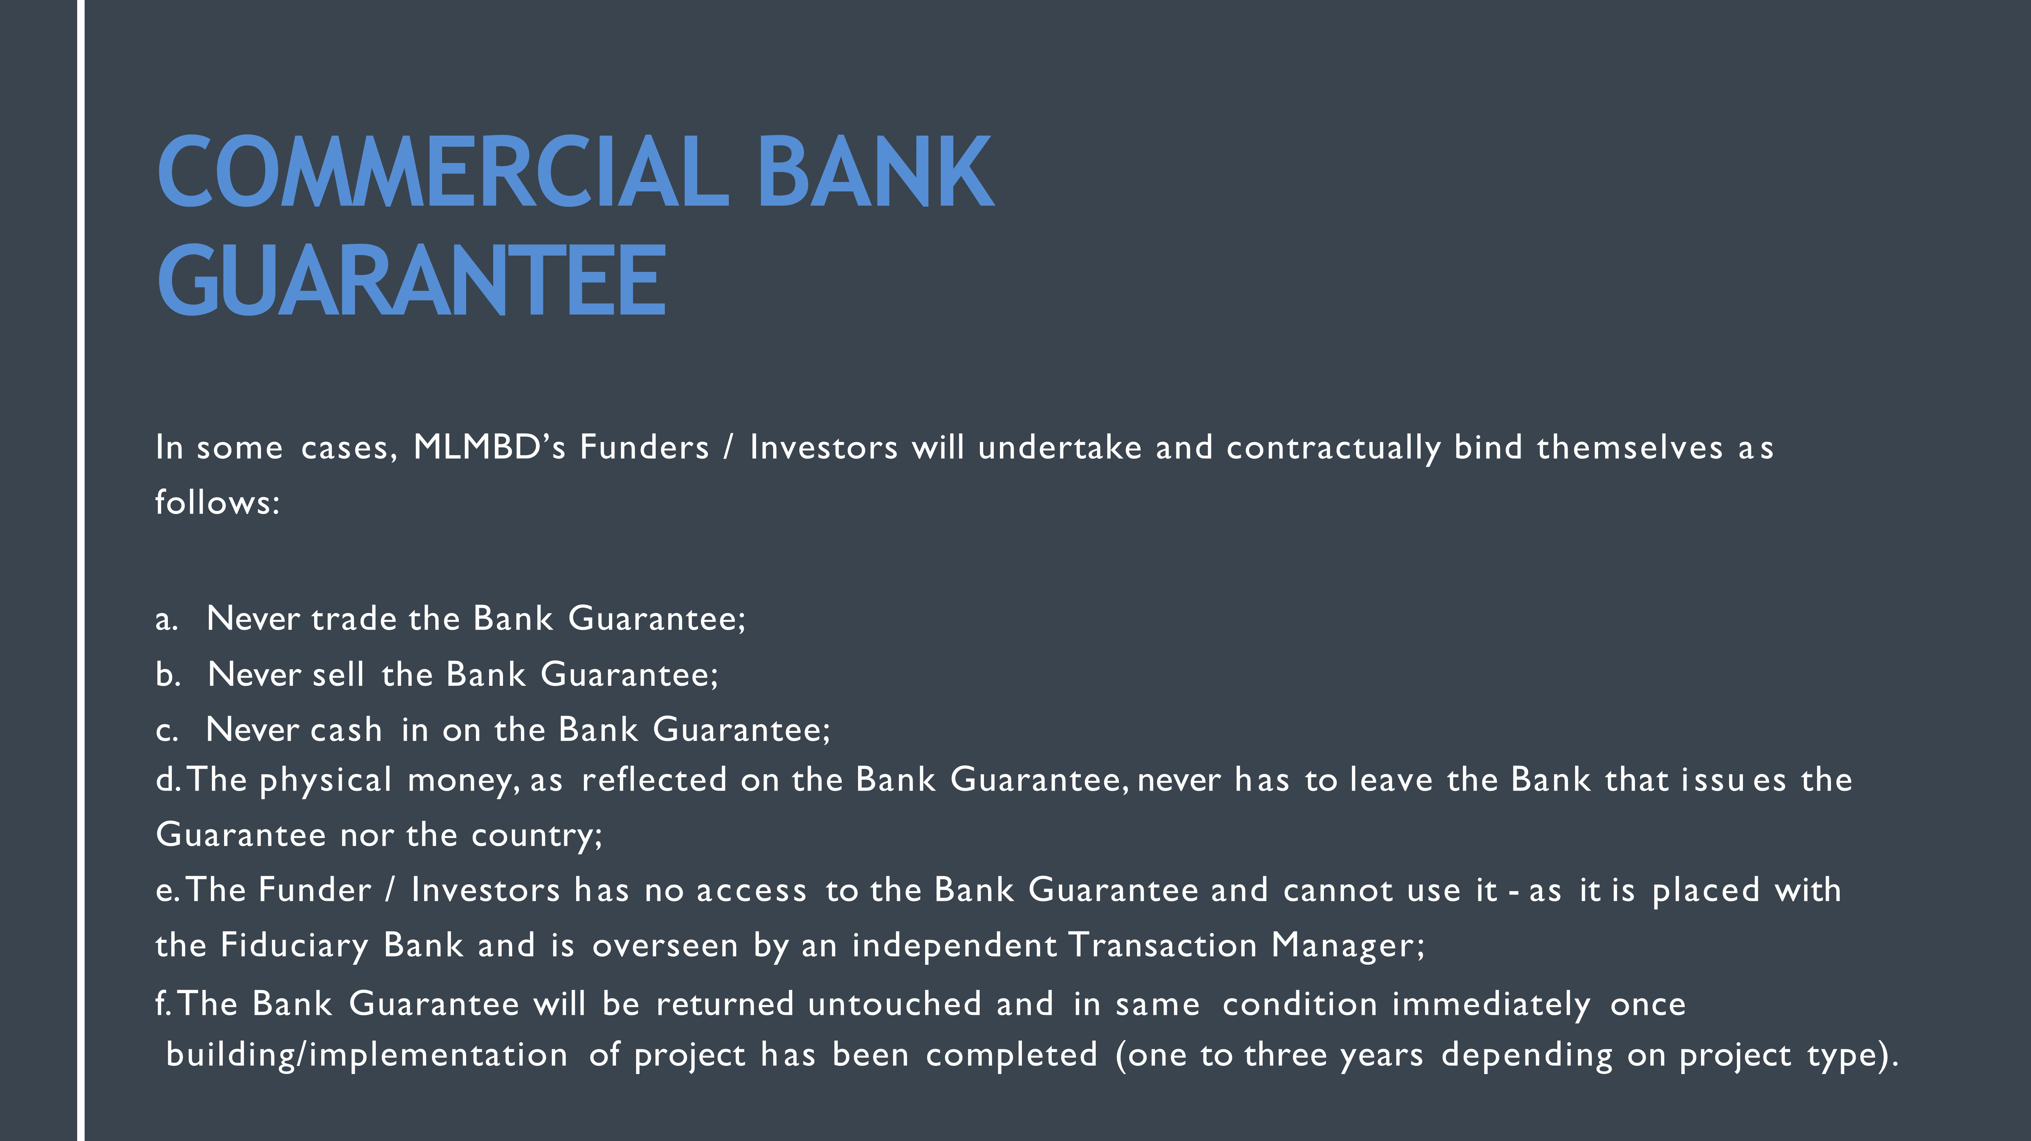
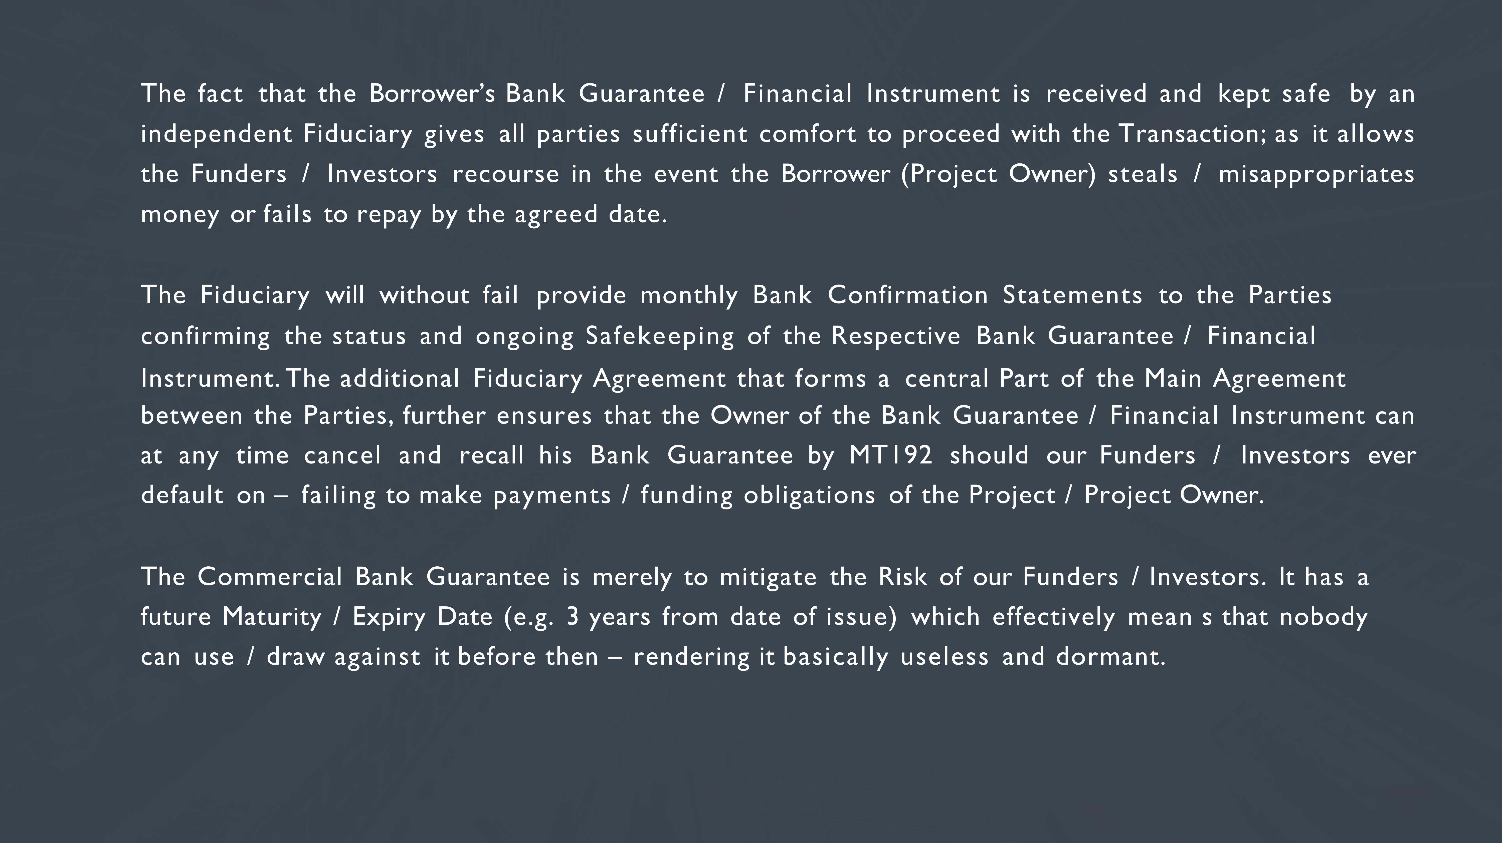
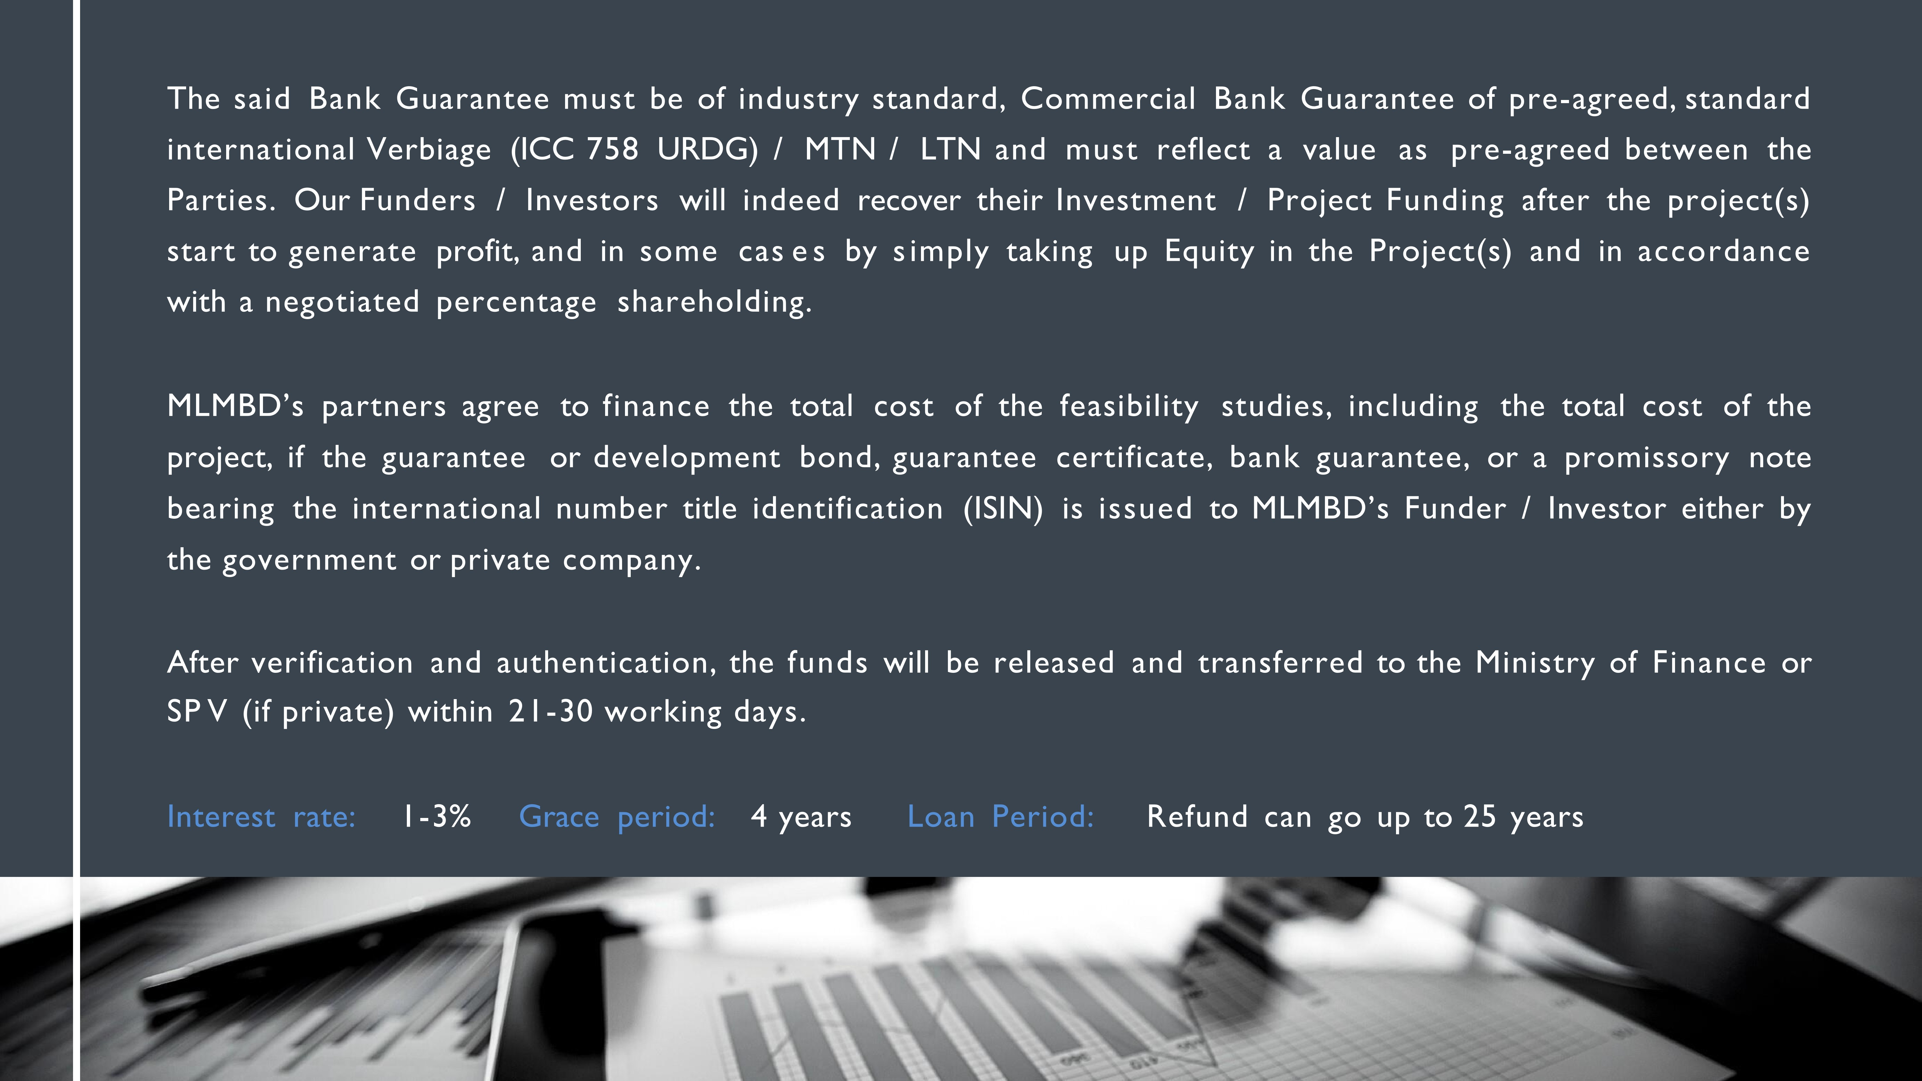

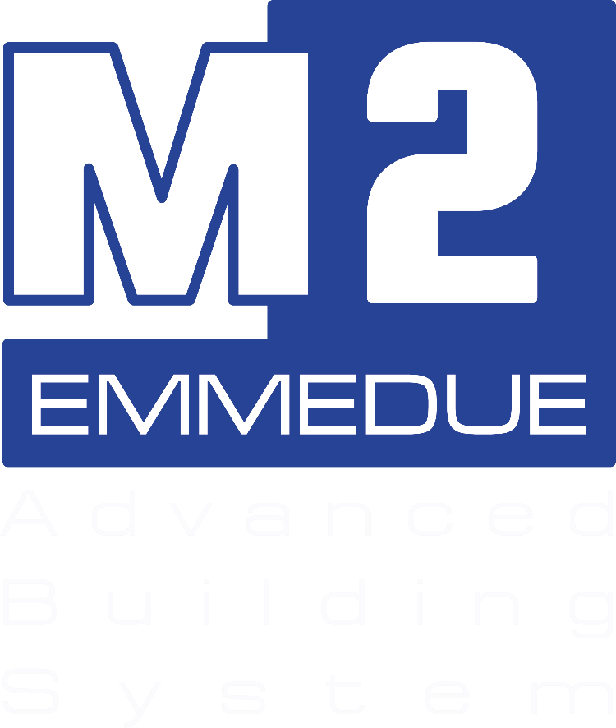
APRIL
2022

EMMEDUE

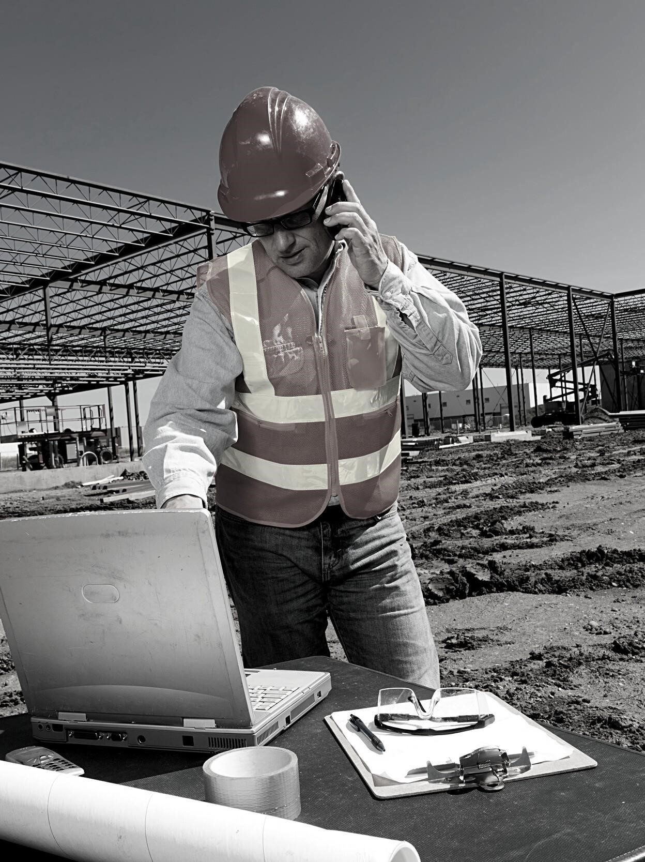

BUILDING
TECH
NO
L
O
G
Y

 | EMMEDUE |   For over 35 years, Emmedue  has been producing  machines and transferring technology to its customers  all over the world. Emmedue is a leading provider of  an innovative building system able to reduce  construction time in the high  -  scale housing projects,  thus offering a strong solutio  n in the socio  -  economic  development of emerging markets throughout the  world. The Emmedue building system allows fast,  efficient, and large  -  scale construction through the  combination of  innovative products and  processes.

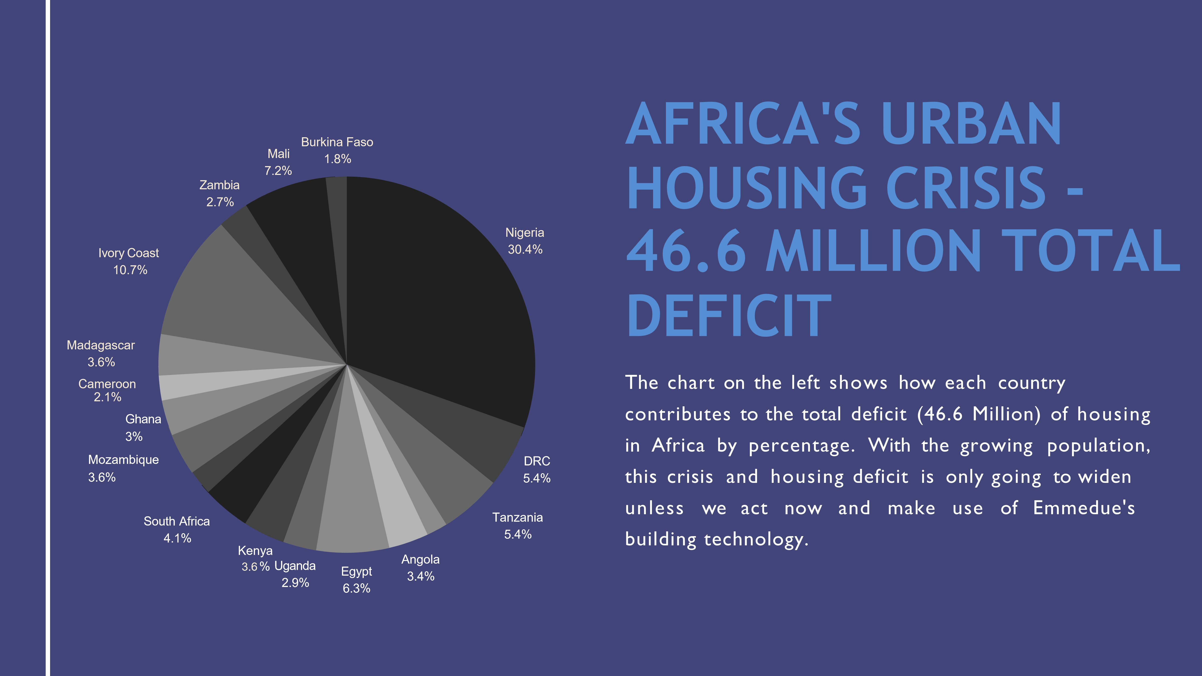
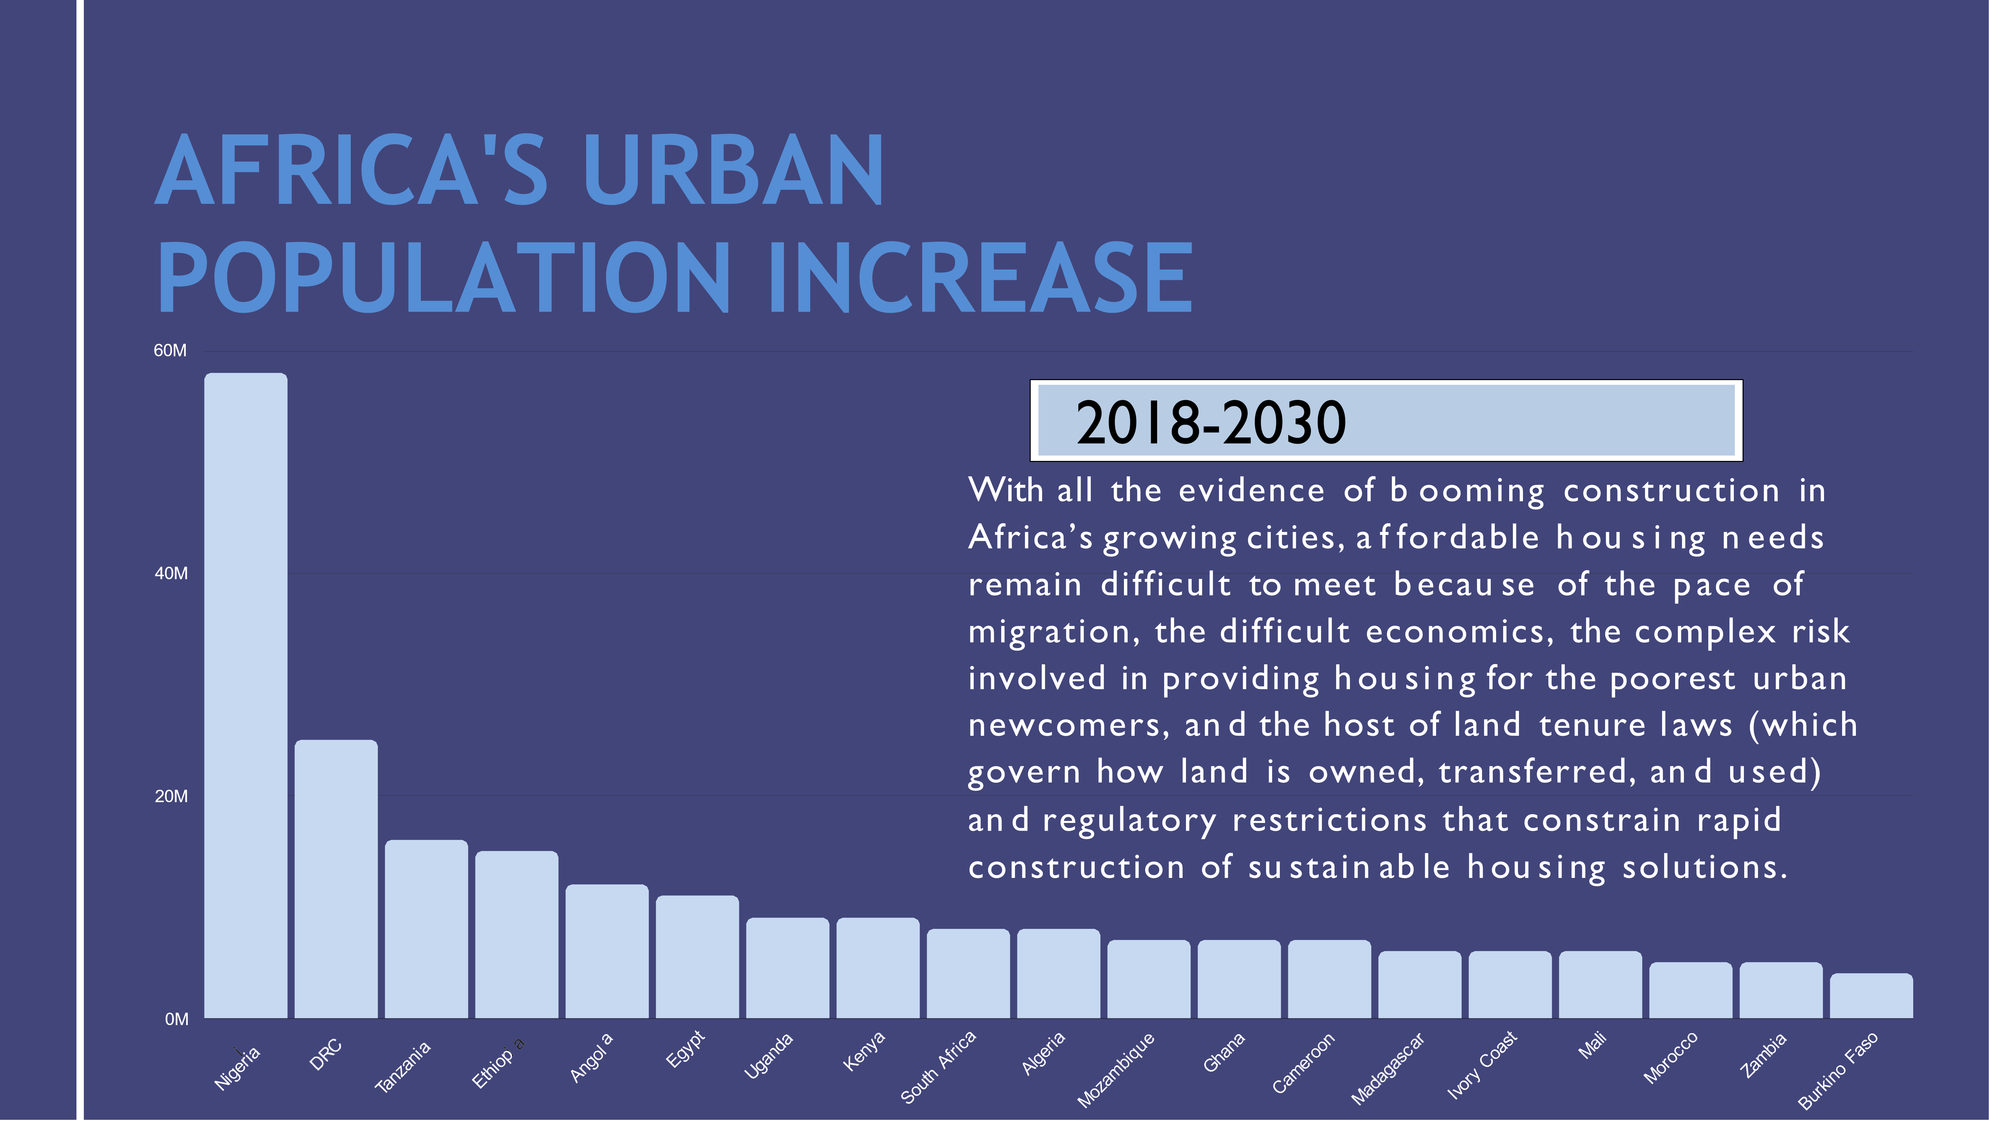
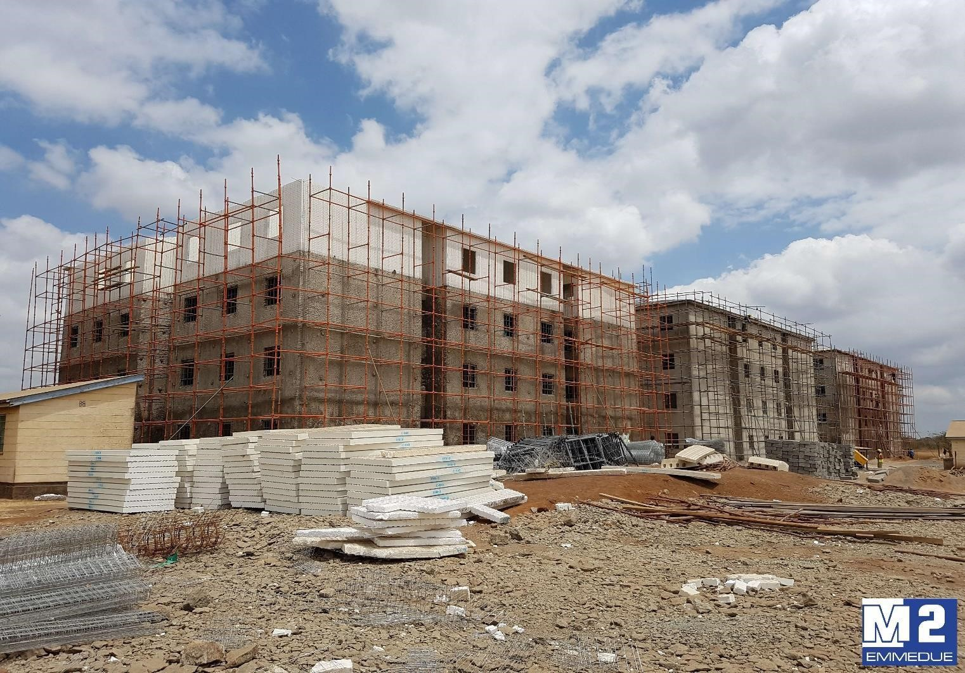
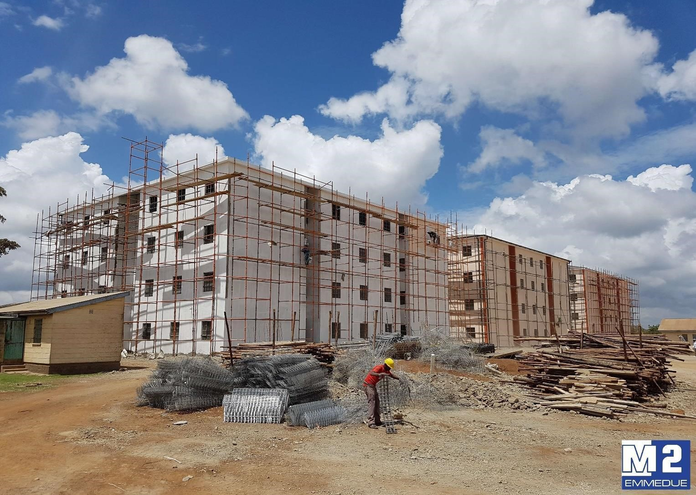

EMMEDUE

AFRICA
B
U
I
L
D
I
N
G

S
Y
S
T
E
M
S

Emmedue has many customers in Africa,

one of the
latest technology transfers has been done in Kenya.
The project was designed

for 4
-
storey buildings

and
about 750

people were employed during

the 9
-
month
project. For this project, our customer’s teams were
locally
trained
and
supported
by
EMMEDUE’s
engineers to ensure both technology transfer and
successful

completion of the Police housing project.

P
R
O
D
U
C
T
S

Emmedue

provides

housing

system

and

solutions

with

relevant

and

distinctive

benefits:

-

Lower

construction

costs

-

Speed

and

lightweight

construction

-

Designs

demanding

structural

flexibility

and

thermal

Insulation

-

Energy

savings

-

Higher

acoustic

performance

-

Speed

of

construction

-

Resistant

to

earthquakes

and

cyclones

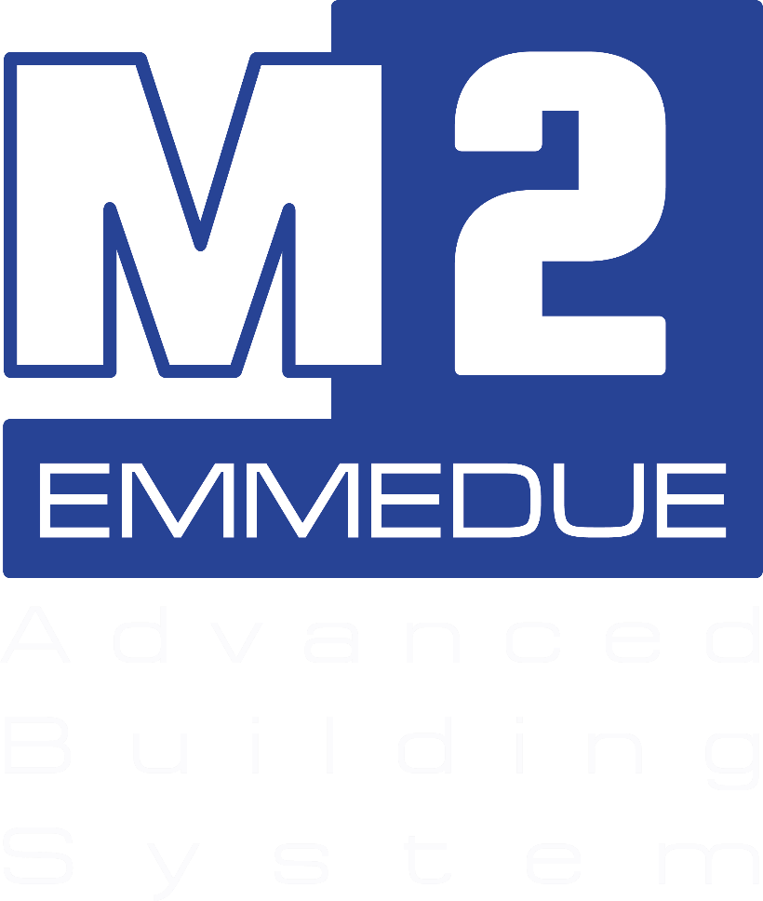
………………………………………………………….

E
MM
E
D
U
E

Website:

www.mdue.i
t

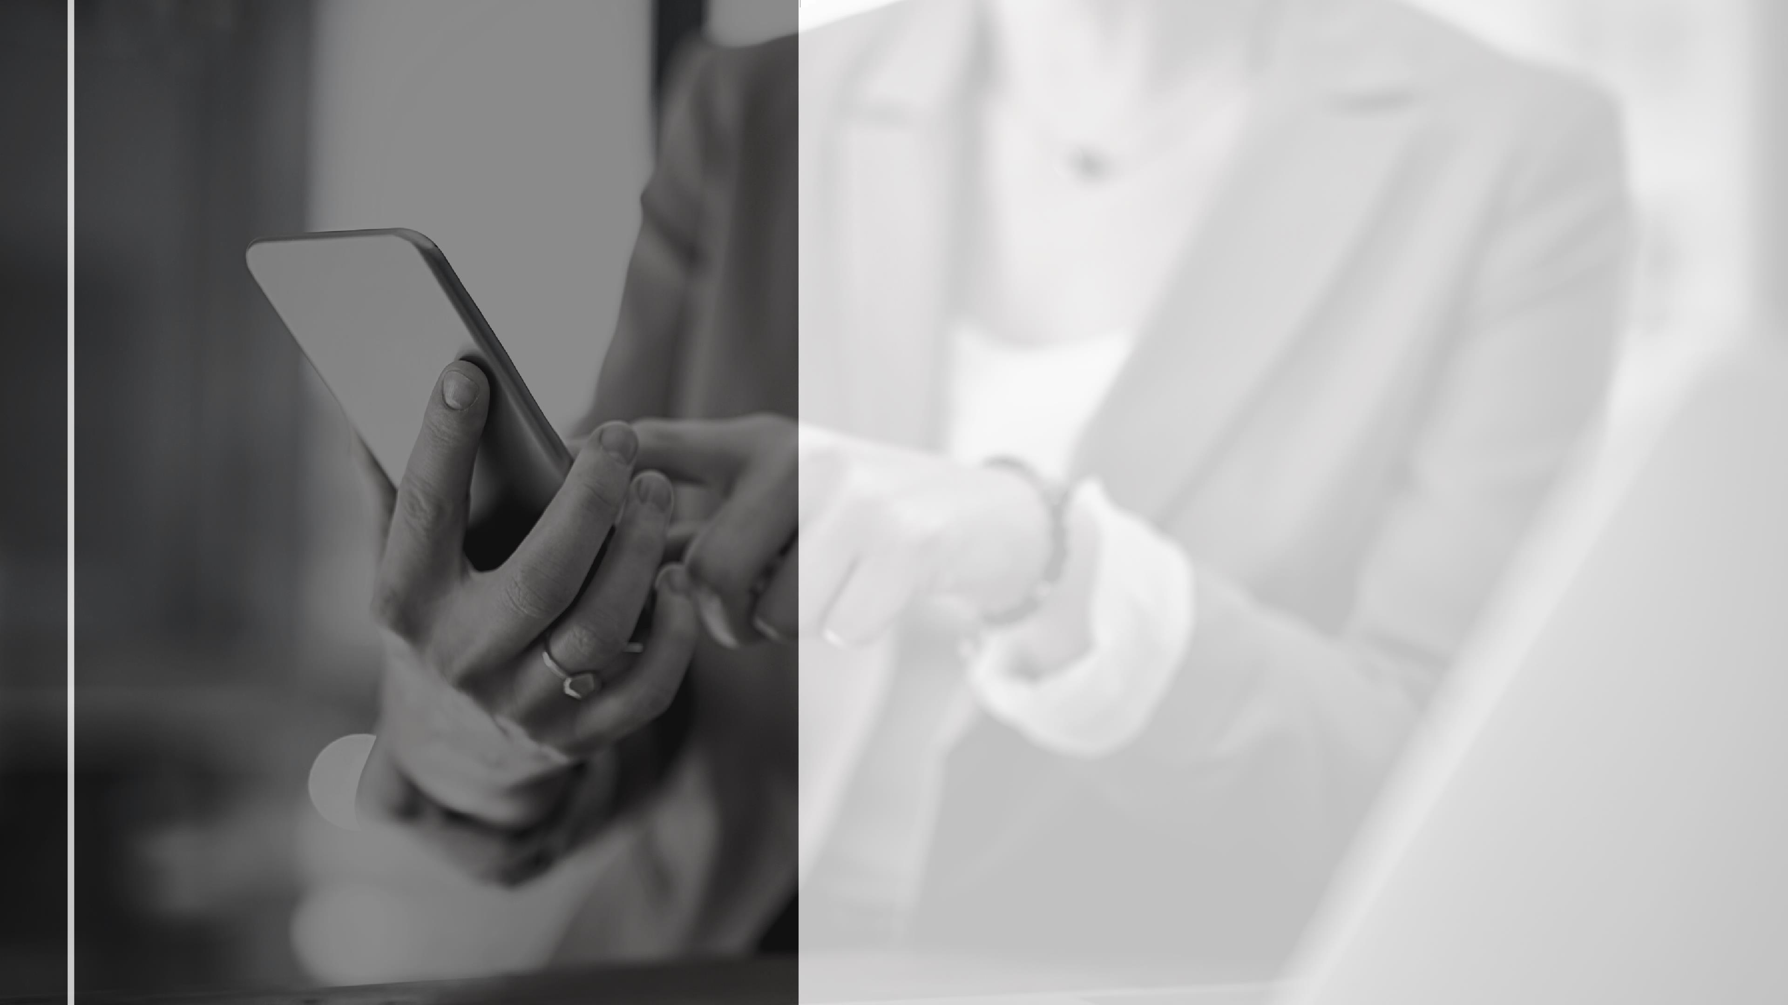
GET

IN

TOUCH

ADDRESS

23

Rue

Labourdonnais,

Port

Louis,

Mauritius

PHONE

+230

214 1644

1644

+230

5778

7033
+27

84

456

1627

EMAIL

aslam@mlmbusinessdevelopments.com

