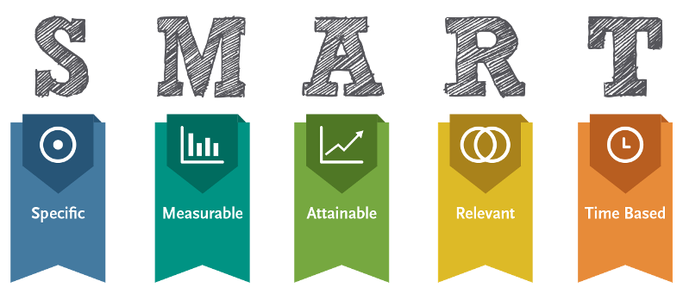

**Name: Zoya Omarali Date: 9/12/18 Period: 4**

**Personal SMART Goal** *(to be achieved in the next year):*

*In the next year, I want to train my dog, Archie, to do all basic commands of the PetSmart requirements so that he will be the ideal dog for my mom so she stops complaining.*

**Personal SMART Goal** *(to be achieved in the next 2-5 years):*

*In the next 2 years, I to be able to get into college so I️ hope to so this by getting a 3.7 GPA because I️ want to go to a old college in the future.*

**Professional/Career SMART Goal** *(to be achieved in the next year):*

*In the next year I️ hope to get an internship with a retail company in the Bay Area because I️ want to go into the fashion industry with business.*

**Professional/Career SMART Goal** *(to be achieved in the next 2-5 years):*

*In the next 2-5 years, I️ want to go to business school, either UCLA or University or Waterloo, to be able to get into the business world and I️ will be able to achieve this with my work experience.*