FLORIDA GOURD SOCIETY FESTIVAL
February 21-23, 2020

TEACHER APPLICATION INSTRUCTIONS
The Florida Gourd Society thanks you for applying to teach at the 2020 Florida Gourd Society Show & Festival. We will again this year be in Melbourne, Florida. Classes will be held in a climate-controlled building, plus a separate covered pavilion outside for all carving and wood-burning. Come share your knowledge of gourds with us in Melbourne, Florida in 2020 and enjoy the Florida Space Coast. We are located just 10 minutes away from the beaches and an hour south of the Kennedy Space Center and Orlando theme parks, so plan on staying a few extra days and enjoying the Central Florida weather. We look forward to working with each and every one of you and seeing the exciting new projects you come up with. See you in Melbourne in 2020!

DEADLINE FOR APPLICATIONS is a firm date of October 1, 2019. You will be notified prior to November 1, 2019, if your class/classes are accepted and a schedule to proof. We will be looking for great classes that are unique and/or new. Classes for beginners are desirable also. If your classes are accepted, you will also be required to do a twenty minute DEMO at the show as well as donate an item for our fund-raisers.

CLASS TIMES are as follows with eight to nine (8-9) different classes offered in each time slot: I will try to accommodate you with your preferred time. Please make sure your project will fit in the time schedule allotted.
Friday: 8:30 a.m. thru 12:00 p.m. (3 1/2 hr. class only) Friday: 1:30 p.m. thru 5:30 p.m. (4 hr. class)
Saturday: 8:30 a.m. thru 12:00 p.m. (3 1/2 hr. class only) Saturday: 1:30 p.m. thru 5:30 p.m. (4 hr. class)
Sunday: 9:00 a.m. thru 2:00 p.m. (3 or 4 hr. class) with 1 hour for lunch. Note: Sunday show hours are until 3 p.m.

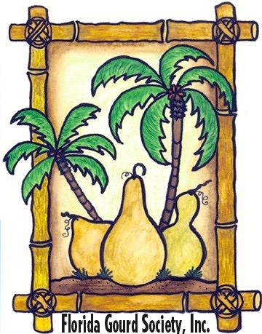
THE CUT OFF TIME for a class to meet the minimum number of students is February 1, 2020. This is a firm deadline. At that time any class not meeting the minimum number of students will have the instructor contacted to determine if the class needs to be cancelled. Please consider a low minimum as we do have many drop-ins at show time.
On the day of your class you may stop by the registration table at any time to check on new additions to your class.

HANDOUTS: We would like for you to have for the students; written instructions with step-by-step procedures, including a photo or illustration of the planned project. If you are teaching a technique, rather than a specific project, please explain the technique thoroughly in your instructions. A list of sources for materials for the project would also be desirable. Also please remember if you are supplying the gourd, students expect a GOOD QUALITY gourd.

PHOTOS: Photograph your projects on a solid background, crop in as close as possible. File size should be no larger than 5” in any direction and 300 dpi. Send only jpg format to: SANDY JORDAN tfjordan@comcast.net
If mailing your application, you can send a clear 4x6” photo. Registration applications/photos must arrive no later than October 1, 2019. See address below.

SUPPLIES: Please note, in fairness to the vendors who are paying to be at our show, that instructors will not be allowed to sell supplies before, during or after their classes. Supplies needed for the class should be added to the cost of the class registration. Please feel free to contact one of the authorized vendors to carry any special supplies that you might be teaching, or we will make arrangements for you to share space in one of the smaller vendor spots during the show. Contact FONDA HADDAD for VENDOR info/fees for these special spaces at fondahaddad@cfl.rr.com

PLEASE HAVE A SAMPLE OF YOUR CLASS PROJECT AT THE REGISTRATION TABLE BY FRIDAY AT 8 A.M.
If the class is full, we do not need a sample. PLEASE NOTE - All wood burning, carving and rotary tool classes will be outside under the large open pavilion.

RETURN APPLICATION TO: SANDY JORDAN, 12454 SUNCHASE DRIVE, JACKSONVILLE, FL 32246
Questions? Contact Sandy Jordan (904) 240-1399 email: tfjordan@comcast.net

