Boys Shorts Instructions

- All stitching should be serged or zigzagged stitched twice over.
- Lay out the pattern on material. Cut out the desired sized shorts patterns.
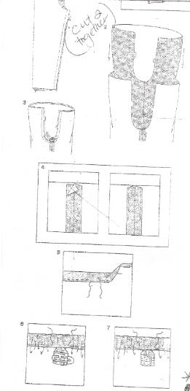
- Use the extra fabric from between the legs of the pattern for a pocket.
  - For pocket, fold over and hem all edges, with the top being a larger hem. Place one pocket piece on your leg fabric. Be sure to place them in the same place on each leg piece.
- Fold over and hem the bottom of each leg piece.
- With the right sides together sew the leg of each pant leg up to the crotch.
- With the right sides together place one leg into the other, matching leg seams then pin in place.
- Sew around the crotch. When finished trim the seam to ¼ in and iron the seam open.
- With your iron fold a 1 ¼ in casing at the top of the shorts to create your waist band. Be sure to fold under the raw edge then sew around the bottom leaving an opening so you can insert the elastic into the waistband.
- Use ¾ inch elastic. Cut elastic to fit the waist plus one inch.
- Size 2 – 20 Size 8 – 24
- Size 4 – 21 Size 10 – 25
- Size 7 – 23 Size 14 – 26
- Feed elastic through the waist. When the ends come together overlap them an inch and pin. Sew the overlapping elastic together. Then sew the waist opening closed.
- Cut any stray thread and turn the pants right side out.

