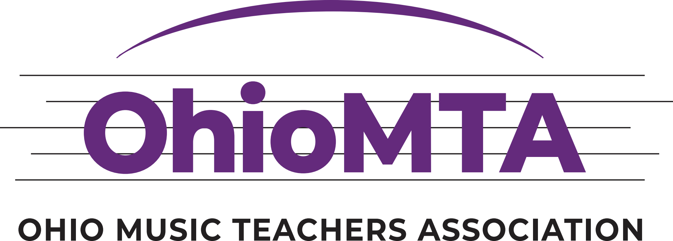

2024-2025 OhioMTA State Buckeye Auditions - Rules & Regulations

Application Procedure
Complete the online registration form available after 1/1/25 at http://www.ohiomta.org/buckeye-auditions

Registration will be streamlined in 2025, with every student registering and paying a single-entry fee through the OhioMTA registration system. It is no longer necessary to send a copy of the registration and payment to the district chair. The registration link will open on January 1, 2025, and close on March 1. All district Buckeye Auditions should be complete by May 1, 2025. If online auditions become necessary, further instructions regarding submission will be supplied by January 1, 2025.

Teacher Eligibility

Teachers may enter only students who are currently studying with them and have studied the performance medium of the audition with the entering teacher a minimum of six (6) months of the nine (9) months immediately prior to the day on which the district auditions are held. The teacher and the entrant may not be the same individual.

OhioMTA Member Teachers
- Current membership dues for MTNA, OhioMTA, and the district must be paid in full before the application deadline.
- If a student enters in a district other than the one in which the teacher resides, the teacher must also pay membership dues for the other district.
- An MTNA/OhioMTA member with student membership status may not enter students.

The Student
- Contestant must have studied the performance medium of the audition with the same member-teacher a minimum of six (6) months of the nine (9) months immediately preceding the day on which the district auditions are held.
- Students may only enter in the district where they live or in the district where the instruction takes place.
- Any previous state winner of an MTNA Competition or state winner of the State Buckeye Auditions may not enter the Buckeye Audition in the same instrument category or level but may enter in a different instrument category or level when eligible.

Competitions Agreement

It is the responsibility of the teacher, entrant, and parent or guardian to abide by all rules and regulations for Buckeye Auditions. Failure to meet this responsibility will result in the disqualification of the entrant at the level of competition where the discrepancy is discovered.

Competition Schedule

- Consult District Audition Chairs or newsletters for district audition dates. Winners of the district competitions become finalists in the state auditions.
- The Buckeye State Auditions begin at the district level during the months preceding the state finals to be held Saturday, June 14, 2025, at Miami University.

Categories

Piano, Strings, Voice, and Winds

Levels (Age as of September 2024)
- Elementary: Ages 9-11
- Junior: Ages 12-14
- Senior: Ages 15-18

Fees
The member and non-member fees are:
Member’s Nonmember
Student(s) Student(s)
Elementary: $70.00 $105.00
Junior: $90.00 $135.00
Senior: $110.00 $165.00

State Winner Awards

Elementary: $400.00
Junior: $550.00
Senior: $700.00
Reproduction of Published Music

- Reproduction of printed music (either by hand or by machine), including transpositions, is not allowed.
- When music is out of print or still in manuscript (not published), the student must present written permission from the publisher or the copyright holder to copy the music at each level of the competition to comply with copyright laws.
- For voice and instrumental categories, the accompanist may reproduce single pages to facilitate page turns. Still, the appropriate published score must also be present on the music stand and/or piano desk.

Repertoire Requirements

- All levels are required to have at least two or more contrasting compositions from different periods of music.
- Senior Piano Level, one composition from the classical period must be programmed.
- Senior Voice, three different songs in three different languages must be programmed with no minimum time limit.
- Pianists and vocalists must perform compositions from memory.
- Memorization is optional for all other categories.
- Cuts (any deletions of the printed score) in the music are not acceptable (excepting accompanying introductions and interludes).
- Contestants may be stopped during the performance of any work due to time constraints.
- No changes in repertoire may be made between district and state competitions.
- No changes in repertoire may be made after the district deadline for entries.
- Judges may ask to hear any composition listed on the entry form.
- Contestants in Strings and Woodwinds may audition on only one instrument in these categories.
- Each contestant will provide judges with one published copy of each piece to be performed with the measures numbered. The copy must not contain any identifying marks (such as name or location of student, teacher, school, library, etc.).

Time Limits
- Elementary: 5-10 minutes
- Junior: 6-12 minutes
- Senior: 9-18 minutes

Staying within the time limits is recommended. Those who fall short of the minimum time will be disqualified. Those who exceed the time limits will be stopped at the point in their performances when the maximum time is reached. Timing should not include the time taken between pieces.

General Regulations

- Students must provide their accompanists. Teachers may accompany their students. Teachers may not identify themselves to or converse with the judges before or during the competitions. Senior contestants should not be assisted on stage with tuning.
- Contestants will not be permitted to perform for comments only at any level of the competitions.
- The adjudicators' decision is final and may not be challenged by the teacher, entrant, parents, or guardians.
- Judges have the prerogative to declare no winner.
- Administrative decisions made at any level of the competitions are binding on all parties concerned.
- Students who win district auditions must compete in the state finals. If this is impossible due to extenuating circumstances, it is the student's responsibility to notify the district and state auditions chairs immediately.
- OhioMTA (at either the district or state level) is not responsible for contestants' travel or any other expenses related to the competitions.
- Auditions will be open to the public.
- There will be no ties at any level. Honorable mentions may be awarded at the district level and state finals.
- The alternate, but not honorable mentions, may represent the district at the state finals if the district winner cannot participate.
- Photography at the Buckeye Auditions is not allowed at either the district or state auditions.
- Audio and videotaping are strongly discouraged at the district and state auditions.

Completion of the Competition

Judges' comment sheets will be given to each participant, and certificates will be awarded to each participant in the state finals.

For more details, please contact the state chair, Dr. Frank Huang, huangfd@miamioh.edu

