 |  |  | Reg. 2016/022961/08  PBO: 930067049  752 Metlatoe Street  Molapo, Soweto, 1818  South Africa  +27 63 071 2093  +27 78 033 8673  info@youthopportunitiessa.org  www.youthopportunitiessouthafrica.org

Programme Report: January 2026

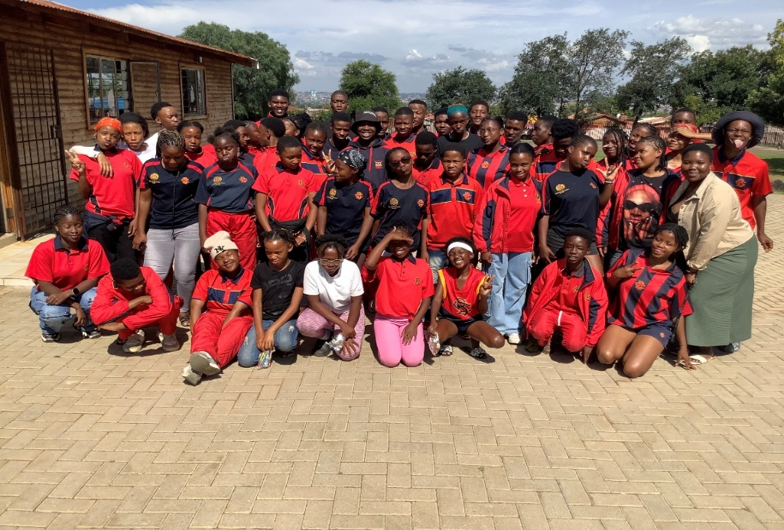
Introduction
The month of January found us in celebratory mood because all the learners in YOSA programme have passed and progressed to the next grades. Our learning support programme proved to be effective. We also spent quite considerable time preparing for the opening of schools in January. We received our friends and regular visitors from Australia. We were also faced with the imperative need for extensive repairs to our facilities and we had to manage with the little resources we had. 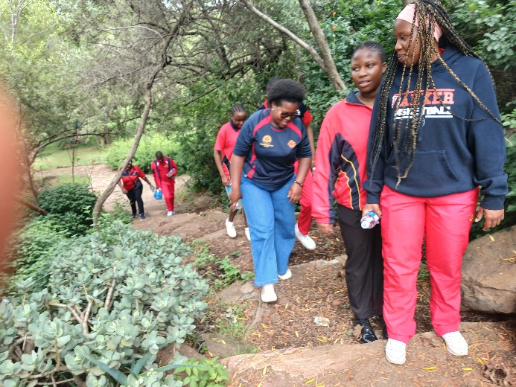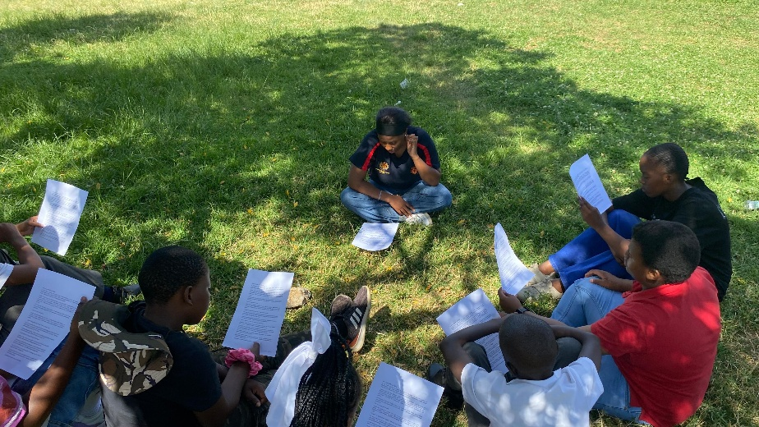YOSA staff on work readiness retreat and inaugural learning support programme in the year

YOSA Staff and university students’ placements
We have received 11 university students on field practice this year. Three of them are from SACAP and 8 are from the University of the Witwatersrand in Johannesburg. University students are great resources for running our psychosocial and learning support programmes as peer mentors. All the schools we support are effectively catered for this year.

January is a critical month in planning our work. The focus of the month was strengthening partnerships, learner engagement, and preparation for programme implementation for the 2026 academic year. We also spent considerable time with our staff and social work students planning our programmes and orienting students on our organizational success matrix. One week was devoted to orienting students to YOSA implementation model. Our professional social workers attended a seminar on students supervision at Wits University. Hiking, community strolls, school communities’ orientation were part of the team building activities during the first half of the month.
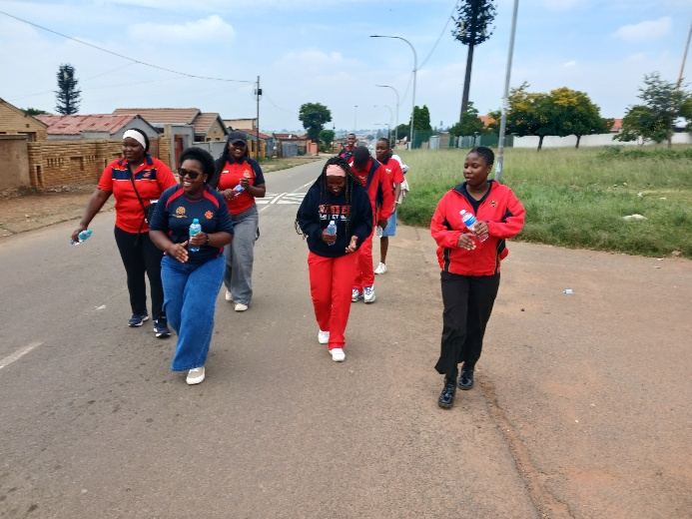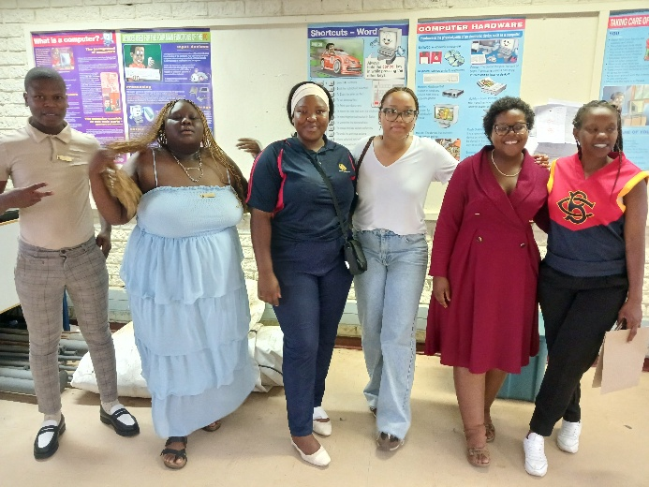
Students’ community orientation and school placements

Donations from Australia
Some activities included hosting international visitors who supported learners and staff through donations. Karen and Trevor arrived from Australia loaded with provisions for our programmes. They also bought and distributed dignity packs for the girls in three different schools. Through long-term placement of social workers and university students in schools YOSA enables positive and sustained adult-youth relationships. These are relations between young people and competent adults who are caring, and continually available, for at least a year, playing mentor, coach, or teacher roles. Karen and Trevor spent considerable time interacting with the girls in schools, motivating and encouraging them to take their education seriously. 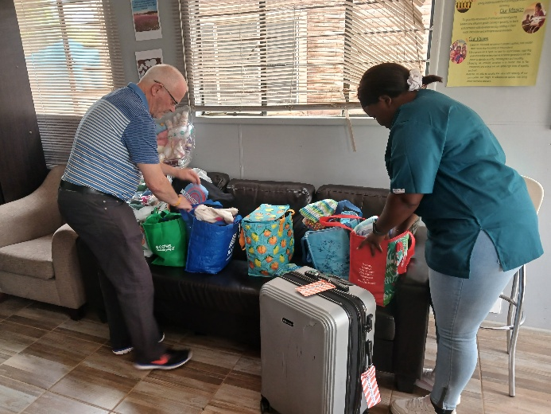
Trevor and Astonishment with a loaded vehicle and Trevro and Melissa unpacking donations at the centre

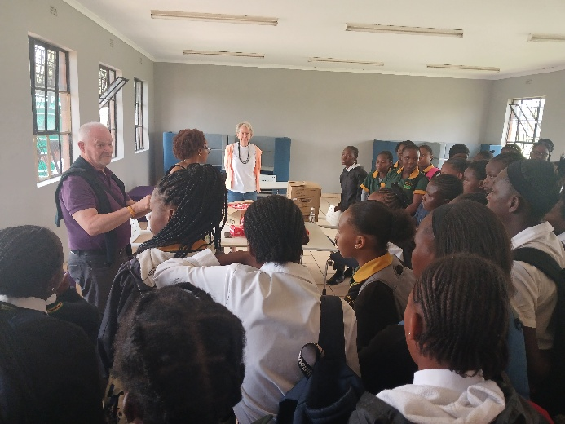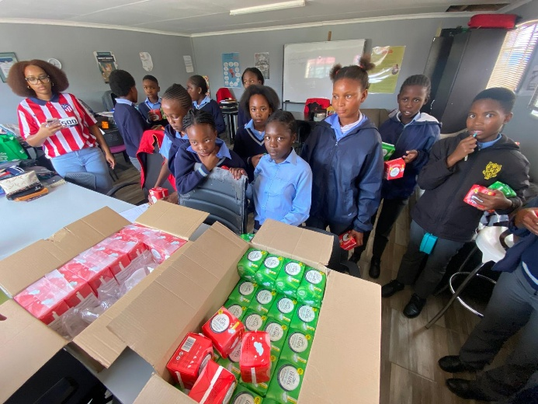
Karen, Trevor and Sebefikile distributing dignity packs to girls in schools

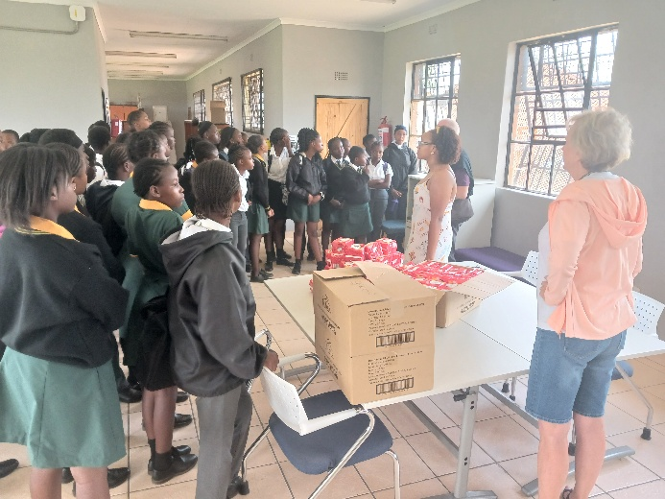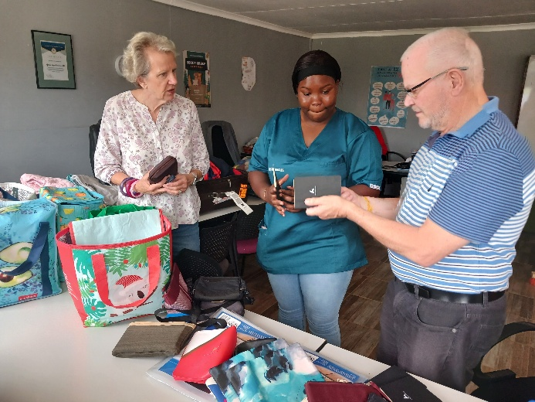
Sebefikile and Karen conversing with girls and Karen, Melissa and Trevor handing over donations.
YOSA Wishlist
YOSA operates on very tight budget. We rely on our friends and well-wishers to provide for most of our needs. Our daily challenges include provisions of necessities for the young people we support. These include food, clothing and school uniforms. Some of them are living in child headed families where they struggle for daily food. Others are in grannies headed families where provisions are very limited as they survive on social grants. We also rely on partners to maintain our facilities.

One of our meeting rooms require painting to preserve the wooden structure. We have just completed repairing the leaking roof. Any support to preserve our structure will go a long way in meeting our programming needs. The updated costs for the repairs are R4,500.

The YOSA nutritional garden shed, and structure were destroyed by hailstorms. The nutritional garden is a valuable project for our programming. It provides meals for the children and some of the children living in child headed households, or with grandparents, take vegetables for consumption at home. The garden plumbing also requires enhancement to enable it to provide more vegetables. We have so far received R3000.00 from Karen and Trevor towards the repairs. Any support to this project will contribute to YOSA food self-sufficiency. The updated costs for the repairs are R3,600.

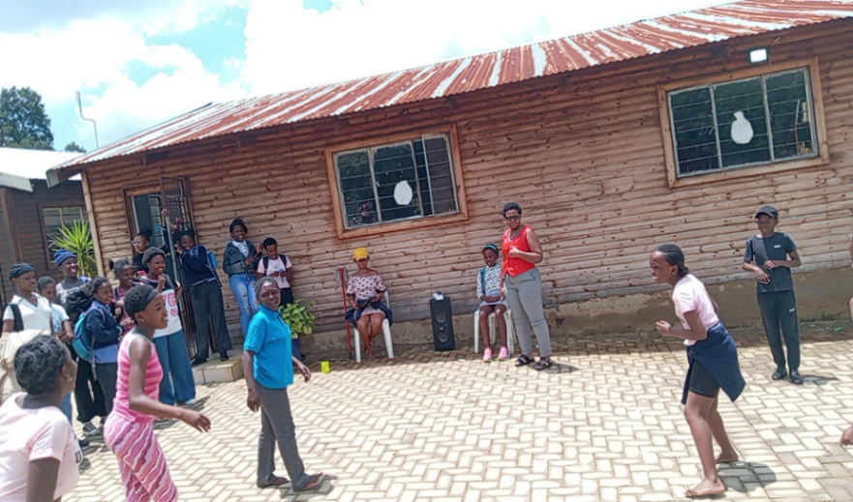 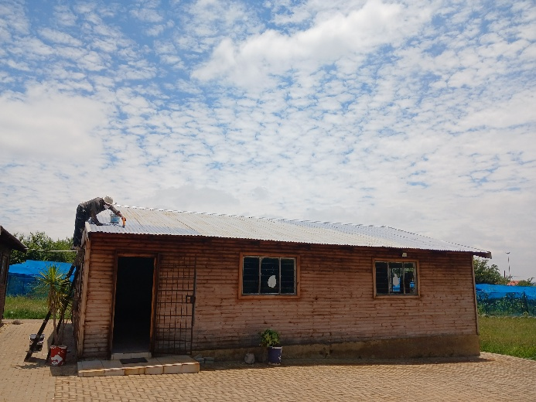Building that required roof repairs now done and still needs structural paint
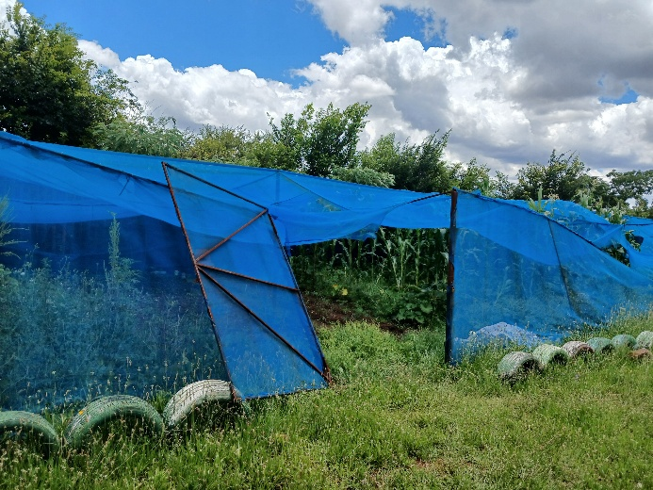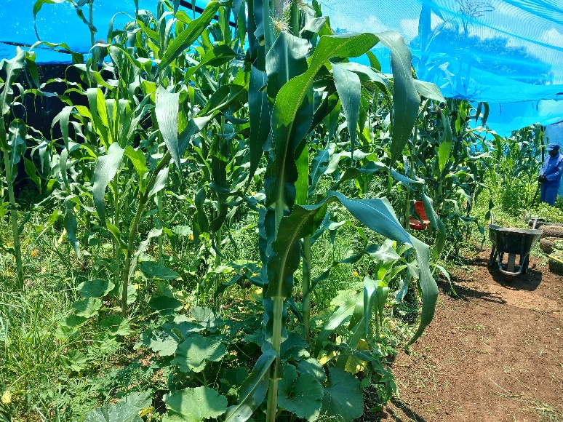
The garden shed is currently under repairs. We need additions funds for completion

YOSA support and motivation is helping vulnerable young people to study hard and qualify for university. Some of those who qualify for university do not have money for initial registration and basic preparations. We YOSA is grateful to Karen and Richard for donating just over ten thousand rand to support students entering universities. We currently have 5 YOSA graduates in universities who require support. Any second-hand gadgets (phones and laptops) will also be greatly appreciated to help set up the young people into tertiary institutions.

We support child headed families with food parcels. 15 of these families rely entirely on YOSA support. With additional support from our nutritional garden, we provide groceries of household basics worth R1500 each to last them two months. Any support or contribution towards provisions for our child headed families will be greatly appreciated.

Acknowledgements
YOSA is eternally grateful for the support from FNZ, a global financial services and fintech company supporting us from their Africa headquarters in Sandton. The support provides the back born for us to run our programmes. We also received donations from Donna, Jay, Karen and Trevor, Hamish, Marty, Karen and Richard. As a nonprofit organization, YOSA depends on well wishers to run its programmes. We receive so many requests for support from schools, but our coverage is strictly determined by the resources at hand.

Conclusion
The month of January provided opportunities for programme preparation before schools opened. We also have a reconfigured staff group due to limited financial resources and the arrival of new group of university students. We are, however, ready to continue making a difference.

