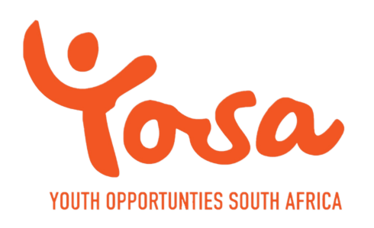 |  |  | Reg. 2016/022961/08  PBO: 930067049  752 Metlatoe Street  Molapo, Soweto, 1818  South Africa  +27 63 071 2093  +27 78 033 8673  info@youthopportunitiessa.org  www.youthopportunitiessouthafrica.org

Programme Report: February 2026

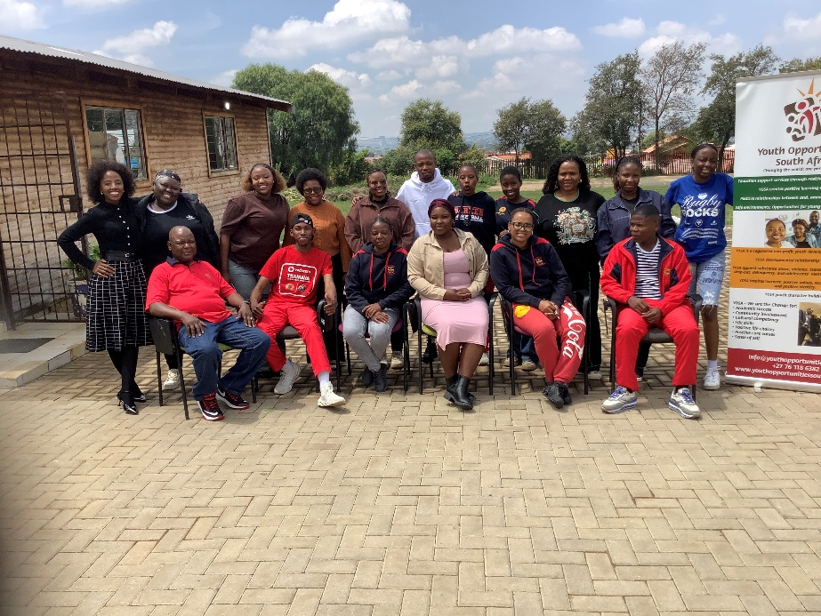
Introduction
The month of February saw the installation of solar power at one of our schools (Sekwati Primary School) where our offices are based. YOSA was also recognised as a valuable partner of the Department of Education, Johannesburg Central District. The team also attained holistic interventions that included learning support, psychosocial support and digital skills development. This programme combination is cherished by learners who appreciate learning while playing.

Solar Project
YOSA has secured partnership with GoSolar, an energy company to install solar energy in schools, starting with those hosting our offices and the computer laboratories. The Sekwati primary school installation was completed in February and Morris Isaacson High School will commence on 27 March 2025. The corporate funded solar project brings a huge relief to schools that are struggling with electricity bills. The solar equipment is supplied and installed in schools at no cost to the school. The project is funded by Investec and other corporates. Schools only pay monthly maintenance subscriptions that are far much less than their current bills. The schools through the School Governing bodies and the Department of Education enter into agreement for solar energy provision.
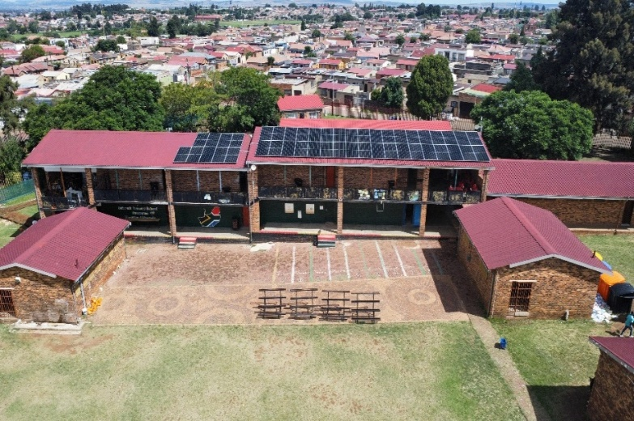 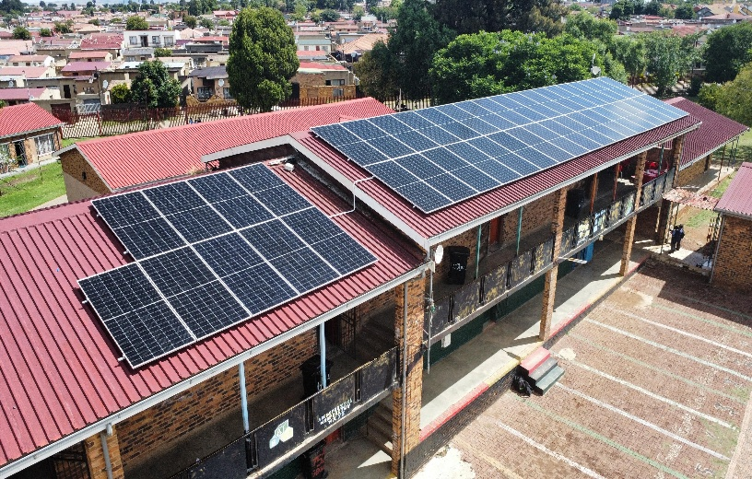 Solar project completed at Sekwati Primary School.

District Academic Merit Awards
YOSA was one of the key participants and partners in the Academic Merit Awards for Johannesburg Central District. The event was meant to celebrate learners, teachers and schools that achieved excellence within the district. Three of the schools being supported by YOSA received awards for being the most improved in delivering high pass rates. YOSA’s involvement strengthened its visibility within the education sector and reinforced its commitment to supporting academic success and holistic learner development. YOSA was recognized as a key strategic partner by the Johannesburg Central District.
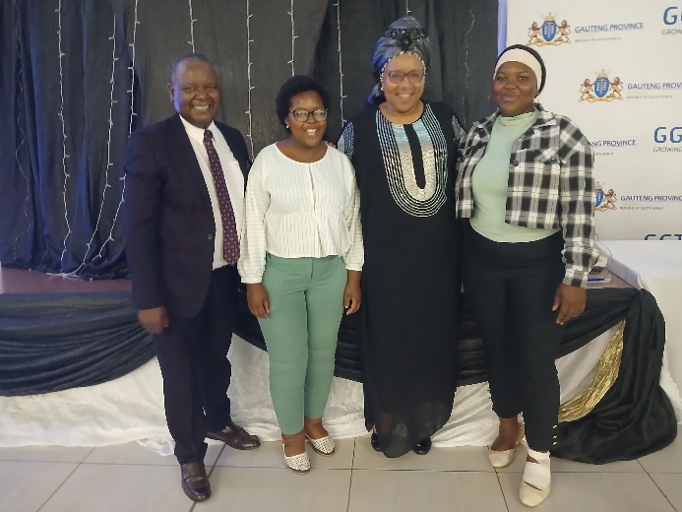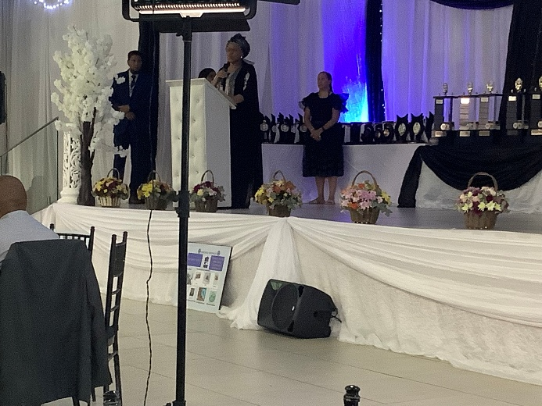
Astonishment, Rethabile (YOSA social worker), Ms Seate (the District Director) and Melissa (YOSA social worker)

Howden Visit and Stationery Donation
During the month of February, we were privileged to receive a huge donation of stationery from Howden, a local engineering company. The company’s interest in supporting education aligns with YOSA’s goal increasing learners’ participation and improving pass rates in STEM subjects in township schools. Howden staff members brought stationery packs to YOSA during their visit. These are essential for enabling the YOSA learning support programmes as well as assisting learners who cannot afford stationery.

Howden visited YOSA at Sekwati Primary School, during which 50 packs of stationery were donated to support learners in need. We held an engaging discussion focused on building future connections and exploring potential volunteer opportunities and collaborative services. We wish this visit can result in long term partnership and created opportunities for ongoing support and corporate community involvement.
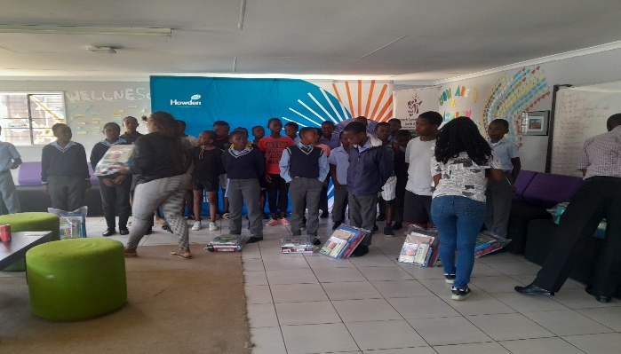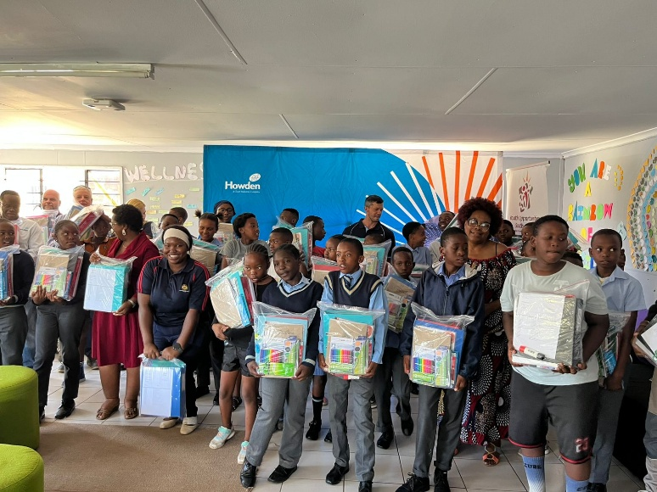
YOSA participants (learners), staff and Howden staff on the day of the stationery donation

Growing Minds: Literacy Programme
The Growing Minds Literacy Programme was implemented with Grade 4 and 5 learners to enhance English comprehension and reading skills in the primary schools supported by YOSA. The programme incorporated structured reading sessions, interactive discussions, and engaging activities to strengthen vocabulary, confidence, and understanding. The initiative aims to cultivate a strong reading culture while improving academic performance and learner participation in the classroom.
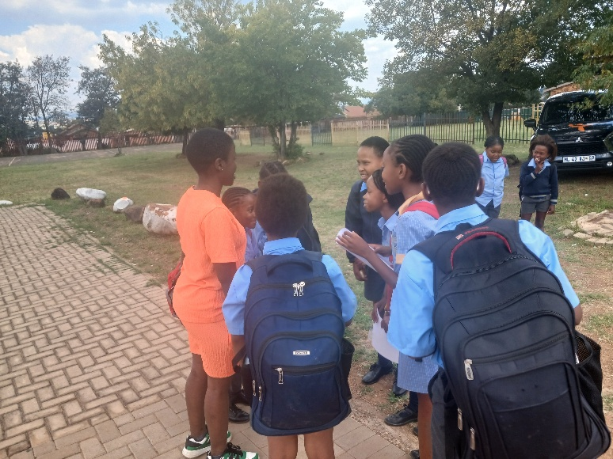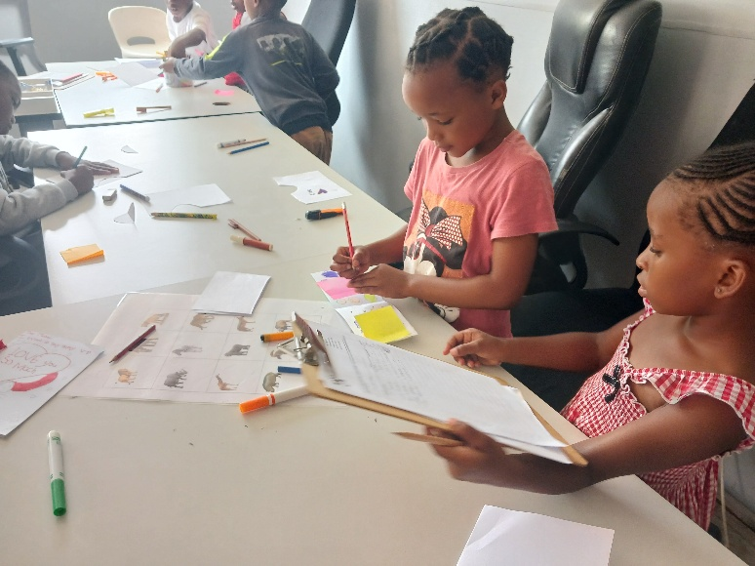
Grade 4 and 5 learners interacting with YOSA learning support staff at the Centre

Mathematics coaching programme
The mathematics coaching program is an ongoing initiative designed to strengthen learners’ understanding of mathematical concepts, increase the number of learners taking Mathematics and sciences route and improve academic performance. Very few learners are studying maths and science subjects in township schools. In the schools we support, the school with the highest number of learners who wrote mathematics in 2025 had 35 out of 200 matriculants. Mathematics is a key subject that develops critical thinking, logical reasoning, and problem-solving skills required for everyday life and future careers. Our programme delivery model makes mathematics enjoyable as it takes learners from simple to complex tasks in a playful way. Learners are encouraged to be more open to engaging in mathematical tasks, particularly during practical sessions and grade-specific exercises. Our current focus is on building a solid foundation with Grade 8 and Grade 9 learners. The gape is so huge that we aim to increase the number of learners who write pure Maths in grade 12 to at least one quarter when current grade 9 class gets to matric (in the next 4 years) and half in the next 5 years.
We are currently appealing for additional resources to increase personnel and resources for our program to strengthen:
- Extra after school and weekend classes and one on one mentoring to reinforce concepts
- Collaborative problem-solving sessions to enhance peer learning
- Fun activities and mathematical games to make learning interactive
- Focused exercises on real-life applications of mathematics
- Regular assessments to track learner progress and understanding
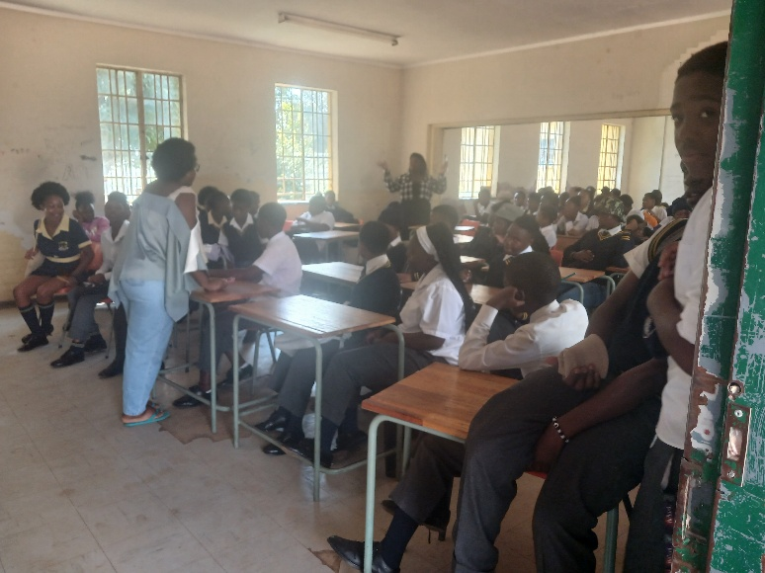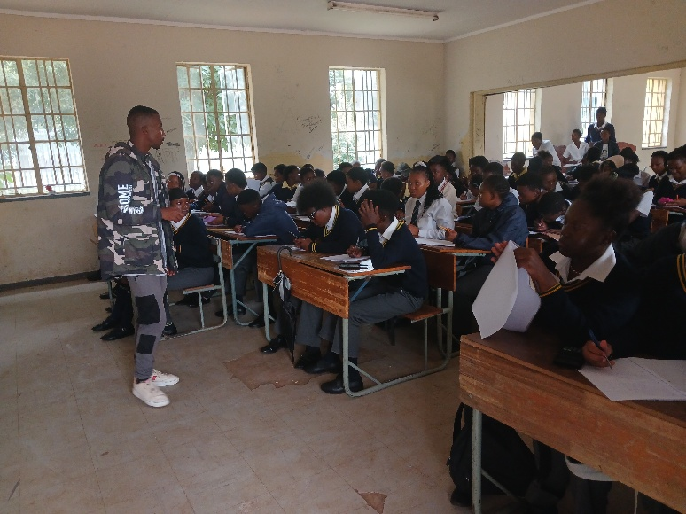
YOSA staff runing weekend mathematics classes

English club and homework support
The English Club and Homework support takes place at the Centre. The sessions provided structured academic support to learners. It focused on improving English comprehension, reading fluency, writing skills, and overall academic confidence. Learners were supported with homework completion and encouraged to participate actively in discussions and reading activities. The initiative contributes to strengthening literacy skills and promoting positive study habits.
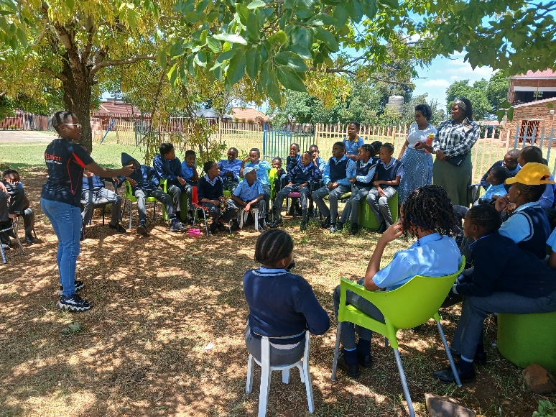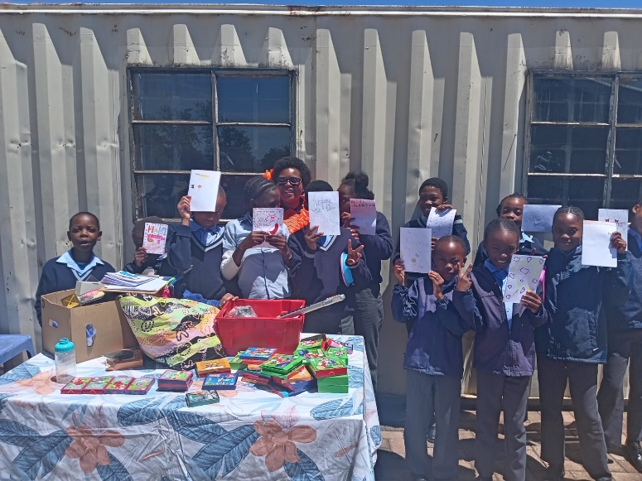
The English club and the homework support activities

Scouts Introduction
The Scouts introductory sessions for 2026 were conducted in February to recruit interested learners with parental consents. The sessions highlighted leadership, teamwork, community service, and responsibility as core values of the Scouts initiative. Learners were encouraged to participate actively and take on leadership opportunities within the school. Our primary and secondary school learners were excited to be part of the scouts’ programme. With 40 learners already enrolled on the programme, YOSA requires resources to help the learners with uniforms, and equipment for the programme.
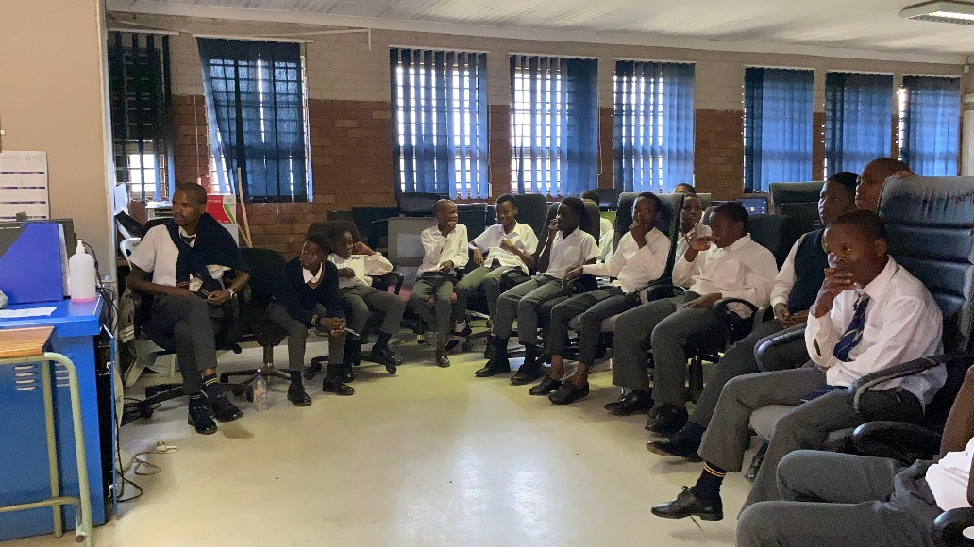
Learners enrolled on the scouts’ programme

Empowering the Boy Child
A session focusing on empowering the boy child was conducted at Sekano Ntoane Secondary School addressing issues affecting boy learners and promoted positive identity development, responsibility, and resilience. The intervention created a platform for open dialogue and encouraged learners to seek support when needed. This addressed issues of bullying, gender-based violence and encouraged learners to take their education seriously.

Digital Literacy
At Sekano Ntoane the lab started functioning to train grade 8 to 11 learners on typing proficiency, Microsoft Word basics and creative digital projects. These activities were also being taught to grade 8 learners at Morris Isaacson High School where we have a functional computer laboratory. Our lab technicians helped learners with safe media presence, supported independent learning and creativity for learners.
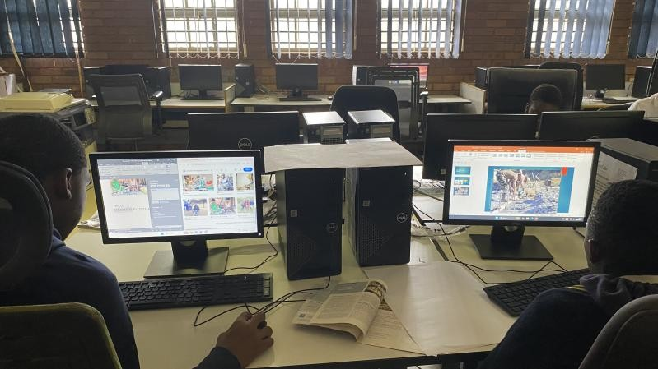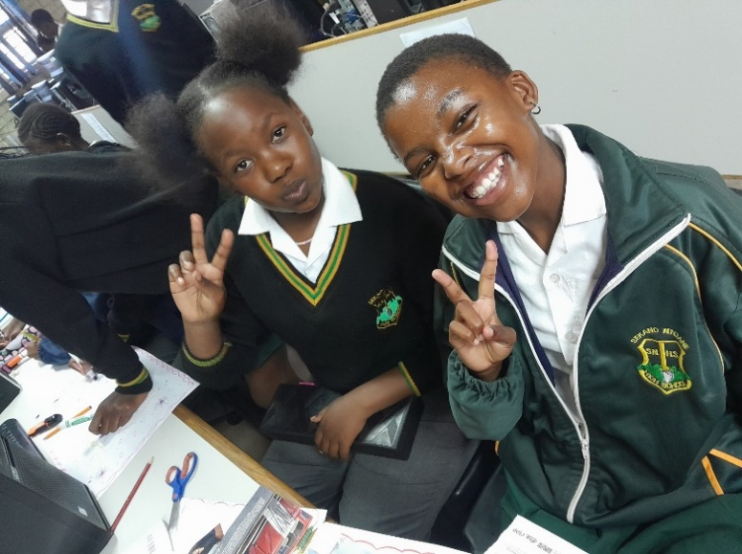
Learners in computer laboratories

Through the learning support, psychosocial support and the digital skills development programme YOSA promoted positive school culture. One of our major programme activities encouraged learners to understand their purpose in school. The computer laboratories were also hand for YOSA learning support team to download the annual teaching plans so they could tailor their curriculum coaching materials accordingly.

YOSA Wishlist
Our core programme that includes psychosocial support, curriculum support and digital skills development is in need of funding. The funding is required to increase the number of curriculum coaches, pay for social workers and lab technicians to support our learning support model. The learners we support have deep psychosocial support challenges so our curriculum coaching programme depends on the wellbeing of learners and digital skills augmentation for effective results.

YOSA learning support model
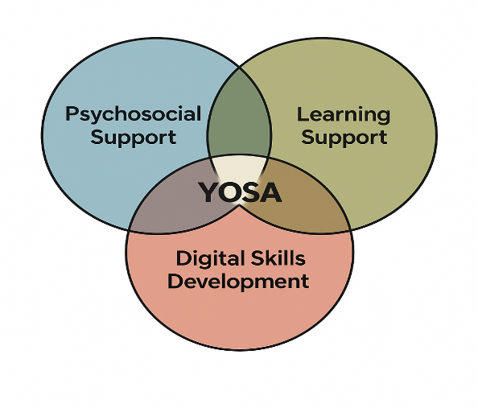
YOSA relies on friends and well-wishers to provide resources for its programming needs. Our daily challenges include provisions of necessities for the young people we support. These include food, clothing and school uniforms. Some of them are living in child headed families where they struggle for daily food. Others are in grannies headed families where provisions are very limited as they survive on social grants. We also rely on partners to maintain our facilities.

One of our meeting rooms require painting to preserve the wooden structure. We have just completed repairing the leaking roof. Any support to preserve our structure will go a long way in meeting our programming needs. The updated costs for the repairs are R4,500.

The YOSA nutritional garden shed, and structure were destroyed by hailstorms. The nutritional garden is a valuable project for our programming. It provides meals for the children and some of the children living in child headed households, or with grandparents, take vegetables for consumption at home. The garden plumbing also requires enhancement to enable it to provide more vegetables. We have so far received R3000.00 from Karen and Trevor towards the repairs. Any support to this project will contribute to YOSA food self-sufficiency. The updated outstanding costs for the repairs and plumping are R3,600.

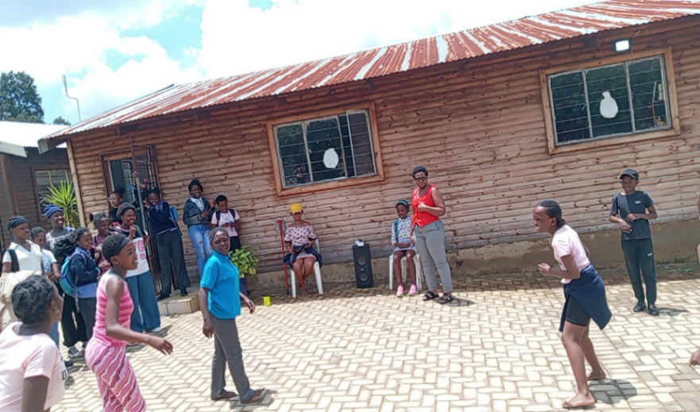 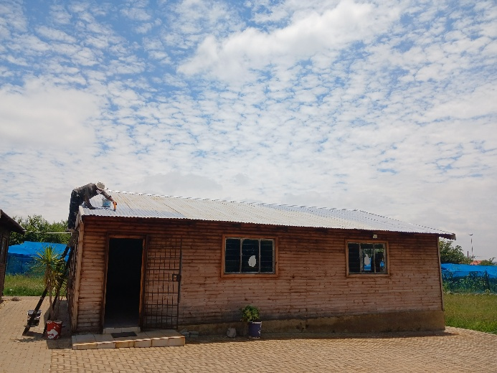Building that required roof repairs now done and still needs structural paint
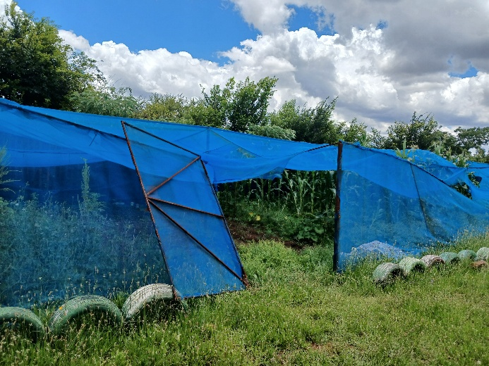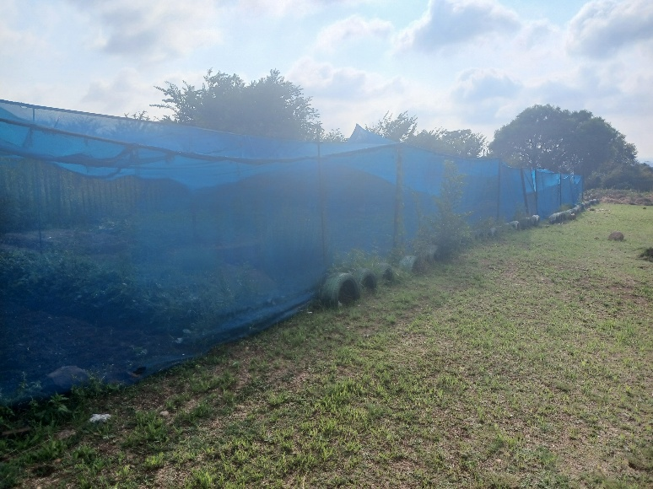
The garden shed is currently under repairs. We need additions funds for completion

YOSA support and motivation is helping vulnerable young people to study hard and qualify for university. Some of those who qualify for university do not have money for initial registration and basic preparations. We YOSA is grateful to Karen and Richard for donating just over ten thousand rand to support students entering universities. We currently have 5 YOSA graduates in universities who require support. Any second-hand gadgets (phones and laptops) will also be greatly appreciated to help set up the young people into tertiary institutions.

We support child headed families with food parcels. 15 of these families rely entirely on YOSA support. With additional support from our nutritional garden, we provide groceries of household basics worth R1500 each to last them two months. Any support or contribution towards provisions for our child headed families will be greatly appreciated.

Acknowledgements
YOSA is eternally grateful for the support from FNZ, a global financial services and fintech company supporting us from their Africa headquarters in Sandton. The support provides the back born for us to run our programmes. We also received donations from Donna, Karen and Trevor, Simone, Hamish, Marty, Debbie Osler. As a nonprofit organization, YOSA depends on well-wishers to run its programmes. We receive so many requests for support from schools, but our coverage is strictly determined by the resources at hand.

Conclusion
The month of February was very productive in driving our psychosocial and learning support programmes. We also covered significant ground in our digital skills development with the broadening of programmes being run at our new laboratory at Sekano Ntoane Secondary School. The installation of solar energy in schools has taken YOSA credibility in schools to the next level. All the schools supported by YOSA are lined up for solar installation. We are so grateful to GoSolar and all the other funders supporting our work in township schools.

