How to beat CPS
https://www.bitchute.com/video/h7fHujX11aHA/

For profit corporations (dun & brad street numbers)
When you know it is a for-profit corporation you do not have a contract with them. Ask for the articles of incorporation.

they won’t give them to you

the articles of corporation have to have a corporate charter and those articles of incorporation have to be consistent with the constitution and all corporations are suable.

Under Monell vs department of social services 436 us 658. (1978)
“You can sue any corporation for their unconstitutional policies, patterns, and practices”
Monell v. Department of Soc. Svcs. :: 436 U.S. 658 (1978) :: Justia US Supreme Court Center

https://supreme.justia.com/cases/federal/us/318/363/

Clearfield trust vs United stAtes

https://tile.loc.gov/storage-services/service/ll/usrep/usrep436/usrep436658/usrep436658.pdf

Clearfield trust vs United stAtes

Clearfield Doctrine
All courts where dissolved in 2008 under the clearfield doctrine then became registered companies on Dunn and Bradstreet company search. When governments enter the world of commerce, they are subject to the same burdens as any private firm or corporation U.S v Burr 309 U.S 22. See 22, U.S CA 286 e Bank of US v Planters Bank of Georgia 6L Ed (Wheat 244.) NOTE: Under the Clearfield Doctrine, the courts are no longer government entities in that they are demanding private monies and must have a contract with you to compel performance. They are no more special as a normal business than your local Jack In The Box. Clearfield Doctrine - “private commercial paper is used by corporate government, then government loses its sovereignty status and becomes no different than a mere private corporation” . Government create and enforce CIVIL LAWS known as statues, acts and legislation created by the Bar Association (set up by Rothschilds) which are duty bound to comply with the LAW of CONTRACTS. The Law of Contracts requires signed written agreements and complete transparency!
Governments Have Descended to the Level of Mere Private Corporations
Clearfield Doctrine Supreme Court Annotated Statute, Clearfield Trust Co. v. United States 318 U.S. 363- 371 1942 Whereas defined pursuant to Supreme Court Annotated Statute: Clearfield Trust Co. v. United States 318 U.S. 363-371 1942: "Governments descend to the level of a mere private corporation, and take on the characteristics of a mere private citizen . . . where private corporate commercial paper [Federal Reserve Notes] and securities [checks] is concerned . . . For purposes of suit, such corporations and individuals are regarded as entities entirely separate from government." What the Clearfield Doctrine is saying is that when private commercial paper is used by corporate government, then government loses its sovereignty status and becomes no different than a mere private corporation. As such, government then becomes bound by the rules and laws that govern private corporations which means that if they intend to compel an individual to some specific performance based upon its corporate statutes or corporation rules, then the government, like any private corporation, must be the holder-in-due-course of a contract or other commercial agreement between it and the one upon who demands for specific performance are made. And further, the government must be willing to enter the contract or commercial agreement into evidence before trying to get the court to enforce its demands, called statutes. This case is very important because it is a 1942 case
Exhibit 8a

Exhibit 8a
that was decided after the UNITED STATES CORPORATION COMPANY filed its "CERTIFICATE OF INCORPORATION" in the State of Florida (July 15, 1925). And it was decided AFTER the 'corporate government' agreed to use the currency of the private corporation, the FEDERAL RESERVE. The private currency, the Federal Reserve Note, is still in use today. References: (i) Articles of Incorporation of UNITED STATES CORPORATION COMPANY http://anticorruptionsociety.files.wordpress.com/2014/01/articles-of- incorporation-of-u-scorp-company.pdf (ii) From The Great American Adventure by Judge Dale, retired. (pages 93-94) http://anticorruptionsociety.files.wordpress.com/2013/07/the-great- american-adventurecomplete-work-by-judge-dale.pdf [4] Corporations are not and can never be SOVEREIGN. They are not real, they are a fiction and only exist on paper. 5] Therefore, all laws created by these government corporations are private corporate regulations called public law, statutes, codes and ordinances to conceal their true nature. Do the Judge and your lawyer know about this? You bet they do! 6] Since these government bodies are not SOVEREIGN, they cannot promulgate or enforce CRIMINAL LAWS; they can only create and enforce CIVIL LAWS, which are duty bound to comply with the LAW of CONTRACTS. The Law of Contracts requires signed written agreements and complete transparency! Did you ever agree to be arrested and tried under any of their corporate statutes? For that matter, did you ever agree to contract with them by agreeing to be sued for violating their corporate regulations? [8] Enforcement of these corporate statutes by local, state and federal law enforcement officers are unlawful actions being committed against the SOVEREIGN public and these officers can be held personally liable for their actions. [Bond v. U.S., 529 US 334- 2000] (iii) Our Government is Just Another Corporation http://anticorruptionsociety.com/is-our-government-just-another- corporation/
https://tile.loc.gov/storage-services/service/ll/usrep/usrep436/usrep436658/usrep436658.pdf

Are they depriving you or your children without a hearing?
how about a trial by jury?
how about a warrant with an affidavit showing probable cause ?

if they haven’t done that then we need to implode their corporate charter with a quo warranto.

in law especially British and American common law, quo warranto is a prerogative writ requiring the person to whom it is directed to show what authority they have for exercising some right, power, or franchise they claim to hold.

Under what authority do you operate? Every corporate charter must be consistent with the US Constitution.

Mothers fathers and their progeny are not currency for federal funding.

Coercive slavery forcing you into a contract and nobody wants their service. and you have a choice not to contract with them if you don’t want to. You have a choice to contract with your doctor or not. any medical provider or third party that you want to and courts cannot Coerce contracts with cps on you. so tell the court if you’re compelled to go to court you can enter a notice of appearance challenge standing and jurisdiction. Because another civil corporation can’t force you. Can Walmart force you to buy their shoes? Can McDonald’s force you to buy their fries? No. CPS can’t force you to use their services it’s all coercive slavery. A federal crime forbidden by title 18 usc sections 1583 1584 1585
1583 enticement into slavery
18 USC 1583: Enticement into slavery (house.gov)

1584 sail into involuntary servitude
18 USC 1584: Sale into involuntary servitude (house.gov)

1585 seizure detention transportation or sale of slaves.

18 USC 1585: Seizure, detention, transportation or sale of slaves (house.gov)

They Cannot force a contract on your free will.

Are they depriving you or your children without a hearing?
how about a trial by jury?
how about a warrant with an affidavit showing probable cause ?

if they haven’t done that then we need to implode their corporate charter with a quo warranto

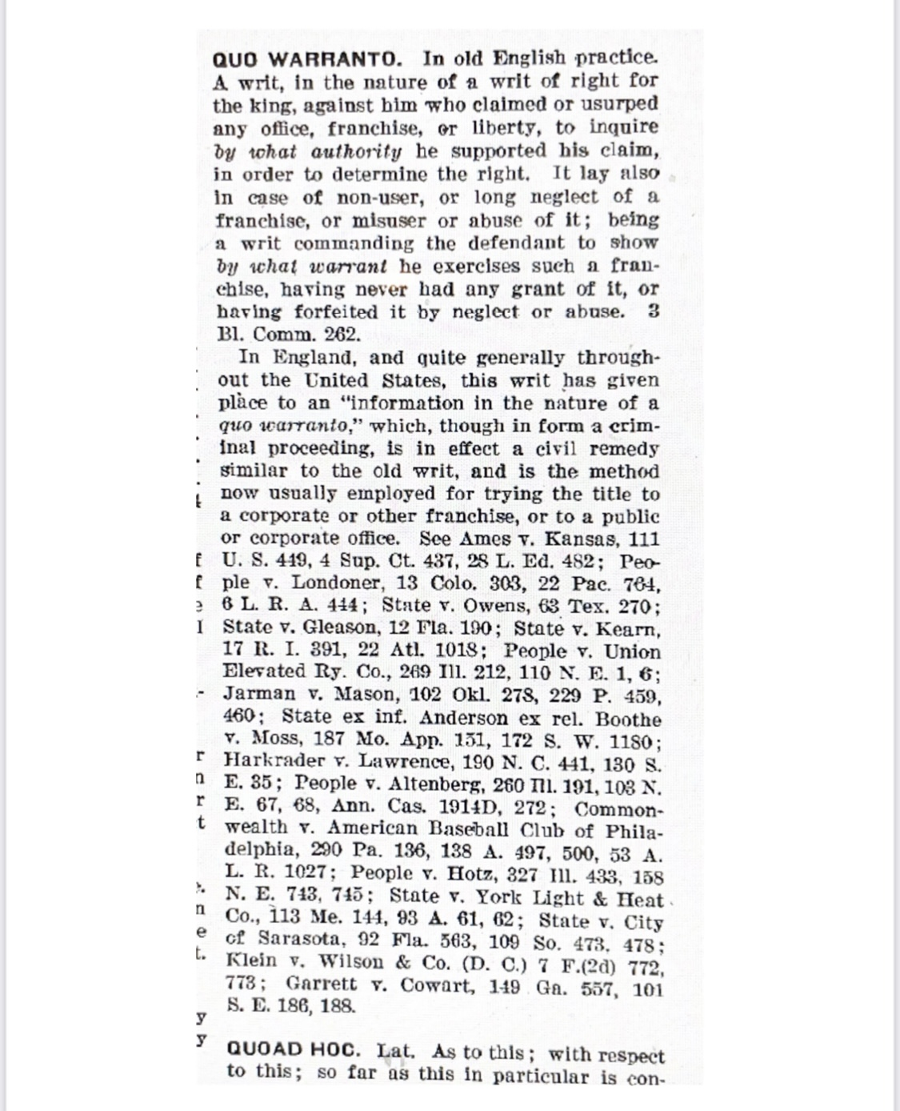
in law especially British and American common law, quo warranto is a prerogative writ requiring the person to whom it is directed to show what authority they have for exercising some right, power, or franchise they claim to hold.

Under what authority do you operate? Every corporate charter must be consistent with the US Constitution.

Mothers fathers and their progeny are not currency for federal funding.

Coercive slavery forcing you into a contract and nobody wants their service. and you have a choice not to contract with them if you don’t want to. You have a choice to contract with your doctor or not. any medical provider or third party that you want to and courts cannot Coerce contracts with cps on you. so tell the court if you’re compelled to go to court you can enter a notice of appearance challenge standing and jurisdiction. Because another civil corporation can’t force you. Can Walmart force you to buy their shoes? Can McDonald’s force you to buy their fries? No. CPS can’t force you to use their services it’s all coercive slavery. A federal crime forbidden by title 18 usc sections 1583 1584 1585
1583 enticement into slavery
18 USC 1583: Enticement into slavery (house.gov)

1584 sail into involuntary servitude
18 USC 1584: Sale into involuntary servitude (house.gov)

1585 seizure detention transportation or sale of slaves.

18 USC 1585: Seizure, detention, transportation or sale of slaves (house.gov)

They Cannot force a contract on your free will.

