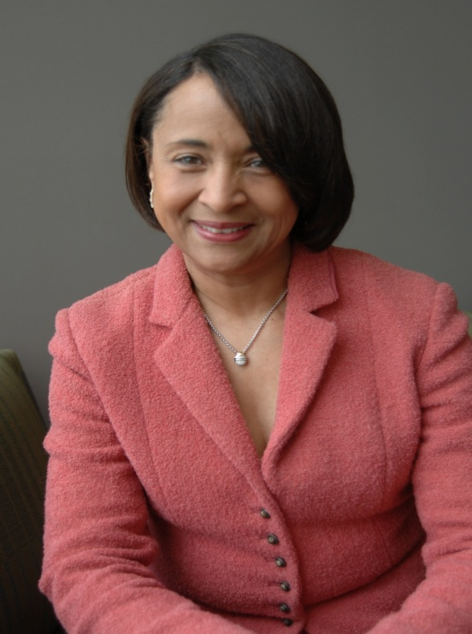

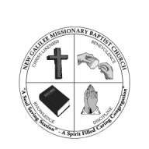

**Come Join us for the**

***Eighth Anniversary Celebration***

**For our Senior Pastor**

**Rev. Karen Gray Sheffield**

**NEW GALILEE MISSIONARY BAPTIST CHURCH**

**“A Soul Saving Station- A Spirit Filled Caring Congregation”**

***Sunday, November 11th 4:00 p.m.***

**11241 Gunston, Detroit, MI 48213**

***“Chosen To Serve”***

***“ye have not chosen me, but I have chosen you, and ordained you, that ye should go and bring forth fruit, and that your fruit should remain: that whatsoever ye ask of the father in my name, he may give it to you.”***

***(John 15:16)***