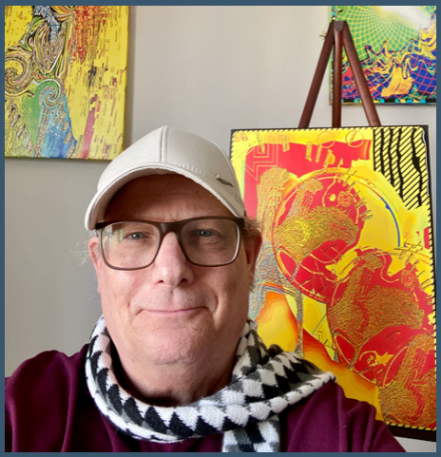

**Keith Edwards – Biography**

**BIO**

K

eith Edwards was born in New York City into a family of creatives: his dad wrote the musical *1776*, his mom was a New York artist and Broadway dancer, and his sister played for the Boston Symphony. Keith trained from an early age on piano and French horn and naturally wrote original music; however, at some point, he devoted most of his time to sports and aviation training. He became a professional pilot at age twenty-one, working as a flight instructor and genal aviation pilot. He believes the visual training and experience of dealing with optical illusions and odd perspectives, especially in and around landings, and flying in varying visibility conditions as elements that helped him develop his artistic vision in the future.

Over time, the seeds of Keith's musical creativity became represented in visual imagery. While traveling widely and living in locales worldwide, he came to believe that similarities amongst disparate peoples and cultures around the world originate in the unconscious. Keith jokingly attributes his natural tenacity to genetics and athletics but credits it with helping him to put in the time to break new ground artistically.

When the pandemic and the lockdown arrived, Keith understood he needed a new activity, so he began organizing his travel photos and playing with the images. His pilot vision, commitment and feeling of music, and travel insights met at one point, where his contemporary digital art was born. Some of these works were submitted to art contests online and international curators. The University of Arizona Museum of Art in Tucson was the first to accept one of his pictures for an exhibit. At about the same time he won the Raw Art Review Journal Summer 2020 Cover Art award and was published in their magazine along with two other works. This was encouraging and subsequently Keith began submitting more and has been published in numerous commercial journals. In the four months since July 2022 his work has been accepted into a steady stream of prestigious international exhibitions with showings in Venice, Parma, and Rome Italy, two exhibitions in New York City, and an exhibition in Istanbul Turkey.

Now, Keith Edwards resides in Vlore, Albania and works daily in his home studio/gallery. His work is regularly being shown in numerous exhibits and magazines, and he continues working on his artistic and stylistic expansion.

Contact information

Location: Vlore, Albania / Green Valley, AZ USA

Phone: +355 67 714 6916 WhatsApp: +355 67 714 6916

Email: [Keith@KeithEdwardsArtist.com](mailto:Keith@KeithEdwardsArtist.com) Website: [www.keithedwardsartist.com](http://www.keithedwardsartist.com)

Instagram: <https://www.instagram.com/keithedwardsartist/>

Facebook Art: <https://www.facebook.com/keithedwardsart>

Facebook Social: <https://www.facebook.com/KeithEdwards2017/>

Saatchi Art Prints: <https://www.saatchiart.com/account/artworks/1992601>

©2022 Keith Edwards

©2022 Keith Edwards