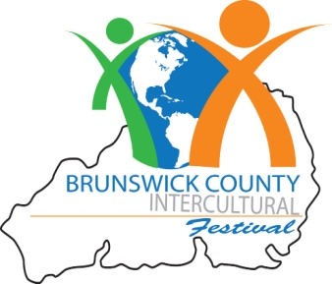

Dear Community Partner:

The Brunswick County Intercultural Festival is proud to present the 14th annual festival on Saturday, September 29, 2017. The festival will take place from 10:00 a.m. to 4:00 p.m. at Brunswick Community College on the grounds of the Odell Williamson Auditorium.

Brunswick County Intercultural Festival events include arts and crafts, children’s activities, ethnic food, music, and entertainment representing the various cultures present in our county.

At each festival, participants enjoy music and featured groups from North and South Carolina that express the fine traditions of Hispanic/Latinos, the Philippines, Germany, Southeast Asia, Europe, and Africa. This year’s festival promises to involve more international groups than ever before as well as a multitude of plays exhibiting cultural artifacts from represented countries.

In addition, the “Passport to Culture,” a children’s wood workshop, Brunswick County Schools’ Poster Art Contest, and a children’s art workshop are only a few activities geared especially for children and their families.

For a minimal fee, festival-goers will have a chance to taste a variety of ethnic foods from various local food trucks. For many, this is a gastronomic treat!

Since sponsorships pay for the cost of this free annual event, we encourage your participation as a sponsor and/or vendor for this special day. A variety of sponsorship levels are available and are detailed in the enclosed information sheet. Please contact Mari Lou Wong Chong at interculturalfestival@hotmail.com for additional details, or mail the enclosed application to Brunswick Community College Foundation;
Attention: Brunswick County Intercultural Festival PO BOX 30, Supply, NC 28462; (910) 755-8198
Please join us in celebrating the diversity of Brunswick County! We look forward to hearing from you.

“Our Diversity has been and will always be our source of strength and pride here in the United States (Michelle Obama)

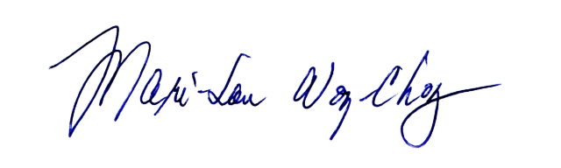
Sincerely,
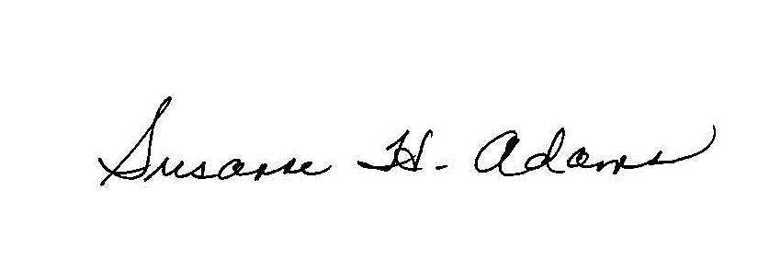
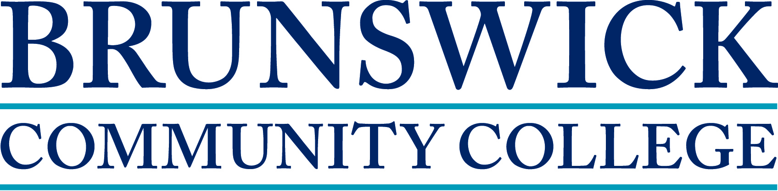


President, Brunswick Community College Festival Chair
Thomas Keiser, Financial Advisor

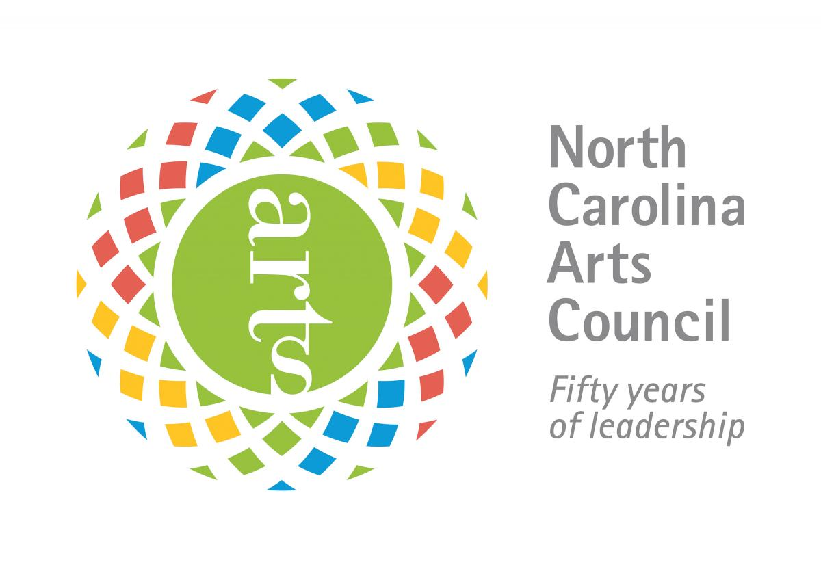
2018 Intercultural Festival Sponsorship Levels

$2,500 – Platinum Sponsor
- Includes 10 x 10 booth space
- One table, two chairs
- Logo/name/contact information listed in event program and posted in celebration area
- Recognition as a major sponsor in all advertising
- Company banner
- Ten meal tickets

$1,000 – Gold Sponsor
- Includes 10 x 10 booth space
- One table, two chairs
- Logo/name/contact information listed in event program and posted in celebration area
- Recognition as a major sponsor in all advertising
- Company banner

$500 – Silver Sponsor
- Includes 10 x 10 booth space
- One table, two chairs
- Logo/name/contact information listed in event program and posted in celebration area

$100 – Bronze Sponsor
- Includes 10 x 10 booth space
- One table, two chairs
- Your company name listed in event program

2018 Intercultural Application

Organization:________________________________________________________________________________________________
Contact Person:
Address:
City: State Zip
Phone: E-mail:
Sponsorship Levels
(Please check sponsor level)

$2,500 – Platinum $1,000 – Gold $500 – Silver $100 – Bronze
$35 - Vendor Levels 10’ x 10’
BCC Foundation Tax ID No. 58-149-3463
Payment must be made by check payable to:
BCC Foundation, Inc. c/o Brunswick County Intercultural Festival
P.O. Box 30
Supply, NC 28462
Attn: Laura Spencer
Office: 910-755-8198 Fax: 910-754-7805

Special space requirement for vendor:

Electrical needs: (Limited-please be specific)

Additional requests:

*Please note you will need to provide a tent and any other supplies that you may need for your booth, including an electrical cord if electricity is required. By signing this agreement, I agree to hold harmless Brunswick Community College in the event of any accident. The Intercultural Festival Committee reserves the right to decline any application and to remove any vendor for inappropriate activity (ies) during the festival.

Signature of Applicant Date

FOR BCC OFFICE USE:
Date Received: Amt.: Paid $ Confirmation Letter Sent

Space Assigned: Authorized Signature:

