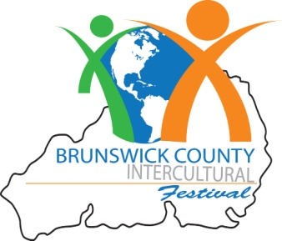
2018 Intercultural Application Deadline: September 15,2018

Organization:________________________________________________________________________________________________
Contact Person:
Address:
City: State Zip
Phone: E-mail:
Sponsorship Levels
(Please check sponsor level)

$2,500 – Platinum $1,000 – Gold $500 – Silver $100 – Bronze
$35 - Vendor Levels 10’ x 10’
BCC Foundation Tax ID No. 58-149-3463
Payment must be made by check payable to:
BCC Foundation, Inc. c/o Brunswick County Intercultural Festival
P.O. Box 30
Supply, NC 28462
Attn: Laura Spencer
Office: 910-755-8198 Fax: 910-754-7805

Special space requirement for vendor:

Electrical needs: (Limited-please be specific)

Additional requests:

*Please note you will need to provide a tent and any other supplies that you may need for your booth, including an electrical cord if electricity is required. By signing this agreement, I agree to hold harmless Brunswick Community College in the event of any accident. The Intercultural Festival Committee reserves the right to decline any application and to remove any vendor for inappropriate activity (ies) during the festival.

Signature of Applicant Date

FOR BCC OFFICE USE:
Date Received: Amt.: Paid $ Confirmation Letter Sent

Space Assigned: Authorized Signature:

