**$450 is due per bird AFTER 120-mile qualifying race**

***\* Payment MUST accompany receipt of birds \****

***Perch Fee is Non-Refundable***

**Perch Fee: Single Bird Entry - $150   
Perch Fee Special: 6 Bird Team - $600**

**10 Bird Team - $1000**

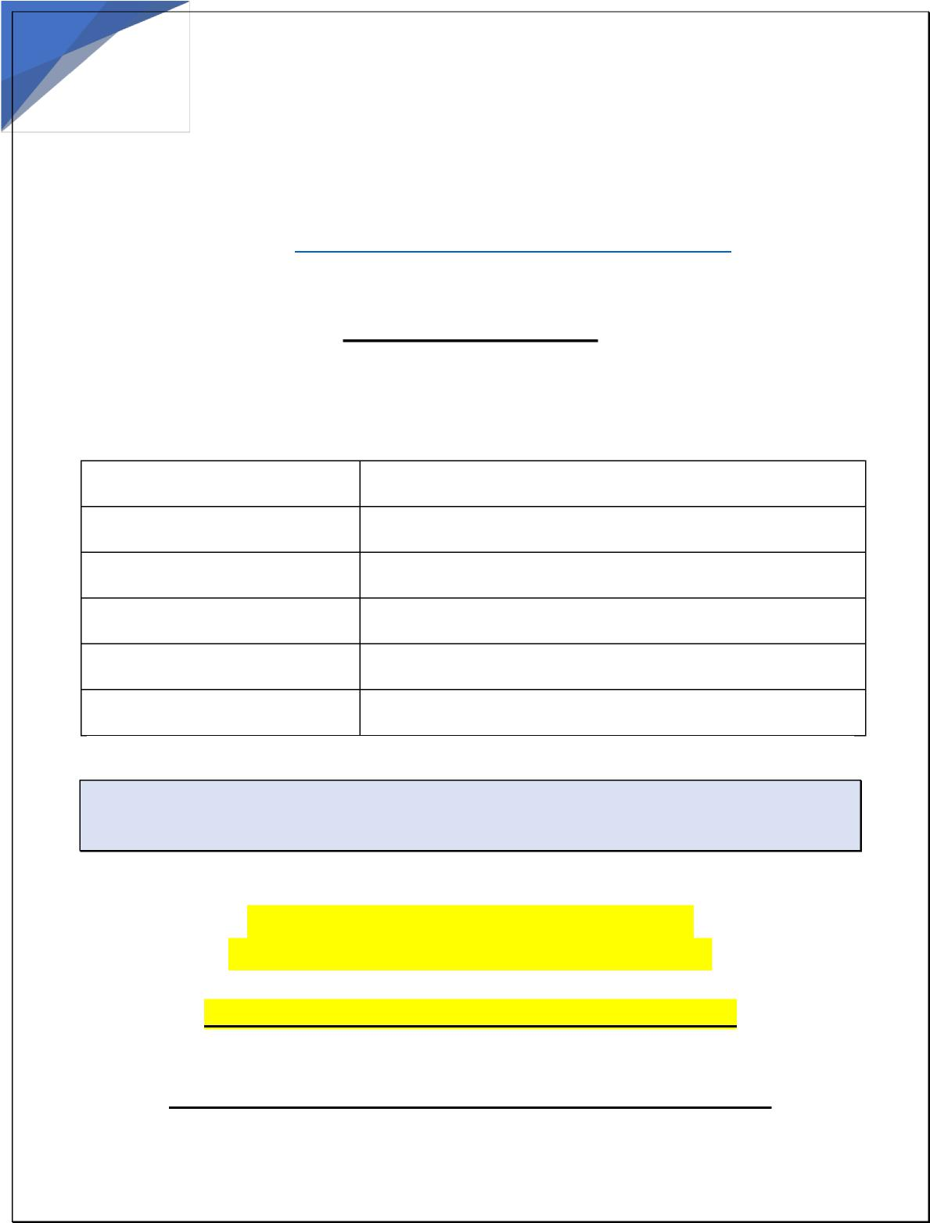

**New England Derby**808 West Washington Street   
Hanson, Massachusetts 02341   
**Contact Info: Hasan Prashkov**Cell: 617-504-2213   
[Email:](mailto:NewEnglandDerbyRace@gmail.com) NewEnglandDerbyRace@gmail.com

**2022 Entry Form**

**American Entrants:**

|  |  |
| --- | --- |
| **Breeder Name:** |  |
| **Loft/Syndicate Name:** |  |
| **Address:** |  |
| **City/State/Zip:** |  |
| **Telephone** |  |
| **Email:** |  |

Accepting Pigeons **March 1st**

Replacements up until **May 31st**

1

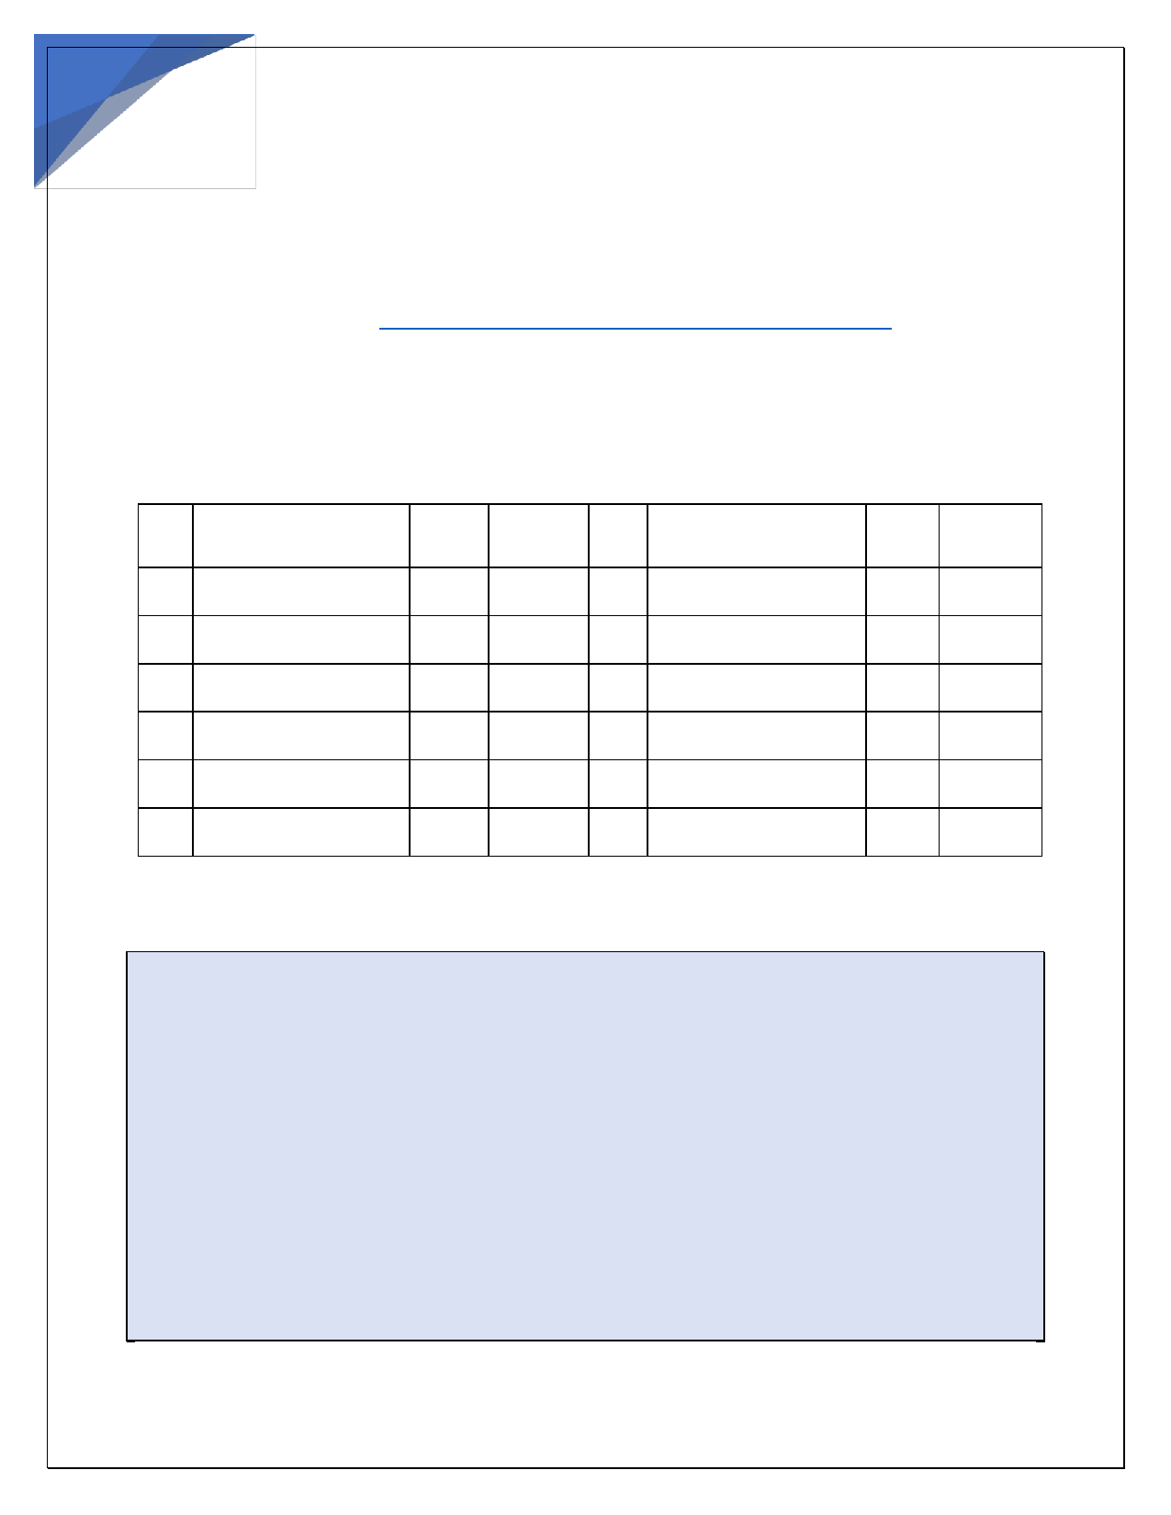

**New England Derby**808 West Washington Street   
Hanson, Massachusetts 02341   
**Contact Info: Hasan Prashkov**Cell: 617-504-2213   
[Email:](mailto:NewEnglandDerbyRace@gmail.com) NewEnglandDerbyRace@gmail.com

**Bird Entry Information:**

|  |  |  |  |  |  |  |  |
| --- | --- | --- | --- | --- | --- | --- | --- |
|  | **Band Number** | **Sex** | **Color** |  | **Band Number** | **Sex** | **Color** |
| **1.** |  |  |  | **7.** |  |  |  |
| **2.** |  |  |  | **8.** |  |  |  |
| **3.** |  |  |  | **9.** |  |  |  |
| **4.** |  |  |  | **10.** |  |  |  |
| **5.** |  |  |  | **11.** |  |  |  |
| **6.** |  |  |  | **12.** |  |  |  |

Activation race will be 120 miles. After the race, the breeders

will have 7 days to pay the $450 activation fee. If the fee is not

paid within 7 days, the bird will be sold to the public and the

new buyer will own the bird.

**To be ELIGIBLE for race prizes, a bird MUST be activated before the race.**

2