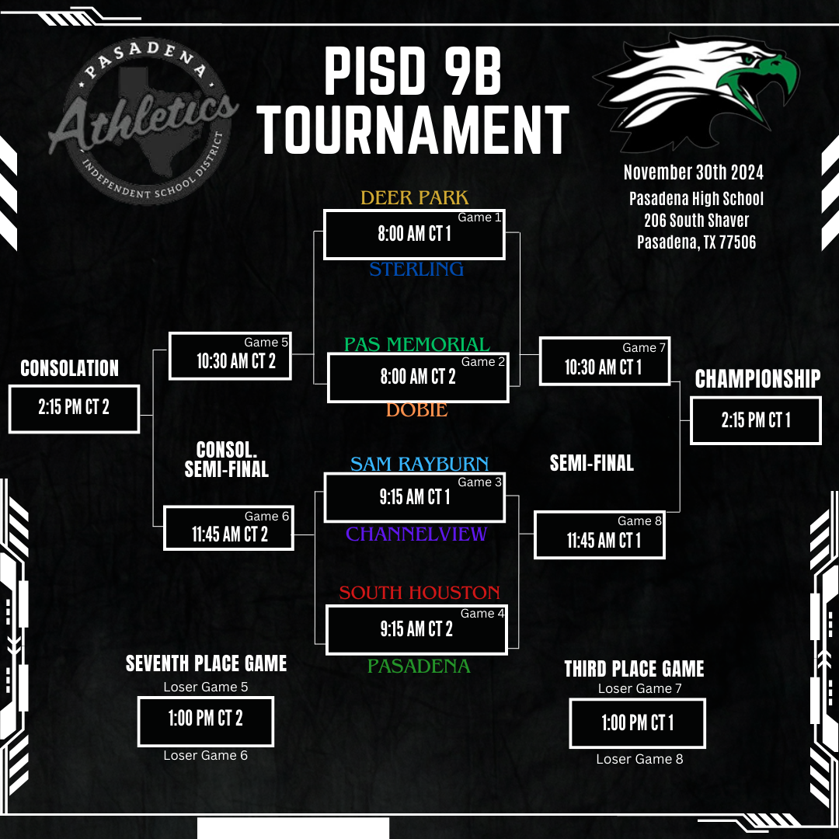

PASADENA

PISD 9B

**Athletics TOURNAMENT**

INDEPENDENT S

SCHOOL

DIST

DEER PARK

8:00 AM CT 1

STERLING

Game

November 30th 2024 Pasadena High School

206 South Shaver Pasadena, TX 77506

Game 5

PAS MEMORIAL

Game 7

Game 2

8:00 AM CT 2

10:30 AM CT 1

CONSOLATION

2:15 PM CT 2

10:30 AM CT 2

CONSOL. SEMI-FINAL

Game 6

11:45 AM CT 2

DOBIE

SAM RAYBURN

9:15 AM CT 1

Game 3

CHANNELVIEW

SEVENTH PLACE GAME

Loser Game 5

1:00 PM CT 2

Loser Game 6

SOUTH HOUSTON

9:15 AM CT 2

Game 4

PASADENA

**SEMI-FINAL**

Game 8

11:45 AM CT 1

CHAMPIONSHIP

THIRD PLACE GAME

Loser Game 7

1:00 PM CT 1

Loser Game 8

2:15 PM CT 1