Capability Statement
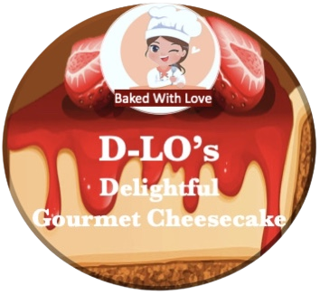

LOGO

2785 E Grand Blvd Suite 1051, Detroit, MI 48211
Contact Person:
Dolores Jackson
Tel: 586-204-6700

Email: dolores@d-los.com

Website:
www.d-los.com

NAICS

311813
424490
PSC
8920

Cage Code
8RAG0

Unique Entity ID
MULXPTBER4A9

Certifications

SAM & WBENC

SUMMARY:
D-LO’ s Delightful Gourmet Cheesecake LLC was founded in 2019. We are a woman-owned, minority-owned company that specializes in creating delicious, creamy gourmet cheesecake. At D-LO’s we believe each bite should taste just as good as the one before it, and the unique flavor of our cheesecake gives us an edge over our competitors.

BUSINESS SUMMARY:

Our goal is to provide quality products that will ultimately lead to growth, which will enable us to create sustainable jobs throughout the Metropolitan Detroit area, and help reduce the rates of poverty, incarceration, unemployment, and recidivism. These efforts would greatly impact the lives of many families, in our community and those in our nearby neighboring communities. We will continue to offer a top-quality product, and a top level of customer care and customer satisfaction.

CAPABILITIES

2 weeks for 5,000 6ct. pack units, and1 week for 2,500. 2 weeks for 5,000 single serving units and 1 week for 2500 units.
Full Cheesecake: 6”, 7”, and 8” -250,000 Monthly
FACILITIES AND EQUIPMENT
We currently produce our Cheesecake at the North Rosedale Park Commercial Kitchen in Detroit, Mi. We have access to plenty of dry storage, cold storage, a locked area for supplies, a commercial stove w/8 burner and a double oven, a commercial convection oven, a commercial freezer, two commercial refrigerators a 30-quart commercial mixer, a 15-quart mixer, a commercial dish washer and spacious prep area.

EXPERTISE
From the crust to the toppings, D-LO’s cheesecakes are made fresh from scratch, with fresh quality ingredients, including fresh graham crackers and cookies, real fruit, choice nuts and extracts, fresh grade A eggs, natural sugar, real butter, and fresh cream cheese. Each one has our one-of-a-kind cheesecake batter recipe. We have 4 prep workers and 3 bakers with a total of 15 years exp.

CUSTOMERS
Meijer Rivertown Market, Fresh Thyme Market and Hollywood Market

