Dr. Marvin Haire – Associate Professor of Political Science
Director/Facilitator, TGOW Institute for AR&D
Contact: mhaire@tgowinstitute.com / (404) 725-0960
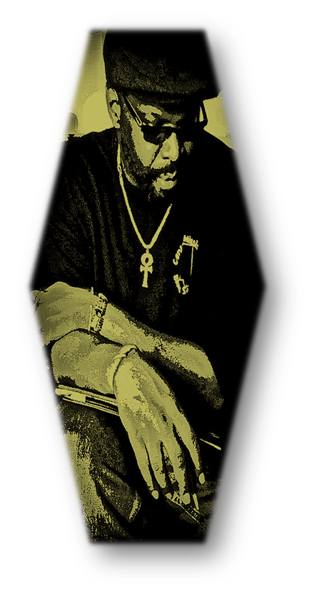
Education:
- East & Ursuline High Schools, Youngstown, OH – Art & English (Diploma)
- Youngstown State University - Psychology/Black Studies/Philosophy, (B.A.)
- The Atlanta University - Graduate Studies in Political Science (M.A. & Ph.D.)
- Certified: Study Circles International; Kettering Foundation Issues Forum Facilitation; Columbia University Adult Learning & Development

Experience & Awards:
- 20+ years of direct experience in collegiate-level adult and continuing education
- Faculty in both traditional and non-traditional post-secondary institutions
- Six (6) Teacher-of-the-Year Awards
- 20+ years of formal experience as a collegiate senior-level administrator
- Former Associate V.P. for Academic Affairs & Dean of International & Continuing Ed at Morris Brown College
- Former Chairman & Assoc. Professor, Department of Political Science, Clark Atlanta University
- Former Director, Delta Research & Cultural Institute, Mississippi Valley State University, Itta Bena, MS
- Past Treasure & President, National Conference of Black Political Scientists
- Public radio production/broadcasts in Atlanta, Dayton & Yellow Springs, OH, & Itta Bena, MS
- Service as a Georgia, Ohio, Mississippi National Endowment of Humanities Scholar
- United States Information Services: Distinguished Lecturer – Southern Africa Tour
- USIS, Special Observer – Democratization in Southern Africa, Zambia

Consultancies - The Gourd of Wisdom Institute for Action Research & Development:
- Education consultant to both public & private organizations throughout the U.S., Europe, Africa and the Caribbean on issues affecting traditional students and adult learners
- Action Research Projects - Selected Areas - Quality Education among African American Rural Populations in the Mississippi Delta; IMMC/Racial Equity Community of Practice - Infusing Human Rights & Dignity; Emmet Till Historic Intrepid Center, Museum Design, Glendora, MS.
- Program Designs: Nollie Jenkins Family Center, Scholars for Peace Program; Race, Class & Gender – Key Issues in Valuing Cultural Diversity; Distance Education Delivery Systems for Adult Learners; Faculty Development Workshop Series – On-Line Instructional Techniques for Educators; Black Politics & the Pedagogy of the Oppressed; Young Blues Writers Workshop Series
- Program Evaluations: Jamaica Bar Association - Alternative Dispute Resolution Program; Hampton University - Service-Learning Program; Christian University, San Andres Island, Columbia, Distance Education Capacity Assessment

