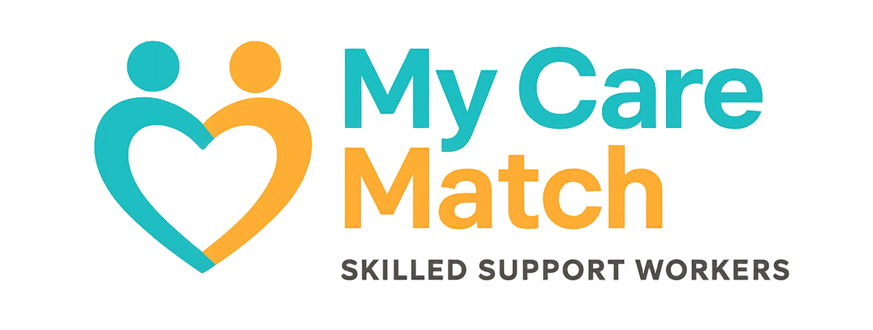

Incident Report Form

This form should be completed in accordance with the Incident Management Policy.
What is your full name?
Your email
Phone number
Date of incident
Time of incident
Where did this incident occur?
What is your role?
Who is this report about?
Incident Category  Please choose the category or categories that best fit the incident from the list opposite.  You can highlight &/or delete those that do not apply. | - Abuse or neglect  - Behaviour of concern  - Bullying, harassment, discrimination  - Death  - Equipment failure  - Health related incident  - Injury – First aid  - Injury – Medical/Emergency treatment  - Mental health  - Other (please specify – add more detail)  - Privacy breach  - Property damage  - Seizure  - Sexual misconduct  - Transport  - Theft  - Unauthorised restrictive practice  - Unlawful sexual or physical contact or assault (physical, sexual, indecent)  - Unsafe environment  - Wellbeing concerns  - Fraud  - Near-miss
Please provide a short summary of the incident
Please provide a summary of what happened before, during and after the incident
Was anyone injured? | Yes  No  Unsure
Who was injured?

Was medical assistance required? If so, provide details.
Would you like Autism Abilities to contact you in relation to this incident?  Autism Abilities may be required to contact you about this incident. | Yes  No
Any other information
Please tell us any other information about the incident

Please complete and email this form to the email below – remember to please mark the subject of the email ‘INCIDENT REPORT’
contact@mycarematch.com.au 0481 112 928.

