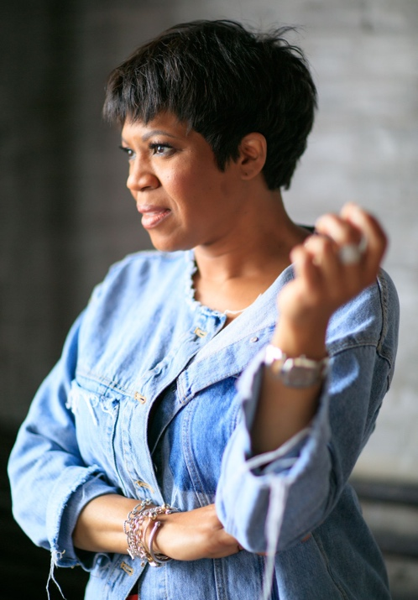

NICCI ROACH
advisor | educator | speaker

Award-winning learning and development (L&D) professional. Catalyst for building leadership capacity. Advocate for the advancement and equality for women and underrepresented groups. Author. Educator. Entrepreneur. Leader-in-Residence. Nicci Roach is diversifying rooms with equipped leaders through interactive lectures, consulting and radio programming.
Nicci currently serves as Special Assistant to the President at Saint Louis University (SLU) where she is responsible for partnering with leadership across the academic and medical communities to assist with planning, developing, implementing and managing institutional priorities. She formerly served as Webster University’s inaugural Associate Vice President for Diversity and Inclusion and Senior Director for Community Engagement. She also contributed as an adjunct professor within the School of Business and Technology - Management Department. Nicci is the principal of covenant exCHANGE, llc, a boutique learning and development consulting firm.
Nicci holds a Master of Arts in Public Relations; Master of Arts in Human Resources; and a Bachelor of Arts in Media Communications with a minor in Women’s Studies from Webster University; Diversity Management certificate from Cornell University; and a certificate of participation in the Women in Educational Leadership program from Harvard University. She is currently completing doctorate studies in Higher Education Leadership at Missouri Baptist University.

