Lamond’s
Litter Information
Sire:
AKC #:
Microchip #:
Additional Information:

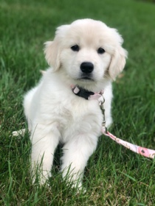
Dam:
AKC #:
Microchip #:
Additional Information:

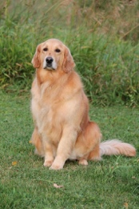
Goldens
Puppy Information

Date of Birth:
AKC Litter #:
AKC #:
Color:
Gender:
Collar Color:

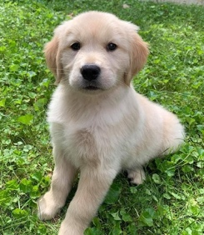
Breeder Information
Alexis & Cory
Lamond

9902 9 Mile Rd
Evart Mi 49631

Alexis 231-287-2970

