CENTRE HOSPITALIER DE FONTAINE #13, Fontaine Duvivier, Drouillard HAITI

INFOFCHF@GMAIL.COM

C.H.F. INTRA HOSPITAL NEEDS . Updated 9/21/2021
Pharmacy
1
Diclofenac 100 mg box of 100 +++
2. Diclofenac 50 mg box of 100 +++
3. Tramadol injection +++
4. Diclofenac gel
5. Diclofenac injection
6. Dipirone
7. Paracetamol 500 mg box of 100
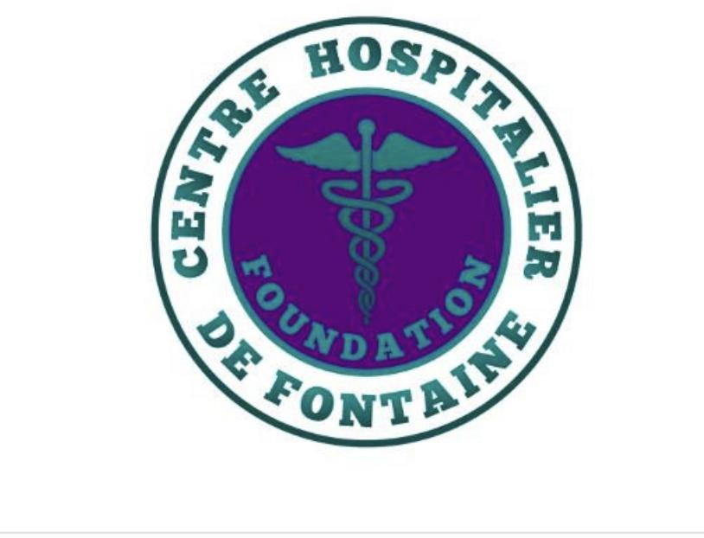
8. Paracetamol suspension +++
9. Amoxicillin 250 mg suspension
10.Amoxicillin 125 mg suspension
11.Cotrim tablets (480 mg) +
12.Cotrim tablets (960 mg) +
13.Cotrim suspension ++
14.Vitamin c tablets box of 100 +++
15.Vitamin C syrup +++
16.Metronidazole tab box of 100 +++
17.Metronidazole syrup ++
18.Metronidazole injection +++
19.Metro + nistatin box of 100 +
20.Fluconazol co +
21.Enalapril 20 mg tab box of 100 ++
22.Enalapril 10 mg tab box of 100 ++
23. (hydrochlorothiazide 25 mg) 24.Nifedipine 10 mg +
25.Ibuprofen 400 mg box of 100 +
26.Ibuprofen 800 mg +++
27.Ibuprofen 600 mg ++
28.Rapidal suspension (ibuprofen)
29.Buscopan count box of 100 +++
30.Omeprazole 20 mg tab 31.Promethazine Comp box of 100
32.Galocur lotion ++
33.Ceftriaxone injection +++
34. Metformin 500 mg tab box of 100
35.Metformin 850 mg tab box of 100
36.Glibenclamide tab box of 30 ++
37.B Complex Pills box of 100++
38. Adsobjel sp or Peptobismol sp or gastrogel or magnesium milk +++
39. Iron syrup ++
40. Nifedipine 20 mg co ++
41. Visine drops ++
42. Ciprox-D Drops
43. Bronchomax sp
44. Histinol sp +++
45. Antitussive sp +++
46. ​​Glucose tablet
47. Glucose children +
48. Gengloben cream +++
49. Vitamin A 50,000 IU +
50. Vitamin E co +
51. Diazepam co 5mg, inj +
52. Bellaphen sp +++
53. B-complex inj 10ml ++
54. Iron dextran injection ++
55. Exaxyl ampoule +++
56. Pediaphen drops +++
57. Aluflat drops +++
58. Ambroxol syrup ++
59. Globugen syrup +++
60. Provit (Powder) ++
61. Pediatyte ++
62. Antacid +++
63. Captopril co ++
64. Propranolol co +
65. Misoprostol +++
66 Syringe, 3cc box of 100 +++
67 Syringe 5 cc box of 100 +++
68.Ringer Lactate (R / L) +++
69.NACL 0.9 ++
70.NACL 0.45 +
71.DNS 0.33 ++
72.DNS 0.22 ++
73.Foley Catheter unit ++
74. Adult urine collector + uniT

CENTRE HOSPITALIER DE FONTAINE #13, Fontaine Duvivier, Drouillard HAITI

INFOFCHF@GMAIL.COM

LABORATORY

- Cassette BHCG +++
- Diluent (Mindray M-30D) gal.
- Purple Tube +++
- Red Tube +++
- Micropipette from 1000 to 5000
- Chips 1000 to 5000 +++
- Hepatitis A, B, C ++ strip
- Anti A Monoclonal ++
- Anti B Monoclonal ++
- Anti D, IgG / IgM ++
- CYAN (Hematocrit, Red head)
- Blood glucose strip (Contour Next, Embrance)
- Serological H-Pylori Strip
- Cassette H-Pylori in stool
- Casette Chlamydia ++
- PSA ++ cassette
- ASO Latex +++
- CRP Latex +++
- Salmonella Typhy O, H
- Applicator not mounted ++
- Rintrobe tube (VS) ++
- Pasteur pipette +++
- Red pipette +
- White pipette +
- Urine Strip (Cypress Diagnostics)
- Slat +++
- White blood cell solution +
- Chromic tube (Urines) +
- Wax Pencil
- Applicator Mounted
- Applicator unmounted
- Lugol
- Rac
- White blood cell solution
- Olympus Microscope
- Mindray BC-10 Auto Hematology
- Minray BA-88 Semi Auto Chemestry analyzer
- Digital Constant Temp. Tank (HH-2)
- B-C-3D Control Mindray
- Diamonds Pro (20-200 ML)
- Rotator

CENTRE HOSPITALIER DE FONTAINE #13, Fontaine Duvivier, Drouillard HAITI
INFOFCHF@GMAIL.COM
Maintenance

- Detergent +++
- Liquid soap +++
- Mistoline ++
- Alèze +++
- Trash bag +++
- Paper 8 ½ x 11 +++
- Bristol not granulated ++
- AAA and AA ++ batteries
- Toilet paper +++
- Sonographic Film +++
- Sonography gel ++
- Cash register printer paper ++
- Wrapping paper for sterilization ++
- Tep marker sterilization
- Tep simple sterilization
- Bleach
- Peroxide
- Industrial Cleaner

CENTRE HOSPITALIER DE FONTAINE #13, Fontaine Duvivier, Drouillard HAITI
INFOFCHF@GMAIL.COM
**= can be purchased in Haiti from small business owners
Additional Needs

- **Generator (11)
- **Inverter (10)
- **Inverter Batteries (120)
- **Breaker/controller (10 )
- Security Cameras (20) ( Audio w/360 rotation)
- Security Monitors (9)
- Security/thermal detection goggles (10)
- **Mobile communication device ( set of 20)
- **Security lockers system (16)
- **Safe (Fire & Water proof) (5)
- **Security Scanners
- **Badge System
- Solar Panels (20)
- Diesel Ambulance (3)
- Diesel mini bus for staff transportation (5)
- Diesel R/V or School bus for mobile clinics (7)
- Mobile transportation units and/or mopeds
- **Printers, Scanners & Copiers (14)
- Desktops and/or laptops (25)
- Tablets (25)
- Projectors & Screens (10)
- E.H.R.
- Ventilators (10)
- Incubators (27)
- Bi-Pap (7)
- Med Beds
- Bed covers
- Pillows
- Sheets
- Industrial towels
- X-Ray Units (3)
- Ultrasound equi.( 10)
- Defibrillator units( 50)
- NICU Equipment
- Air Compressor (7)
- M.R.I. (2)
- Anesthesia Machine (5)
- A/C Units (12)
- Microscopes (12)
- Centrifuge (7)
- P.C.R. Equipment (1)
- Autoclave XL (
- Cold Storage Units XL (3)
- Ultra low Temp. cold storage unit (1)
- Dehumidifiers XL (12)
- Air purifier (XL) 12
- Washing machines XL (5)
- Dryer XL ( 3)
- Scales infant (7)
- Scales adult (7)
- Monitors XL (15)
- 1 Terabite Jump drive (25)
- Industrial indoor & outdoor oven
- Office supplies (pens, calculators, highlighters, printing paper, notebooks, notepads etc…)
- Additional tires for existing transportation units
- Training :
  - Nurses
  - Auxiliary
  - Security
  - Doctors
  - Admin
  - Lab & Pharmacy
  - Tech. Support
  - Structural/Civic Team

CENTRE HOSPITALIER DE FONTAINE #13, Fontaine Duvivier, Drouillard HAITI
INFOFCHF@GMAIL.COM

How you can help us obtain the items above:

- Medication & equipment we can purchase in Haiti:

- Please note there is a minimum order of USD $1,000.00
    - Click on the - DONATE NOW - link at the bottom of this page to make a donation we will use specifically to purchase equipment, supplies etc.. .
**We are a proud verified PayPal Giving Fund Member
    - You will receive a receipt for personal and tax records.
    - Once we place the order, you will receive a copy of the purchase order via email.
    - Once the items are delivered to the hospital you will receive an email confirmation with pictures.

2. Send us equipment & materials not found in Haiti:
- Click on the link above the -DONATE NOW- to view Shipping Information sheet

  - We work with one company ( EMEX) in an effort to:
    - Ensure one party oversees the entire process
      - **Please contact EMEX directly for details.
      - You will receive a tax deductible receipt from us.
      - Emex will keep you updated with the status of donation
      - We will send pictures once the items arrive at the hospital.

