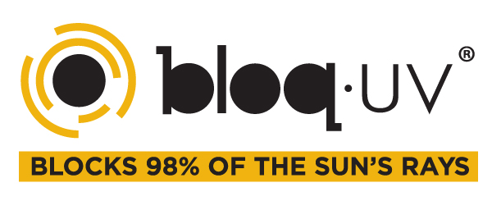
l

UPDATED 7.10.2019
Private Label Program
24 units minimum per order for both Silk Screen and Embroidery
Silk Screen
- Set-up: Based on 1 color - $40 ($20 per screen and $20 flash)
- Re-orders of more than one color logo will be charged $20 per color for color swap.
  - Example: If you are doing silver on some colors and then changing to white on other colors there will be a charge of $20 per color)
- Must provide Vector File (.AI, .PSD, .EPS) – screener can convert for a fee depending on the logo
- Logo also must be provided in .JPEG format
- Logo price ranges $3.00-$6.00 (or more) depending on the logo, and details of the logo
- One location per order (must indicate where on the PL Form)
  - Example: Right Sleeve – 5” down from the seam or L/C (will be printed on the standard L/C location)
  - Location change fee: $20 (Customer will be charged for multiple logo locations; location change fee does not apply if there is a pocket, zipper or seam and logo needs to be moved. Please try to do one location for the whole order.)
- If specific style doesn’t get a logo, such as the bottoms please indicate
  - Example: NO LOGO ON BOTTOMS or NO LOGO ON #2009
- Must provide specific logo size
- PLEASE NOTE ALL SCREENS WILL BE KEPT FOR UP TO 6 MONTHS. IF A CLUB ORDERS ONCE A YEAR FOR LOGO THEY MIGHT HAVE TO PAY A SET-UP FEE AGAIN.
- If the order has more then one placement for logo there might be an additional set up fee for another screen.
Embroidery
- Set-up: No set up fee if .DST file is provided. If .DST file is not provided embroiderer can digitize the logo. Digitizing fee depends on the logo, stitch count, and logo detail.
- Logo price ranges $5.00 - $7.00 (or more) all depends on the stitch count and detail of the logo.
- One location per order (must specify where on the PL Form)
  - Example: Right Sleeve – 5” down from the seam or L/C (will be printed on the standard L/C location)
  - Location change fee: $20 (Customer will be charged for multiple logo locations; location change fee does not apply if there is a pocket or a zipper and the logo needs to be moved. Please try to do one location for the whole order if possible)
- If specific style does not get a logo, such as the bottoms please indicate
  - Example: NO LOGO ON BOTTOMS or NO LOGO ON #2009
- .DST file must be done in the same size as the logo size (.DST files cannot be modified or resized)
  - Example: if they want logo to be 1” x 2” .DST file must be that size
- Must provide .JPEG format
- If logo contains TEXT/NUMBERS, the size cannot be smaller than ½”. It’s very hard to embroider a small logo on our fabric. Please recommend silk screen if that happens, or they will need to increase the logo size. If the club does not want to switch to silk screen or size up the logo, BloqUV will not be responsible for any logo that does not come out perfect.

