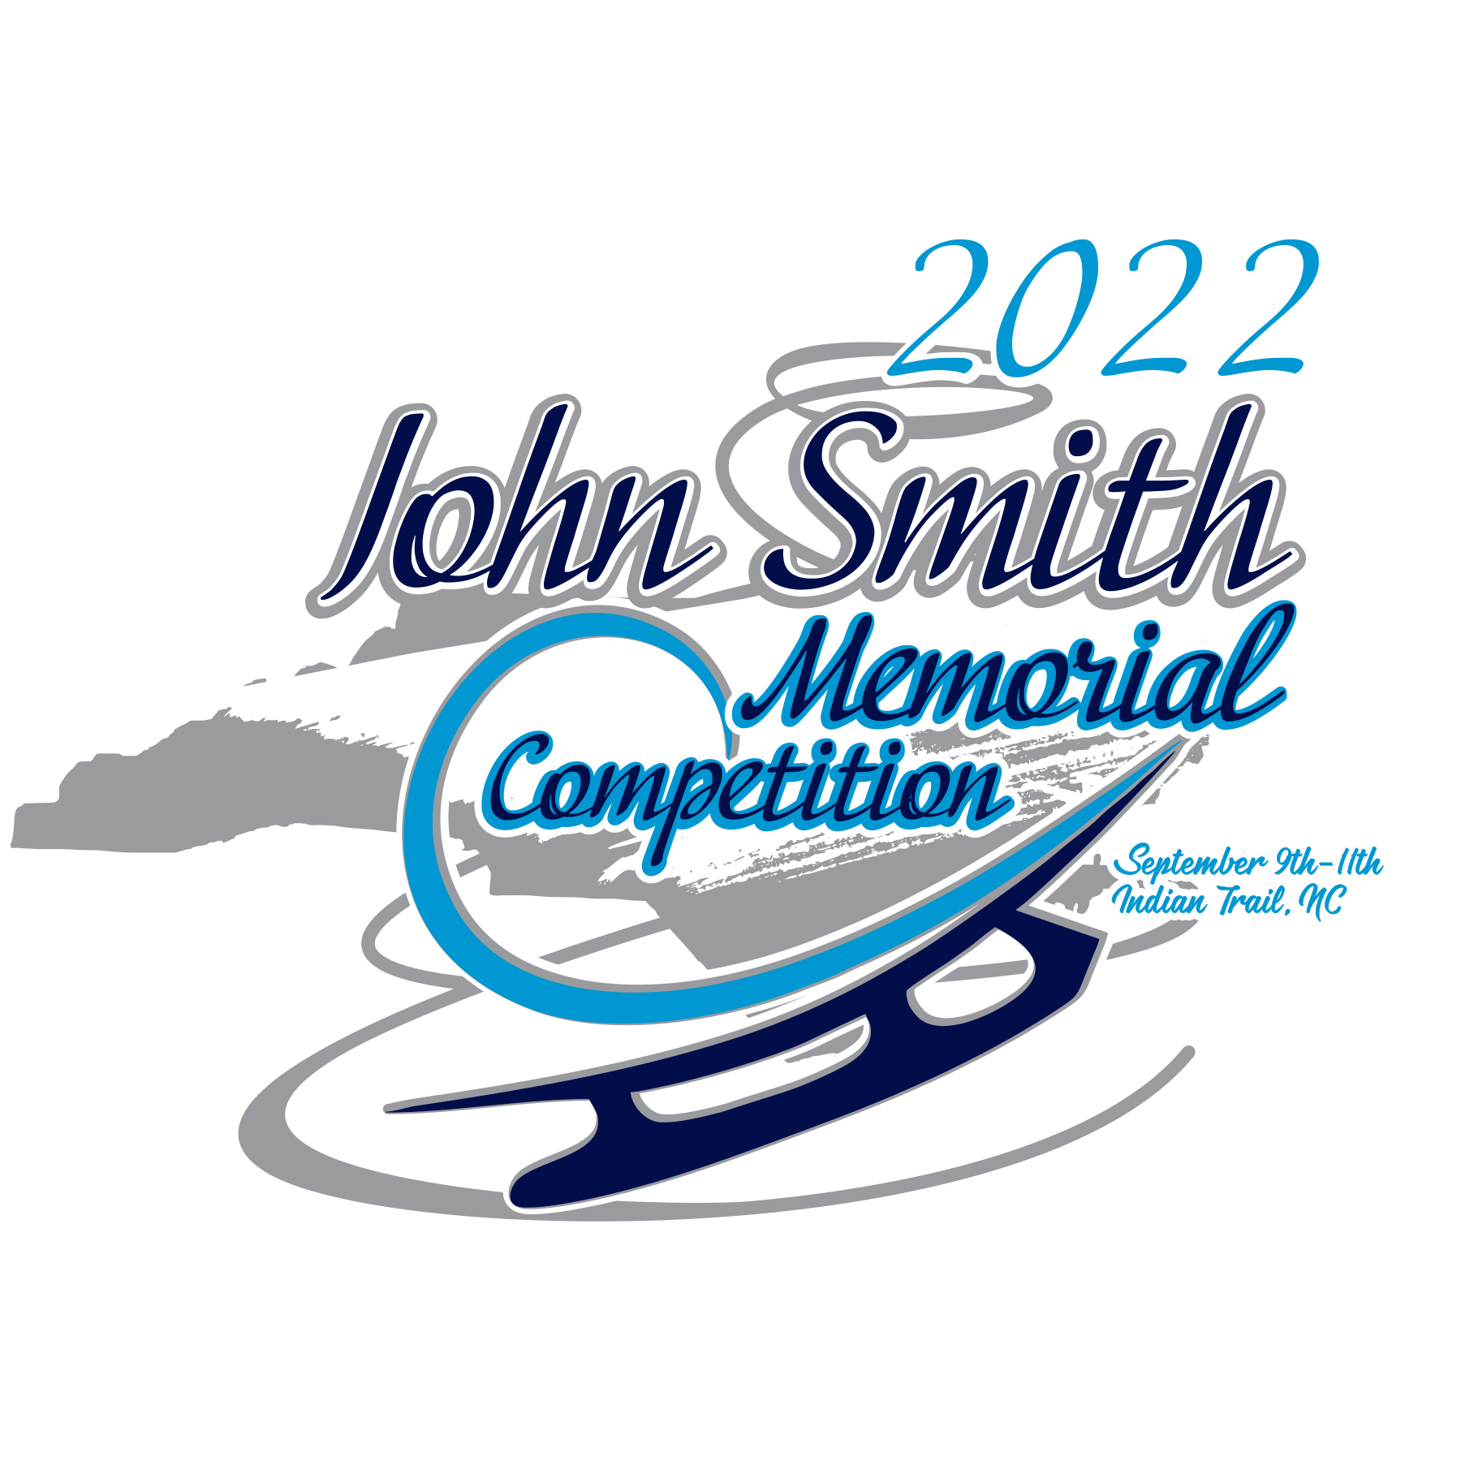

2022 John Smith Memorial Competition

Competition Dates: September 9 – 11, 2022
Hosted By: Carolinas Figure Skating Club
Location: Extreme Ice Center
4705 Indian Trail Fairview Rd.
Indian Trail, NC 28079

The John Smith Memorial Competition will be conducted in accordance with the rules and regulations of U.S. Figure Skating, as set forth in the current rulebook, as well as any pertinent updates that have been posted on the U.S. Figure Skating website.

This competition is open to all eligible, restricted, reinstated or readmitted persons as defined by the Eligibility Rules, and who are currently registered member of a U.S. Figure Skating member club, a collegiate club or who is an individual member in accordance with the current rulebook.

NATIONAL QUALIFYING SERIES (NQS)
This competition is approved for the 2022-23 National Qualifying Series (NQS) in Singles, Juvenile – Senior.

For the 2022-2023 season, the Competitions Committee has proposed a National Qualifying Season combining the stand-alone October qualifying competitions, Regional (singles) and Sectional (pairs and ice dance) Challenges, into approved series competitions from mid-July to late September allowing athletes to advance to the Sectional Singles, U.S. Pairs and U.S. Ice Dance Finals in November 2022 and culminating with the 2023 Toyota U.S. Figure Skating Championships and National Development Camp in January 2023 (San Jose, California).
Beginning July 1, athletes/team wishing to participate in the qualifying season may register via the EMS Series Application. The Series Application is the key requirement for qualifying registration AND replaces regional/sectional registration from July 15 – September 1. All interested athletes (including potential and known byes) MUST complete this step.

Without a completed/paid series application prior to the start of this competition, your scores will NOT count towards National Qualifying Series Standings – no exceptions. For some, this may mean completing registration for an approved NQS competition prior to the EMS Series Application.

For additional information, review the NQS Athlete Handbook here.
Questions can be directed to events@usfigureskating.org.

ELIGIBILITY/TEST LEVEL

Test Level: competition level is the highest test passed as of the entry deadline in the discipline the skater is entering or one level higher.

Age restrictions/requirements: Singles free skate events (well-balanced program) have the following requirements:

Juvenile: Girls – 12 years or younger; Boys – 13 years or younger
Open Juvenile: Girls – 13 years or older; Boys – 14 years or older
Intermediate must be under the age of 18
Adults must be 21 years or older

Skaters entering pre-juvenile and lower events will be divided as closely as possible by age should the number of entries warrant more than one group.

Adult Events:
Age classes for all free skate and showcase events:
- Young Adult: 18 years through 20 years
- Class I: 21 years through 35 years
- Class II: 36 years through 45 years
- Class III: 46 years through 55 years
- Class IV: 56 years through 65 years
- Class V: 66 years and older

All age classes may be divided or combined depending on the number of entries and at the discretion of the chief referee and/or the competition committee.

If there are large entries for National Qualifying Series (Juvenile – Senior) events, the Referee may choose to break the event into two or more seeded groups per the U.S. Figure Skating Rulebook. Athletes will remain in the same groups for each applicable segment. There will be NO consolation or final rounds for NQS.

Please note, there will be NO segment only competitive events for NQS levels (i.e. Intermediate Men’s Short Program, only Intermediate Men’s Combined).

EMS COMPETITION REGISTRATION

Entries will be accepted via EMS with credit card only.
Each transaction includes a 3% credit card fee.

Registration Deadline: 07/31/2022 at 11:59 ET

Late Registrations will be evaluated by the Chief Referee and Competition Chair on a first come first-serve basis via email at competitions@carolinasfsc.org.

Late Registration Evaluation Deadline: 08/07/2022 at 11:59 ET + $35 Late Fee

- Go to https://m.usfigureskating.org
- Enter your U.S. Figure Skating or if Compete USA events are offered, your Learn to Skate USA member number and password
  - If you need assistance with your member number and password, contact Member Services at memberservices@usfigureskating.org.
- Click EMS then “Competition Registration”
- Choose John Smith Memorial from the list of nonqualifying competitions.
  - If you need assistance completing your registration, contact productsupport@usfigureskating.org.

FOREIGN SKATERS

Non-U.S. skaters intending to register for this competition must set up a non-member account prior to registering for the competition (click here for HOW TO). This can be done by choosing the “Create Account (Non-Member)” option on the Members Only login page.

Note: foreign athletes may register and compete in NQS events but are not eligible to participate in the series (and receive a standing/score).

PARTNERED EVENTS

Only one partner will complete registration for the team. During the registration process, you will be asked to identify your partner and verify their test information. The registered partner will be responsible for managing all aspects of the competition for the team including music/PPC upload, practice ice sales, etc

MANDATORY ATHLETES

Athletes age 18+ as of the competition start date who will be competing on a team (i.e. synchro, dance, pairs, shadow dance, theatre, etc.) with at least one minor athlete must complete SafeSport training. *

Minor Athletes who turn 18 mid-season are encouraged to seek parental consent to take the online SafeSport training early to avoid any disruptions in their ability to participate as the training is required upon turning 18. The athlete will not be SafeSport compliant until they have completed the training and their Members Only portal reflects completion. Please email skatesafe@usfigureskating.org for instructions or questions regarding parental consent.

REFUND POLICY

Entry fees will not be refunded after entry deadline unless no competition exists or the event is canceled. There will be no refunds for medical withdrawals.

SCHEDULE

Competitors may be scheduled on any day or time during the announced dates of the competition. The competition and practice ice schedule will be available after the close of entries. All participants will be notified via email once available.

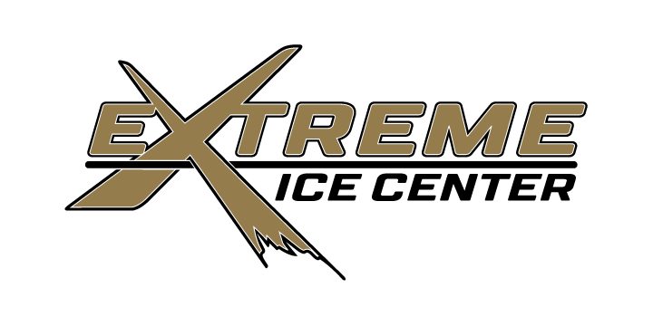
FACILITIES

The competition will be held at:

4705 Indian Trail-Fairview Road
Indian Trail, NC 28079
(704) 882-1830
https://xicenter.com/

The Extreme Ice Center has two ice surfaces that measure 200’ X 85’ with rounded corners and hockey barriers and seating in each arena. The rink also has a puddle surface as well as dressing rooms, snack bar, pro shop, arcade and Tavern/Restaurant. The facility does not allow outside food or drink.

EMS COMPETITION PORTAL | MUSIC UPLOAD:
DEADLINE: 08/26/2022 at 11:59 ET
LATE FEE: $15

Competitors participating in events with music are required to upload their music to EMS no later than 08/26/2022 11:59 ET. After this date, skaters will be locked out of this feature and subject to a $15 late fee. The late fee will automatically be added to each skater's cart who doesn't meet this requirement by the deadline. Late fees will not be removed under any circumstances and must be paid prior to receiving the skater credential onsite.

MUSIC UPLOAD HOW TO: CLICK HERE
If you need assistance, email productsupport@usfigureskating.org

All music must meet the following criteria. If you have questions about what format you have, please contact your coach and get a new version of your music that meets the criteria listed below.

MUSIC CRITERIA:

- File Format: MP3
- Bit Rate: 192 kbps or higher and Sample Rate: 44,100 kHz
  - This will be verified by the music chair and they may request you upload a corrected file.
- Leaders and trailers (the silence or "dead space" before and after the actual start and end of the program music) may not exceed two (2) seconds. We prefer that there be NO leaders or trailers at all. Excessive leaders and trailers may disrupt the playing of the music during competition.

Competitors must also have available a backup copy of their competition music on a cellphone and it must be immediately available rink side whenever the skater competes. If the phone does not have the standard round headset connector an appropriate adapter, such as an Apple Lightening connector or Samsung USB-C adapter is required to be attached. The phone should be presented to the music person with the file ready to play, phone in airplane mode, and volume turned to maximum.

EMS COMPETITION PORTAL | PLANNED PROGRAM CONTENT (PPC)
DEADLINE: 08/26/2022 at 11:59 ET
LATE FEE: $15

Competitors participating in IJS events are required to submit PPC in EMS no later than 08/26/2022 11:59 ET. After this date, skaters will be locked out of this feature in EMS and subject to a $15 late fee. The late fee will automatically be added to each skater's cart who doesn't meet this requirement by the deadline. Late fees will not be removed under any circumstances and must be paid prior to receiving the skater credential onsite.

PPC UPLOAD HOW TO: CLICK HERE
If you need assistance, email productsupport@usfigureskating.org

LIABILITY

U.S. Figure Skating, Carolinas Figure Skating Club and Extreme Ice Center accept no responsibility for injury or damage sustained by any participant in this competition. This is in accordance with Rule 1600 of the official U.S. Figure Skating Rulebook.

ONSITE CHECK-IN

Check-in will open on Friday, September 9, 2022, 1 hour before the Competition starts and will be located at the front desk in the lobby.

LOCKER ROOMS AND CHANGING AREAS

Locker rooms and changing areas at U.S. Figure Skating competitive events are for athletes only, will be labeled with regard to specific use and where identified will be gender specific. An exception can be made for athletes 11 years old and younger that will allow for one parent of the same sex to assist their child immediately prior to and after their skating event(s). Please review the Locker Room and Changing Area Policy and the SkateSafe Handbook (both found on the U.S. Figure Skating SkateSafe page).

PRACTICE ICE

Practice ice sessions (20 minutes) in advance (pre-purchase during registration window) and after schedule of competition is published, we will open additional practice ice sales. All practice ice will be available for purchase online only through the EMS Competition Portal. Pre-Purchase of Practice Ice Sessions will be limited to 1 per event (2 if it is a combined event) with the option to buy additional sessions during the Open Period. A timeline for practice ice sales periods will be available for viewing on the competition information page of your Skater Portal. Athletes will be notified about the practice ice selection starting/ending times and additional practice ice sales openings via email. All skaters are encouraged to purchase practice ice through EMS on their mobile devices/computers and sales will remain live through the competition depending on ice availability.

Pre-Purchase Practice Ice Session fee: $20
Open Sales Practice Ice Session fee: $25

PHOTO/VIDEO

Professional video will be provided by Looking Glass Productions. You will be able to access video of your Performance via a Secured Website approximately 1 week after the competition.

Danielle Woods Photography. LLC will be providing photography for this competition. They will photograph all skaters entered in this competition. No pre-purchases or registration is needed. Photos will be available for purchase after the event: You will receive an email the Thursday after the event is over with a link to your private online photo gallery. This will be sent to the email you used to register for this event. You will be able to shop online and all print and product purchases will be shipped to your house. To find out more about your photographer visit https://www.daniellewoodsphotography.com/

Note, per U.S. Figure Skating policy, photographing and/or recording of anyone other than your own skater is strictly prohibited.

AWARDS

Medals will be awarded to the top four skaters in each flight for all events. Medal Ceremonies will occur every couple of hours throughout the competition.

OFFICIAL NOTICES

All competition information will be included in the EMS Skater/Coach portal. It is the responsibility of each competitor, parent and coach to check the front desk frequently for any schedule changes and/or additional information. Skaters are requested to arrive 45 minutes prior to the scheduled time of their event. A tentative schedule of events will be posted prior to the competition.

COMPETITION TEST CREDIT

Skaters that meet the requirements for test credit may request their test credit forms at registration. Forms must be picked up at the registration desk prior to the end of the competition. Submission of test credit form to USFSA is the responsibility of the skater upon return home in conjunction with their home club test chair. Cost for test credit form preparation is $10.

IMPORTANT NOTICE FOR ALL COACHES:

To be a credentialed coach at a sanctioned nonqualifying competition, coaches must meet the compliance requirements listed below and verified by the U.S. Figure Skating.

Coach/Choreographer (domestic/non-foreign):
- Must be a current full member of U.S. Figure Skating either through a member club or as an individual member.
- If 18 years or older, must submit information for, proper payment of $30 and successfully pass a background check. *
  - The background check will be valid for two seasons, the one in which it was completed plus one additional.
- If 18 years or older, must complete annual SafeSport Training. *
  - The training will be valid for 365 days from date of completion and there is no cost for the training/certification.
- Must complete the Professional Coach/Choreographer Coaching Education Requirement (CER) through the Professional Skaters Association (PSA).
- Must submit proof of general liability insurance with limits of $1 million per occurrence/ $5 million aggregate.
- Must agree to the U.S. Figure Skating Code of Ethics. *
- Must complete three waivers: 1) Assumption of Risk, Waiver and Release and Indemnification Agreement, 2) Medical Consent and 3) Name and Likeness Release and Consent Agreement. *
- If athlete is participating in the National Qualifying Series, must be a full member of the Professional Skaters Association (PSA).

Learn to Skate USA Coach:
- Must be a current full member of U.S. Figure Skating either through a member club or as an individual member OR Learn to Skate USA instructor membership
- If 18 years or older, must submit information for, proper payment of $30 and successfully pass a background check. *
  - The background check will be valid for two seasons, the one in which it was completed plus one additional.
- If 18 years or older, must complete annual SafeSport Training. *
  - The training will be valid for 365 days from date of completion and there is no cost for the training/certification.
- Learn to Skate USA Instructor Certification completed OR U.S. Figure Skating compliance coach (details above)


* Accessible via U.S. Figure Skating Members Only Website:
www.usfsaonline.org → Person Icon or Account → Member Profile → Compliance

Foreign Coach/Choreographer:
- Required to present the LOC with a letter from their federation verifying they are a member in good standing.

For more information regarding Coach Compliance, please visit the Coach Compliance page.

CRITIQUES

As an approved National Qualifying Series competition, no critiques will be offered at this event – for any level or discipline.

CONTACT INFO

If you have questions, please email Competitions@carolinasfsc.org.

Competition Committee
- Daniel Ashton - Competition Chair
- Dara Barnett – Assistant Competition Chair
- Amanda Ransom – Medical Chair
- Jenny Gwyn – Sanction Chair
- Casey Mallory – Skate Safe Chair
- Keri Lennon - President

ADDITIONAL INFORMATION

Official Hotel information can be found on our website: carolinasfsc.org

NATIONAL QUALIFYING SERIES
 |  | 1st EVENT | 2nd EVENT | 3rd + EVENT
Juvenile Singles Free Skate | IJS | $175 | N/A | N/A
Intermediate – Senior Singles Combined (SP & FS) | IJS | $270 | N/A | N/A

U.S. FIGURE SKATING EVENTS
SINGLES | IJS/6.0 | 1st EVENT | 2nd EVENT | 3rd + EVENT
Excel Free Skate (Pre-Preliminary – Senior) | IJS | $175 | $125 | $100
Excel Free Skate (Beginner and High Beginner) | 6.0 | $120 | $100 | $75
Adult Free Skate (Adult Pre-Bronze – Master Jr/Sr) | IJS | $175 | $125 | $100
Adult Beginner & High Beginner Free Skate | 6.0 | $120 | $100 | $75
Singles Short Program (Open Juvenile & Juvenile) | IJS | $175 | $125 | $100
Singles Free Skate (No Test – Pre-Juvenile & Open Juvenile) | IJS | $175 | $125 | $100
SPECIALTY | JUDGING | 1st EVENT | 2nd EVENT | 3rd + EVENT
Compulsory Moves (No Test–Senior) | 6.0 | $120 | $100 | $75
Excel Compulsory Moves (Excel Beg.–Excel Prelim.) | 6.0 | $120 | $100 | $75
Adult Compulsory Moves (Adult Beginner–Masters Jr/Sr) | 6.0 | $120 | $100 | $75
Jumps Challenge (Beginner–Senior) | 6.0 | $120 | $100 | $75
Adult Jumps Challenge (Adult Beginner–Masters Jr/Sr) | 6.0 | $120 | $100 | $75
Spins Challenge (Beginner–Senior) | 6.0 | $120 | $100 | $75
Adult Spins Challenge (Adult Beginner–Masters Jr/Sr) | 6.0 | $120 | $100 | $75
Step Sequence (Pre-Pre.–Senior) | 6.0 | $120 | $100 | $75
Adult Step Sequences (Adult Pre-Bronze–Masters Sr) | 6.0 | $120 | $100 | $75
Moves in the Field (Pre-Pre.–Senior) | 6.0 | $120 | $100 | $75
Partnered Moves Challenge (Bronze – Gold) | 6.0 | $120 | $100 | $75
Adult Moves in the Field (Adult Pre-Bronze–Masters Sr) | 6.0 | $120 | $100 | $75
SHOWCASE – NEW EVENT IMPLEMENTATION** | JUDGING | 1st EVENT | 2nd EVENT | 3rd + EVENT
Individual Entertainment (No Test – Senior, Adult) | IJS | $150 | $125 | $100
Duets (No Test – Senior, Adult) | IJS | $150 | $125 | $100
Adaptive Individual Events | 6.0 | $80 | $50 | $50
Adaptive Unified Partner Events | 6.0 | $80 | $50 | $50
COMPETE USA EVENTS
Snowplow Sam-Basic 6 Program w/ Music | 6.0 | $80 | $50 | $50
Pre-Free Skate – Free Skate 1-6 Program w/ Music | 6.0 | $80 | $50 | $50
Adult 1-6 Program w/ Music | 6.0 | $80 | $50 | $50
Snowplow Sam – Basic 6 Elements | 6.0 | $80 | $50 | $50
Pre-Free Skate – Free Skate 1-6 Compulsory Moves | 6.0 | $80 | $50 | $50
Adult 1-6 Compulsory Moves | 6.0 | $80 | $50 | $50
Compete USA – Showcase | 6.0 | $80 | $50 | $50
2021-22 Compete USA Manual
SPECIAL OLYMPICS/ADAPTIVE SKATING
Special Olympics Badges | 6.0 | $80 | $50 | $50
Special Olympics – Free Skate Program, Pairs & Dance | 6.0 | $80 | $50 | $50
Skate United Badges | 6.0 | $80 | $50 | $50
Special Olympics Manual/Handbook
Adaptive Skating Manual

