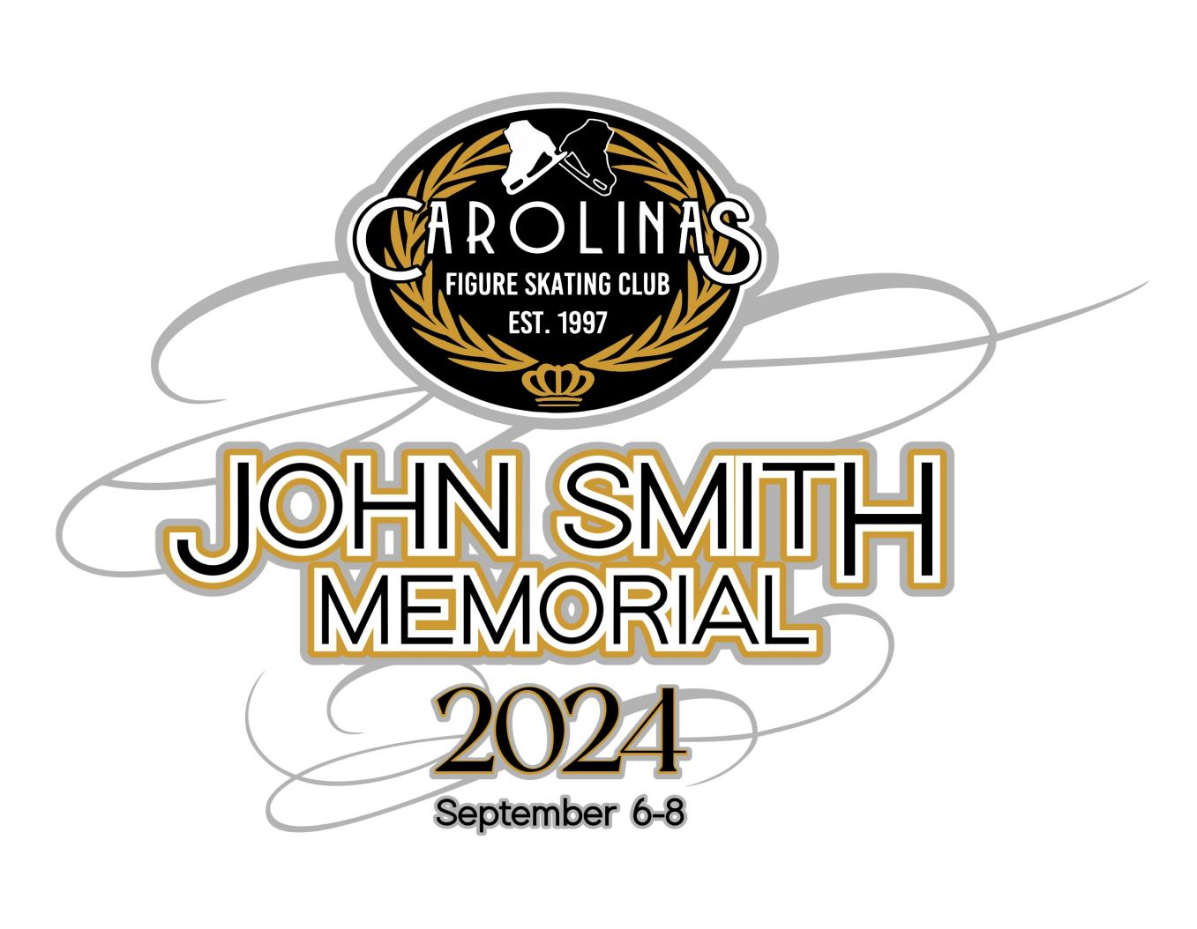**2025 John Smith Memorial Competition,**

**September 5-7, 2025**

**Hosted by Carolinas Figure Skating Club**

**Extreme Ice Center,**

**4705 Indian Trail Fairview Rd.**

**Indian Trail, NC 28079**

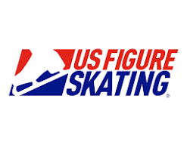

**I. COMPETITION OVERVIEW**

The 2025 John Smith Memorial Competition will be conducted in accordance with the rules and regulations of U.S. Figure Skating, as set forth in the current rulebook, and/or current Compete USA handbook as well as any pertinent updates that have been posted on the U.S. Figure Skating website. The competition will be open for registration on EntryEeze.

This competition is open to all eligible, restricted, reinstated or readmitted persons as defined by the Eligibility Rules.

Skaters must be a currently registered member of a U.S. Figure Skating member club, a Learn to Skate USA® member, a member of a collegiate club or an individual member in accordance with the current rulebook. For non-U.S. citizens, please refer to the rulebook for more information.

**II. ELIGIBILITY  
Singles: Excel and Well-Balanced Events:**

●  Skaters must meet at least the minimum singles test requirements for the event’s level. A skater’s singles test level may be higher than the minimum requirement.

●  Skate Up: skaters may skate up one level higher than their minimum test requirement allows.

●  Skaters may not register for an event level lower than allowed by their competitive floor. An athlete’s competitive floor is set by one of the following scenarios:

○  If an athlete has a paid EMS series application for the NQS series, the event level registered for in the most recent NQS will become the lowest level they may compete at in any U.S. Figure Skating sanctioned event.

○  If an athlete has a paid EMS series application for the Excel Series, the event level registered for in the most recent Excel series will become the lowest level they may compete in any Excel event. For Well-Balanced and Specialty events the skater will be permitted to register at one level lower than the “floor” set by their excel series entry.

○  If an athlete has never had a paid EMS series application in the NQS or Excel series, the athlete may select their level based on their goals and technical skills as long as the minimum test requirements are met.

●  Skaters are not permitted to enter an Excel free skate and a Well-Balanced free skate event at the same competition (example: Juvenile Girls Free Skate and Juvenile Girls Excel Free Skate). However, they are permitted to enter an Excel and a Well-Balanced event of different types such as a short program (if stand-alone event option), specialty or showcase events (example: Intermediate Women Short Program and Intermediate Women Excel Free Skate).

●  For more details about establishing event levels, refer to information sheet HERE or email events@usfigureskating.org.

**High School Teams:**

All skaters participating in this part of the competition must be part of a U.S. Figure

Skating high school figure skating team. Teams must be registered with U.S. Figure Skating for the 2024-2025 competitive season. All skaters must be enrolled as a full-time student as defined by the institution that they attend, grades 9-12, as per state guidelines. This includes both traditional and homeschooled students. Athletes may compete either for the high school they are attending, or as a high school collaborative defined as athletes from a single school, representing the school or athletes representing two or more area high school combining to form a team. Competitors may not represent more than one high school skating team at one time.

A minimum of two (2) skaters are required to form a team. Team members may include skaters of any gender. Skaters do not have to be at the same test level. For the Team Maneuver Events, athletes may compete at their test level or any higher level as described in the team maneuver event requirements.

**All other singles and partner events (such as Adults, Pairs):**

● Skaters must meet the minimum test requirements for the event's level, but not exceed the maximum permissible test requirement.

**EVENTS OFFERED**

Program requirements for the events listed below can be found at https://www.usfigureskating.org/program-requirements.

NOTE: Skaters may not enter Excel and Well-Balanced free skate events at the same competition.

|  |  |  |  |  |
| --- | --- | --- | --- | --- |
| ***SINGLES*** | IJS/6.0 | 1st event | 2nd event | 3rd event |
| Well Balanced Free Skate (Pre-preliminary to Prejuvenile) | IJS | $170 | NA | NA |
| Excel Free Skate (Pre-Preliminary to Senior) | IJS | $170 | NA | NA |
| Adult Free Skate (Pre-Bronze to Master Jr/Sr) | IJS | $170 | NA | NA |
| Adult Beginner and High Beginner Free Skate | 6.0 | $130 | $100 | $80 |
| Snowplow Sam-Basic 6 program with music | 6.0 | $80 | $50 | $50 |
| Aspire 1-4 program with music | 6.0 | $80 | $50 | $50 |
| Adult 1-6 program with music | 6.0 | $80 | $50 | $50 |
| Snowplow Sam-Basic 6 elements | 6.0 | $80 | $50 | $50 |
| ***SHOWCASE*** |  |  |  |  |
| Individual Entertainment (Aspire 1-Senior, Adult 1-Masters Jr/Sr) | CJS | $125 | $110 | $100 |
| Duets (Aspire 1-Senior, Adult 1- Masters Jr/Sr) | CJS | $125 | $110 | $100 |
| Production Ensembles | CJS | $125 | $110 | $100 |
| ***SPECIALTY*** |  |  |  |  |
| Compulsory moves Levels 1-8 | 6.0 | $100 | $80 | $60 |
| Adult Pre-Bronze to Masters Compulsory | 6.0 | $100 | 80 | 60 |
| Adult 1-6 Compulsory Moves | 6.0 | $100 | $80 | $60 |
| Jumps Challenge Levels 1-9 | 6.0 | $100 | $80 | $60 |
| Spins Challenge Levels 1-6 | 6.0 | $100 | $80 | $60 |
| ***High School*** |  |  |  |  |
| Team Maneuvers (Beginner, low, intermediate, high) | 6.0 | $100 per team | NA | NA |
| Artistic | 6.0 | $110 per skater | $80 | $60 |
| ***Special Olympics*** |  |  |  |  |
| Special Olympics Badges | 6.0 | $80 | $50 | $50 |
| Special Olympics - Free Skate Program 1-4, Pairs 1-2 & Dance 1-2 | 6.0 | $80 | $50 | $50 |
| Skate United Badges | 6.0 | $80 | $50 | $50 |
|  |  |  |  |  |

**OUR COMMUNITY:**

U.S. Figure Skating is dedicated to fostering a culture of belonging and community that is welcoming for all individuals. We are committed to championing diversity, equity, and inclusion and understand its value in combating discrimination and challenging inequalities necessary to develop champions both on and off the ice. We are actively working toward developing equitable practices and policies that foster safety and empower all individuals to authentically pursue their unique path in all areas of our sport. We stand firmly on the belief that our members are the most important asset to our organization and that our differences are meaningful and strengthen our sport. We believe that skating is for everyone.

**NON-DISCRIMINATION:**

U.S. Figure Skating commits in policy, principle, and practice to sustain a non-discriminatory approach on and off the ice for all members. We strive to provide equal opportunity for all despite their varied backgrounds, experiences, and identities, and want all members to feel valued and respected at every level of the organization. U.S. Figure Skating’s SkateSafe® Program receives, investigates, and addresses allegations of discrimination or harassment throughout its membership and the organization. Please refer to the SkateSafe® Program Handbook for further definition of harassment, discrimination and abuse.

By attending this event, all participants are willingly committing to upholding U.S. Figure Skating’s Code of Ethics (*GR 1.01*) and Code of Conduct (*GR 1.02*), as detailed within the U.S. Figure Skating Rulebook.

To report a concern of discrimination or harassment to U.S. Figure Skating, please visit www.USFigureSkating.org/SkateSafe or email SkateSafe@USFigureSkating.org.

**SKATESAFE COMPLIANCE**

For full details about SkateSafe compliance at U.S. Figure Skating competitions, refer to the U.S. Figure Skating SkateSafe webpage: www.usfigureskating.org/skatesafe.

**COACHES**

To be an eligible coach at a nonqualifying competition, coaches must meet the applicable compliance requirements and verified by U.S. Figure Skating. Coach compliance falls into two categories, Coach Compliance (includes choreographers) and Learn to Skate USA® Instructor Compliance. Details regarding compliance requirements can be found HERE. All compliance requirements must be met at the time of check-in to access the competition, no exceptions.

Coaches of foreign athletes: If you are a coach of a foreign athlete only, you are not subject to U.S. Figure Skating coach compliance and will only be asked to provide a letter of good standing for the federation your athlete represents.

All coaches will have to confirm their skater’s registration via EntryEeze. Coaches can view music, PPC, and schedules on EntryEeze.

**MANDATORY ATHLETES**

Athletes aged 18+ as of the competition start date who will be competing on a team (i.e., synchro, ice dance, pairs, shadow dance, theatre, etc.) with at least one Minor Athlete must complete SafeSportTM Training.

Minor athletes who turn 18 mid-season are encouraged to seek parental consent to take the online SafeSportTM Training early to avoid any disruptions in their ability to participate as the training is required upon turning 18. The athlete will not be compliant until they have completed the training and their Members Only portal reflects completion. Please email skatesafe@usfigureskating.org for instructions or questions regarding parental consent.

**III. REGISTRATION INFORMATION**

**ONLINE REGISTRATION VIA ENTRYEEZE**

Online registrations will be accepted via EntryEeze. Payment must be made at the time of registration by credit card only. **Please ensure you have checked the correct boxes while registering. If you incorrectly mark a box that results in the event needing to be changed after Aug. 13, 2025, you will be assessed a $30 fee per changed event. *No event changes due to registration errors will be made after Aug. 21, 2025.***

***Registration Opens: 06/29/2025 at 8:00 AM ET  
Registration Deadline: 08/04/2025 at 11:59PM ET***

*The host club reserves the right to close registration at any time if event capacity is met. Late registrations will not be accepted.

**HOW TO REGISTER**

Go to www.entryeeze.com

Under “skaters,” click on “start here.” Select North Carolina as the state, and navigate to “John Smith Memorial Competition.” Complete the registration process.

**PARTNERED EVENTS**

Only one partner will complete registration for the team. During the registration process, you will be asked to identify your partner and verify their test information. The registered partner will be responsible for managing all aspects of the competition for the team including music/PPC upload, practice ice sales, etc.

**FOREIGN SKATERS**

Non-U.S. skaters intending to register for this competition must set up a non-member account prior to registering for the competition (click here for HOW TO). This can be done by choosing the “Non-Member? Create Account” option on the Members Only login page.

**TEST CREDIT**

Skaters that meet the requirements for test credit may request their test credit forms at the registration desk. Forms must be picked up at the registration desk prior to the end of the competition. Submission of test credit form to USFSA is the responsibility of the skater upon return home in conjunction with their home club test chair. Cost for test credit form preparation is $15 by credit card or check.

**MUSIC SUBMISSION / UPLOAD**

EMS MUSIC UPLOAD: Competitors participating in events with music are required to upload their music to EntryEeze no later than **August 21, 2025 at 11:59PM ET.** After this date, skaters will be locked out of this feature and subject to a $30 late fee. The late fee will automatically be added to each skater's cart who doesn't meet this requirement by the deadline. Late fees will not be removed under any circumstances and must be paid prior to receiving the skater credential onsite.

**DEADLINE: August 21, 2025 by *11:59PM* ET, *late fee of $30***

Competitors must also have available a backup copy of their competition music on a cell phone or tablet and it must be immediately available rinkside whenever the skater competes. If the phone does not have the standard round headset connector, an appropriate adapter, such as an Apple Lightning connector or Samsung USB-C adapter is required to be attached. The phone should be presented to the music person with the file ready to play, phone in airplane mode and volume turned to maximum.

**PLANNED PROGRAM CONTENT (PPC) SUBMISSION/UPLOAD (FOR IJS EVENTS ONLY)** Competitors participating in IJS events are required to submit PPC in EntryEeze no later than **August 21, 2025 at 11:59PM ET**. After this date, skaters will be locked out of this feature and subject to a $15 late fee. The late fee will automatically be added to each skater’s cart who doesn’t meet this requirement by the deadline. Late fees will not be removed under any circumstances and must be paid prior to receiving the skater credential onsite.

**DEADLINE: August 21, 2025 11:59PM ET, *late fee of $15***

**REFUND POLICY**

Entry fees will not be refunded after entry deadline unless no competition exists or the event is canceled. There will be no refunds for medical withdrawals.

**LIABILITY**

U.S. Figure Skating, Learn to Skate USA, Carolinas Figure Skating Club and Extreme Ice Center accept no responsibility for injury or damage sustained by any participant in this competition. This is in accordance with Rule 1600 of the official U.S. Figure Skating Rulebook.

**IV. COMPETITION DETAILS**

**FACILITY**

Extreme Ice Center  
4705 Fairview Indian Trail Rd,  
Indian Trail, NC 28079

Each sheet of ice is 85’ x 200’ with rounded corners, hockey barriers, and seating areas in each arena. The facility has a full-service tavern, coffee bar, and a pro-shop that sells figure skating supplies. Extreme Ice Center does not allow any food or drink to be brought in from outside sources.

**LOCKER ROOMS AND CHANGING AREAS**

Locker rooms will not be available to change in. Athletes will be provided with an area to put skates on but changing will not be permitted in these spaces.

**U.S. FIGURE SKATING TRAVEL POLICY**

All travel must strictly adhere to Two-Deep Leadership requirements. An Adult Participant cannot transport a Minor Athlete one-on-one and Two-Deep Leadership requirements must be adhered to at all times during In-Program travel, by transporting at least two minors or a second Adult Participant. An Adult Participant cannot share a hotel room or other sleeping arrangement with a Minor Athlete(s). Full details of the SkateSafe Travel Policy and any exceptions can be found starting on page 12 of the SkateSafe Handbook.

**OFFICIAL WEBSITE AND UPDATES:**

https://carolinasfsc.org/john-smith-memorial  
It is the responsibility of each competitor, parent and coach to check the website and email notifications frequently for any schedule changes and/or additional information pertaining to the competition.

**SCHEDULE**

Competitors may be scheduled on any day or time during the announced dates of the competition. The competition and practice ice schedule will be available after the close of entries. All participants will be notified via email once available.

**PRACTICE ICE**

All Practice Ice Sessions will be 20 minutes in length. Practice ice credit may be pre-purchased in EntryEeze while registration is open. Prepaid practice ice is non-refundable and may not be sold to other skaters. Once the registration opens at the event, all remaining practice ice sessions will be sold online. Specific details will be emailed to all competitors at a later date.

Prices:  
• $25 pre-purchase sales practice ice session (limit 2 per event) • $30 open sales practice ice session (after schedule release)

**ONSITE CHECK-IN**

Registration will be open one to two hours before the first event and run through the last event of the day. The registration table will be located as you enter the rink, behind the podium and banner. Please register/check in promptly upon arrival.

If you are participating in a role requiring compliance, please be sure to download or print your compliance card to verify your compliance status on-site, if requested. If you believe your compliance card does not accurately reflect your compliance status, please contact skatesafe@usfigureskating.org at least 2 business days prior to the competition for assistance.

**AWARDS**

Medals will be awarded to the top four skaters in each flight for all events. Awards ceremonies will take place during the ice resurfaces following events. Medals can also be picked up from Registration once results are posted.

**VOLUNTEER INFO AND COMPLIANCE:** Volunteer info will be posted to the competition website Reminder: Compliant positions at all U.S. Figure Skating events include key LOC members, locker room monitors and ALL medical event personnel. Click here for volunteer compliance information.

**PHOTO/VIDEO**

Videography for this event is provided by Looking Glass Productions. For more information about videos, visit the competition website at [www.carolinasfsc.org/john-smith-memorial.](http://www.carolinasfsc.org/john-smith-memorial.) Videos will be provided to all competitors after the competition. Information will be sent out to competitors regarding downloading the videos after the competition. Videos will not have music.

The photographer for the event is Jason Jackson with JSK Photography. Their website is <https://jskphotodigital.com.>

**ADDITIONAL INFORMATION:**

**Hotel Information:** The hotel for the event is the Courtyard Marriott Matthews at 11425 E. Independence Blvd. in Matthews, NC 28105. Visit https://www.marriott.com/event-reservations/reservation-link.mi?id=1745418987178&key=GRP&guestreslink2=true&app=resvlinkor the hotel discount link.

**Courtyard Charlotte Matthews for 119.00 USD -** **134.00 USD** **per night** - **Last Day to Book :Friday, August 22, 2025**

**Airport information:** Charlotte Douglas International Airport is the closest airport.

**Vendor and Sponsorship opportunities** will be posted to our competition website

**CONTACT INFO**

If you have questionsIf you have questionsCompetitions@carolinasfsc.org.

Competition Committee:

Alyson Hansen - Competition Chair

Amanda Ransom - Medical Chair

Jenny Gwyn - Sanction Chair