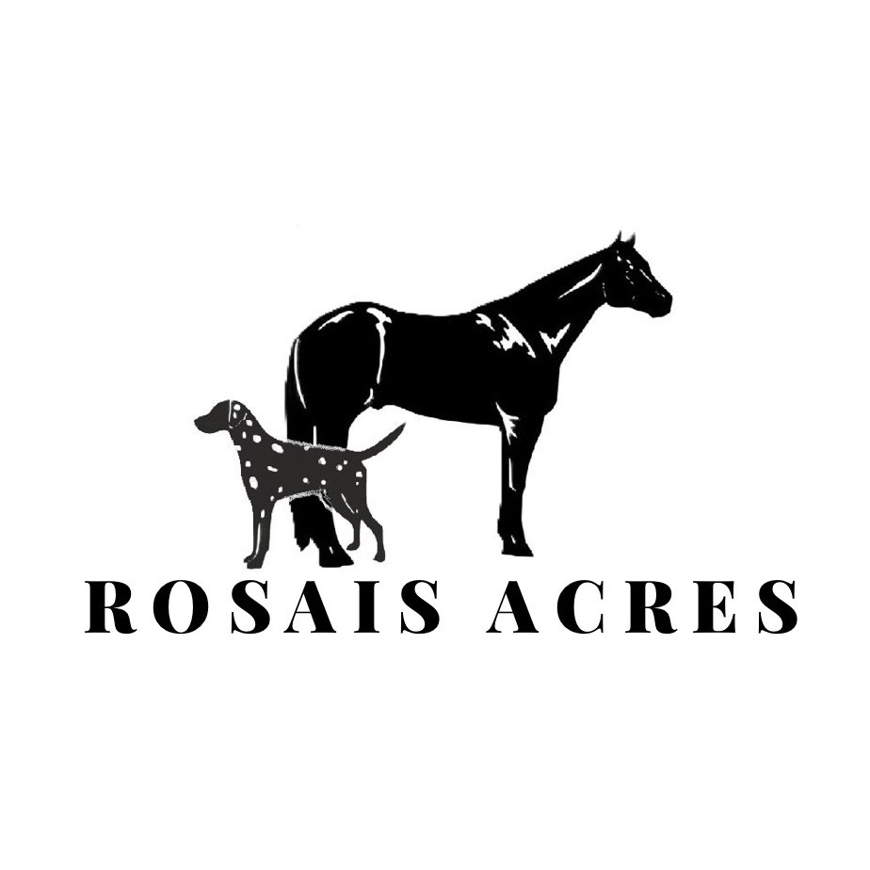

**Puppy Purchase Agreement (Show/Breeding Dog)**

PARENTS:

Dam – Mother:

Sire – Father:

Whelp Date:

Purchase Price:

We never guarantee color, sex or suitability, adult size, conformation, reproductive ability, testicular descending, potty training ability or the temperament of the puppy/dog. Seller reserves the right to refuse the sale of puppy/dog at any time.

The puppy will come with a microchip already implanted. Seller’s name and phone number must be listed as one of the contacts.

Seller reserves the right to terminate this contract at any time prior to the exchange of any money.

HEALTH GUARANTEE: Puppy/dog comes with a limited health guarantee. To qualify for the health guarantee, Buyer must have the puppy/dog examined and checked by a licensed veterinarian at the Buyers expense within 72 hours of receiving the puppy/dog. **Failure to perform veterinary exam will void all guarantees** If the puppy/dog should have a life threatening defect, during the above examination, it may be returned to Seller for purchased price. Return must be within 7 days of the 72 hours, at the Buyers expense, along with papers, written assessment from examining veterinarian stating in what respect there is a defect. Once the stated health problem has been verified by the Seller’s veterinarian, the buyer will be issued the refund. The health guarantee only covers the puppy/dog. We do not cover nor are we responsible for associated costs such as, but not limited to, veterinarian fees, animal clinic costs, medications, shipping, personal damage, and emotional grief. The guarantee does not cover common conditions such as, but not limited to, improper bite, thin coat, hernias of any kind, ectropion, cherry eye, internal & external parasites, loose stools, coccidian, or any condition that can be corrected by veterinarian treatment.

24 MONTH HEALTH GUARANTEE: After the initial 72 hour examination to the 24th month, Buyer agrees to continue all inoculations and proper vet care throughout life of the dog. Buyer is responsible for any continuing vet bills, corrective or preventative, for the life of the dog. Puppy/dog is guaranteed until it is 24 months old for life-threatening hereditary conditions (meaning something serious that cannot be fixed and is likely to cause an early death). If a condition does occur, present a certified letter from a licensed veterinarian within 48 hours of finding the defect as well as all medical records from any and all veterinarians the puppy/dog has visited. If a hereditary condition causes the puppy’s/dogs demise, an autopsy, at buyer’s expense, must be performed to verify this without a doubt. A replacement of the Seller’s choice will be given when one is available. No guarantee is made as to the time frame for replacement. Buyer is responsible for all transportation charges. At Seller’s discretion, Seller may choose to refund Buyers money minus $500 non-refundable deposit instead of replacement puppy/dog. Seller reserves the right to have the puppy/dog with the alleged condition examined by the Seller’s veterinarian for conformation purposes, at the Sellers expense. This guarantee does not include hereditary conditions regarding Hip Dysplasia, Deafness, or High Uric Acid as these are common issues within the breed and are addressed separately in this contract.

HIP OR ELBOW DYSPLASIA: Puppy/dog is guaranteed against severe hip or elbow dysplasia up to 24 months. We feed our puppy/dog quality dog food to help ensure best possible nutrition for fast growing puppies and healthy mature dogs. This is extremely important for the dog’s growth and continued health. If buyer fails to provide the puppy/dog with comparable quality dog food, all guarantees hereby are void. A puppy/dog that spends too much of their time in a crate will also not have the Dysplasia guarantee as proper exercise is equally important for proper growth and development. Buyer will also take care not to overexert the puppy/dog until fully developed. If this condition does occur, present a certified letter as well as PennHIP or OFA results, at Buyers expense, from a licensed veterinarian within 48 hours of finding the defect. OFA results are required and considered only form of proof of hip or elbow dysplasia. If buyer chooses to keep the puppy/dog, spay/neuter must be completed if not done so already and registration papers must be returned to the Seller. After providing documentation that spay/neuter has been done, registration papers are returned, and Seller’s veterinarian has confirmed results, the buyer may have $1,300 deducted from the purchase price of another puppy when available. At the Seller’s discretion, Seller may choose to refund Buyer’s money of $1,300 instead.

DEAFNESS: Seller will disclose to Buyer if puppy is known to be deaf or have unilateral hearing and $1,300 will be reduced from the purchase price. If it is found that the puppy is deaf or has unilateral hearing within the puppy’s first 3 months of life Buyer must present a certified letter as well as BAER test results at the Buyers expense, from a licensed veterinarian within 48 hours of finding the defect. BAER results are required and considered the only form of proof of deafness. If buyer chooses to keep the puppy/dog, spay/neuter must be completed if not done so already and registration papers must be returned to the Seller. After providing documentation that spay/neuter has been done, registration papers are returned, and Seller’s veterinarian has confirmed results, the buyer may have $1,300 deducted from the purchase price of another puppy when available. At the Seller’s discretion, Seller may choose to refund Buyer’s money of $1,300 instead.

URIC ACID: Seller will have puppy/dog genetically tested for hyperuricosuria.

If the results show that your puppy/dog has the High Uric Acid (HUA) gene, your puppy/dog can be prone to developing uric acid stones in the kidneys and bladder. It is the buyer’s responsibility to feed the appropriate diet for a HUA puppy/dog which includes feeding a diet low in purines to prevent the formation of stones. These stones can create discomfort in the puppy/dog and can potentially require surgery to resolve the blockage. Should the puppy develop stones it is the buyer’s expense and responsibility to provide all veterinary and dietary care related to the formation of these stones.

If the results show that your puppy/dog has the Low Uric Acid (LUA) gene, your puppy/dog is not genetically prone to developing uric acid stones in the kidneys and bladder but does not mean that your puppy will never develop stones. Should the puppy develop stones it is the buyer’s expense and responsibility to provide all veterinary and dietary care related to the formation of these stones.

REGISTRATION: All puppies/dogs are registered with AKC and must carry the Rosais name on their registration papers. This puppy/dog is sold on a Show/Breeding contract with full registration. Seller will release registration papers upon receiving them from the AKC with the Limited Registration box marked. Buyer must perform all applicable testing in order to receive the puppy’s/dog’s OFA CHIC number and provide Seller with the results. Once this has been done, Seller will submit request to AKC to change registration status from Limited to Full.

BUYERS RESPONSIBILITIES: Buyer agrees to provide proper care for the life of the puppy/dog to include but not limited to: proper food in the correct amount, water, shelter, annual exams, vaccinations, and parasite preventatives.

Buyer agrees never to fight puppy/dog, chain puppy/dog, or cage the puppy/dog in any area of improper size. Buyer agrees that if abuse or neglect is discovered, this contract is void and the puppy/dog is to be returned to Rosais at once without incident.

Buyer agrees that Seller has the right to use any pictures or accomplishments of the puppy/dog for advertisement, etc.

Buyer agrees that puppy/dog will live as part of the family, and must be maintained within the household of the purchaser at all times (except for brief periods when the pup must be cared for by another due to temporary absence of the owner from the home). Puppy/Dog may not be loaned, leased, gifted, traded, or resold at any time without Rosais having first opportunity. If Buyer is unable or unwilling to continue proper care for the puppy/dog or has decided to sell, give away, or euthanize the puppy/dog at any time, the puppy/dog must be returned to Seller without refund of any kind. Seller may give permission to sell or give the puppy/dog to an approved second owner whom must also agree to abide by this contract. If such permission is given, new owner must sign a new contract, identical or similar to this one. Under no circumstance is the puppy/dog ever to be surrendered to a shelter, given away, sold or destroyed.

OTHER TERMS AND CONDITIONS: The puppy/dog is not to be used in dog fights or any other illegal activities. In the case of any breach of contract for mistreatment, if the puppy/dog is bred prior to Full Registration being released, found to be in illegal activity, or is sold/rehomed Buyer is to compensate Seller $10,000 and the puppy/dog will be immediately repossessed.

Seller is not responsible for death of any puppy/dog due to injury, neglect, loss, accident, abuse, elective surgery or carelessness.

No guarantees are made regarding puppy’s/dog’s temperament. Temperament of the puppy/dog is based on the amount of time Buyer gives to the puppy/dog and its socialization.

Seller is not responsible if puppy/dog contracts a communicable disease after leaving Seller’s possession, the puppy/dog is now in Buyer’s care.

LEGAL: Seller will not be liable for any medical expenses, veterinary fees, or any other expenses related to the puppy/dog. This agreement may be modified or amended only in writing signed by both of the parties. The parties also acknowledge that this agreement may be signed in one or more counterparts in one or more counterparts, each of which shall be deemed on original, and taken together to constitute one and the same agreement. Parties further agree that, in the event a dispute arises between them as a result of this transaction all parties shall make best efforts to resolve such a dispute without intervention of a judicial system. In the event the parties resort to use the judicial system, all parties agree that suit be brought exclusively and only in the jurisdiction that Seller resides in at the time the parties resort to litigation and that each party shall bear their own attorney fees.

The Buyer agrees that by signing this agreement, they understand and accept all terms and conditions.

___________________________________________

Buyer Printed Name

___________________________________________

Buyer Signature

_______________

Date

___________________________________________

Seller Signature/Shannon O’Hair

_______________

Date