Radiation Safety in a Hospital Setting

Heather Dorrell

Objectives:

Objective 2: Staff will describe the use of three radiation protection methods (Time, Distance, and Shielding) and their significance in relation to the ALARA policy.
Objective 3: Staff will utilize their understanding of radiation safety concepts to practice ALARA.

Strategies Description:

Facts, concepts, and procedures are involved in training staff to describe and use radiation safety protection methods to practice ALARA. Pre-instructional strategies will combine presentation of the objectives and inclusion of an audio overview of the expectations of the learner.

The initial presentation for objective two and three will be presented using the RUL-EG method. Visuals and audio (with closed captioning for accessibility) will be used to present the initial facts and concepts, along with examples and non-examples for each fact and concept. Visuals will be a combination of decorative, representational, and interpretive. Each visual will signal the learner by using headings, colors, and specific layouts. Audio will provide additional cueing and signaling using a casual speaking voice, along with signaling words. These strategies will decrease the extraneous cognitive load of the learner.

Three main learning strategies will be used for teaching the content in these two objectives, and the strategy will switch to EG-RUL. The first strategy will use a photograph and a video to demonstrate examples and non examples of radiation safety practices in a hospital setting. The employees will be asked to list the examples and non-examples of radiation safety procedures in the photograph and video. After they are asked to list these, the expert will provide an audio explanation of a graphic (list) that gives immediate feedback to the employees regarding these examples and non-examples.

During the second strategy, the expert will provide one to three written scenarios with multiple choice answers that include a “best answer.” The employee will be asked to choose an answer. Once the answer is chosen, immediate feedback will be given in written form as to whether the answer is correct or incorrect. After the informal assessment, the expert will explain the scenario’s best answer and how it relates to best practices in radiation safety.

A short, formal assessment or evaluation with multiple choice and true/false will be given at the end of this training module that will include questions that serve as a review of the material and cues the employee as to what the main objectives of the module are.

Technology Choice & Rationale:

This training will be presented in an asynchronous, digital format on Workday. This training is a requirement of the Virginia Department of Health for all employees that work with radiation in the hospital setting and wear dosimeters. The asynchronous format allows individuals who are onboarding at various times to take the training when necessary. It is digital, so employees in different departments and different geographical locations with a variety of work schedules can access the training.

Although the training already exists, it is lacking in learner accessibility. The audience for this training benefits from signaling, cueing, branding, audio, and closed captioning. Those items, along with the content, visuals, transitions, learning strategies, and evaluations will be updated.

The institution currently uses Workday as their Learning Management System and Microsoft PowerPoint for training. There is an internal preference for the presentation to be created in that program. However, the final project for this course will be presented in Articulate Storyline or Rise to allow for the inclusion of an assessment. Other tools, like Audacity, may be used in the final creation.

Technology Choice & Rationale
Requirements: Relevant Characteristics of Learners or Context, and/or Instructional Strategies | Best-Fitting Technology & Rationale
Contextual Characteristic: Learners must engage from multiple distant locations at different times. All have access to a computer and wired Internet or fast wireless connections.  Instructional Strategy selected: Asynchronous, digital presentation of visuals and audio will be used to present the initial facts, concepts, and respective examples and non-examples.  A photograph with a request to identify radiation safety practices occurring within the visual will be used.  A video demonstration with a request to identify radiation safety practices will be used.  Informal scenario-based questions will be added to instruction, along with immediate feedback from an expert to increase engagement and critical thinking for employees. | Power Point Presentation and Articulate Rise or Storyline:  Visuals and audio will be used to present the facts, concepts, and examples. The institution supports this format.  Photographs and videos: A photograph and video demonstration, along with a request for the employee to identify the radiation safety practice examples and non-examples will increase engagement and critical thinking about the topic.  Scenarios with Immediate Feedback from an Expert: Including scenario-based learning opportunities will increase engagement and retention.  Informal scenario-based questions will be added to instruction, along with immediate feedback from an expert to increase engagement and critical thinking for employees.  Rationale for Selection:  - Employees are onboarding continuously  - Employees have different schedules and geographical locations.  - Data must be collected on completion of the course since it is a requirement of a regulatory institution.  - Employees have previous training in hospital settings and access to online training materials.

Instructional Message Design
Details of the Instructional Message Design flow chart can be found in the notes section of each box using the link below. Each module is designed to be taken successively, and employees must allow 15-20 minutes to complete each module. Upon completion, a short, five-minute assessment will be given as an overview of the material.

Link for Additional Details:

https://mm.tt/app/map/3015608809?t=IHM8BDShzF

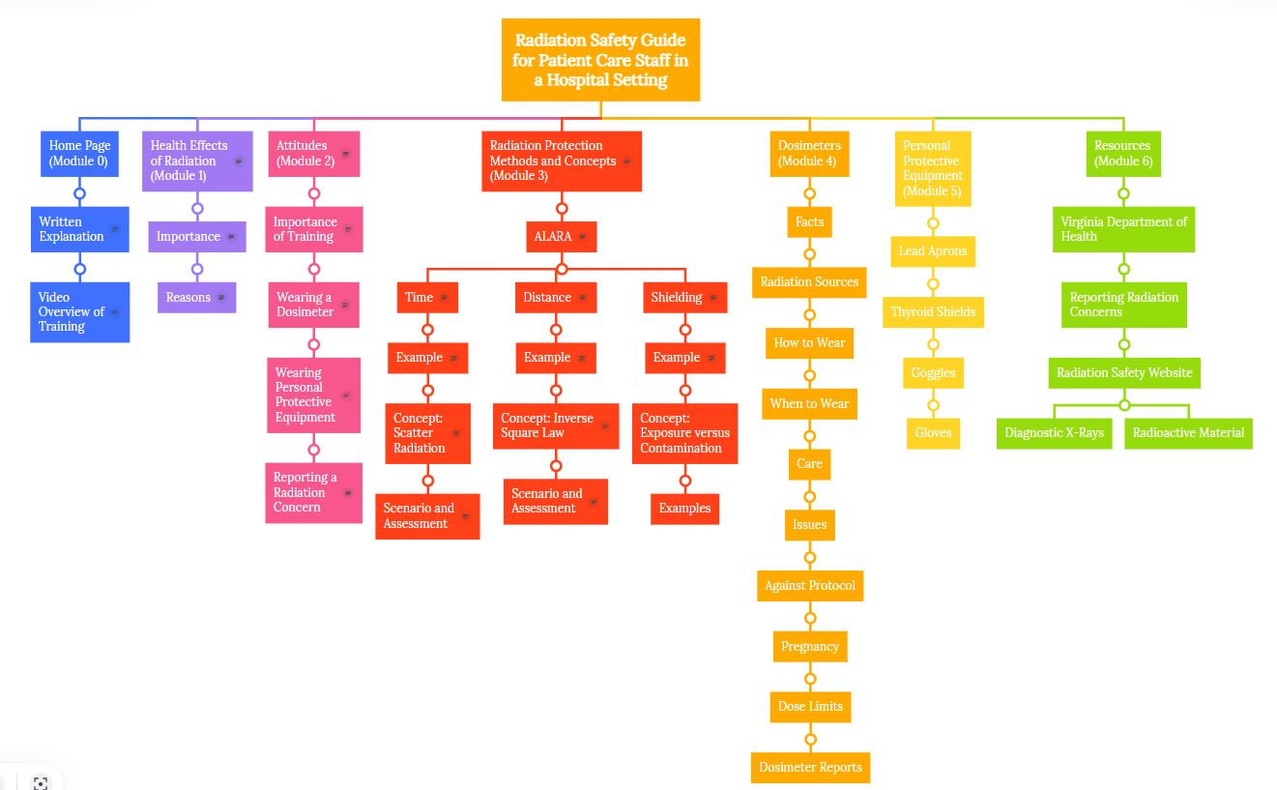

Instructional Sequence

Module 0: Introduction to Radiation Safety Guide in a Hospital Setting
- No objectives. The module serves as an introduction to the course.

Module 1: Health Effects of Radiation
- Objective 1: Identify the personal and instructional significance of radiation safety in a hospital setting.

Module 2: Attitudes
- Objective 1: Identify the personal and instructional significance or radiation safety in a hospital setting.

Module 3: Radiation Protection Methods and Concepts
- Objective 3: Describe the use of three radiation protection methods (Time, Distance, and Shielding) and their significance in relation to the ALARA policy.
- Objective 4: Utilize ALARA radiation safety methods.

Module 4: Dosimeters
- Objective 4: Staff will describe the proper care and use of a dosimeter and be able to read a personal exposure report as it relates to dose limits.

Module 5: Personal Protective Equipment
- Objective 3: Describe the use of three radiation protection methods (Time, Distance, and Shielding) and their significance in relation to the ALARA policy.
- Objective 4: Utilize ALARA radiation safety methods.

Module 6
- Objective 5: Staff will successfully utilize the Radiation Safety website to locate resources and points of contact necessary for a given scenario.

Message Design Specifications

Pre-instruction

Module 0 will consist of a Home Page with a video link. A visual of the training’s objectives will be available in the video, along with a sequence of Modules 1-6. An expert in a video will discuss an overview using a script. Closed captioning will be provided.

Initial Presentation of Material

The objective for each Module will be presented visually, along with an audio introduction of what will be covered in the module. The initial presentations will use a vignette, a scenario, or an example/non-example of radiation safety practices in a hospital setting. The employee will be asked by the expert to analyze these presentations based on prior existing knowledge using open-ended questions. These presentations will serve as the Module’s “hook” to engage learners in the material.

From there, the initial presentation for objectives will be presented using the RUL-EG method. Visuals and audio (with closed captioning for accessibility) will be used to present the initial facts and concepts, along with examples for each fact and concept. Visuals will be a combination of decorative, representational, and interpretive. Each visual will signal the learner by using headings, colors, and specific layouts. Audio will provide additional cueing and signaling using a casual speaking voice, along with signaling words. These strategies will decrease the extraneous cognitive load of the learner.

Generative Activities

Generative Learning Strategies will be interspersed throughout the Modules at the end of sections or at topic transitions. Scenarios and questions about facts, concepts, and procedures will be presented in written form or by using a visual, along with multiple answers to choose from. The employee will be asked to choose the best answer listed. Then, immediate feedback on that answer will be given using visuals and expert audio.

Review Activities / Retention Activities / Transfer Activities

A review or summary will take place after generative learning strategies. At the end of all the Modules, a general multiple-choice quiz will be taken where employees are expected to answer 90% of the questions correctly. Feedback will be given in a post-summary of the final quiz, along with a percentage correct. This information will go to the Radiation Safety team to assist them in developing or revising future training. If the employee does not receive an accurate score, s/he will be asked to return to the portions of the training that need to be reviewed before retaking the quiz.
Retention and Transfer Activities take place while on the job. The Radiation Safety Officer in the hospital monitors the staff for compliance by observing at least once a week. Managers within each unit are trained to consult with the RSO if there are continuous issues with an employee’s compliance. The state inspection occurs annually, and the institution receives a report detailing ways in which the staff can improve their radiation safety practices.

Implementation of Message Design

Module 3 Home Page:
Strategy: EG-RUL
Slide/Visual One:
Text:
Objective 2:
Describe the use of three radiation protection methods (Time, Distance, and Shielding) and their significance in relation to the ALARA policy.
Objective 3:
Utilize ALARA radiation safety methods.
Representational Photograph: Photograph in which employees are using radiation protection methods.
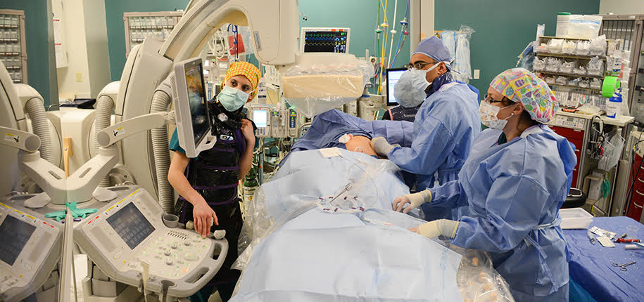
Audio: Expert discusses what is happening in the photograph and introduces ALARA.
Expert Script:
Hello! Let’s look at the objectives for Module Three. After this Module, you will be able to describe the use of three radiation protection methods as they relate to the ALARA policy. These include Time, Distance, and Shielding. You will utilize ALARA radiation safety methods while working around radioactive sources.
Module Three will also include discussions of important Radiation Concepts, such as Scatter Radiation, the Inverse Square Law, and Exposure to Radiation versus Contamination. You will be provided with examples and scenarios that will help you to learn these concepts and how they can help you minimize personal exposure, contain radioactive contaminates, and address any injury from overexposure to sources of radiation.
Let’s look at this photograph of an interventional radiology procedure. What radiation safety practices and procedures can you identify in this photograph? How are employees acting to help them stay safe from radiation?

Slide/Visual Two:
Visual: Representational Images of Example (Sunburn)
Audio:
Expert Script:
How can you protect yourself from radiation?
It's like protecting yourself against a sunburn. If you were out on the beach on a sunny day, you would want to minimize your time in the sun, and you would maximize your time inside a structure. You would shield yourself from the sun as much as you could using umbrellas, sunscreen, or clothing.
These principles of sun safety are the same as the rules of radiation protection-time, distance, and shielding.

Slide Visual Three:
Visual: Representational Image of ALARA
Audio:
Expert Script:
What is ALARA? ALARA is an acronym for "As Low as Reasonably Achievable." It's a general philosophy about radiation protection and it's the law.
ALARA is defined by the Nuclear Regulatory Commission, or NRC, as "making every reasonable effort to maintain exposures to ionizing radiation as far below the dose limits as practical, consistent with the purpose for which the licensed activity is undertaken."
That's not as complicated as it sounds. The ALARA rule simply means that the radiation dose to the occupational worker should be kept as low as reasonably achievable. Not as low as possible, but as low as we can while still providing quality medical imaging to our patients.

Slide/Visual Four:
Visual: TBD
Text: Important Aspects of the Law
Nuclear Regulatory Commission states:
ALARA means “making every reasonable effort to maintain exposures to ionizing radiation as far below the dose limit as practical, consistent with the purpose for which the licensed activity is undertaken.”
Audio:
Expert Script:
And as stated in the law, the responsible legal use of radiation should result in occupational doses that are far below the legal limits. Time, Distance, and Shielding are the ways in which we apply the ALARA rule. Each one of these affects the radiation dose to a worker in a predictable way.

Slide/Visual Five:
Text:
Radiation Protection Method: Time
The more time spent by a radiation source, the higher the radiation dose will be.
Decrease time in proximity to the radiation source by stepping out of the room when possible and minimizing the area being treated by the beam.
Decorative Visual: Clock
Representational Visual: Proportional Relationship Arrows
Audio:
Expert Script:
Time is the first rule of radiation protection.
A person's time in a radiation field should be minimized because the relationship between exposure time and radiation dose is directly proportional. As time around the radiation source goes up, the radiation dose goes up by the same amount. As time goes down, the radiation dose goes down by the same amount.

Slide/Visual Six:
Representational Visual: Worked Sample of the Example
Audio:
Expert Script:
As an example, let's say a health care professional assists in an exam that takes four minutes of fluoroscopy, and they received an absorbed dose of 60 micro gray. If the exposure time were reduced by half, the worker's exposure would go down by half to 30 micro grays. If the exposure time went up by two minutes to six minutes, the worker's exposure would go up to 90 micro grays.

Slide/Visual Seven:
Representational Visual: Representation of patient being hit by radiation from a beam and scattering throughout the room.
Text:
Concept: Scatter Radiation
Scatter radiation occurs when the beam from a machine intercepts an object, causing X-rays to be scattered.
Audio:
Expert Script:
An important concept when thinking about time, distance, and shielding is scatter radiation.
Scatter radiation occurs when the beam from a machine intercepts an object, causing X-rays to be scattered. The scattered radiation from the patient comprises the main source of radiation dose to staff. X-rays deflect off the patient and table during procedures and have the potential to cause left-sided brain tumors, skin cancer, thyroid disease, and neurodegenerative diseases in hospital staff that are exposed for long periods of time.
This is why workers' schedules should consider the amount of time spent in areas with higher occupational doses. Fluoroscopy, surgery, and portable radiography are all associated with higher radiation doses since the operator must be near the radiation field. When possible, workers' schedules should be balanced so that no one should spend an excessive amount of time on these assignments.

Slide/Visual Eight:
Scenario
Jan, a medical student, observes a case involving X-ray equipment. Jan puts on proper shielding equipment before entering the room. She stands right next to the doctor. She is there to see a specific part of the procedure but finds that she continues to learn additional things as the procedure goes on. The doctor conducting the procedure is willing to discuss the entire procedure with Jan while he works.
Representational Visual of a student standing next to a doctor in an x-ray room.
Expert Audio:
Let's look at this scenario as it relates to ALARA and Time.
Expert reads the scenario.
Answer the following question about Jan's actions in this scenario.
Assessment: Multiple Choice Question (No Audio)
Question: When thinking about ALARA's radiation safety protocols around time, what was the proper action for Jan to take in this scenario?
a. Jan should have left after the specific part of the procedure she was required to observe was over.
b. Jan should have retreated to a location farther from the patient to continue her discussion with the doctor after the specific part of the procedure was over.
c. Jan is a medical student and there to receive instruction, so staying for the entire procedure is permitted.
d. Jan should not have attended the procedure at all.
After the answer is chosen, the correct answer is highlighted:
Expert Script:
If you chose b, Jan should have retreated to a location farther from the patient to continue her discussion with the doctor after the specific part of the procedure was over, you are correct.
Jan needs to minimize her time next to the X-ray machine to decrease the amount of scatter radiation she receives. Stepping back from the table enables her to listen and learn from the case while lowering her radiation exposure.

Slide/Visual Nine:
Visual: Decorative Visual of Measuring Tape
Representational Visual: Dose goes down as distance goes up with arrows.
Radiation Protection Method: Distance
The intensity of the radiation goes down by the inverse of the square of the distance from the source.
Minimize distance from the radiation source when possible.
Audio:
Expert Script:
Distance is the second rule of radiation protection.
An operator should always maximize the distance between themself and the radiation dose. In other words, increasing the distance decreases the radiation dose. Distance has a massive influence on radiation dose because it follows the inverse square law.

Slide/Visual Ten:
Visuals:
Decorative Visual of a Measuring Tape
Representative Visual of the Inverse Square Law Formula and Math
Audio:
Expert Script:
The Inverse Square Law is an important concept in radiation safety as it relates to Distance.
Here's an example of how the inverse square law applies to occupational dose. If we increase our distance from the source by a factor of three, our dose decreases by a factor of three-squared, which is nine. If we reduce our distance by a factor of four, dose increases by a factor of four-squared, which is 16. For more complex math, we'd need to use the inverse square law formula. But for the purpose of this lesson, what you need to know is increasing your distance from the patient is a very effective way of decreasing your dose.
In radiography, the most significant source of occupational dose is the patient. The operator should never be in the primary beam and tube leakage is minimal, so scatter radiation from the patient is the greatest concern. For that reason, the operator should increase their distance from the patient during exposure. Distance from the X-ray tube is not a major concern.

Slide/Visual Eleven:
Scenario
Richard, a nuclear medicine technologist, is about to inject a patient with a radiopharmaceutical. The female patient is elderly, frail, and appears very anxious about the procedure. Since the syringe is ready, Richard asks the patient if there are any questions she has about the procedure. She looks overwhelmed but shakes her head. He injects her, and as he is about to leave the room, she asks him how long she will be in the room and if she can get a drink of water.
Representational Photo of a nurse injecting a patient
Expert Script:
Let's look at another scenario and think about ALARA and Distance.
Expert reads the scenario.
Answer the following question about what Richard should do in this scenario as it relates to ALARA and distance.
Assessment: Multiple Choice Question (No Audio)
When thinking about ALARA and Distance, what should Richard do in this scenario?
a. Richard should tell the patient that he can no longer answer questions or get her anything to drink and leave the room as quickly as possible.
b. Richard should ask her to stay where she is and answer the question from the door, then quickly get her a drink of water from the sink in the room while minimizing his time near her person.
c. Richard should tell her he will be back in thirty minutes. When he comes back, he should bring her a glass of water and tell her how long she will be in the room while he is bringing it to her.
d. Richard should tell her how long she will be in the room as he moves toward the door and say he will be back soon with a glass of water. He should then let her know that when he comes back with her water, he can answer any additional questions that come up and do so while standing near the exit door.
After the answer is chosen, the correct answer is highlighted:
Expert Script: Although ALARA is important in a hospital setting, so is patient care. Interpersonal communications with patients need to be considered, along with best practices in radiation safety.
The best practice in this scenario is not listed as an option. The optimal action for the nuclear medical technologist is to meet with the patient before the time of injection to discuss the next steps. At this time, the technologist can inform the patient that he will be bringing the syringe into the room and ask the patient to come up with any necessary questions to ask him before the procedure. Explaining that he needs to leave immediately after the procedure beforehand will help the patient understand what is about to happen.
In this scenario, the best thing for Richard to do is d, Richard should tell her how long she will be in the room as he moves toward the door and say he will be back soon with a glass of water. He should then let her know that when he comes back with her water, he can answer any additional questions that come up and do so while standing near the exit door. In answers a and c, the patient's feelings and concerns are not being addressed appropriately. These answers are not best practices in a patient care setting. Answer b does not minimize Richard's time near the patient, nor does it allow the patient processing time for additional questions that may come up.

Slide/Visual Twelve:
Text:
Radiation Protection Method: Shielding
We use radiation dosimeters and personal protective equipment to shield and protect us from radiation exposure and contamination.
Dosimeters are used to gauge radiation exposure.
PPE assists in decreasing radiation exposure.
Visual:
Decorative: Shield
Representational: Person wearing PPE
Audio:
Expert Script:
The last rule of radiation protection is shielding.
Sometimes, it is impossible to leave the room or even step away from the radiation source. When that happens, shielding can be used to reduce the radiation dose.
There are many types of shielding devices; aprons, gloves, leaded glasses, and thyroid shields are commonly worn by operators. Even walls and doors of X-ray rooms have shielding to protect people outside of the room. The amount of radiation dose reduction depends on the shielding material and the thickness of the shield. Lead is more effective than other materials because it's very dense and has a very high atomic number. More lead results in more attenuation and a lower radiation dose. Lead shielding is very effective at reducing occupational dose from scatter radiation. Depending on the CVP in use and the thickness of the shield, lead shielding can reduce occupational dose by 85% up to 99%.

Slide/Visual Thirteen:
Text:
Scenario
Jesse has had a very busy day and must attend one last x-ray procedure before going home. He shows up outside where the guest lead aprons are located, because he has not been assigned one of his own. He looks around for a wrap-around lead apron. All the lead aprons in the area are missing shielding on one side.

Question:

When thinking about ALARA and shielding, what should Jesse do in this scenario?

- Jesse should cancel the procedure and reschedule for another time. He also needs to inform the supervisor right away that proper guest PPE is not available.
- Jesse should look for the supervisor and ask for a proper lead apron right away. He cannot attend the procedure without a proper lead apron, even if there is a delay in care.
- Jesse should go ahead with the procedure with a partially shielded lead apron on.
- Jesse should go ahead with the procedure with a partially shielded lead apron on but take care to keep his back turned away from the x-ray tube while the tube is on.
Expert Script:
Let’s take a look at this scenario.
Expert reads scenario.
Answer the following question about what Jesse should do in this scenario.
After the employee chooses an answer:
Expert Script:
If you chose d, Jesse should go ahead with the procedure with a partially shielded lead apron on but take care to keep his back turned away from the x-ray tube while the tube is on, you are correct.
Everyone must wear a lead apron during cases that use x-ray producing equipment. Full wrap-around aprons are the best choice in cases that involve a lot of exposure time. In cases that only have a few exposures, an apron without full coverage is adequate. However, the staff must be cognizant of when exposures are taken, so they can keep their shield between themselves and the patient. Concerns about the types and number of lead aprons available in your department can be addressed with your supervisor.

Slide/Visual Fourteen:
Text:
Concept: Exposure versus Contamination
Flying Text after Introductory Audio:
External Radiation occurs when radioactive material comes into contact with a person's skin, hair or clothing.
Representational Image: Image of a person receiving radiation in the air, solid, and liquid form.
Audio:
Expert Script:
Introductory Audio:
Two additional concepts are important in radiation safety as they relate to shielding: exposure and contamination.
There is a big difference between the two.
After Flying Text:
Radiation exposure refers to the energy that is released from the radioactive material that can pass through and damage molecules in a person's body, causing harm to the individual. Radioactive materials can be gases, liquids, or solids in our general vicinity that emit radiation.

Slide/Visual Fifteen:
Text:
Concept: Exposure
Representative Visual: Radioactive waves emitting from a patient and/or machine.
Audio:
Expert Script:
In a hospital setting, the main source of radiation is usually a machine or a patient. As you can see from these visual representations, ionizing radiation can come in the form of scatter radiation from a machine or an internally contaminated patient who is emitting ionizing radiation.
Getting away from the source of the radiation will stop the exposure. Using the concept of the inverse square law, stepping back, and staying there can greatly reduce the amount of radiation exposure you will receive.

Slide/Visual Sixteen:
Text:
Concept: Contamination
External Radiation occurs when radioactive material comes into contact with a person's skin, hair or clothing.
Representative Visual: A person being exposed to radioactive material.
Additional Visuals TBD
Audio:
Expert Script:
Contamination, on the other hand, refers to radioactive materials that are on or inside a person. These also include gases that we can breathe in, liquids that can spill and touch us, or solids. If the person washes off the external contamination, or decontaminates themselves, they will not be able to expose others to radiation.
For example, a hospital employee could become contaminated during a radiopharmaceutical therapy session if there is a spill. Another way that you could become contaminated is if you touch bodily fluids of a patient who is internally radioactive. It is important to wear personal protective equipment, such as gloves and goggles, when working with radioactive liquids.
If an area becomes contaminated, the employee must stay in the room and call the Radiation Safety Office immediately. Important phone numbers and other information can be found at:
https://ehs.virginia.edu/Radiation -Safety.html (Website)
The Radiation Safety Office extension should be listed by the nearest phone. The extension is 2-4919.
A Radiation Safety Team Member will ask you to stay where you are and send a staff member to you. They will survey the room and assist with the process of decontamination.
When patients are staying in one of the hospital rooms because they are radioactive, patient care staff need to be extremely cautious that they are not bringing contamination out of these spaces on their person. Specific training will be provided to staff who are working with these types of radiopharmaceuticals. Additional training will be provided discussing how to dispose of radioactive materials and waste for those employees who need it.

Slide/Visual Seventeen:
Text:
Scenario (No Audio)
In preparing for a diagnostic imaging study, Susie, a nurse, connects a syringe containing a radiotracer to a length of tubing while discussing the treatment with her patient. After snapping on her gloves and putting on goggles, she begins the injection. While answering some important questions, she notices that there is no liquid in the tube. She looks down and realizes that the radiotracer liquid is all over the floor under her stool. She realizes she forgot to check the IV connection prior to administering the radiotracer.
Question: What should Susie do next in this scenario?
- Susie should keep her gloves on, find a paper towel and quickly wipe up the spill. She should put all her cleaning materials in the nearest hazardous waste basket.
- Susie should call the other nurses into the room to help move the patient away from the spill while she cleans it up with her gloves on. She should dispose of all of her cleaning materials and PPE in the nearest hazardous waste basket.
- Susie should call the Radiation Safety Office immediately and ask them to send over a staff member to survey the room and assist with decontamination while keeping all staff members away from the spill and staying in the room to prevent the spread of contamination.
- Susie should call the Radiation Safety Office immediately and ask them to send over a staff member to survey the room and assist with decontamination. While she waits for someone to help, she should move the patient away from the spill and leave the room to decontaminate herself.
Expert Script:
Let’s look at this scenario as it relates to contamination.
Expert reads the scenario.
Answer the following question about what Susie should do after the environment has been contaminated with radioactive material.
Expert Script:
If you chose c, Susie should call the Radiation Safety Office immediately and ask them to send over a staff member to survey the room and assist with decontamination while keeping all staff members away from the spill and staying in the room to prevent the spread of contamination, you are correct.
Although it is important that Susie wears proper PPE, such as gloves and goggles, during a spill like this, special equipment is needed to make sure that the radioactive contamination does not spread. We cannot see radiation, so a Geiger Counter may be used. Staff trained specifically for decontaminating the area are needed. Calling more people in the room may cause more people to spread contamination, so it is best for Susie and the patient to stay in the room and call in the experts.

Text:
Concept: Exposure Versus Contamination
Radioactive Exposure and Radioactive Contamination are different.
A person exposed to radiation is not necessarily contaminated with radioactive material.
For a person to be contaminated, radioactive material must be on the inside of his or her body.
Decorative Visual: Radioactive symbol
Audio:
Expert Script:
It's important to remember that if a person is exposed to radiation, that person does not pose any risk to others. If a person is exposed to radiation and also contaminated, once they remove the contamination by washing, that person does not pose any risk to others.
People who are internally contaminated can expose people near them to radiation from the radioactive material inside their bodies. The body fluids, including blood, sweat, and urine, of an internally contaminated person can contain radioactive materials. Coming in contact with these body fluids can result in contamination and/or exposure.

Slide/Visual Nineteen:
Multiple Choice Questions:
- What is the difference between radioactive contamination and radioactive exposure? (Answer e)
- Exposure to radiation occurs when someone is around a radioactive source, and contamination occurs when a radioactive substance touches hair, skin, or clothing.
- Radiation exposure happens when you are near a radioactive substance, like blood, sweat or urine. Radiation contamination happens when you ingest a radioactive substance.
- Radiation contamination occurs when a radioactive substance, such as iodine, touches something, whereas radioactive exposure can happen when you stand near the iodine.
- Radiation exposure refers to the energy that is released from the radioactive material that can pass through and damage molecules in a person's body. Radiation contamination refers to substances that have entered your body.
- Both a and c
- During a procedure, a staff member does not properly secure his lead apron. What type of radiation could he receive in this scenario? (Answer a)
- External Radiation Exposure
- Internal Radiation Exposure
- Internal Radiation Contamination
- External Radiation Contamination
- If radiation contamination occurs in the hospital, what should a staff member do? (Answer a)
- Call the Radiation Safety Team immediately and stay in the area.
- Call the Radiation Safety Team immediately and leave the area.
- Clean the contamination immediately and leave the area.
- Clean the contamination immediately and stay in the area.

Slide/Visual Twenty:
Flying Text:
ALARA= "As Low as Reasonably Achievable"
Time
Distance
Shielding
Audio:
Expert Script:
In summary, the general philosophy for radiation protection is guided by the ALARA rule, which stands for As Low As Reasonably Achievable. The ALARA rule can be accomplished by exercising the three rules of radiation protection: time, distance, and shielding.

Instructional Materials Specifications

These materials specifically apply to Module Three. However, these types of materials will be required for each Module.

Medium | Description & Purpose
Video | - Recorded Video with Expert for Introduction of each Module.  - To cue for a major transition and pre-instruct them of the purpose of the module.
- 15–20-minute narrated slideshow
- Initial Presentations and Examples
- Audio for Scenarios
Web Site | - To provide additional resources and information
Assessment | - 360 Articulate Storyline  - Multiple Choice
Handout | - Note-taking Graphic Organizer  - Contact information and website for Radiation Safety Team Members

