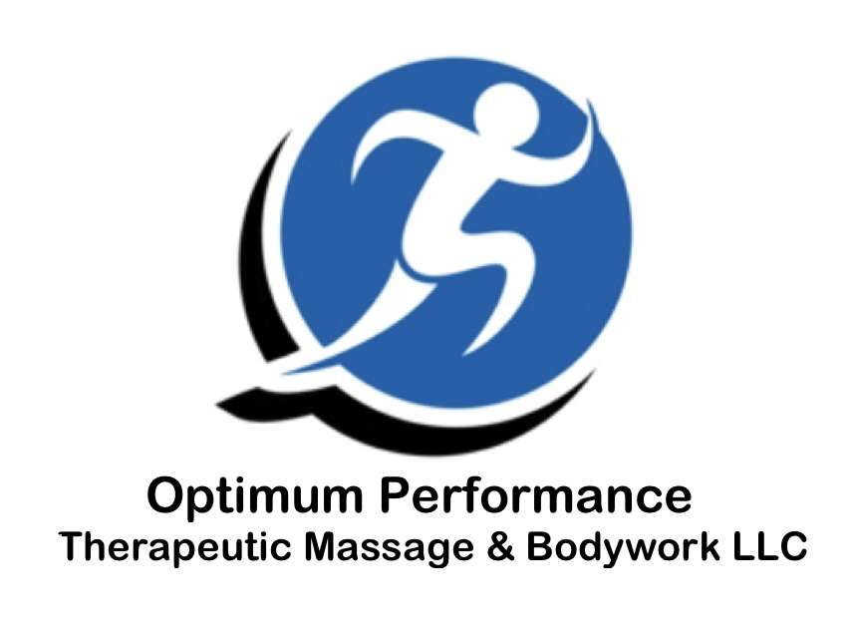
"I understand that the massage given to me by Optimum Performance Therapeutic Massage & Bodywork LLC, is for the purpose of (stress reduction, pain reduction, relief from muscle tension, increasing circulation, or specific reasons stated here).

I understand the massage therapist does not diagnose illness or disease and does not prescribe medical treatment or pharmaceuticals, nor are spinal manipulations part of massage therapy.

I understand that massage therapy is not a substitute for medical care and that it is recommended that I work with my primary caregiver for any condition I may have.

I have stated all my known physical conditions and medications, and I will keep the massage therapist updated on any changes."

***COVID-19 (Coronavirus)***

“I understand that close contact with people increases the risk of infection from COVID-19. By signing this form, I acknowledge that I am aware of the risks involved and give consent to receive massage from this practitioner.”

“I understand that my name and contact information might be shared with the state health department in the event that a client or practitioner at this facility tests positive for COVID-19. My contact details will only be shared in the event they are relevant based on suspected exposure date, and only for appropriate follow-up by the health department.”

“I understand I am required to bring and wear a mask or cloth face covering that completely cover the nose and mouth unless doing so would be contrary to his or her health or safety due to a medical condition.

Client Signature:________________________________________Date____________________

