The Benefits of Donating Appreciated Securities to EDTC
Gifting appreciated securities is one of your most effective means of tax savings. Also, your charitable dollars to EDTC will go further and make even more of a difference.
Know your money is invested in a cause important to you. Avoid capital gains taxes on the stock. Receive a charitable income tax deduction for the fair market value of stock at the time of the gift. Contact your legal, tax and/or financial advisors today!
See How a $10,000 Gift in Appreciated Securities to EDTC Benefits You
The table below illustrates the tax savings from donating securities originally purchased for $2,000 that are now worth $10,000, as compared to making a cash gift of $10,000.
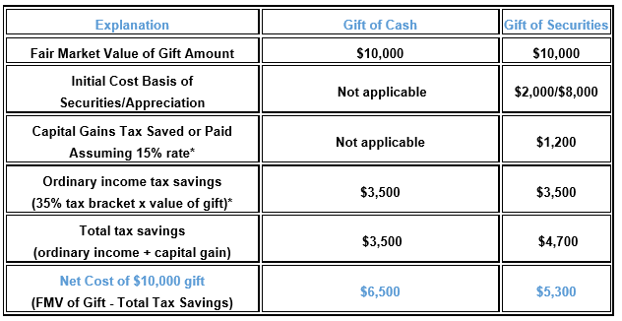
In order to be eligible for the tax savings, the stock must have been held by you for at least one year and must be transferred to EDTC’s account prior to being sold in order to avoid capital gains taxation. Your financial advisor can arrange for a gift of stock directly from your account to EDTC. If you plan on donating stock in certificate form prior to year-end, please have the mailing postmarked by December 31. The illustration used is for educational purposes only. EDTC does not provide tax advice. A different tax rate may apply to you and, accordingly, the charitable benefit you receive may vary. Please consult with your own legal, tax and/or financial advisors to determine your specific situation. Contact information: Don Haynes, Treasurer of EDTC 989-450-3430 or edtctreasury@gmail.com to provide stock transfer instructions and for any other assistance we can give to help make this an easy transaction for you. Thank you for your support!
Ebenezer DTC
PO Box 473
Hudsonville, MI 49426

