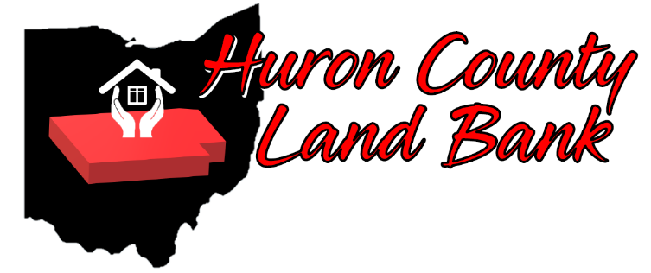
Huron County Administration Building
180 Milan Avenue
Norwalk, Ohio 44857
419-663-4232
www.HuronCountyLandBank.com

APPLICATION TO ACQUIRE PROPERTY

Application will NOT be processed if not completed in its entirety. *
Applicant Information

Name of Applicant(s): Mailing Address: City / State: Zip:
Phone: Alternate Phone:

Email:

Address of property requested:

Parcel No(S).: ______________________________________________________________

Willing to Pay The Asking Price : YES _______ NO ________

If No, what price are you willing to offer? ________________________________________________

Please check all that apply:

- This property is next to the property that I own and will be used for a side lot.

- This property is next to an investment property that I own, and property will be used for a side lot.

- This property is next to the business that I own, and property will be used for a side lot.

- Property requested is vacant with no structure(s) on the site.

- Property requested has structure(s) to be demolished and seeded prior to transfer at the cost of purchaser.

- Property requested has structure(s) on site that DOES (DO NOT) require demolition prior to transfer.

- If the property is to be rehabbed, I agree to bring the structure up to code.

- Neither I nor a family member has owned or used this property as a personal residence at any time during the past twelve (12) months.

- I have been a rental tenant of required property during the past twelve (12) months.

- I have no un-remediated code or ordinance violations on any property I owned by any name within Huron County.

- I have no delinquent property taxes in Huron County.

- I have a property tax payment plan and have made at least six (6) consecutive payments.

- I have never had any tax foreclosures under any name within Huron County,

- I agree to pay future property taxes and/or assessments on this property if I am given ownership.

- I own properties in Huron County under the following names (i.e. Corporation Names, Business Names, Maiden Names, etc.) ____________________________________
Please describe the plan of use for the requested property:

If a vacant lot:
- Side Yard
- Garden
- Parking
- Green Space
- Construction of ___________
- Other ______________

If an existing structure:
- Rehab/owner-occupied
- Rehab/rental
- Rehab/resell
- Demolition
- Deconstruction
- Other For Profit Use: ______________
- Other Not-for-Profit Use: _________________

Does the intended use of this property comply with local zoning codes? Yes No

SIGNATURE: To the best of my knowledge, the information provided in this application is true and in compliance with HCLRC Policies and Procedures. I understand that HCLRC staff will review this request and confirm that it is in compliance with these Policies and Procedures, as well as existing HCLRC and neighborhood plans. I also understand that this form is a statement of interest only. Submitting it does NOT commit HCLRC to transfer property.

The Land Bank makes no representation regarding any Federal lien, assessment or claim of any kind and each prospective Buyer is urged to consult with a title company or other title advisor. DO NOT SEND MONEY WITH THE APPLICATION. FIFTY PERCENT (50%) OF PURCHASE PRICE (DEPOSIT) IS DUE WHEN PURCHASE AGREEMENT IS SIGNED AND BALANCE DUE AT CLOSING AFTER COMPLETION OF RENOVATION OR DEMOLITION AS SPECIFIED IN THE PURCHASE AGREEMENT. Buyer will forfeit deposit if Buyer does not close within 60 days from date Land Bank notifies Buyer that closing documents are ready for Buyer’s signature.

Applicant will be called and/or emailed with actual price prior to entering into a purchase agreement. Applicant has the right to withdraw application after receiving the actual selling price.

Signature of Applicant: _______________________________ Date: _____________

Signature of Co-Applicant: _______________________________ Date: _____________

Witness: _______________________________ Date: _____________

You will be given a quit claim deed with purchase after completion of renovation or demolition.
All properties are sold AS IS.

Please submit this completed application to:

Huron County Land Reutilization Corporation
180 Milan Avenue
Norwalk, Ohio 44857
Email: HuronCountyLandBank@gmail.com

Revised 05/27/2020

