Guideline for Design Development of Ball Grid or Column Grid Arrays with Pad Pitch of .5 mm or less.

In most cases, if a BGA (Ball Grid Array) exists on your design, the escape requirement for the device will usually determine the stack-up needed for the design. Most large pin-count arrays are either 1.27mm, 1.0mm, or 0.8mm ball pitch that allows traces between pads. When you encounter an MBGA with a pad pitch of .65mm, .5mm or .4mm, traces between pads no longer work and a different design/stack-up strategy must be created.
These smaller pad-pitch devices generally have lower pin counts with fewer rows of pads to escape. However, they will require via-in-pad technology since there is no room for dog-boned vias next to each component pad. If pin swapping is allowed on the I/O pins, and especially if all the I/O pins are not used, you can work with the engineer to improve the escape strategy for the part. Your first concern should be any controlled impedance traces, their relationship to their reference plane, and whether you plan to use stripline or micro-strip routing techniques.
At this point, there are some important fabrication reliability and cost considerations to be reviewed. Selecting the fabricator that you wish to use for the board is important at this stage since interface with the fabricator will help to ensure high reliability and lowest cost for the technology, process and stack-up decisions made. For instance, blind via technology will almost certainly be required but whether to use laser micro-vias or mechanically drilled vias must be decided as well as which vias will be through and which will be blind. Another consideration at this stage is whether to use sequential lamination or additive layers (stacked blind vias). These decisions and the costs and reliability associated with them cannot be made without a fabrication partner. Even the small variations in equipment and methodologies from one fabricator to another could dramatically affect your product.
Since a laser drilled blind via should not exceed an aspect ratio of 1:1 (the preferred ratio is only 0.5:1), stacked vias would be required to get to inner layers more than about 6 mils deep (one or two layers). Mechanically drilled vias of 4.7 mils, 5.9 mils and 7.9 mils can be drilled when using sequential lamination. Be sure that the sub-part overall thickness is substantially below 10:1 aspect ratio to achieve good hole wall plating properties.

Now for .4 mm MBGA escape strategies. Use the spreadsheet in Figure 1. as a starting point for ball pad size, via size, and trace and space width to begin configuring a stack-up and your escape strategy.
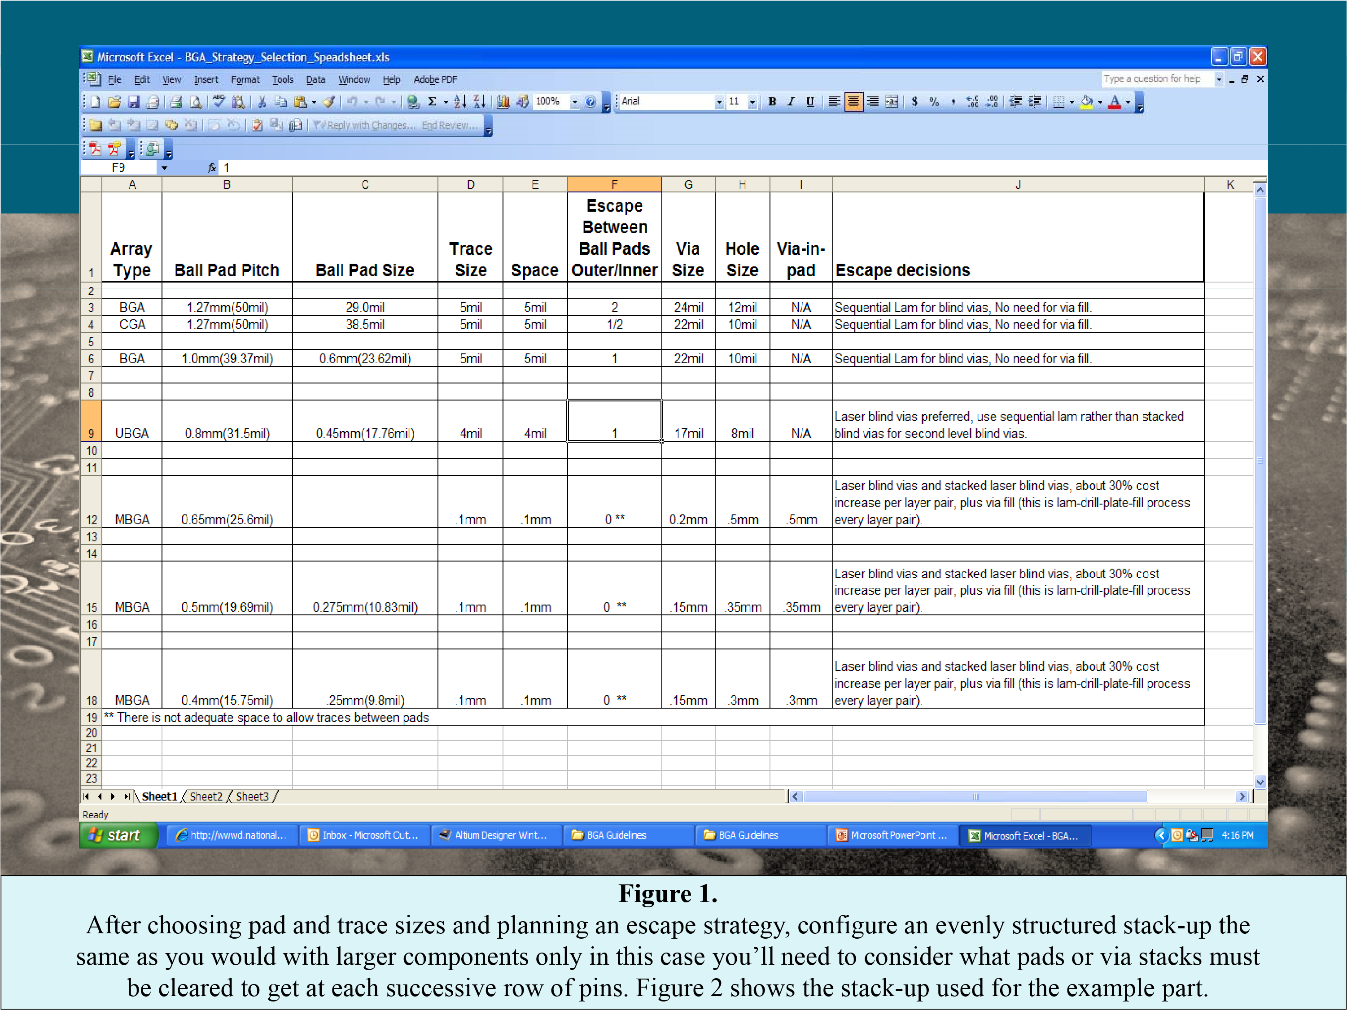
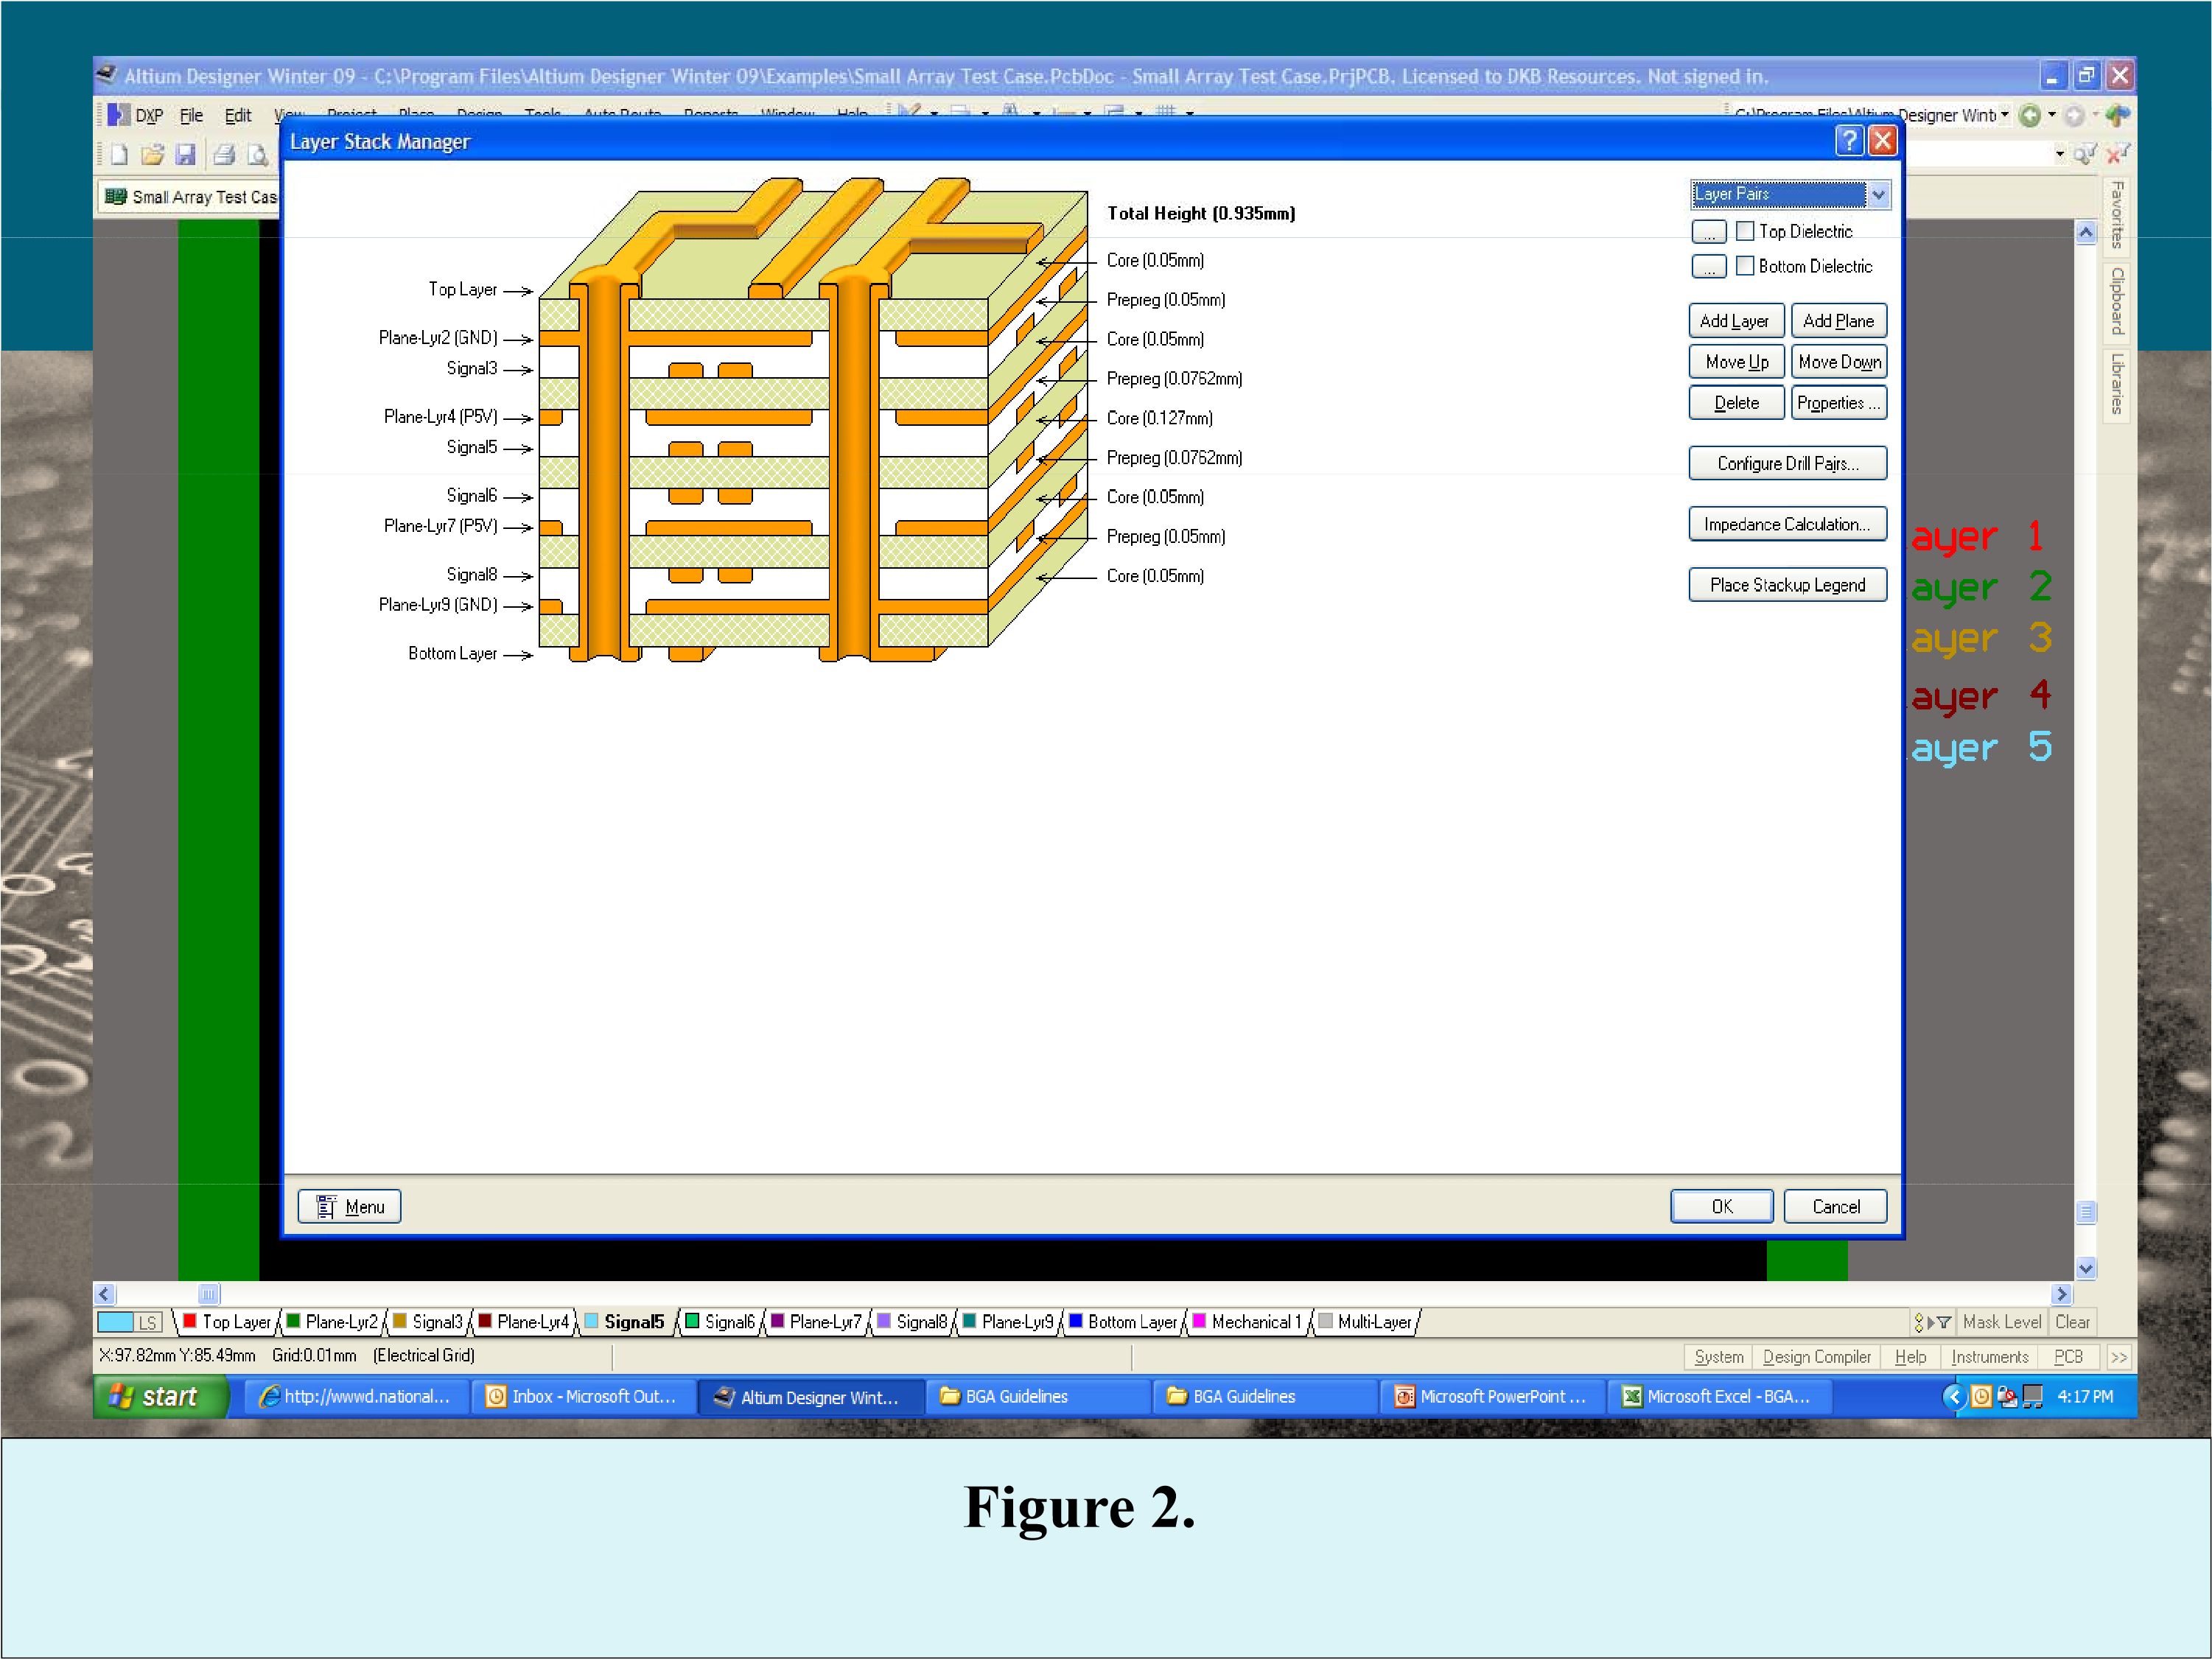

This design is a ten layer stack up using a four layer core composite (all .5 oz copper) and with 3 pairs of additive layers successively added pair by pair to achieve the 1, 2, 3, and 4 deep stacked via sets and then through vias needed for this design. The stacked vias are laser drilled, filled with non-conductive resin and then plated to mate with the next via above. They are called out at .15mm (6mils) allowing the fabricator to use an optimum hole size between .1 and .15mm. The through vias are 6 mil mechanically drilled vias. The overall board thickness must be held to no more than about 1.4mm, an aspect ratio of < 10:1 hole size to maximum board thickness, not nominal thickness.
To create the stacked vias, beginning with the four layer core part, each set of vias must be laser drilled then plated, filled, imaged, and etched, after each successive pair of pre-preg and foil layer pairs is added.
This particular board must go through four press runs, pointing up the need to have even build up of signal and plain layers to reduce and copper distribution to ease stress during the lamination cycles and reduce the possibility of warpage in the finished product.
The example in Figure 3 is a .4mm pad pitch array with 209 pins. This is a fairly large pin count for a .4mm part for today s’ technologies. It should demonstrate most of the issues and problems you might encounter during your own design effort. On this design, the ball pads are .3mm, the traces are .1mm as are the spaces. The vias are also .3mm with a .15mm hole. That includes the through vias.
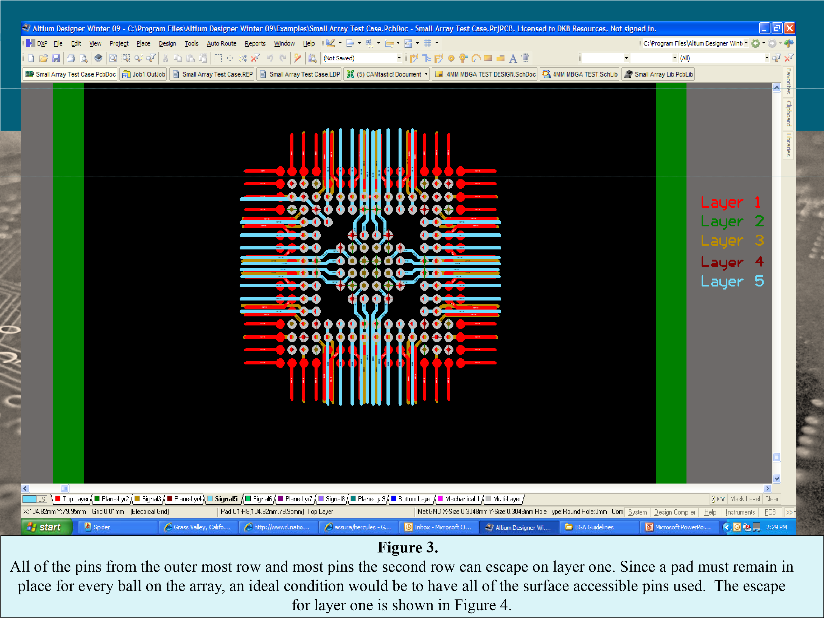
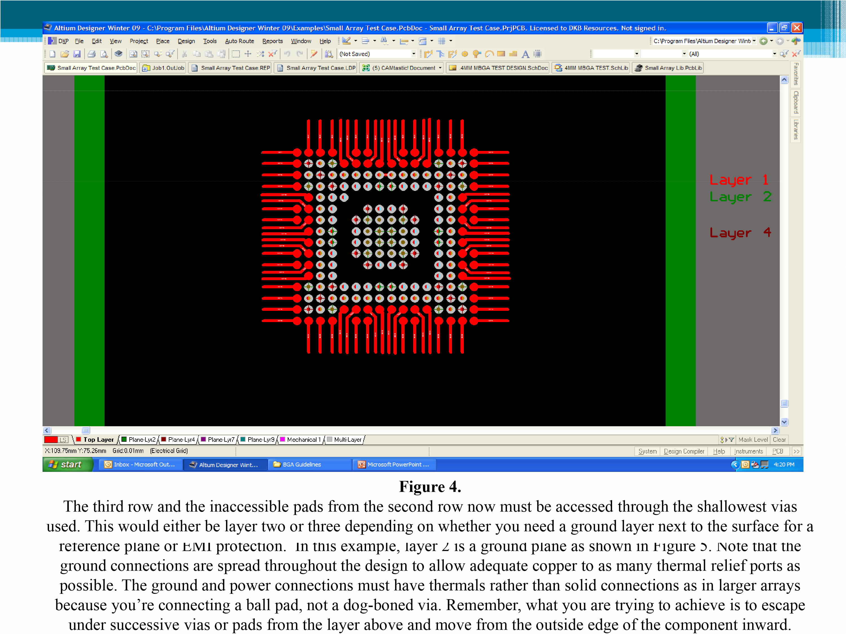
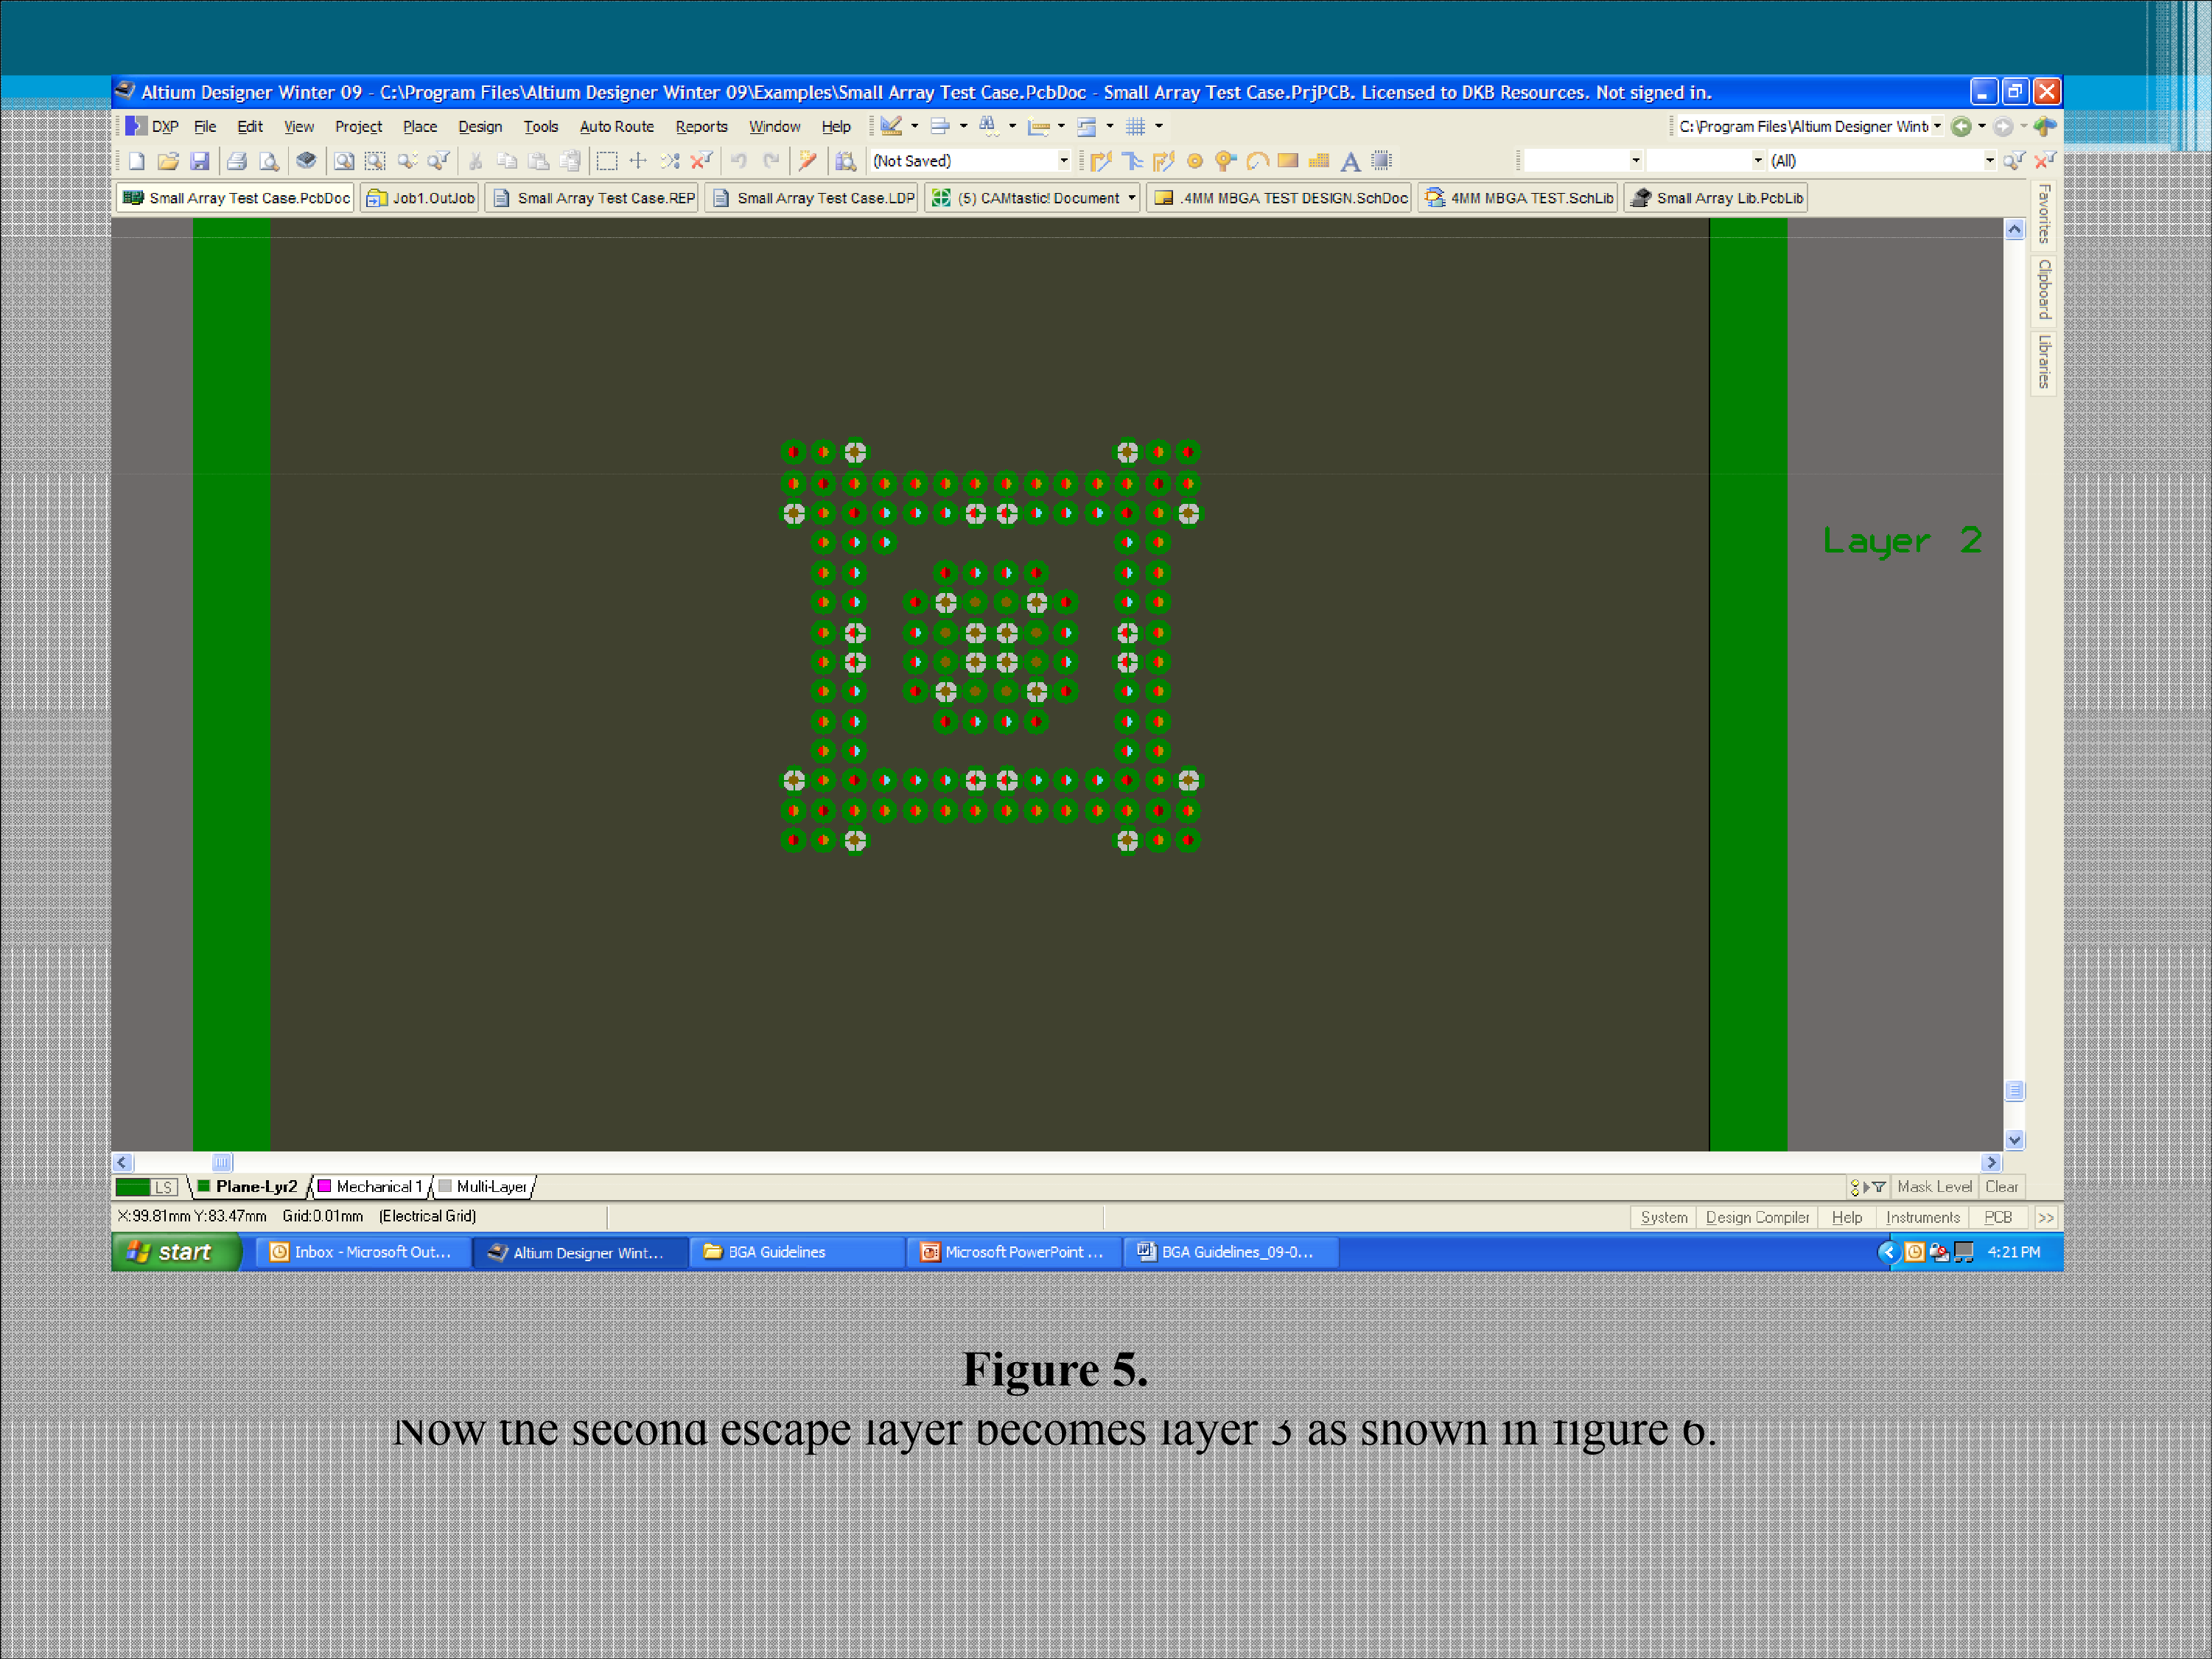
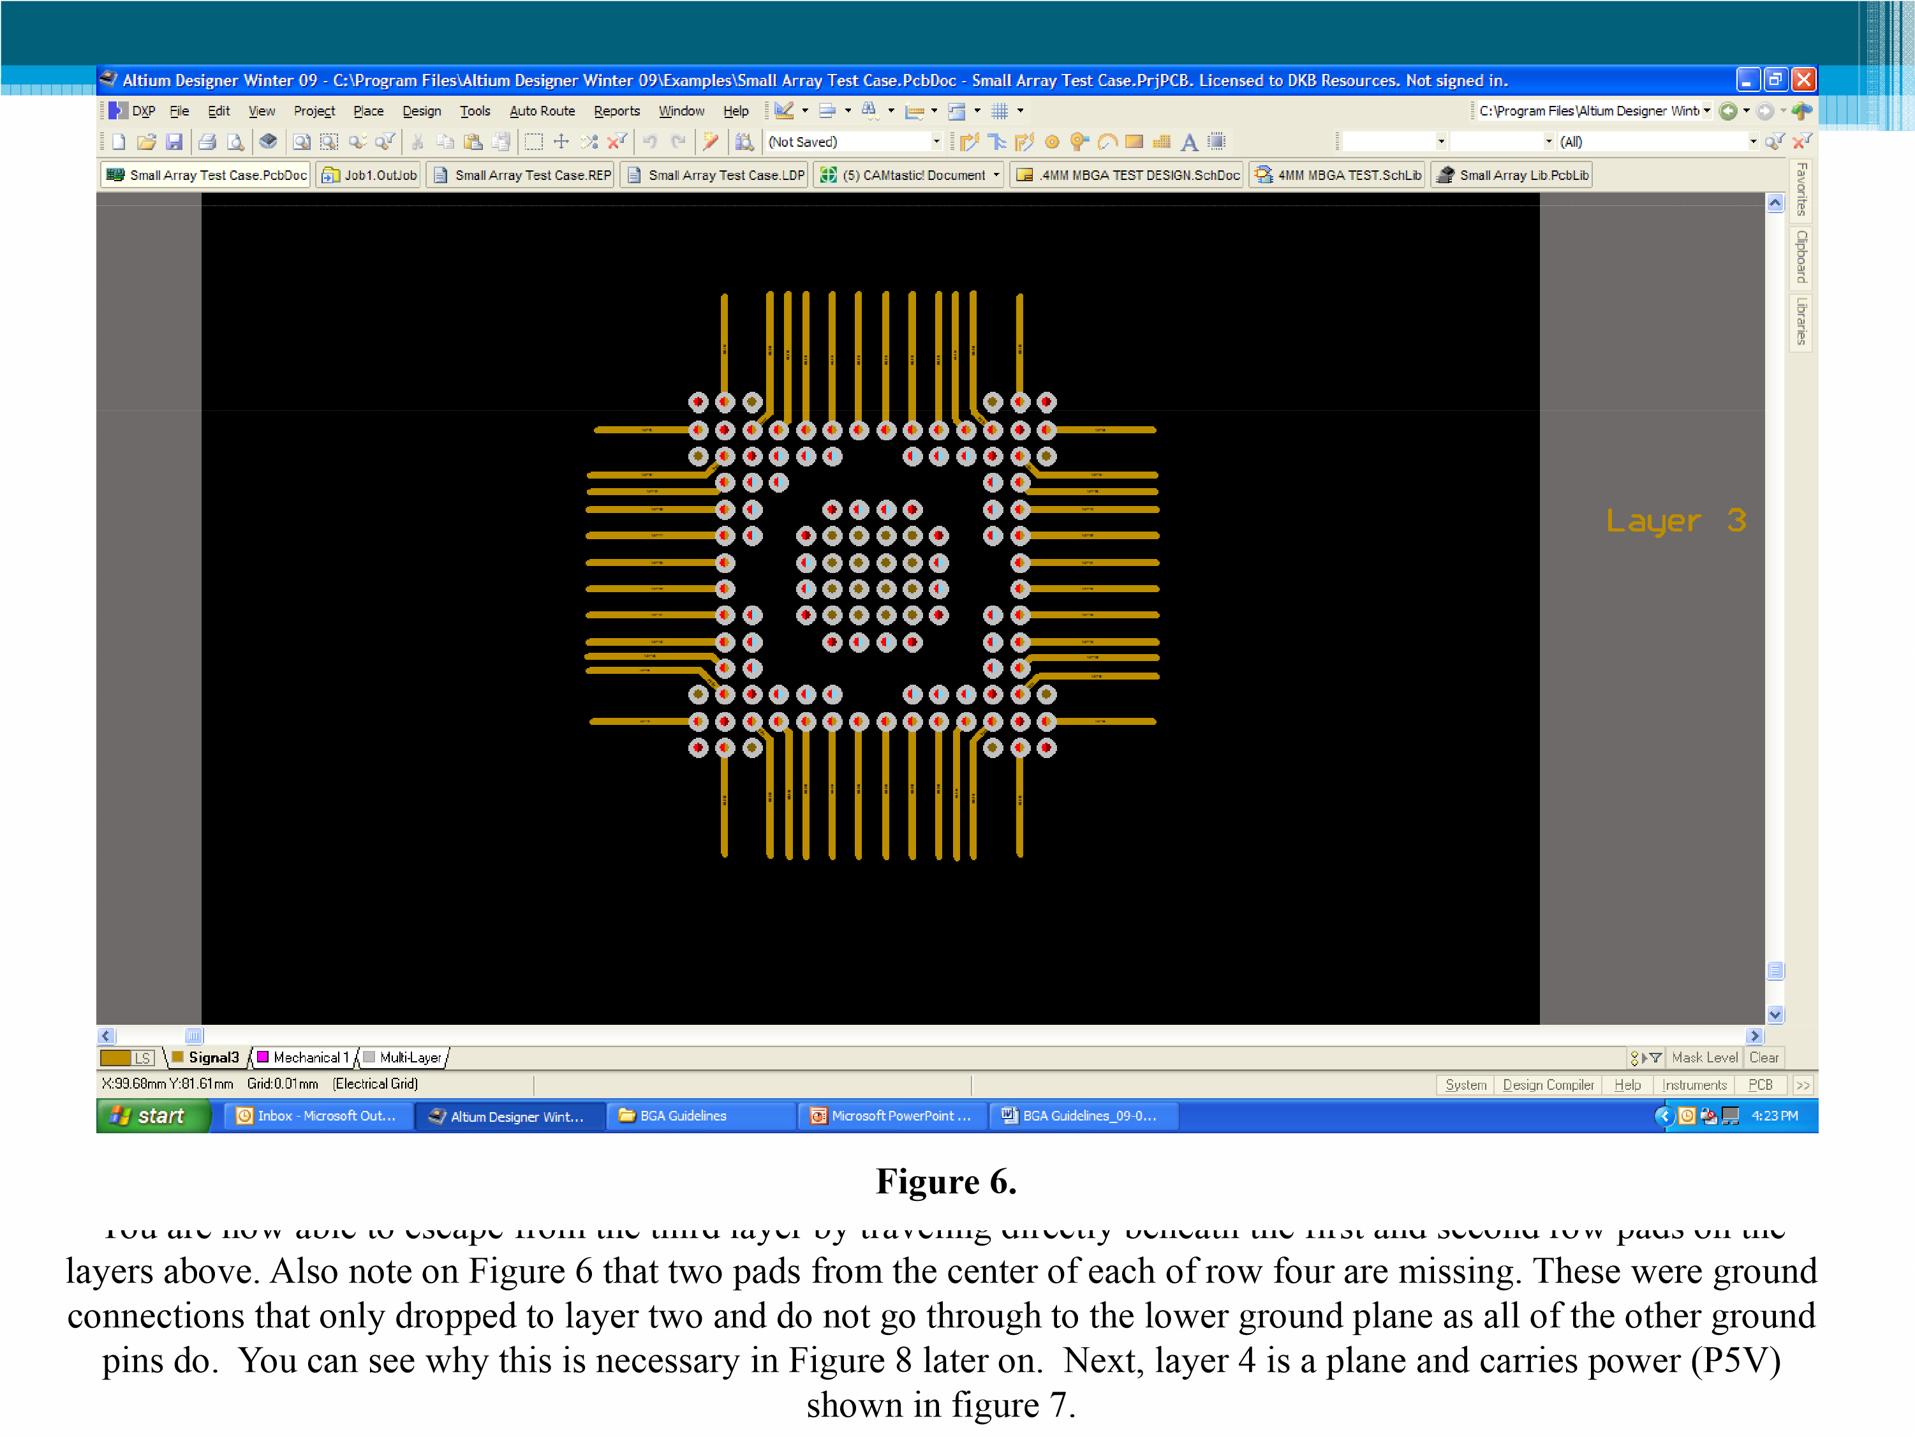
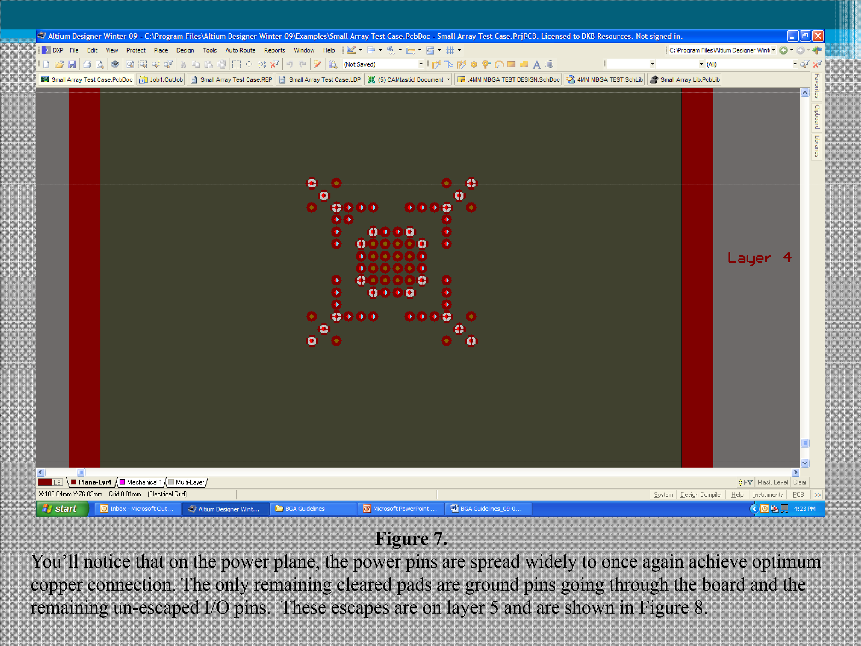
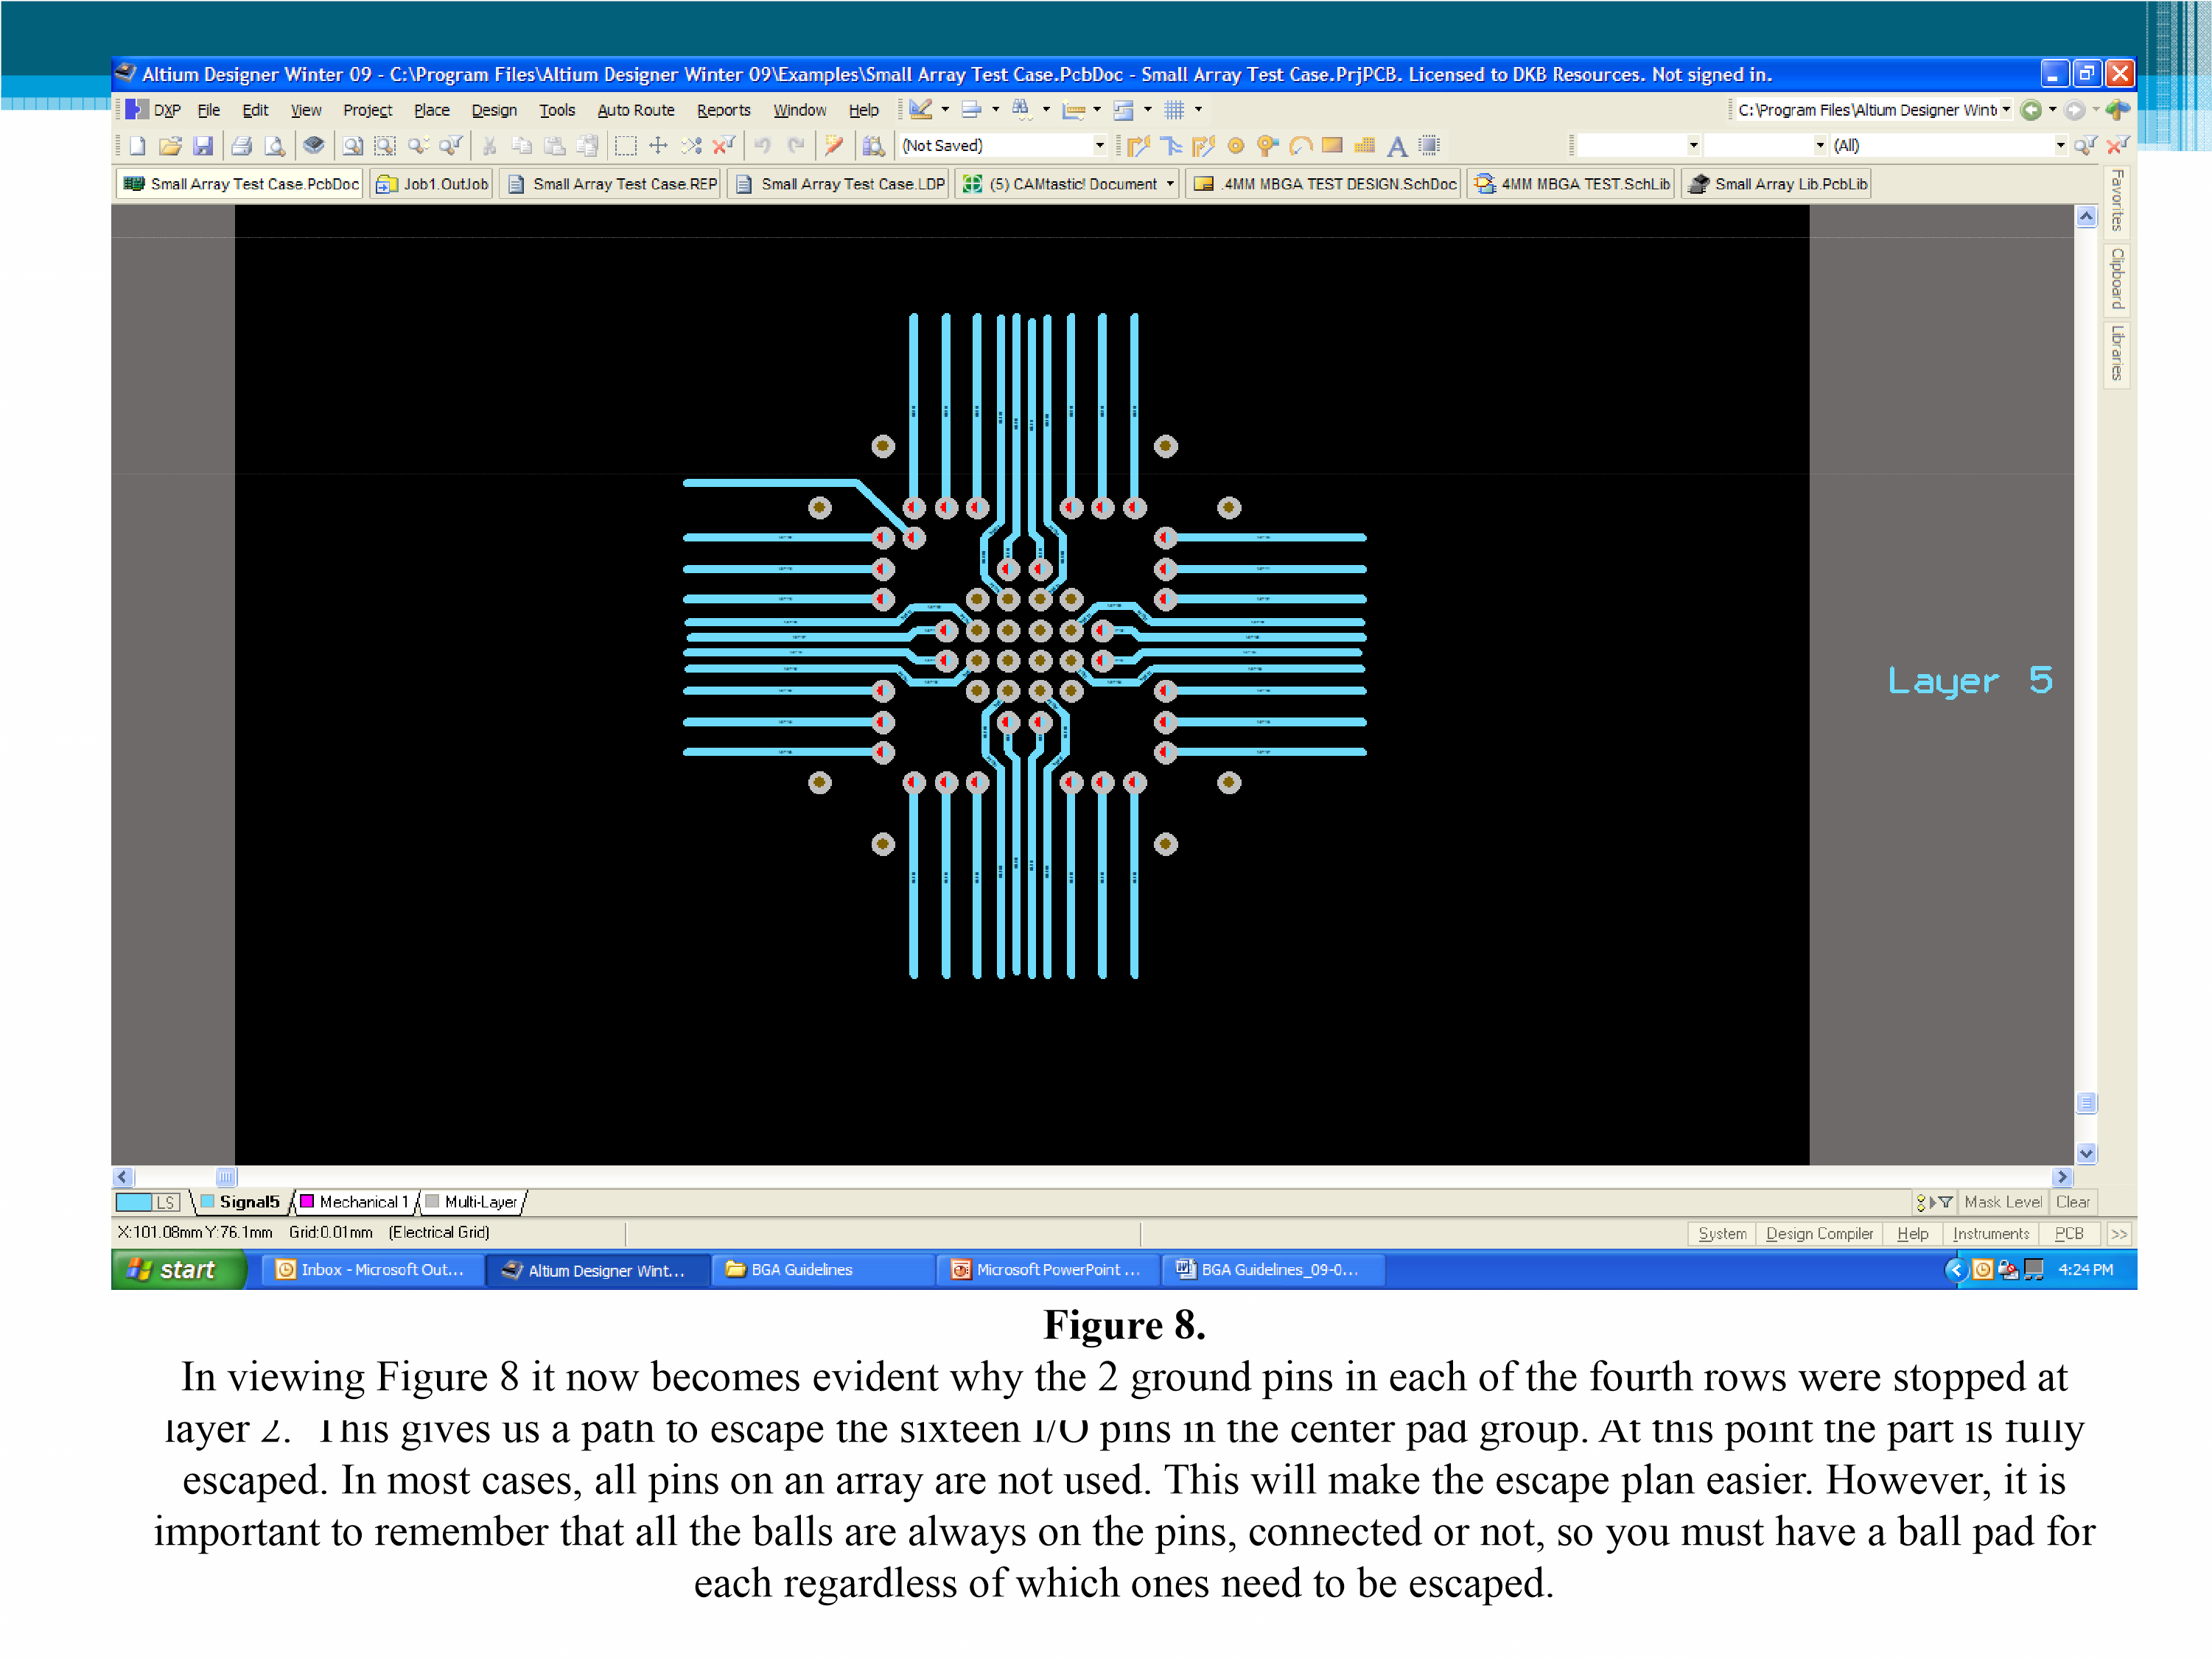

There are two conditions that are of concern when using stacked vias. These items have been mentioned earlier but bear repeating. First, all of the connections for power and ground, if connected to a plane rather than trace, must be thermally relieved on the plane layers. At fabrication, all vias whether through or blind must be filled and plated to receive the array ball. You’re likely to get cold or open connections when the part is soldered if thermal relief is not provided.
Second, the power and ground connections should be alternated rather than next to each other in the pattern. Although there will probably be some restrictions placed on the location of these pins from the array manufacturer and possibly by the engineer as well, it is critical that they are arranged to optimize copper connection as part of your escape strategy from the start.

