E90-92-93
Heads up gauge pod
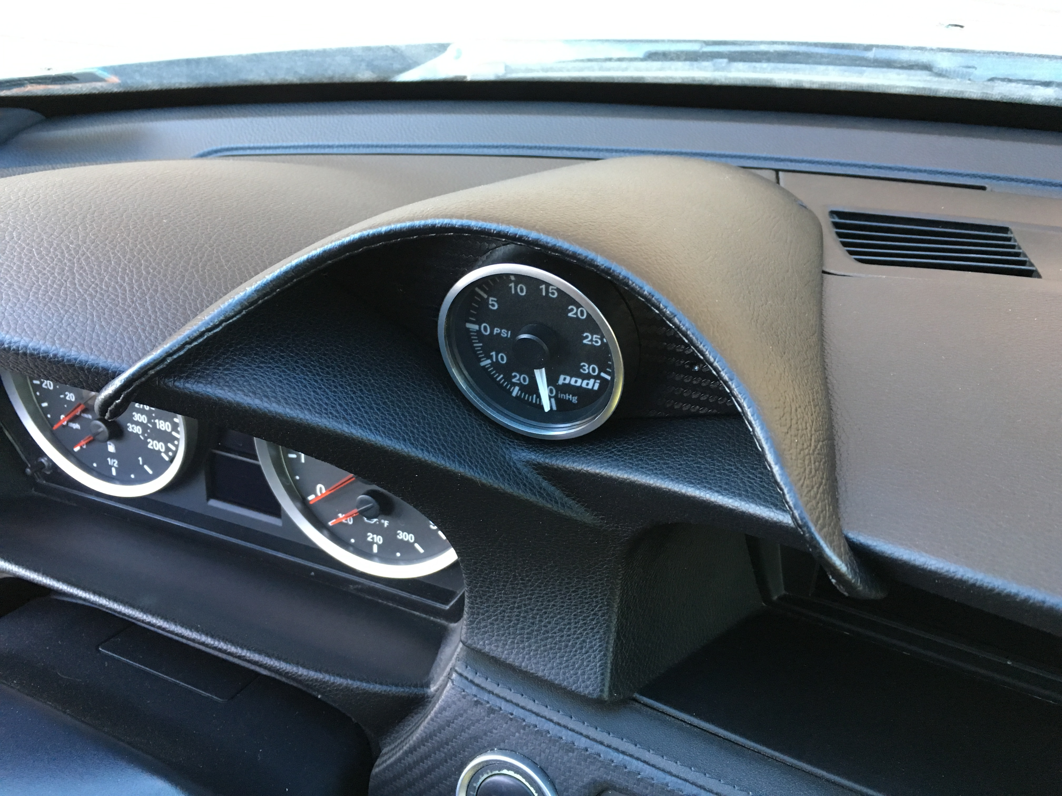
Installation guide

Welcome to you new Podwurx heads up gauge pod! Gauge not included
Make sure that you have what is shown here before you start
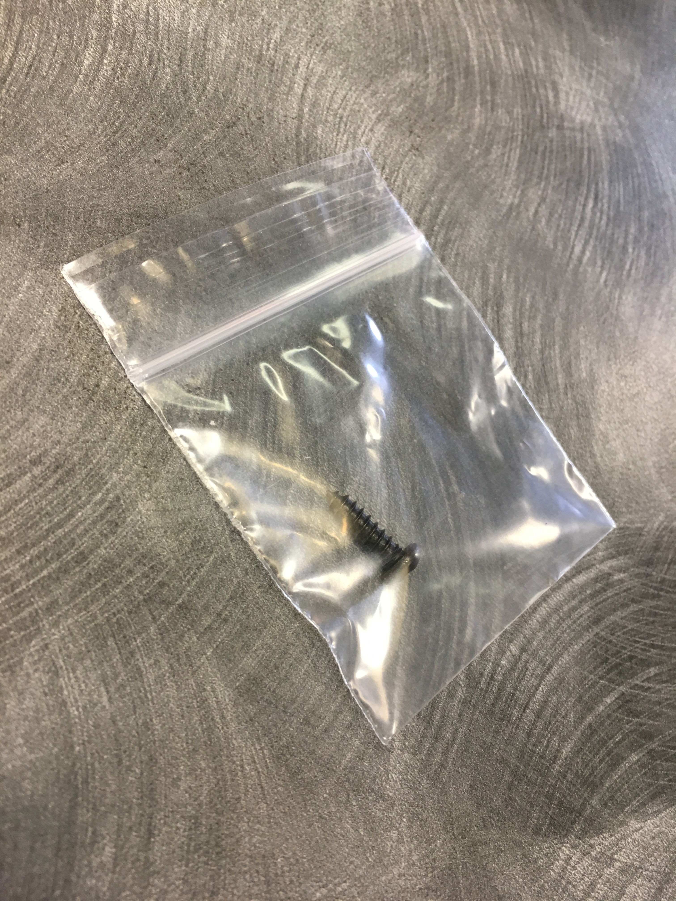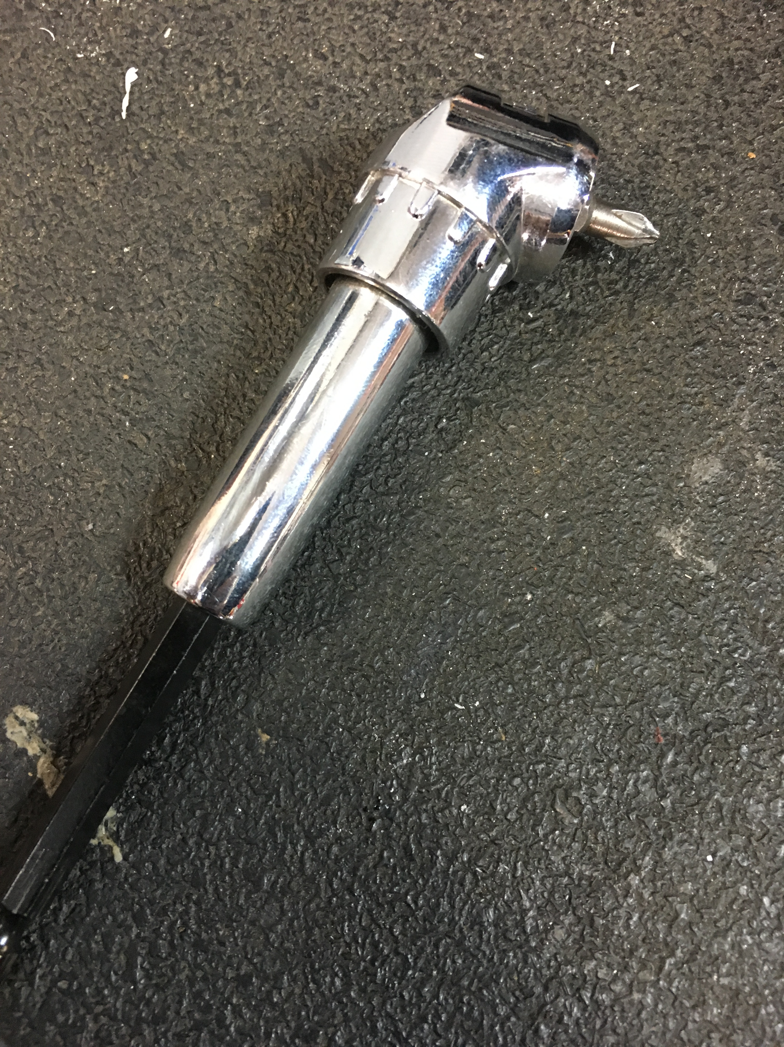

Then start by just putting your new Podwurx pod on to the dash in its future location just to make sure your pod fits the natural contours of your dashboard. 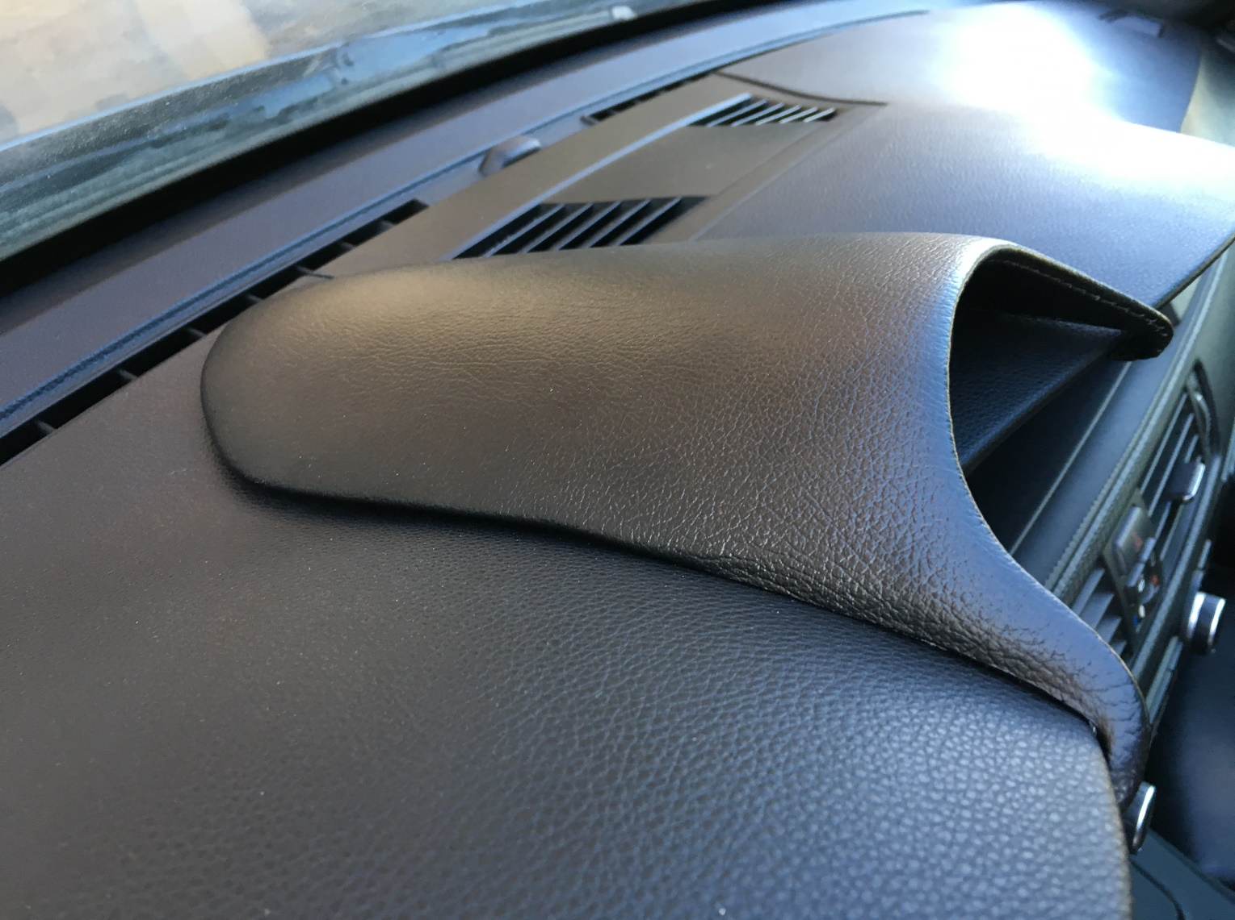

Then remove the center trim popping each clip gently all the way across as to not crack the plastic. Tip: use a plastic trim tool to get it started
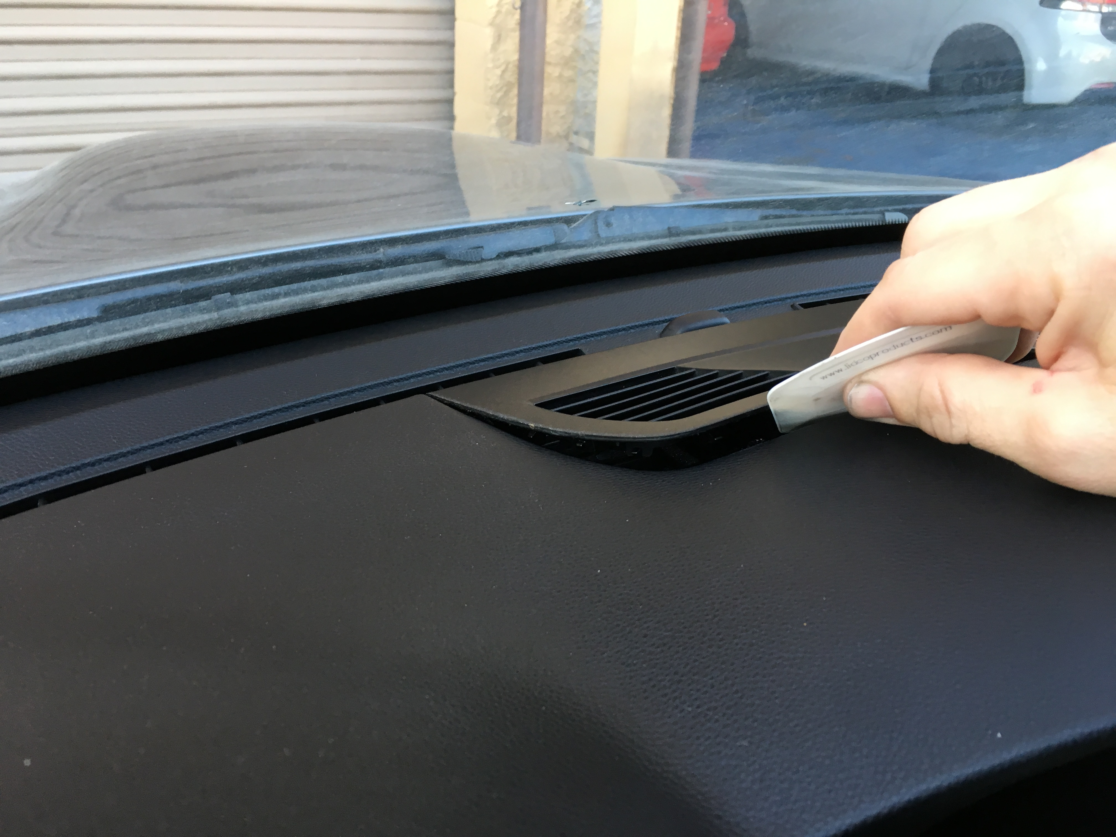

You don’t have to take it all the way out just enough to make room for what wires or lines connect in to your 52mm gauge or controller, this may require cleaning under the trim panel and or clearanceing it to fit the wires/lines.

In our example we just have a few wires. They slip through with
no modification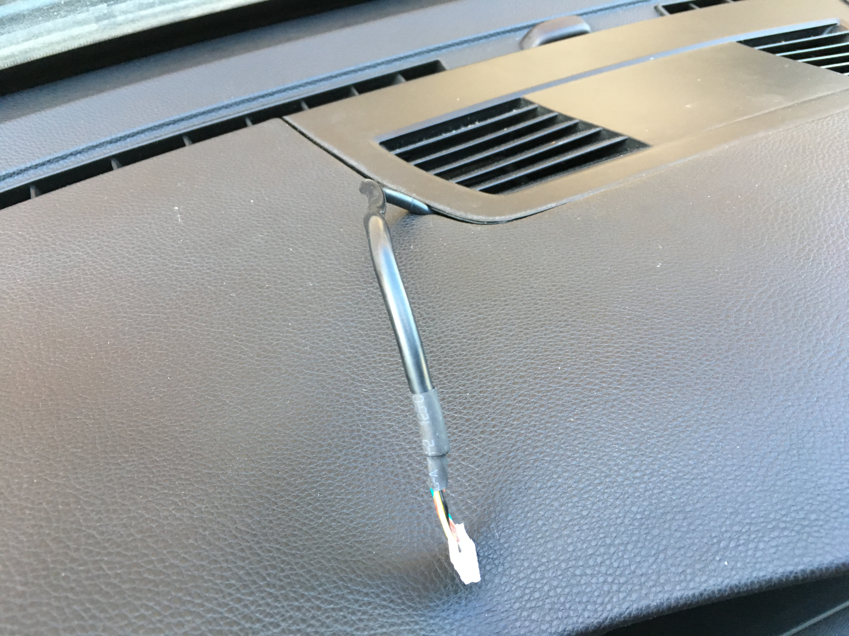
Proceed to set in position your Gauge pod, making sure your wires/lines are hooked up.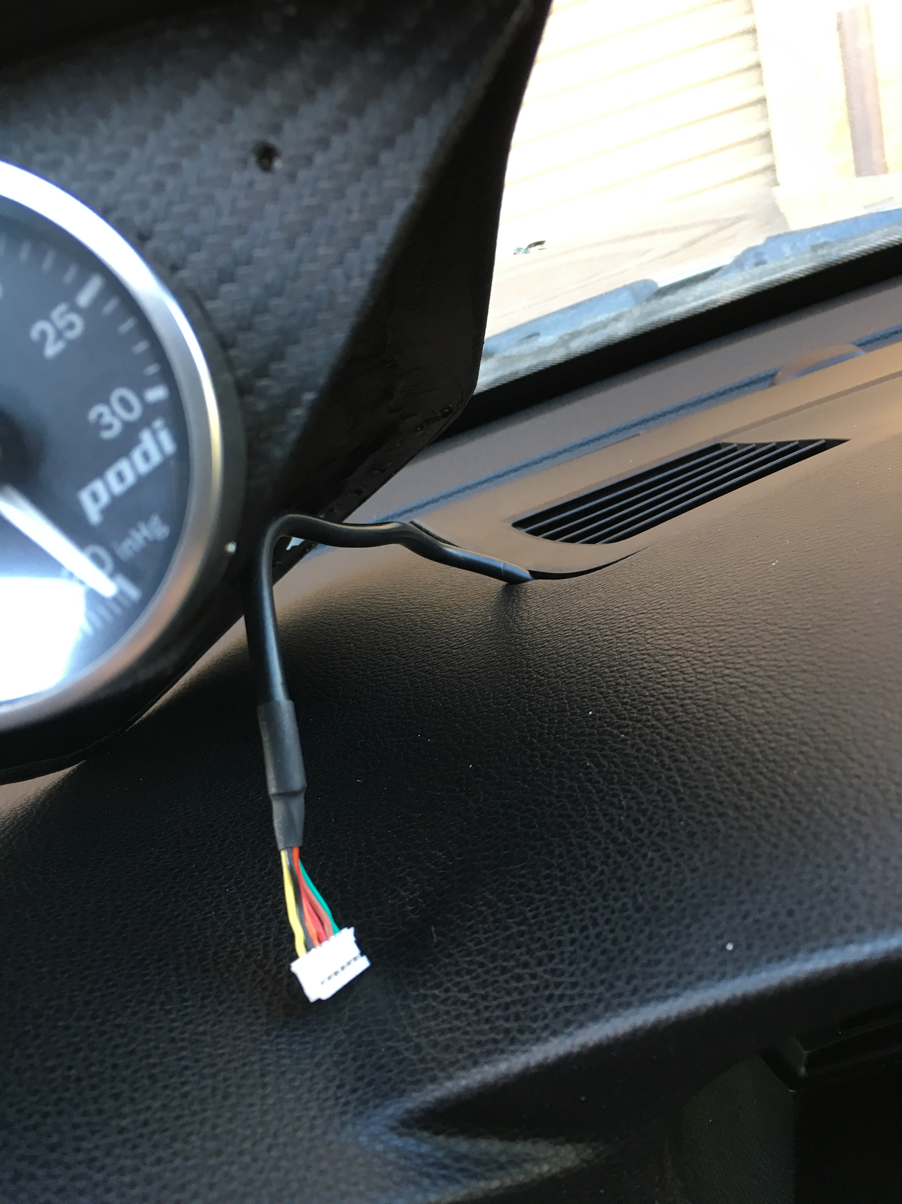

With your gauge installed and tested, finish setting it in its final position.
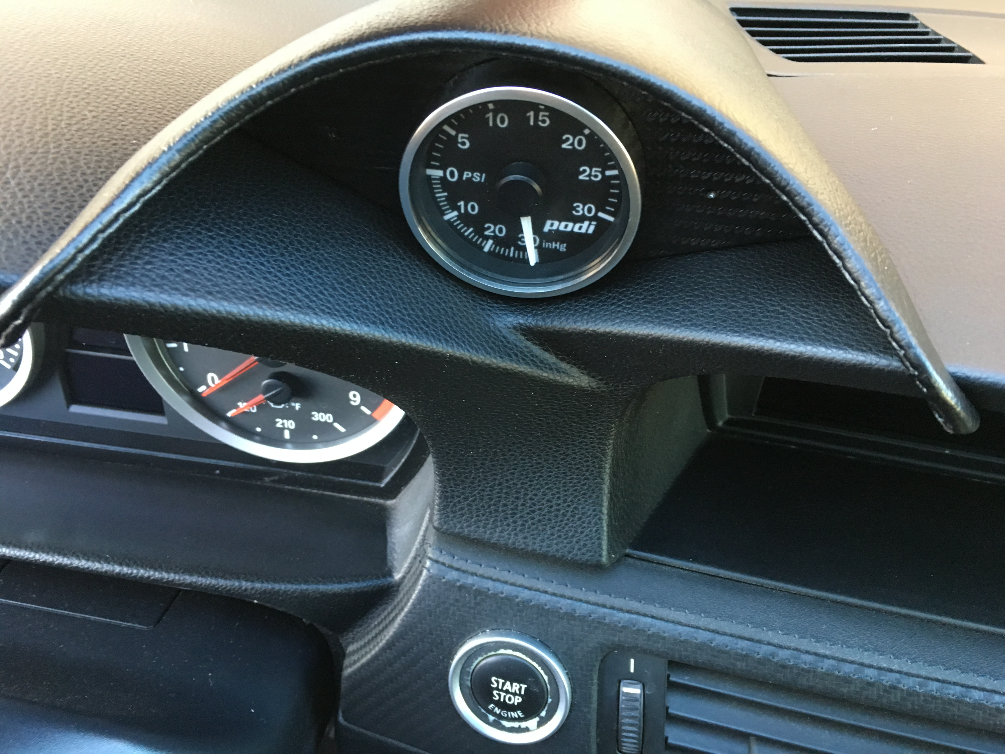

Carefully set the provided black screw in the retaining hole.
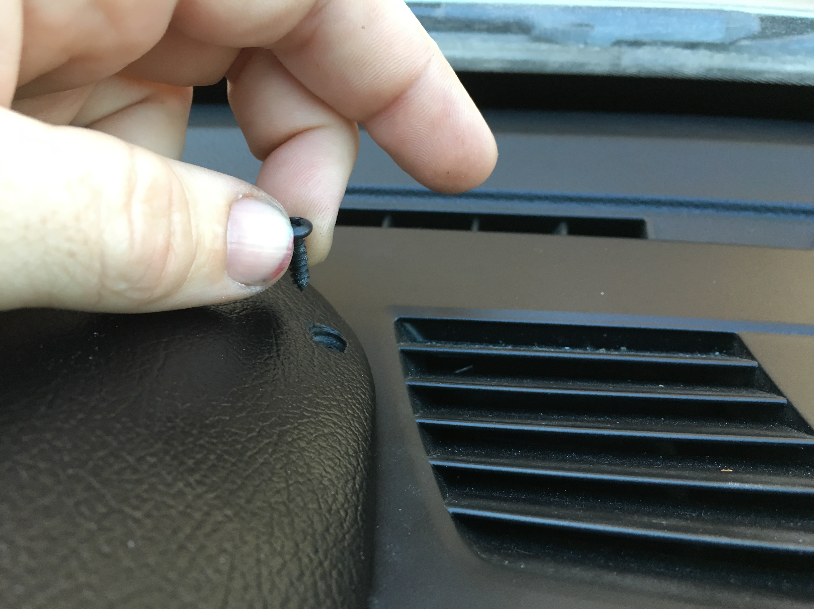

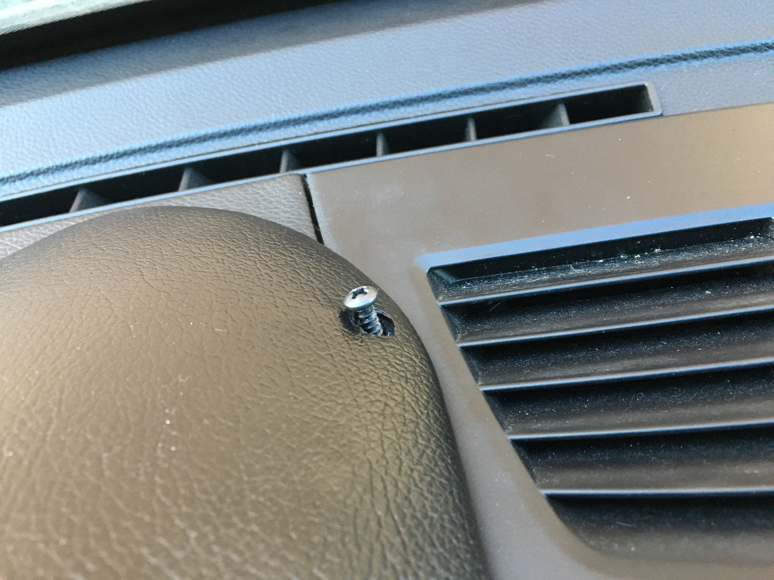

If desired you can make a mark with the point of the screw, set the pod aside and make a
Pilot hole in the edge of the trip panel.
Or
Continue using the Milwaukee Off-Set Screwdriver Power Head
MET-48322100 available at most hardware stores.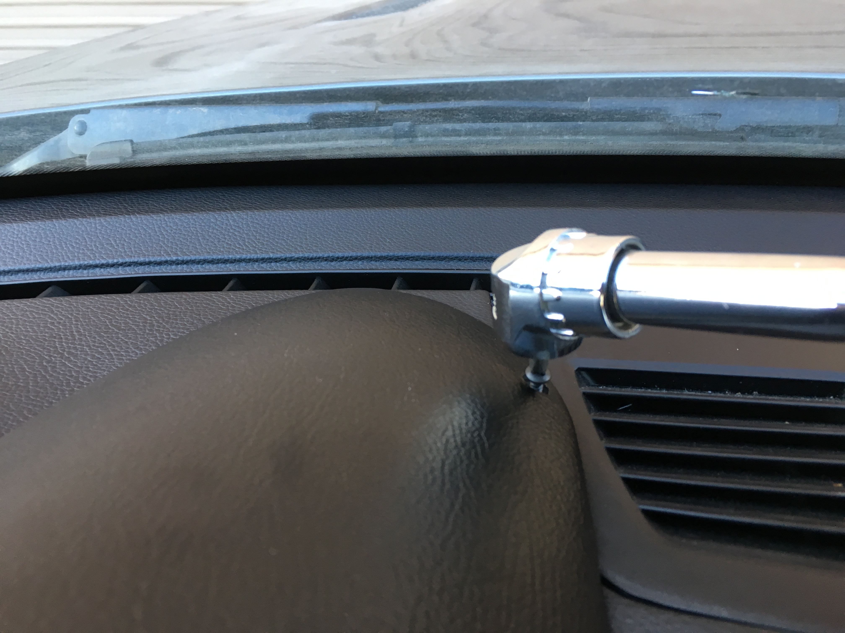

This will complete your installation

