Audi B8-B8.5
Center display pod
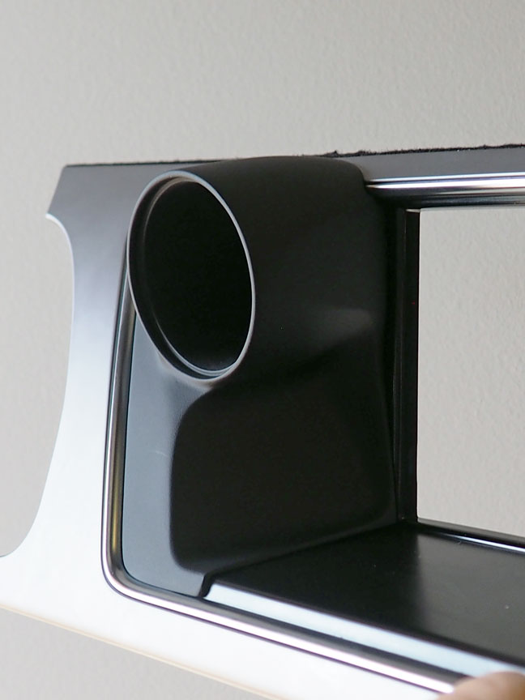
Installation guide

Welcome to you new Podwurx Audi Center display 52mm gauge pod!
Make sure that you have what is shown here before you start
1 pod, 1 alignment tool, 2 screws and one square "O"ring
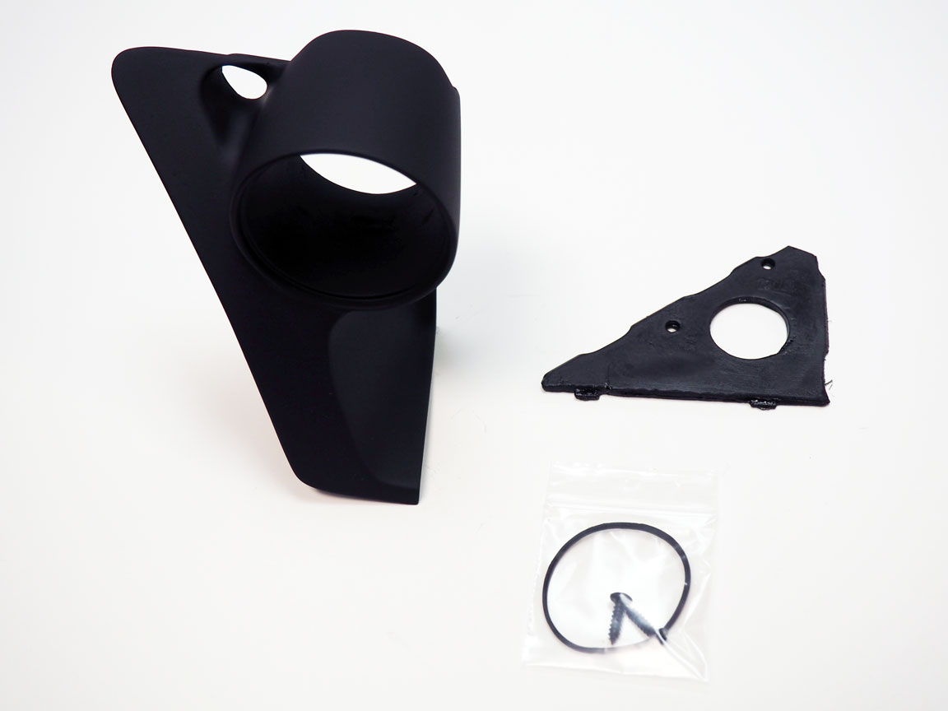

Then start by just putting your new Podwurx pod on to the dash in its future location just to make sure your pod fits the natural contours of your dashboard.

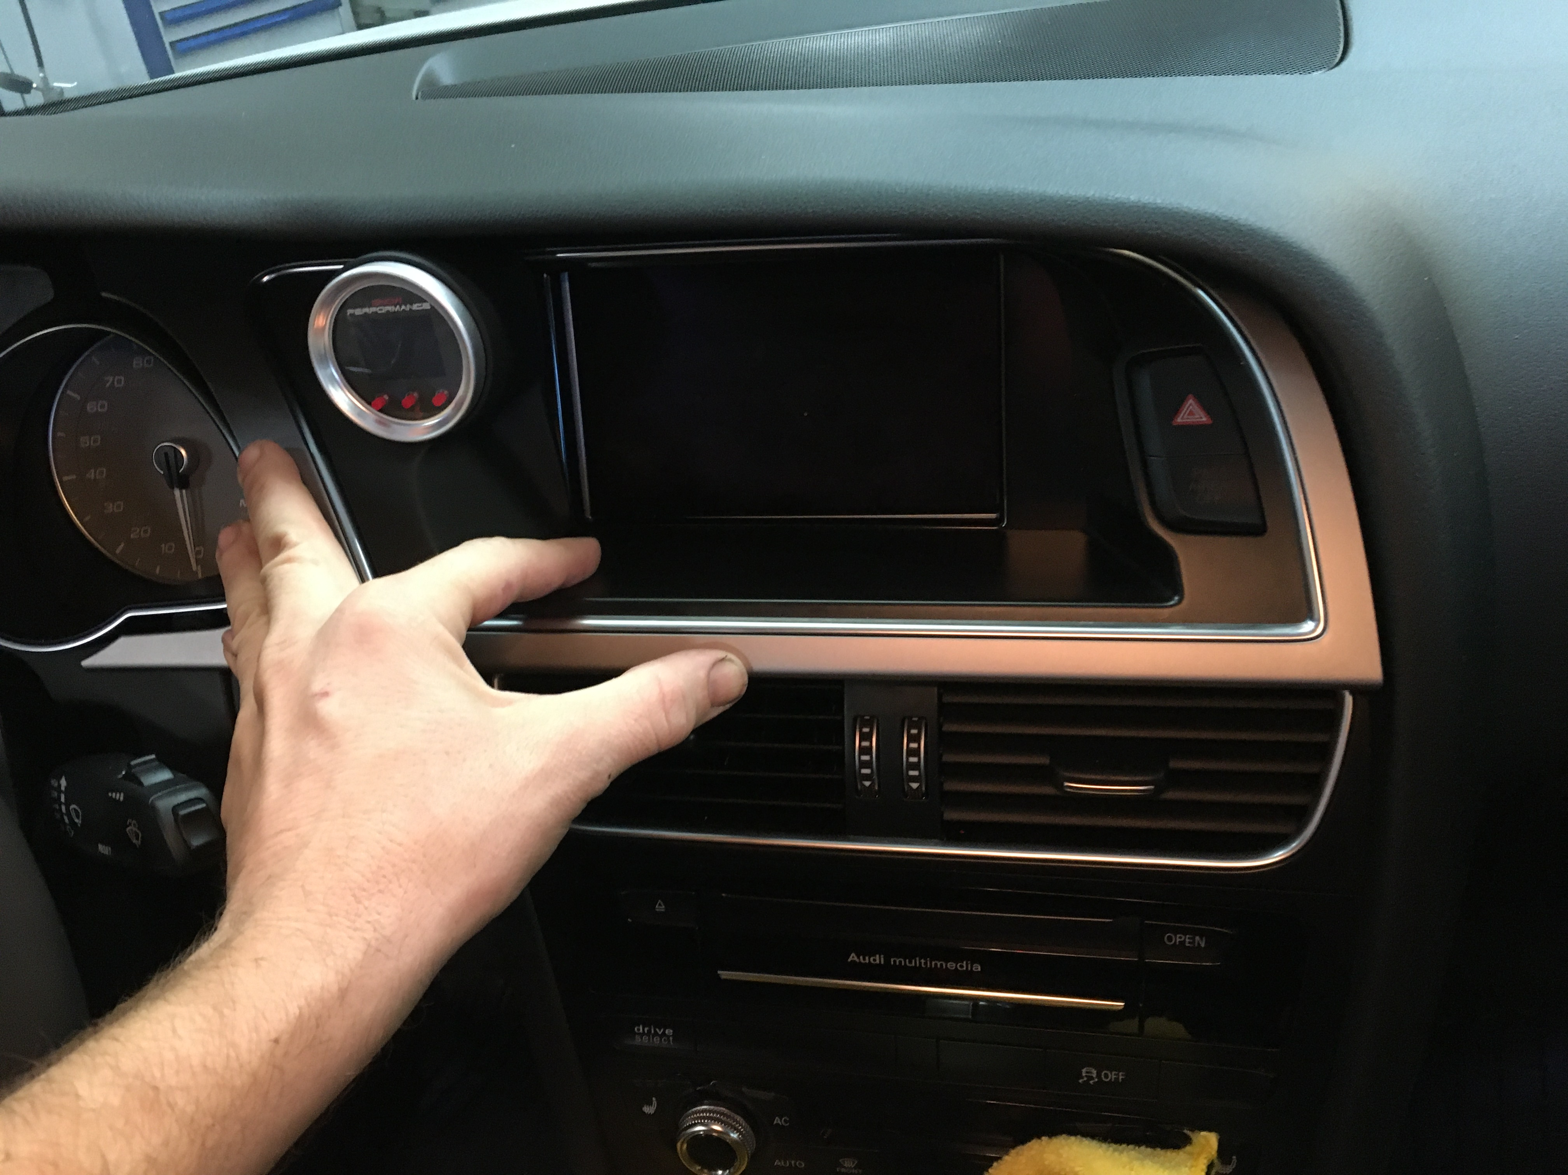

Then remove the center display trim popping each clip gently all the way across as to not crack the plastic
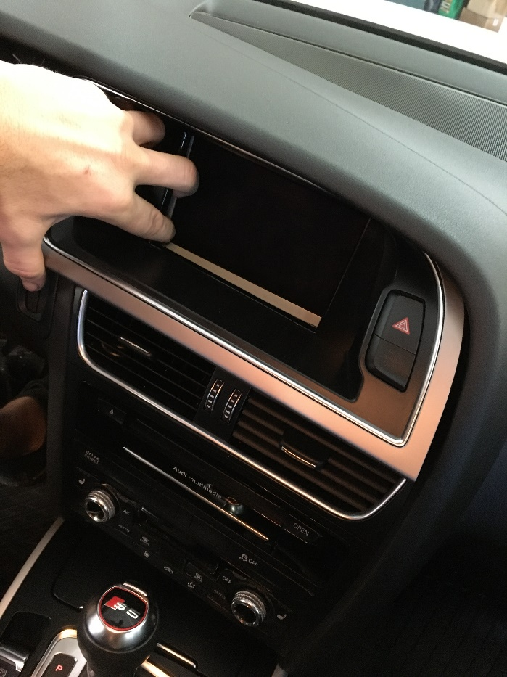
if you are working with a A4 you may have to lower the steering column to remove this bezel.
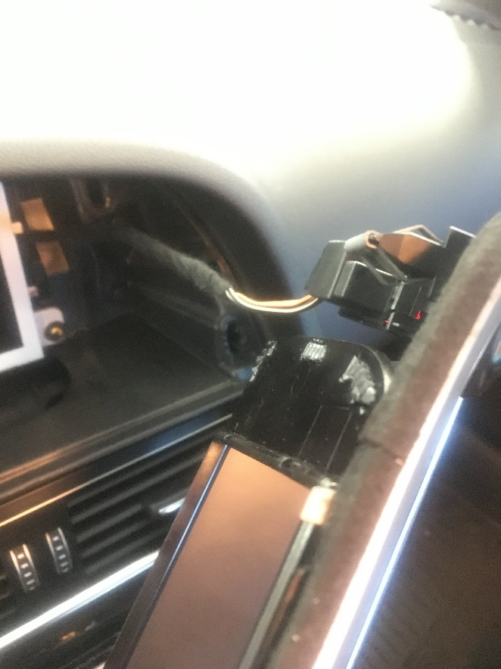Then disconnect the hazard button connector.

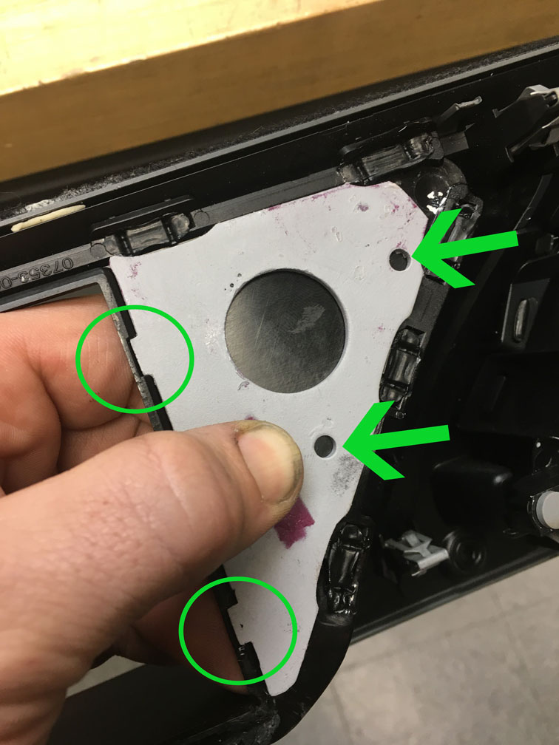
Now with the center display bezel removed use your supplied drill alignment tool and set it in place on the back side as shown. You will see 2 tabs that lock it in place shown in the green circles.
Then you will need to drill 2 small holes as indicated by the green arrows. These holes will later line up with the pods pre drilled screw holes. (NOTE, IF BEING USED ON THE SMALL DISPLAY SCREEN TOOL MAY HAVE TO BE AJUSTED TO THE RIGHT!)
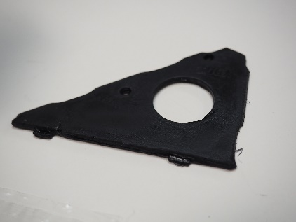TOOL (included)

You will see that the holes now line up with the pod
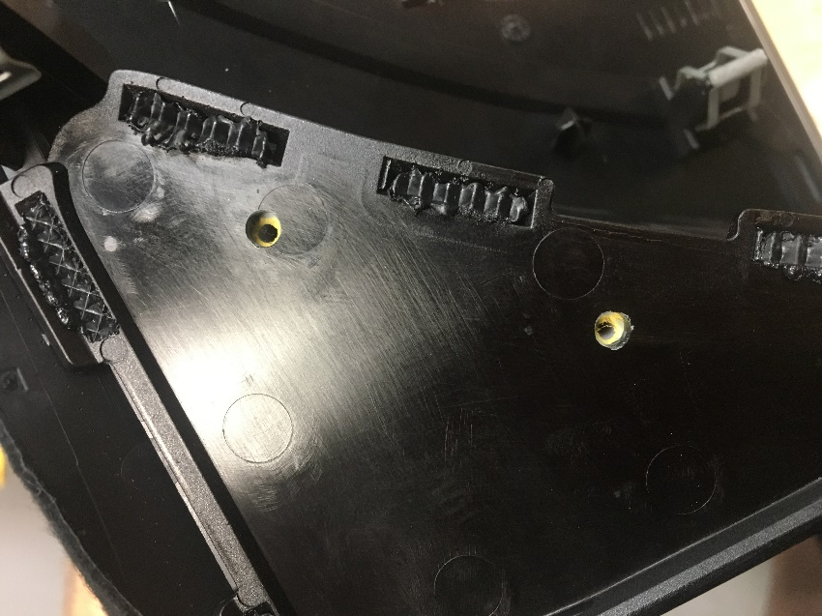
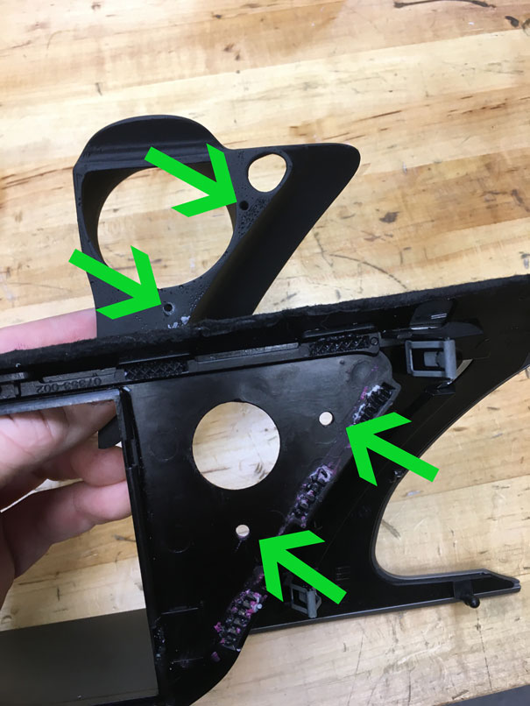

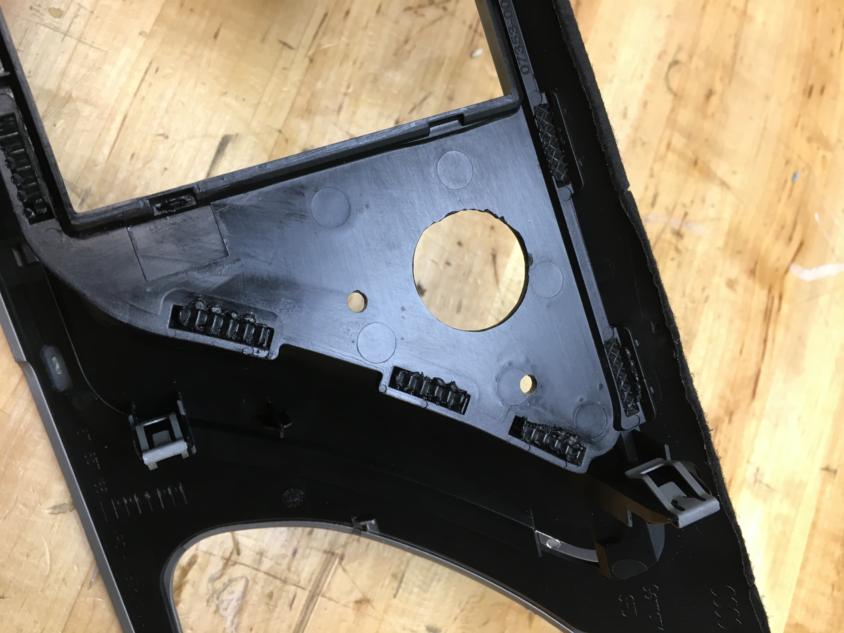
You now have the option to also drill or cut a larger hole to run the conection for your specific gauge or controler. This hole does not have to be made to any specific size. The patern tool is just a good example for most comon gauges wires or conectors to pass though.

For much larger or deaper gauges this hole can be ported out to fit. Or for gauges that have 2 threded studs 2 small holes can be drilled to acomidate mounting.

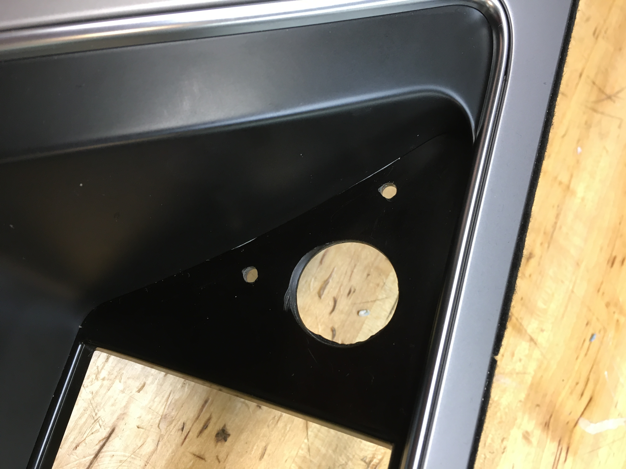

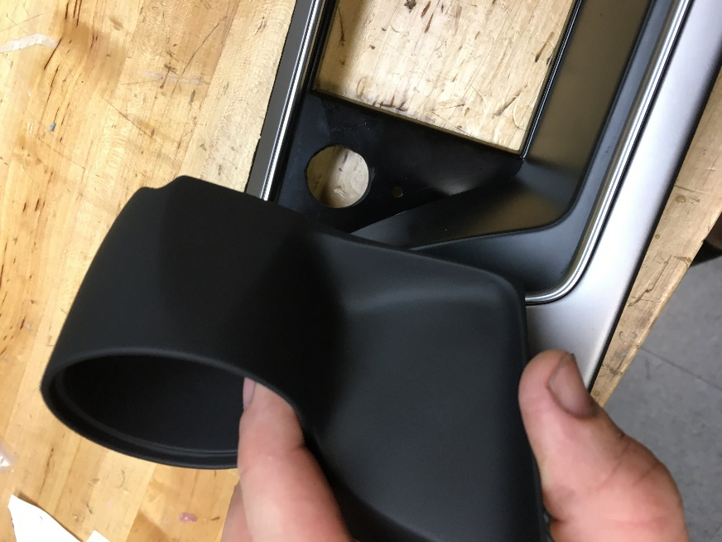
Now that the holes are drilled and the aligment has been
Checked set the pod in place.

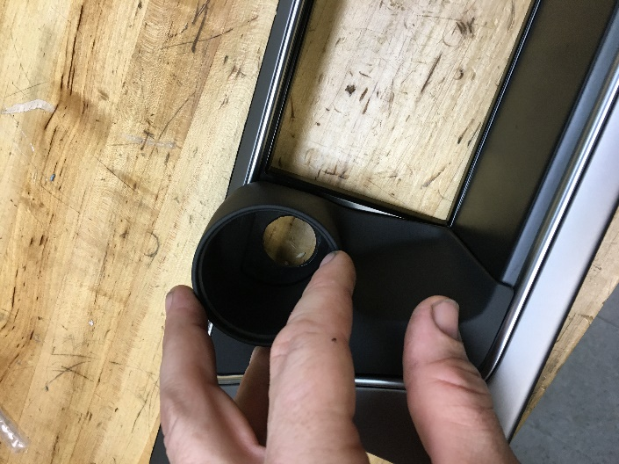
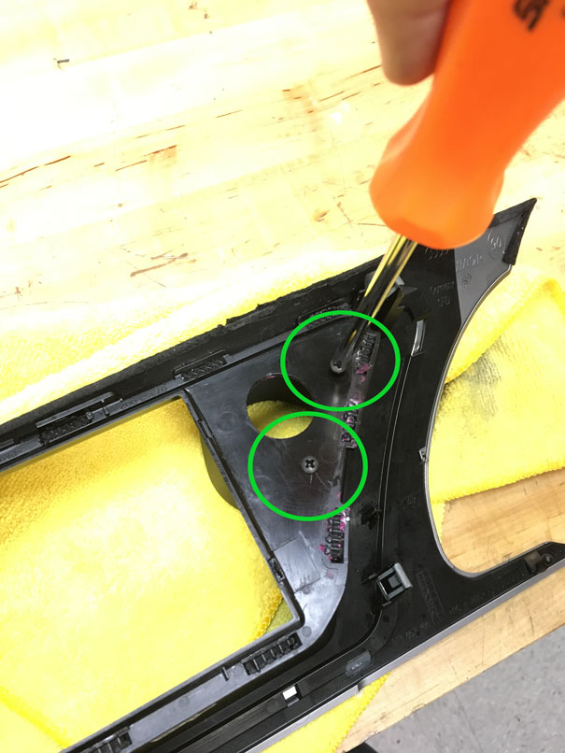

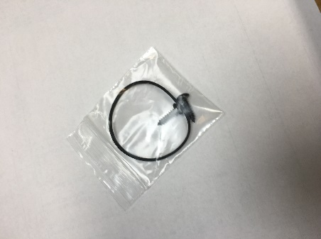

Using the supplied screws, secure the pod to the bezel. As shown in the green circles.
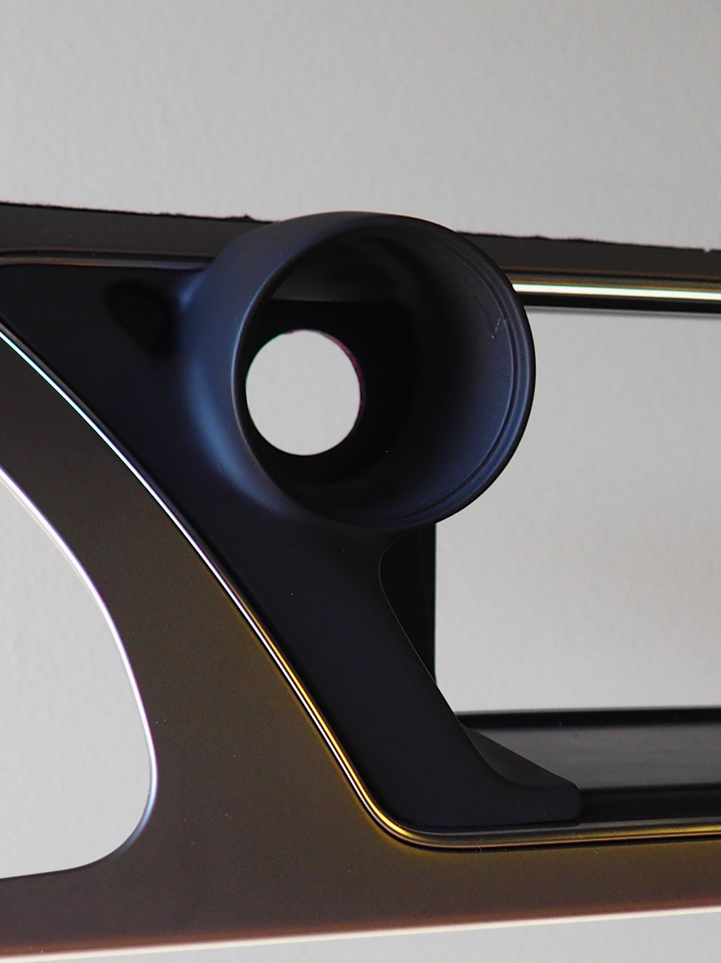

Your new PodWurX pod is now installed to the Oem center display and ready for your gauge to be installed

For an example we will complete the instructions with an example gauge.

In the case of a Snow performance gauge/controller

In the case of a snow performance gauge that has no connection in the back of the gauge you may have to be creative and run your wires through the pod and make all your connections leaving extra room to slide the pot into place
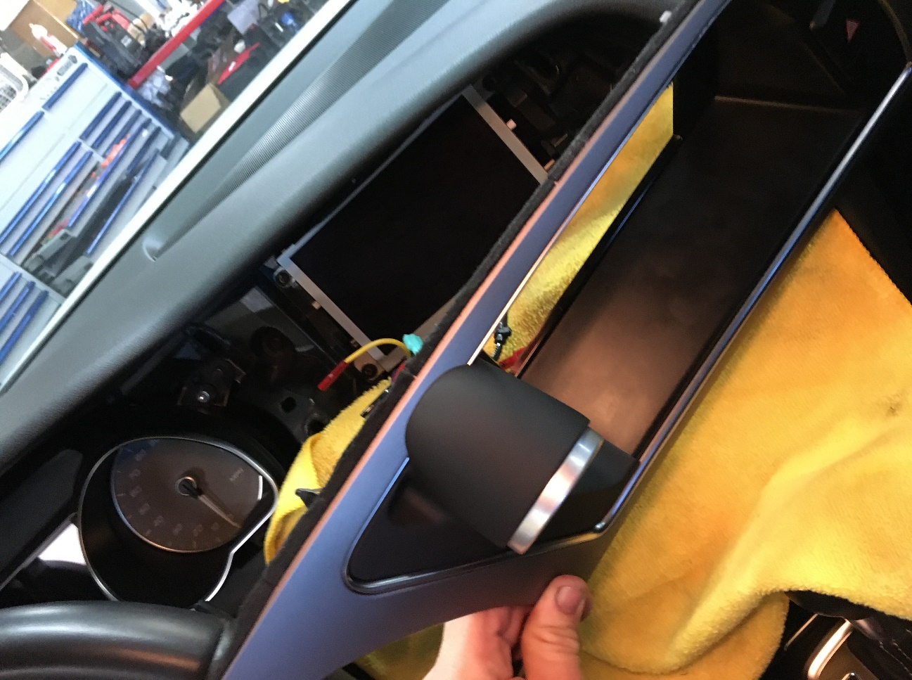

For most gauges slide or insert in to pod and reinstall center display bezel. Make your connections for the gauge.

We have also included a square rubber mounting grommet use this around the gauge to make a tight press fit. Like shown

This is where the need of a rubber band or grommet will be helpful to ensure a tight fit into the pod opening.
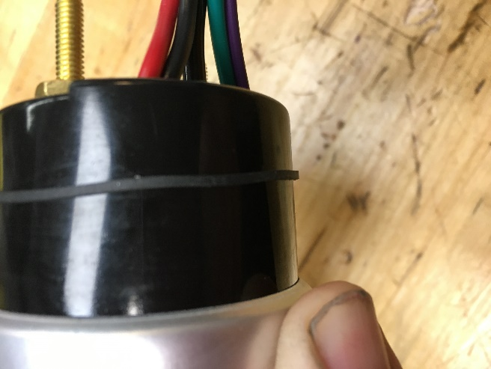

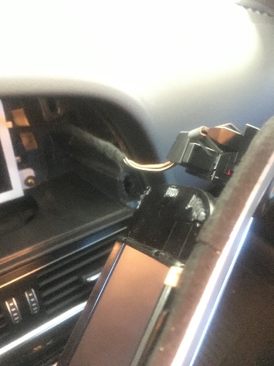

Remember to reattach the hazard connector

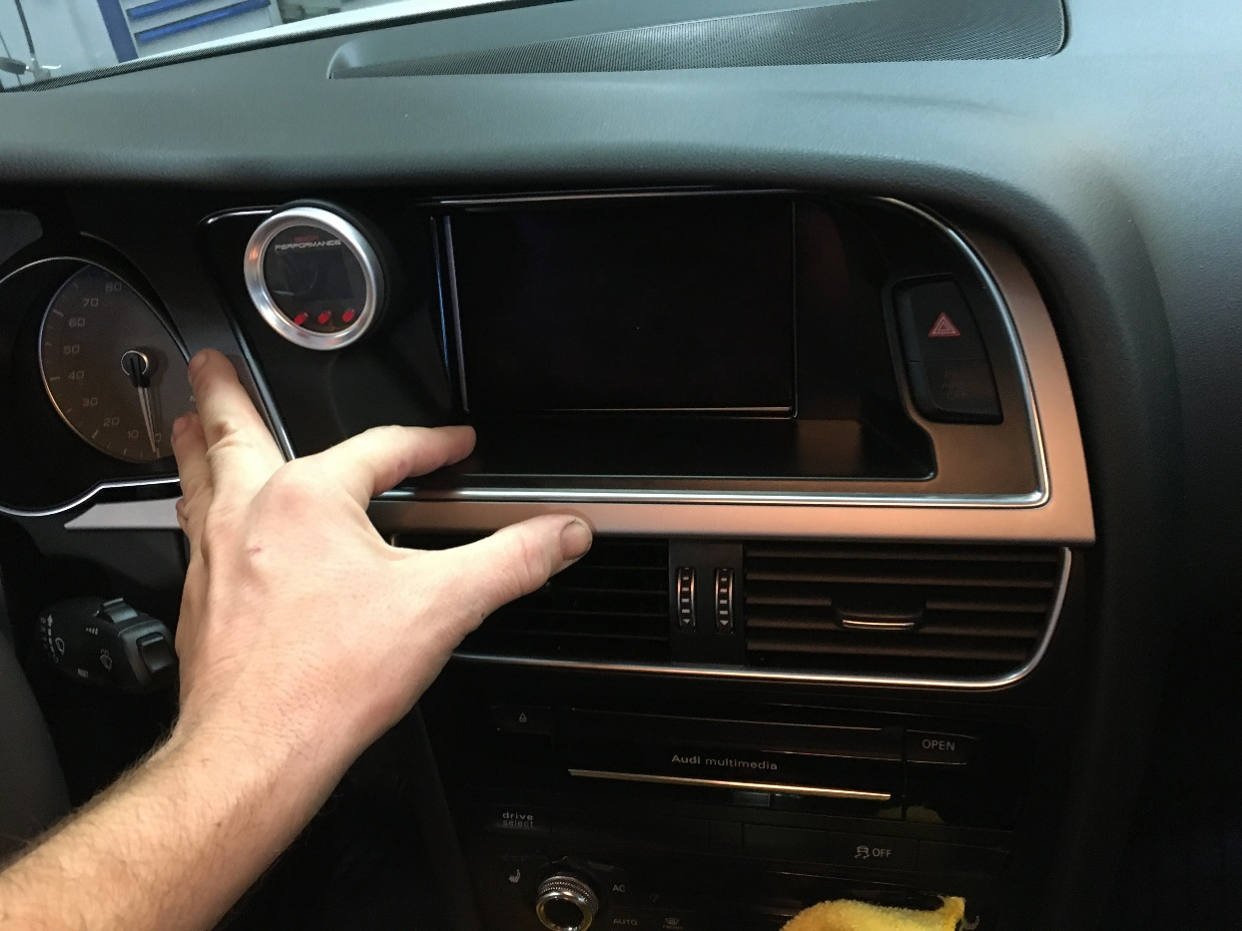

Then snap your bezel with gauge pod back in to position making sure not to pinch any wiring or lines.

You have now completed your gauge install.
Enjoy!
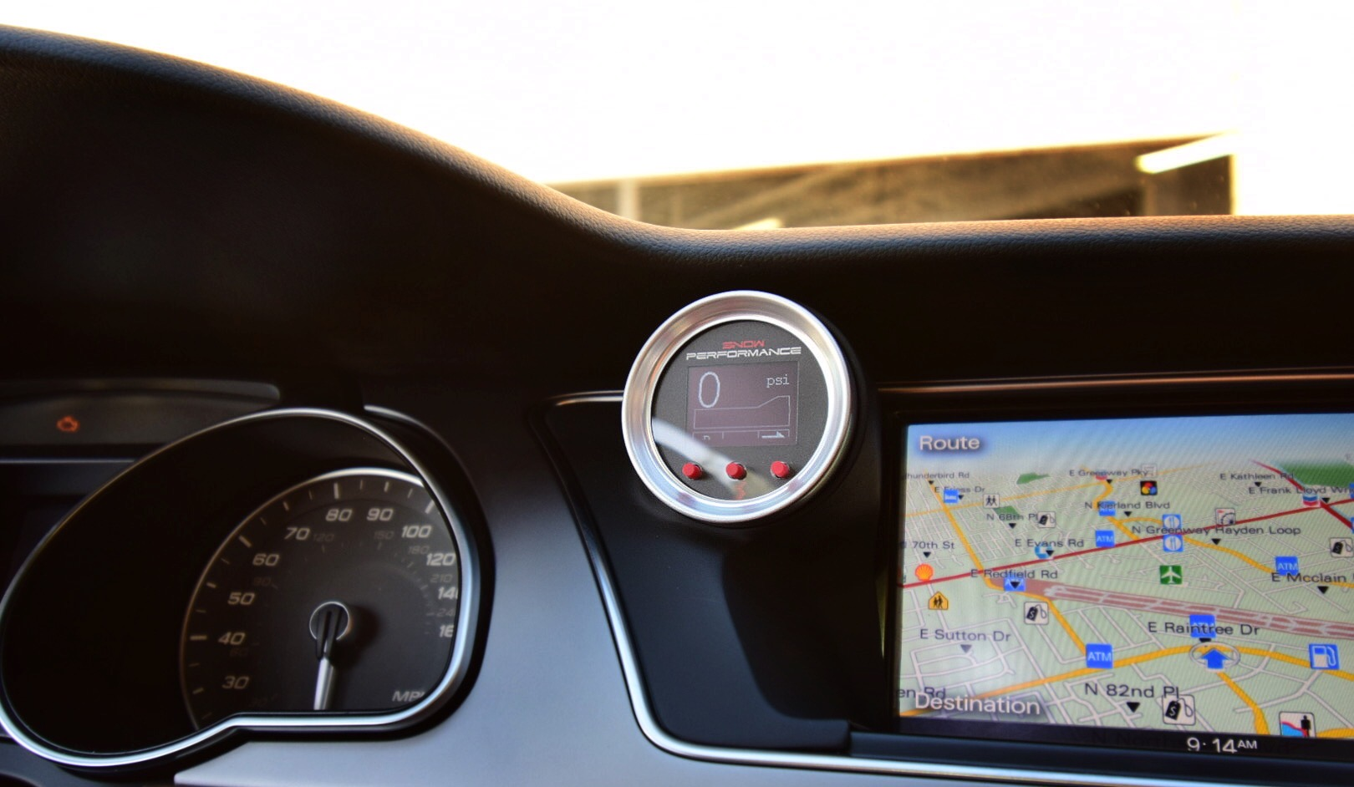

PodWurX
602-935-8955 info@podwurx.com
www.podwurx.com

