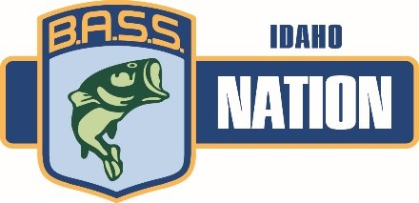

2021 Idaho Bass Nation

High School and Junior State Championship

Entry Form

**When: Sunday, August 1**

**Where: Lake Lowell, Caldwell, ID**

**Two Divisions:**

**High School (9th – 12th grade)**

**Junior (2nd – 8th)**

**\*Because the tournament is being held in August, this is the student’s grade for 2021-2022 school year.**

This is a one-day event. The winning High School team and winning Junior team will have the opportunity to represent Idaho at the 2022 BASS High School and Junior National Championship.

Mandatory check in, meeting, and draw at 6:00 pm, July 31 at the Caldwell Ramp.

Pre-fishing allowed until 6:00 pm July 31.

This is a 2 angler, team event. Each team consists of two students and must have an adult boat captain. Students must be an active member of B.A.S.S., and the Idaho B.A.S.S. Nation to be eligible to participate.

The team limit is 5 fish per day, and scores will be based on weight.

There is no entry fee for this tournament. However, the B.A.S.S. membership fee and Idaho B.A.S.S. Nation membership fee are $10 each ($20 total).

Contact the Youth Director, Rodney Ryza, at (208) 473-0606 or [idahostudentanglers@gmail.com](mailto:idahostudentanglers@gmail.com) for more information.

Please return the fully completed form on the next page to:

IBN Youth Director:

Rodney Ryza

2330 E Halsey Dr

Eagle, ID 83616

Or idahostudentanglers@gmail.com



**August 2021 High School and Junior Entry Form**

Student #1 _________________________________________

Address _____________________________________________

E-mail ______________________________________________

Phone Number _______________________________________

B.A.S.S. Member Number _____________________________

B.A.S.S. Club________________________________________

* Contact Rodney Ryza for Club information

Student #2 __________________________________________

Address _____________________________________________

E-mail ______________________________________________

Phone Number ________________________________________

B.A.S.S Member Number ________________________________

B.A.S.S. Club _________________________________________

* Must be member of same club as Student #1

Adult Boat Captain for Team_________________________________

Address _____________________________________________

E-mail ______________________________________________

Phone Number ________________________________________

Boat Insurance Carrier _____________________________________

Insurance Policy No. _________________________________________

*I represent and warrant that I have or will obtain before the tournament boat owners liability insurance (including coverage for third party property damage and bodily injury) with no “tournament exclusion,” having a minimum limit of $300,000 per occurrence.

**By entering the tournament, all participants release, without exception, the IBN, its owners, officers, sponsors, employees and affiliates, from liability for any accidents, loss or theft. All contestants will be required to sign the Bassmaster High School and Junior Rules and Participation Agreement. Violation of any rule will warrant appropriate disciplinary action by the Tournament Director and IBN Board of Directors.**

Sponsored by the Idaho B.A.S.S. Nation