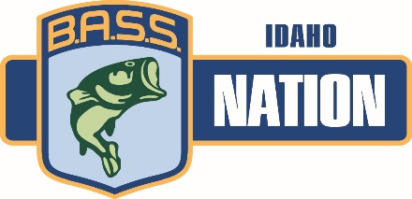
2021 Idaho BASS Nation State Championship Qualifier
Brownlee Reservoir, Woodhead Ramp
Fri. June 25 & June 26
(No off limits period)
Idaho’s only true State Championships Bass Tournament
Test your skills against the best anglers in the State of Idaho
Format
- Pro Am Style format similar to BASS Pro Open Circuit format. Western Regionals will be the same format. Boaters will only compete against boaters and non-boaters will compete against non-boaters.
- Sign up with a Non-boater no later than one week prior to the tournament
- Boaters entry fee $300 – Make every effort to sign up with a non-boater or you will not be drawn to fish alone if numbers are not even….
- Non-Boater entry Fee $150 – Make every effort to sign up with a boater or we may not have a boater for you…..
- First Place will be recognized as Idaho BASS Nation State Champion.
- Top 10 Boater and top 10 non boaters qualify for Regional Championship site to be determined.
- Payout--- Added Money and Options pots.
- Idaho BASS Nation gets $10 dollars from every entry to cover tournament cost
- $20 for every entry will go to the National Championship qualifier Boater and Non Boater.
- $270 of each boater entry will go to State Team boater travel fund. Travel funds will be paid to state team members 2 weeks prior to Regional tournament.
- $120 of each non boater entry will go to State Team non-boater travel fund. Travel funds will be paid to team members 2 weeks prior to Regional tournament.

Three steps to Qualify for the Bassmaster Classic?
- Qualify to make the Idaho Bass Nation 20 person State Team, fish the Western Regional.
- Finish first at out of State of Idaho at the Western Regional Tournament. Top boater and non-boater from each state will advance to the National Championship
- Finish in the top three at the BASS Nation National Championship. Top three boaters will advance to fish in the Bassmaster Classic. Top finishing non-boater wins a boat and fishes the final day as a boater for a chance at a classic spot.
New Incentives at Regionals
- Payout at Regional Tournament
- Top 3 boaters at Nationals win a boat get the use of a new Tundra and bass boat for a year, paid entries to BASS Pro Shop Circuit of choice.
- National Champion receives invite to Elite Series
- National Champion Non-boater wins a boat, paid entries to a BASS Pro Shop Open Circuit of choice and a chance at a Bassmaster Classic spot.

To be eligible to compete must be an active B.A.S.S. member and a member of an Idaho BASS Nation affiliated club. To find a club near you, more info and entry forms visit www.idahobassnation.com

