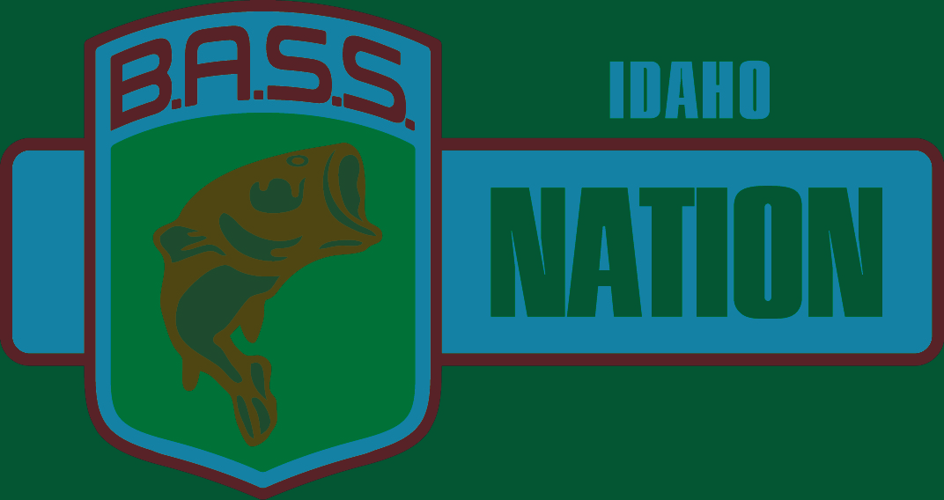

2021 Idaho Bass Nation State Championship

Qualifier Entry Form

**(The Idaho State Battle on the Border)**

**When June 25th – 26th Fri, Sat. 2021– Brownlee Reservoir, Woodhead Ramp**

**Check-in and Mandatory meeting 6:00 p.m. Draw @ 7:00 p.m. June 24th at Woodhead Campground.**

**This is a two day event for the Idaho BASS Nation State Championship. The top 10 Boaters and top 10 Co-Anglers will qualify for the Idaho B.A.S.S. Nation State Team representing Idaho at the**

**2022 BASS Nation Western Regional Tournament.**

**Pre-fishing allowed until 5:30 PM June 24th**

**Must be an active member of B.A.S.S. and the Idaho B.A.S.S. Nation to be eligible to participate. Go to** [**www.idahobassnation.net**](http://www.idahobassnation.net) **to find a club.**

This is a Pro Am style event pairing Boaters and Co-Anglers. Boaters are competing against Boaters and maintain control of the boat for the entire day, fishing for boater spots on the Idaho State Team. Co-Anglers are fishing from the back of the boat the entire day and are fishing against Co-Anglers for Co-Anglers spots on the Idaho State Team. Pre-registration is strongly encouraged. To avoid a late fee you must sign up one **week prior** to tournament (June 18th). Late entries will be accepted until 6 pm Mtn. Time Thursday June 24th with a $50 Late Fee. Signing up with Boater/Co-Angler pairs is highly recommended. Boaters who do not sign up with a Co-Angler will be ineligible for the drawing to fish alone. Note: Co-Anglers signing up alone may submit a paid Tournament Entry Form. Boater placement will be made for you based upon availability; (excess Boaters are usually the norm). **Please contact to confirm placement**

**Mandatory** Pre-tournament check-in and safety meeting will begin at 6pm, with pairings at 7 p.m. Mtn Time on June 24th.

Boater and Co-Angler pairings and starting positions will be done at this meeting. If the meeting is missed you will be assigned **last boat out** both days following completion of safety instructions. On day two the Starting Position will be reversed from day one and Co-Anglers will move one Boater down.

Boater limit is 5 fish per day, Co-Angler limit is 3 fish per day. The top two day weight totals in each category will qualify for the 2022 Idaho BASS Nation State Team and BASS Nation Western Regionals. The first place Boater will be named the Idaho BASS Nation State Champion. The Idaho State Team will be announced at the conclusion of the weigh in. All Idaho State Team members will be required to participate in public events promoting the IBN and bass fishing in the state of Idaho and attend the annual banquet.

Tournament Waters

All of Brownlee Reservoir up to the Railroad Bridge, by The Burnt River Arm and the Powder River Arm

(Oregon Waters must have Oregon License and Invasive Species Permit for Oregon to enter)

**To avoid late fee entries must be received one week prior June 18th. Late entries will be accepted June 24th at Pre-Tournament meeting with a $50.00 late fee. Current Covid state rules will be observed.**

Please Return Fully Completed, Signed Form with payment To:

Idaho BASS Nation

1760 E. Star Ln.

Meridian, ID 83646

IBN President: David Bertsch (208)-660-1937

IBN Treasurer: Chris Rambough (208)-519-9955

IBN Tournament Director: Glenn Ainsworth (541)-216-1058



**2021 Qualifier Entry Form – June 25th and 26th Brownlee Reservoir**

**Boater and Co-Angler forms may be sent separately by noting your registration partner name.

Entry forms and money must be received by June 18h

Boater Name _________________________________________ Entry $300.00

Address _____________________________________________

E-mail ______________________________________________

Phone Number _______________________________________

Insurance Carrier _____________________________________

Policy No. ___________________________________________

B.A.S.S. Member Number ____________________

Bass Club________________________________

Total Paid _________

Co-Angler Name ______________________________________ Entry $150.00

Address _____________________________________________

E-mail ______________________________________________

Phone Number ________________________________________

BASS Member Number ________________________________

Bass Club _______________________________

Total Paid ___________

$20.00 of each Entry is set aside for the State Regional Champion to attend Nationals.

$10 will go to the Idaho BASS Nation to run tournament.

$270 of each boater entry will go to the State Team boater travel fund. Travel funds will be paid to state team members 2 weeks prior to Regional tournament.

$120 of each Co-Angler entry will go to State Team Co-Angler travel fund. Travel funds will be paid to team members 2 weeks prior to Regional tournament.

**Cash only option pots will possibly be available at the Pre-tournament meeting. (interest pending)**

**Possible Big Fish Pot Each Day for Boater – Co-Angler (Separate Pots)**

By entering the tournament, all participants release, without exception, the IBN, its owners, officers, sponsors, employees and affiliates, from liability for any accidents, loss or theft. All contestants by signing and submitting this Entry Form agree they have read and understood the Idaho B.A.S.S. Nation Official Tournament Rules and agree to the terms as listed. Violation of any rule will warrant appropriate disciplinary action by the Tournament Director and IBN Board of Directors.

Boater:___________________________________________________ Date ________________

Co-Angler: _________________________________________________ Date ________________

Signatures Required

**Sponsored by the Idaho B.A.S.S. Nation**