General

Upon Arrival
First and foremost as a volunteer arriving to a clinic day: communicate with the lead volunteer about your expectations and duties for the day as well as any questions, comments, and concerns you may have. If something comes up that you feel is important to communicate: ie you will be late arriving, a patient asked a question you did not know the answer to; this should be communicated to the lead volunteer before, during, or immediately after the event, whichever is most applicable in the circumstances. If you are unable to identify who the lead volunteer is at the time of the event, it is also appropriate to communicate any issues that may arise to a board member or the CEO if they are available instead. Please arrive in uniform, with a positive attitude, at least 35 minutes prior to the start of the clinic, ready to have a great day devoted to helping the underserved!

The following steps are to be taken when the bus is parked at the destination:
- Unlock each door, starting with the driver’s door and bi-fold doors at the front of the bus.
  - All doors except the wheelchair ramp can be left open while setting up the bus. Note that the bifold doors cannot be left fully open or a light will be left on without the engine running so it is recommended to partially open the doors until needed to fully open them, after which you should partially close them again.
  - A “spare” key can be utilized if the front door cannot be accessed. This key is in the form of a long, black PVC pipe with a clothes hanger on the end. This device is located on the back bumper of the bus. If inserted through the bifold doors of the bus, the piping can reach the door latch of the driver’s side door and unlock with the the clothes hanger side of the pipe.
- Move generator from its storage on the bus to a safe location outside the bus.
  - If you are unable to carry the generator the wheelchair ramp can be used to lower it outside. To use the handicap ramp, you will need to turn the ramp switch to the lighted on position at the driver’s functional station prior to operating the ramp controller.
  - Locate the extension cord under the passenger side body midway underneath the body frame. Note the manner in which the cord is bundled as it will need to be put back this way before departure.
- Start generator and plug in power. Turn on light switch by triage area to turn on the bus lights. (A manual including detailed instructions for starting the generator is attached to the physical generator)
**If it is raining: the generator cannot be used out in the open in the rain or there
is a risk of electrocution. In order to combat this, the generator must only be
used if it is on top of something, like a plastic tarp, and underneath something,
like the check-in tent if possible. If this is not feasible, flashlights are to be
used in the interim--do not take a chance with the generator if unsure.
- Set out tent and check-in table.

Driving the bus:
- Driving the bus is the same as driving a car in theory. There is nothing different about the gears, the pedals, or any other basic functionality of the bus compared to a car. However, it is important to keep in mind when you are driving the bus:
  - Both sliding pocket doors MUST be secured using the velcro straps provided prior to moving the bus. Failure to do so will cause damage.
  - You will not be able to see out of the rearview mirror as the lab room walls block its view. Use your side mirrors to help navigate. Do not attempt to back up the bus without help from others standing outside to navigate from obstacles.
  - The driver’s-side door will open while you are driving unless you push the lock down (found at the bottom of the window on the interior side of the door).
  - The rear end of the vehicle is wider than the front end, so while you are driving be mindful of your position on the road, remaining centered.
  - The speedometer works, to a point. If you are below 40 mph it is accurate. Once you exceed 40 mph it sticks at 40 and stops increasing or decrease as you speed up or slow down throughout the course of your trip--ie, once you get up to speed once, the needle of the speedometer will stay there until you restart the engine. We will be working to fix this issue, but in the meantime, gauge your speed by others driving speed and always aire on the safer, slower side. Speeding tickets are not the responsibility of Railcare Health and will be the responsibility of the employee committing the offense.
  - When you are driving the bus remember that you are representing Railcare and it is important to be respectful, careful, and courteous at all times of others on the road.
  - Don’t forget your license as it is illegal to drive any vehicle, including the Railcare Health vehicle without a valid US license.
- When getting gas:
  - You will need the key that unlocks the gas cap
  - The bus takes regular, unleaded fuel (NOT DIESEL); engine may explode if diesel is put in this gasoline engine.
  - The max amount a gas station will let you put in at a time is $100 worth. A Railcare Health board member will be needed to pay with the Railcare Health debit card. If one is not present and gas is purchased, save the receipt so a refund transaction can take place.
  - Once the gauge drops below a quarter of a tank, it is a safe bet to stop and refuel. Railcare Health does not have AAA, so stop early to refuel.

Utilizing the Bus
The following procedure is to be followed while the bus is in use:
- The velcro holding the two pocket doors open MUST remain around the door unless the door is closed. The doors are to be velcroed back between patients.
- When not in use, the wheelchair ramp must remain up and the bi-fold entry doors at the front of the bus must not remain fully open (see that step lighting is off) - failure to do this will result in the bus battery dying.
- While a patient is in the lab or exam room the windows must be closed and the curtains down. The back door can be opened when the exam room is free and the hall windows may remain open during clinic.
- Always attempt to minimize your contact with the walls to avoid contacting the insulation within.

Closing Up
To be done after clinic or outreach is complete for the day:
- Pick up any trash and put away any supplies still out. Sweep the lab, triage, and exam areas.
- Make sure all windows are closed and locked and all curtains are fully closed.
- Velcro pocket doors open and ensure all equipment is secured.
- Turn off lights, unplug power, and move generator back to its storage location on the bus.
- Coil and secure the power cord underneath the passenger side body.
- Lock each door starting with the rear door, the wheelchair ramp, and lastly the bi-fold front door using the steel cable provided.
- Lock the driver’s door by pushing inward on the door by the handle and locking with the key. Door MUST be locked with the key and not the interior lock on the door panel.

Emergency Procedures
The board will perform a risk assessment at least annually. Resultantly we will implement and monitor the risk mitigation plans decided on.

In Case of Fire:
- Exit the bus through the quickest exit route. Assist any patients in exiting the bus, especially the elderly or handicapped.
  - Do not use wheelchair ramp as fire could damage the power supply.
- Call 9-1-1.
- Evacuate the area immediately surrounding the fire.
  - Note that some people in the waiting area may be reluctant to evacuate before uniting with the person they accompanied to the clinic.
- Report to the lead volunteer and account for all people - patients and staff.
- If safety allows, try to minimize property damage by moving equipment out of the zone of the fire. Safety is key, do not re-enter the immediate area of the fire unless cleared by emergency response teams.
- File an incident report upon request.

Lead Volunteer in Case of Fire:
- Upon safe exit of the bus and evacuation of the area surrounding the area, establish a check in area.
- Account for all persons - both staff, patients, and those accompanying patients.
- Upon arrival of the fire department notify them of: location of fire or damage as well as any known hazardous materials, i.e. the generator or lab equipment.
- Any injuries or damages are to be filled out in an incident report.

Threats and Acts of Violence:
A threat is any behavior consisting of, but not limited to, any expressed intention, directly or indirectly to:
- Harming oneself or another individual
- Endangering a group of volunteers or patients within the vicinity of our clinic
- Destruction of personal or organization property

A weapon is any instrument or device that is at least 3” long with the intent to attack or for defence.

Iminitent or Direct Threat:
Behavior consisting of, but not limited to:
- A potential physical assault or use of a weapon
- Actions or statements that have the immediate potential for violence against persons or property (i.e. breaking or throwing objects, gesturing with a fist, etc.)

Response Plan - Non-Imminent Threat:
- Immediately report all specific occurrences to the lead volunteer.
- Lead volunteer to follow up.
- Complete an incident report form to be passed along to the board.

Response Plan - Imminent Threat
- Take steps to ensure your safety and that of your patients.
- Call 9-1-1 immediately, or relay the information along to someone who can.
- If safety allows, report to the lead volunteer.
- Encourage the evacuation of all out of harm's way until help arrives.
- Complete an incident report.

Dangerous weather:
Dangerous weather includes: lightning, hail, flash flooding, straight line winds, extreme cold or heat.

Policies for cancelling or rescheduling:
Lead volunteer will make final decision regarding whether or not to hold the clinic that particular day or not based upon the threshold of each dangerous weather event. Weather will be watched and an informed decision will be made. Lead volunteer shall inform a Board member of the decision, or may consult a Board member to make such a decision, as soon as it is practical to do so.

Patient Process
Check In
- Patients are to visit the check in tent and receive a number. Patients will be called into triage and vitals by number.
- They will provide documentation to meet the following requirements
  - 18 years or older OR parent guardian present (Photo ID)
  - Second visit only - Documentation of income below the Federal Poverty Guidelines (tax return forms, proof of income)
  - Second visit only - Proof of north carolina residence (Bills, paychecks mailed to address)
- Patients will receive check in document that includes questions on their current health complaint, medical history, social history, and family medical history.
- After completing paperwork, patients are to return their paperwork to the check-in tent
- Volunteers in the check-in tent will review proof of eligibility and patient documents.
- Patients will be called into vitals by number.

Vitals
- Patients will be called onto the bus to have their vitals and measurements taken by a trained volunteer. (EMT, CNA, nursing student, etc.)
- Height and weight will be checked
- Basic vitals of blood pressure, heart rate, respirations, and blood glucose level will be taken
- Vitals will be documented on patient chart and uploaded to an EMR device

Lab-Services
- Lab services will be provided on board by Railcare in conjunction with LabCorp.
- Patients will be directed to the lab room and assisted with specimen collection under the direction of the physician on board.

Physician Exam
- Patient will be seen by a physician in the exam room (very back of bus).
- The physician will offer a basic check-up exam as well as consultation for specific concerns.
- Patients may be referred to outside resources for more specific care or prescribed a pharmacological sample.

Follow up and Continuing care
- The physician will offer a suggested plan for follow up treatments.
- Patients will receive their Visit Summary that explains what steps they should be taking next and if/when they should see another doctor.
- The after-visit summary will also include information on medications if pertinent.

Handling Check-In Paperwork
- Patients will return completed paperwork to check-in tent.
- Check-in paperwork will be added to folder with corresponding patient number.
- Folder contains visit summary forms to be filled out by physician.
- As patients are called by number for vitals, their folder goes with them.

Conflict of interest:

CONFLICT OF INTEREST POLICY AND AGREEMENT

ARTICLE I

PURPOSES

It is important for Railcare Health directors, officers, and staff to be aware that both real and apparent conflicts of interest or dualities of interest sometimes occur in the course of conducting the affairs of the corporation and that the appearance of conflict can be troublesome even if there is in fact no conflict whatsoever. Conflicts occur because the many persons associated with the cooperation should be expected to have, and do in fact generally have multiple interests and affiliations and various positions of responsibility within the community. In these situations a person will sometimes owe identical duties of loyalty to two or more corporations. The purpose of the conflict of interest policy is to protect the corporation’s tax-exempt interest when it is contemplating entering into a transactions or arrangement that might benefit the private interest of an officer or director of the corporation or might result in a possible excess benefit transaction. The policy is intended to supplement but not replace any applicable state and federal laws governing conflict of interest applicable to nonprofit and charitable organizations.

Conflicts are undesirable because they potentially or eventually place the interests of others ahead of the corporation’s obligation to its charitable purposes and to the public interest. Conflicts are also undesirable because they often reflect adversely upon the person involved and upon the institutions with which they are affiliated, regardless of the actual facts or motivations of the parties. However, the long-range best interests of the corporation do not require the terminations of all association with persons who may have real or apparent conflicts that are harmless to all individuals or entities involved.

Each member of the board of directors and the staff of the corporation has a duty of loyalty to the corporation. The duty of loyalty generally requires a director or staff member to prefer the interests of the corporation over the director’s/staff’s interest or the interests of others. In addition, directors and staff of the corporation shall avoid acts of self-dealing which may adversely affect the tax-exempt status of the corporation or cause there to arise any sanction or penalty by a governmental authority.

In connection with any actual or possible conflict of interest, an interested person must disclose the existence of the financial interest and be given the opportunity to disclose all material facts to the director and members of committees with governing board delegated powers considering the proposed transaction or arrangement.

ARTICLE II

DEFINITIONS

2.1 Interested Person

Any director, principal officer, or member of a committee with governing board-delegated powers, who has direct or indirect financial interest, as defined below, is an interested person.

2.2 Financial Interest.

A person has a financial interest if the person has, directly or indirectly, through business, investment, or family:

(a) An ownership or investment interest in any entity with which the corporation has a transaction or arrangement,

(b) A compensation arrangement with the corporation or with any entity or individual with which the corporation has a transaction or arrangement, or

(c) A potential ownership or investment interest in, or compensation arrangement with, any entity or individual with which the corporation is negotiating a transaction or arrangement.

Compensation includes direct and indirect remuneration as well as gifts or favors that are not insubstantial. A financial interest is not necessarily a conflict of interest. Under Article III, Section 2, a person who has financial interests may have a conflict of interest only if the appropriate governing board or committee decides that a conflict of interest exists.

ARTICLE III

PROCEDURES

3.1 Duty to Disclose

In connection with any actual or possible conflict of interest, an interested person must disclose the existence of the financial interest and be given the opportunity to disclose all material facts to the directors and members of committees with governing board delegated powers considering the proposed transaction or arrangement.

3.2 Determining Whether a Conflict of Interest Exists

After disclosure of the financial interest and all material facts, and after any discussion with the interested person, he/she shall leave the governing board or committee meeting while the determination of a conflict of interest is discussed and voted upon. The remaining board or committee members shall decide if a conflict of interest exists.

3.3 Procedures for Addressing the Conflict of Interest.

(a) An interested person may make a presentation at the governing board or committee meeting, but after the presentation, he/she shall leave the meeting during the discussion of, and the vote on, the transaction or arrangement involving the possible conflict of interest.

(b) The chairperson of the governing board or committee shall, if appropriate, appoint a disinterested or committee to investigate alternatives to the proposed transaction or arrangement.

(c) After exercising due diligence, the governing board or committee shall determine whether the corporation can obtain with reasonable efforts a more advantageous transaction or arrangement from a person or entity that would not give rise to a conflict of interest.

(d) If a more advantageous transaction or arrangement is not reasonably possible under circumstances not producing a conflict of interest, the governing board or committee shall determine by a majority vote of the disinterested directors whether the transaction or arrangement is in the corporation’s best interest, for its own benefit, and whether it is fair and reasonable. In conformity with the above determination it shall make its decision as to whether to enter into the transaction or arrangement.

3.4 Violations of the Conflicts of Interest Policy

(a) If the governing board or committee has reasonable cause to believe a member has failed to disclose actual or possible conflicts of interest, it shall inform the member of the basis for such belief and afford the member an opportunity to explain the alleged failure to disclose.

(b) If, after hearing the member’s response and after making further investigation as warranted by the circumstances, the governing board or committee determines the member has failed to disclose an actual or possible conflict of interest, it shall take appropriate disciplinary and corrective action.

ARTICLE IV

RECORD OF PROCEEDINGS

4.1 Minutes

The minutes of the governing board and all committees with board delegated powers shall contain:

(a) The names of the persons who disclosed or otherwise were found to have a financial interest in connection with an actual or possible conflict of interest, the nature of the financial interest, any action taken to determine whether a conflict of interest was present, and the governing board’s or committee’s decision as to whether a conflict of interest in fact existed.

(b) The names of the persons who were presented for discussion and votes relating to the transaction or arrangement, the content of the discussion, including any alternatives to the proposed transaction or arrangement, and a record of any votes taken in connection with the proceedings.

ARTICLE V

COMPENSATION

5.1 A voting member of the governing board who receives compensation, directly or indirectly, from the corporation for services is precluded from voting on matters pertaining to that member’s compensation.

5.2 A voting member of any committee whose jurisdiction includes compensation matters and who receives compensation, directly or indirectly, from the corporation for services is precluded from voting on matters pertaining to that member’s compensation.

5.3 No voting member of the governing board or any committee whose jurisdiction includes compensation matters and who receives compensation, directly or indirectly, from the corporation, either individually or collectively, is prohibited from providing information to any committee regarding compensation.

ARTICLE VI

ANNUAL STATEMENTS

Each director, principal officer and member of a committee with governing board-delegated powers shall annually sign a statement that affirms such person:

(a) Has received a copy of the conflicts of interest policy.

(b) Has read and understands the policy,

(c) Has agreed to comply with the policy, and

(e) Understands that the corporation is charitable and in order to maintain its federal tax exemption it must be engage primarily in activities, which accomplish one or more of its tax-exempt purposes.

ARTICLE VII

PERIODIC REVIEWS

To ensure the corporation operates in a manner consistent with charitable purpose and does not engage in activities that could jeopardize its tax-exempt status, periodic reviews shall be conducted. The periodic reviews shall, at a minimum, include the following subjects:

(a) Whether compensation arrangements and benefits are reasonable, based on competent survey information and the results of arm’s length bargaining.

(b) Whether partnerships, joint ventures, and arrangements with management corporations conform to the corporation’s written policies, are properly record, reflect reasonable investment or payments for goods and services, further charitable purposes and do not result in inurement, impermissible private benefit or in an excess benefit transaction.

ARTICLE VIII

USE OF OUTSIDE EXPERTS

When conducting the periodic reviews as provided for in Article VII, the corporation may, but need not, use outside advisors. If outside experts are used, their use shall not relieve the governing board of its responsibility for ensuring period reviews are conducted.

CERTIFICATE OF ADOPTION OF CONFLICT OF INTEREST

POLICY AND AGREEMENT

I do hereby certify that the above stated Conflict of Interest Policy and Agreement for Railcare Health were approved and adopted by the board of directors on Thursday, April 27, 2017 and constitute a complete copy of the Conflict of Interest Policy of the corporation

How to train/recruit volunteers:
We will continue to grow our online presence via social media, blog, and our website. We will do this through social media campaigns (i.e. #AllAboard or #tickettohealth) and streamlining our website to be more user friendly via advice from community members that we talk with during our recruitment push.

Once volunteers have been recruited, our policy for training our first group of volunteers is to have them to attend a two hour training session at Dr. Khan’s Al-Aqsa clinic with the volunteer coordinator there. After there is an established baseline of trained personnel in the rank and file of Railcare, future training of volunteers can be done 1.5 hours before the start of any clinic day on site by volunteers who have participated in a training and a separate clinic day themselves. Their preparedness to volunteer on the day in question will then need be approved by our Volunteer Coordinator.

Process for replacing board members
In the event of a board member resigning/being asked to step down, it will be our goal to replace them with a suitable candidate as soon as possible. In order to make the process fair, it will be our policy to post available positions on our website for at least one week before filling the position. Other board members may also take the liberty to headhunt other candidates who may be interested and offer them additional information about the position. All eligible and interested candidates will then be expected to fill out a google form or some application tool expressing their interest and answering questions--this will serve as their job application--as well as send their CV to the acting CEO. After the board reviews these applications and selects the candidate they wish to add to the organization this candidate will be notified and given 48 hours to accept or reject the position after having been explained the expectations and likely time commitment. If this candidate rejects the position, the board will move to the next most qualified candidate and repeat the process. After such time as someone accepts the position, all other candidates will be notified that they will not be added on as a board member, but are encouraged to help with Railcare in other capacities and that their interest is appreciated. A candidate cannot be sworn into a board member role officially until a 3 month “trial period” has been concluded. This trial period will end with a board vote on whether this candidate is fit for a board member title.

Quarterly meetings
Every three months we will hold a quarterly meeting which we will require every member of Railcare to dial in to. Volunteers and unnecessary personnel who are not normally expected to attend meetings will be expected in these cases. These meetings will be held every three months and will cover only pertinent information, but information nonetheless that the board deems significant enough that it need be communicated to the whole of Railcare--delivering a unified message. Notice of the first quarterly meeting will be sent out two weeks prior to the event. This first meeting will take place in January and all other quarterly meeting dates for the year will be sent out at this date.

Patient Health Information Storage
Patients must trust that their health information is secure and private to reap the benefits of digital health technology, as stated by Office of the National Coordinator for Health Information Technology. This allows health care professionals to utilize IT to decrease spending and conduct better health and wellness outcomes. If patients do not feel that their information is kept securely, they may not be willing to disclose information, which could keep them from receiving the care they need.
When organizations don’t have strong security and privacy practices in place, it puts your health information system at a heightened risk of experiencing a cyber-attack. This can jeopardize the reputation of the facility and put patients’ health at risk.
Railcare Health will utilize an Electronic Health Record (EHR) system known as: Athena. This EHR system has been graciously donated to Railcare Health free of charge and will be the main way we store our patient records on this cloud based interface. Patient records will be recorded on paper check in forms, updated on the EHR system by a certified user, and paper records shredded on an onboard shredder. Any and all forms, signatures and documents should be uploaded to the EHR system, if pertinent to a patient’s health record, prior to shredding.

Process for Handling Sharps:
Sharps will be handled and disposed of safely in a sharps container located on the bus. The container must be emptied in compliance with the proper WHO sharps disposal policy. Additional information outlining the proper procedure for handling and disposing of sharps is included in our QI/QA plan.

Process of sending out patient health information
The waiver below must be completed by a patient before we are permitted to release any of their health information.
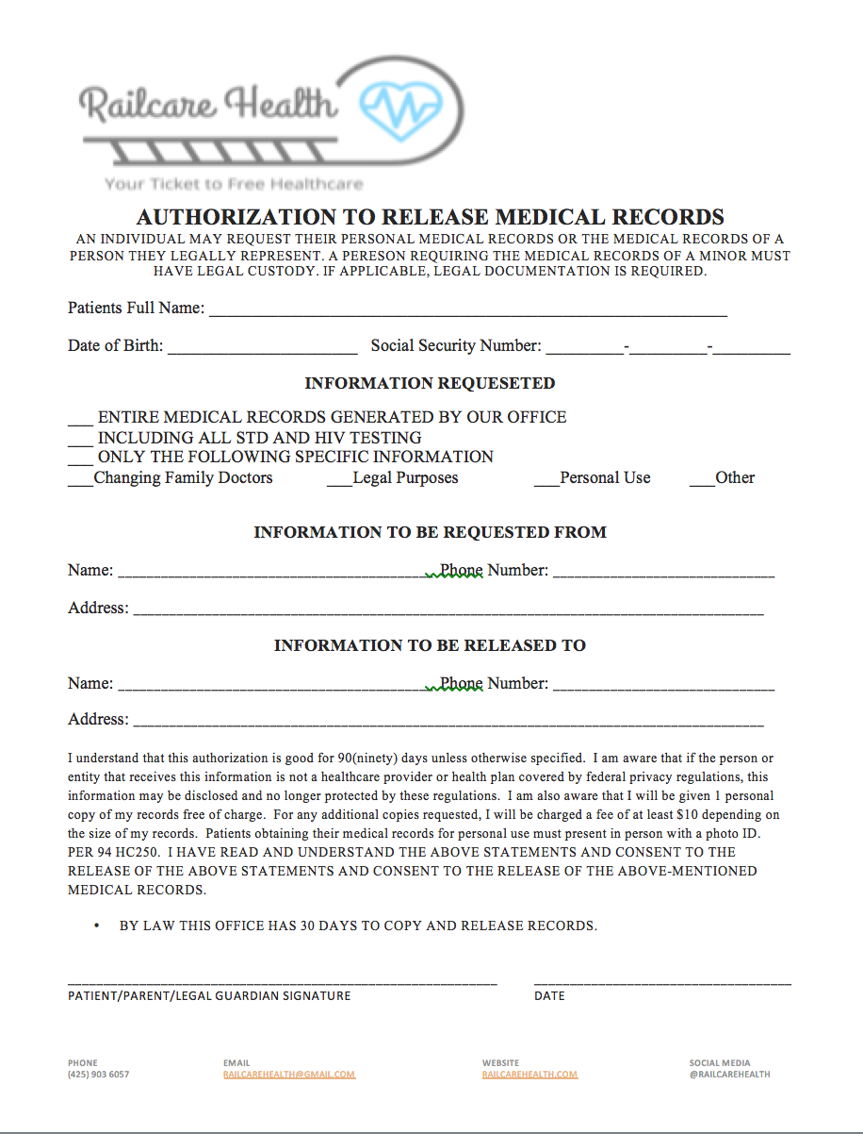

Venmo for Donations
If someone asks about making a donation or if we use Venmo, the answer is yes. Donations can be made via Venmo @railcarehealth. Make sure to provide them with the receipt included below when a donation is made.

How to give a receipt for donors
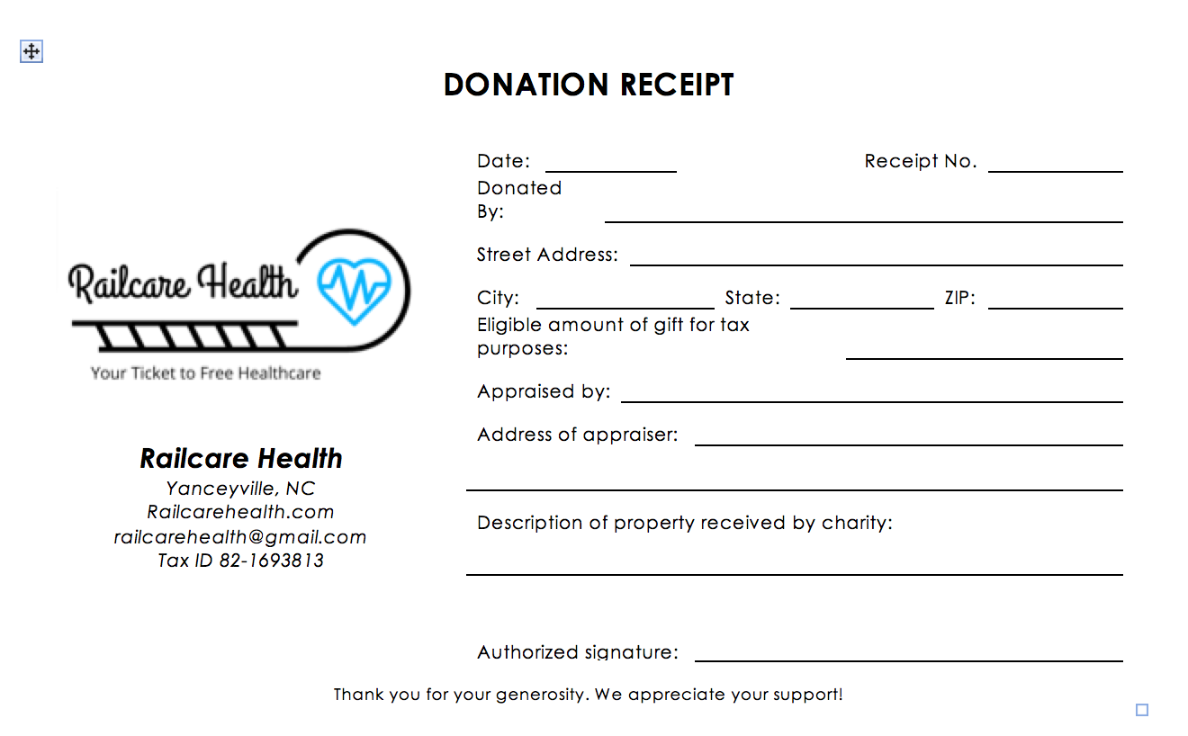We will use this document as a receipt for donors and it will be filed by our CFO whenever Railcare receives donations. During this time where our CFO position is vacant, our communications chair will be handling this responsibility.

How insurance, LabCorp, and pharmacy will work--save this one till the end cause we don’t really know the exact protocol yet--we’re working with pharamcy samples, we’re working with LabCorp to provide lab services to the community for free--LabCorp will help with blood and urine testing

Uniforms
Every volunteer is required to wear a uniform. Uniforms consist of a Railcare collared shirt which cost volunteers $25. This cost is to mitigate the burden for other volunteers who may be unable to pay for their uniforms due to financial hardship. The uniform is meant to be business casual, men should wear khaki bottoms and women should wear something other than jeans or leggings--khakis are also appropriate for female volunteers. Volunteers not in uniform on the day of events may be turned away for that day, if there is not a suitable/comparable alternative for them to wear. Uniforms will be organized and costs managed by the Ethics and Compliance Committee.

Volunteer Waiver of Liability
All volunteers must sign this form before they are permitted to volunteer with us. It must be signed by each volunteer before the start of their first clinic volunteering. Copies will be printed and available on the date of the clinic, but must be signed before the actual time that the clinic is scheduled to begin.

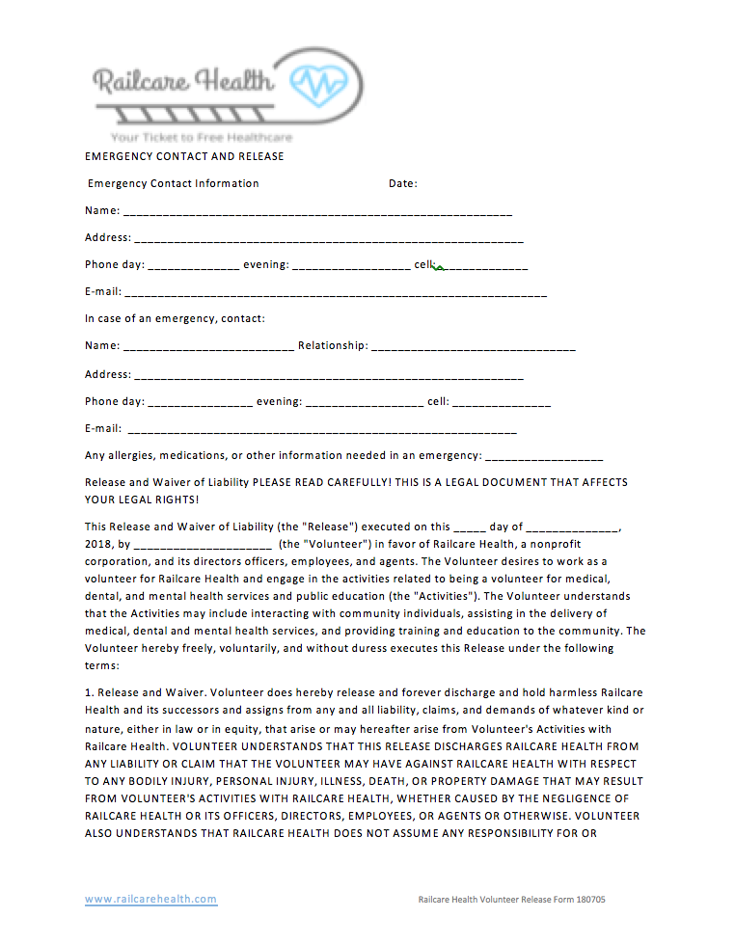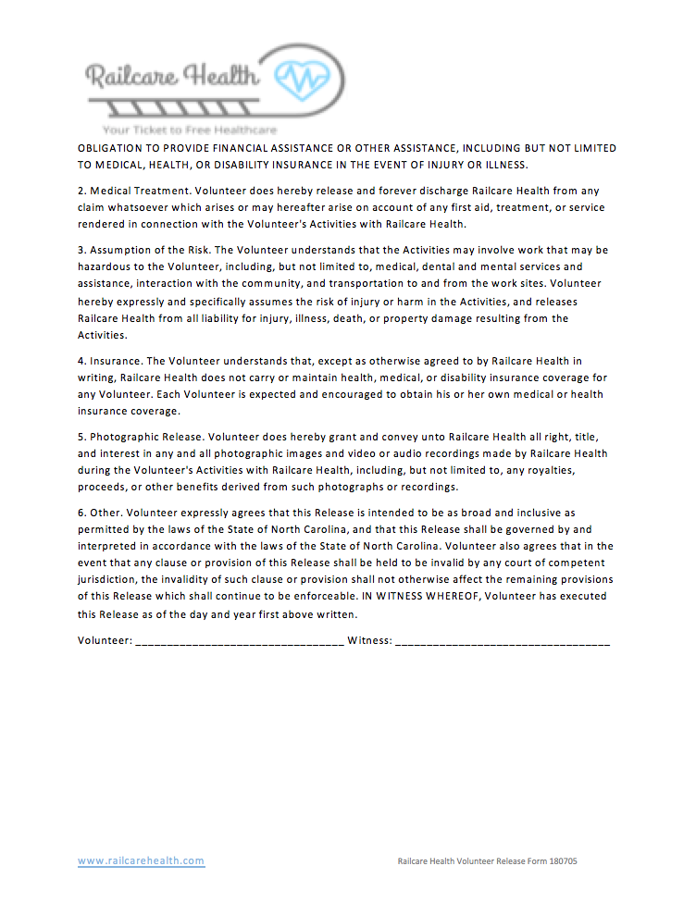Non-discrimination Statement:
Adopted by the Board of Directors on Sunday, Feb 26, 2017
The Railcare Health Organization does not and shall not discriminate on the basis of race, color, religion (creed), gender, gender expression, age, national origin (ancestry), disability, marital status, sexual orientation, or military status, in any of its activities or operations. These activities include, but are not limited to, hiring and firing of staff, selection of volunteers and vendors, and provision of services. We are committed to providing an inclusive and welcoming environment for all members of our staff, clients, volunteers, subcontractors, vendors, and clients.

The Railcare Health is an equal opportunity employer. We will not discriminate and will take affirmative action measures to ensure against discrimination in employment, recruitment, advertisements for employment, compensation, termination, upgrading, promotions, and other conditions of employment against any employee or job applicant on the bases of race, color, gender, national origin, age, religion, creed, disability, veteran's status, sexual orientation, gender identity or gender expression.

The Railcare Health prohibits discrimination against or harassment of any person employed by or seeking employment with the organization because of race, creed, religion, color, or national origin or because of age, physical or mental disability, marital status, or sex when the reasonable demands of the position do not require an age, physical or mental disability, marital status, or sex distinction. Federal law requires proof of citizenship or "alien right-to-work" status.

CERTIFICATE OF ADOPTION OF CONFLICT OF INTEREST

POLICY AND AGREEMENT

I do hereby certify that the above-stated Operational Plan for Railcare Health were approved and adopted by the board of directors on Sunday, October 21, 2018 and constitute a complete copy of the Operational Document of the corporation.

Secretary: Ricky Zheng

Date: October 21st, 2018

