**SLAMM VISION** Refugee youth who are academically supported and inspired to be successful in school and confidently pursuing future individual goals

**SLAMM COLLEGE INTERN GOALS** To create community, have fun, and grow in professionalism as we lead volunteers and participants in a summer of:Leadership, Learning, and New Experiences

**SLAMM MISSION** Provide summer literacy and enrichment experiences for refugee and immigrant youth that lead to increased literacy and school success

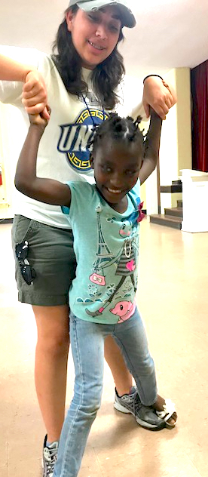New Arrivals Institute (NAI) seeks college interns to plan, lead and manage a summer literacy-based program under the direction of the SLAMM Lead Teacher to offer refugee and immigrant youth the opportunity to improve their literacy in a fun, inclusive environment. SLAMM (Summer Literacy Art Music and Movement) serves immigrant and refugee youth ages 6-15 summer weekdays from 9:00am to 1:00pm, at NAI. Other activity leadership opportunities include soccer, art, crafts, photography, technology, financial literacy, dance, Science, drama, music, Legos, and more. Intern Orientation begins June 3 and interns may serve 2-5 days per week. The last day of the SLAMM program will be August 23.

View the NAI website at [www.newarrivalsinstitute.org](http://www.newarrivalsinstitute.org)

Contact Lynn Thompson, Community Engagement Director, at NAI at [lthompson@newarrivalsinstitute.com](mailto:lthompson@newarrivalsinstitute.com)

