SLAMM VISION Refugee youth who are academically supported and inspired to be successful in school and confidently pursuing future individual goals

SLAMM HIGH SCHOOL VOLUNTEER GOALS To enjoy service learning, create community, have new experiences, and grow in leadership skills.

SLAMM MISSION Provide summer enrichment experiences for newly arrived refugee youth that lead to increased literacy and school success

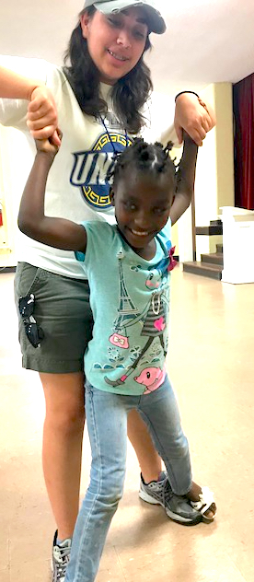
New Arrivals Institute (NAI) seeks high school volunteers to help refugee and immigrant youth improve literacy skills through friendship, reading and teaching under the supervision of the SLAMM (Summer Literacy Art Music and Movement) Lead Teacher and SLAMM College Interns. The SLAMM program offers refugee and immigrant youth the opportunity to improve their literacy in a fun, inclusive environment. SLAMM serves immigrant and refugee youth ages 6-15 summer weekdays from 9:00am to 1:00pm, at NAI. Other leadership opportunities include soccer, art, crafts, photography, technology, financial literacy, dance, Science, drama, music, Legos, and more. Volunteers will be asked to attend an orientation in early June. Volunteers may serve 1-5 days per week. The last day of SLAMM will be August 23.
View the NAI website at www.newarrivalsinstitute.org
Contact Lynn Thompson, Community Engagement Director, at NAI at lthompson@newarrivalsinstitute.com
