SLAMM 2020 High School Orientation Dates: Tuesday June 2 or Wednesday June 3
SLAMM or NAI Preschool 2020 High School Volunteers serve June 8 – August 7

SLAMM VISION Refugee youth who are academically supported and inspired to be successful in school and confidently pursuing future individual goals

SLAMM MISSION Provide summer enrichment experiences for newly arrived refugee and immigrant youth that lead to increased literacy and school success

SLAMM HIGH SCHOOL VOLUNTEER GOALS To enjoy a diverse service learning opportunity, create community, have new experiences, and grow in leadership skills.

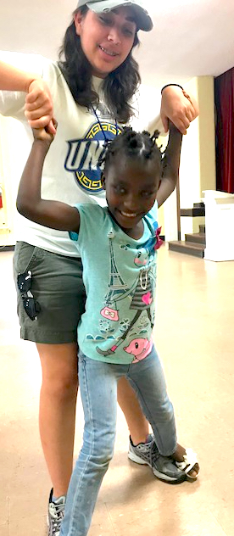
New Arrivals Institute (NAI), located at Peace United Church of Christ, seeks high school volunteers, ages 15-19, to help refugee and immigrant youth improve literacy skills through friendship, literacy and other activities. The Summer Literacy Art Music and Movement (SLAMM) program offers the opportunity to improve literacy in a fun, inclusive environment. SLAMM serves immigrant and refugee youth ages 6-15 summer weekdays from 9:00am to 1:00pm. Other activities for high school volunteers to help with include literacy, science, art, technology, dance, drama, soccer, Legos, and more.
Additional volunteer opportunities include serving in the NAI Preschool.

View the NAI website at www.newarrivalsinstitute.org and contact Lynn Thompson, Community Engagement Director, at NAI at lthompson@newarrivalsinstitute.com
