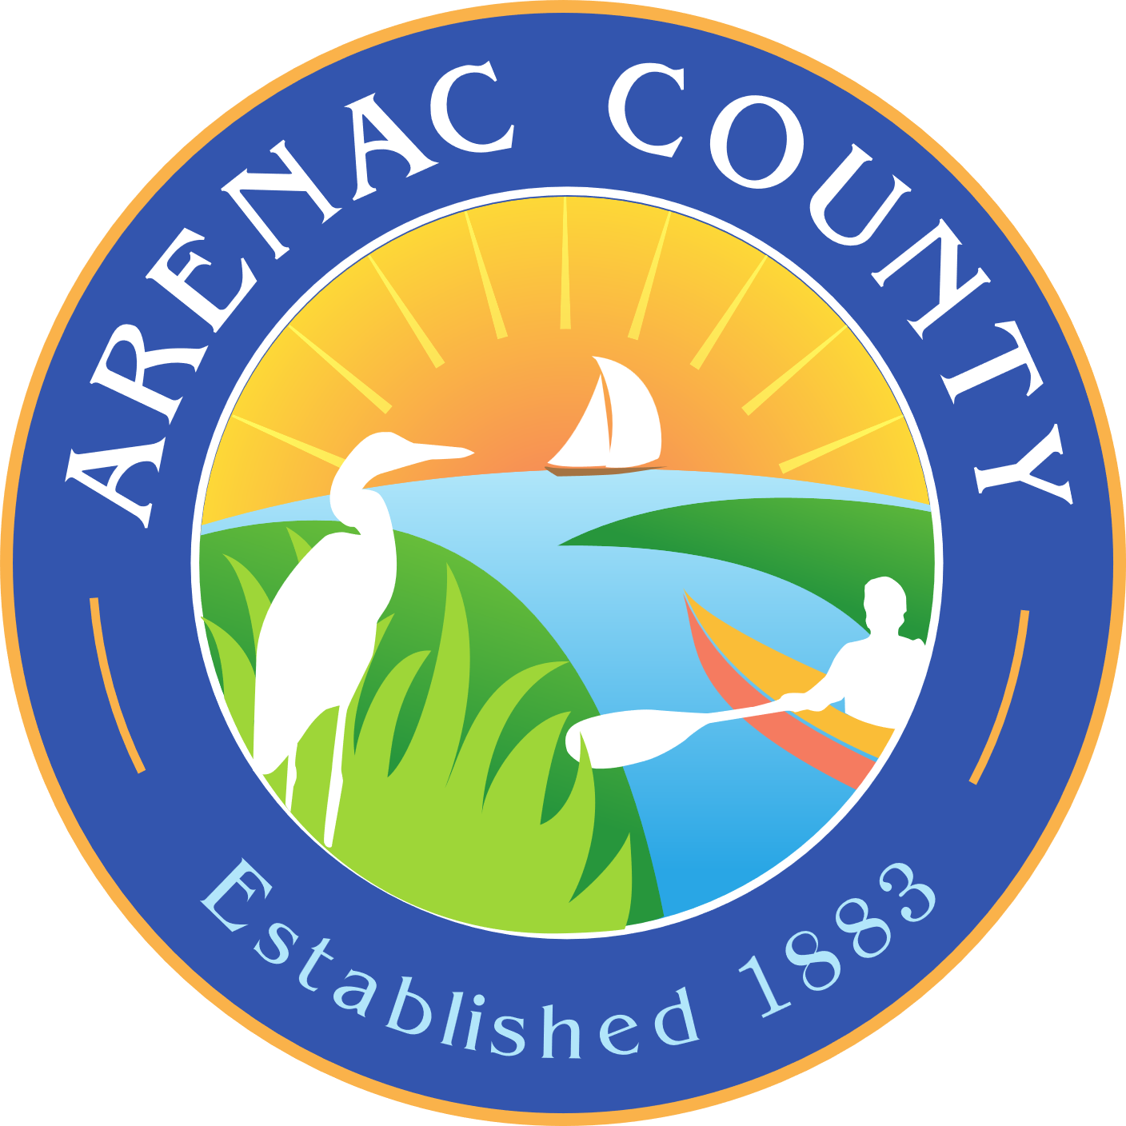**Arenac Conservation District**

4490 W. M-61, Standish MI 48658

PH: 989-846-4565 | Email: [arenaccd@gmail.com](mailto:arenaccd@gmail.com)

*This institution is an equal opportunity provider*

**APPLICATION FOR AN *EXTENSION* OF AN SESC PERMIT**

If a permittee is unable to complete the permitted SESC work within the permits’ specified time, they may apply in writing to the County Enforcing Agent for an extension *at least ten (10) days prior to the expiration date of the permit*. This permit extension application is for a 12 (twelve) month period.

LANDOWNER NAME:__________________________________________

PERMIT #: ____________________________________________________

Applicant name and address: __________________________________

Job site location: ______________________________________________

Describe the portion(s) of project not completed and the schedule for completion

**____________________________________________________________________________________________________________________________________________________________________________________________________________________________________________________________________________________________________________________________________________________________________________________________________________________**

Who is the “onsite” individual responsible for the remainder of the earth changes?

Name: _________________________________ Phone #: ________________________

Signature:______________________________ Date: ___________________________

Print Name: ____________________________

----------------------------------------- Agency Use Only ---------------------------------------------------

This request for a Soil Erosion and Sedimentation Control permit extension has been reviewed by the Arenac County Enforcing Agency, and is hereby issued in accordance

with Rule 1705(2) of Part 91.

Reviewed by: ____________________ Date:_____________________________