Arenac Conservation District
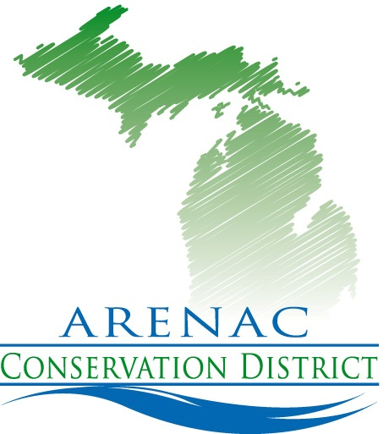
4490 W. M-61
Standish Mi. 48658
989.846.4566 ext. 5
www.arenacconservationdistrict.com

2019-20 Board Meeting Schedule
All meetings are open to the public
Meetings are at 9:30 a.m. at the Arenac Conservation District Office
Second Wednesday of the Month
Unless otherwise noted

October 9th
November 13th
December 11th
January 8th
February 12th
February Annual Mtg. 20^{th tentative}
March 11th
April 8th
May 13th
June 10th
July 8th
August 12th
September 9th

“Better Communities Through Strong Conservation”

