Arenac Conservation District
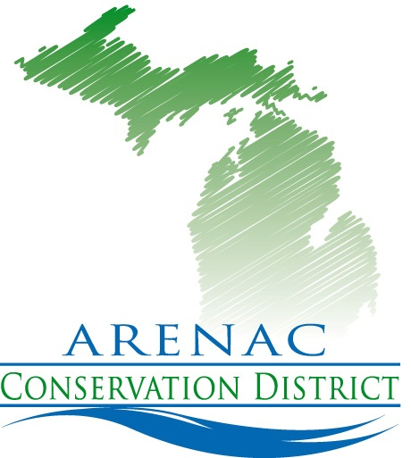
4490 W. M-61
Standish Mi. 48658
989.846.4566 ext. 5
www.arenacconservationdistrict.com

2020-21 Board Meeting Schedule
All meetings are open to the public
Meetings are at 9:30 a.m. at the Arenac Conservation District Office
Via zoom until further notice
Second Wednesday of the Month
Unless otherwise noted

October cancelled
November 12th
December 9th
January 13th
February 10th
February Annual Mtg. 18th
March 10th
April 14th
May 12th
June 9th
July 14th
August 11th
September 8th

“Better Communities Through Strong Conservation”

