Arenac Conservation District
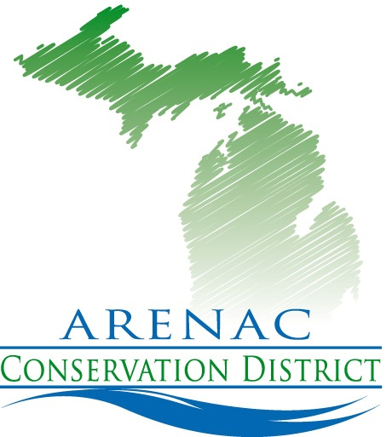
4490 W. M-61
Standish Mi. 48658
989.846.4566 ext. 5
www.arenacconservationdistrict.com

2021-22 Board Meeting Schedule
All meetings are open to the public
Meetings are at 9:30 a.m. at the Arenac Conservation District Office
Via zoom until further notice
Second Wednesday of the Month
Unless otherwise noted

October 13th
November 10th
December 8th
January 12th
February 9th
February Annual Mtg. 17th Tentative
March 9th
April 13th
May 11th
June 8th
July 13th
August 10th
September 14th

“Better Communities Through Strong Conservation”

