Arenac Conservation District
4490 W. M-61
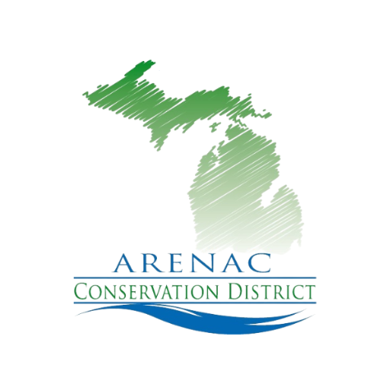
Standish Mi. 48658
989.846.4566 ext. 5
www.arenacconservationdistrict.com

2025-26 Board Meeting Schedule
All meetings are open to the public
Meetings are at 9:30 a.m. at the Arenac Conservation District Office
Second Wednesday of the Month
Unless otherwise noted

October 8th
November 5th
December 3th
January 16th
February 11th
February Annual Mtg. 19th
March 10th
April Tree sale time no meeting
May 13th
June 10th
July 8th
August 12th
September 9th

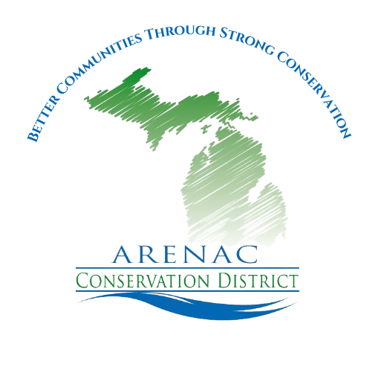

“Better Communities Through Strong Conservation”

