

ARENAC CONSERVATION DISTRICT
4490 W. M-61 Standish, MI 48658
Phone: 989-846-4565 ext. 5
e-mail: arenacsescpermits@gmail.com
This institution is an equal opportunity provider.

Soil Erosion and Sedimentation Control (SESC) Application Packet
THE FOLLOWING ITEMS ARE REQUIRED BY PART 91 OF THE NATURAL RESOURCES AND ENVIRONMENTAL PROTECTION ACT 451 OF 1994 PRIOR TO OBTAINING A PERMIT
Check off items included on drawing, site plan, and/or construction schedule
☒ 1) Final design plan detailing all items of work.
☒ 2) Map or site plan scaled down to no more than 200 feet per inch showing all predominant land features, physical structures, contour intervals, and distance from the earth change to nearby drains, lakes, or streams.
☒ 3) Written description of soils at the affected area.
Percentage of Each Soil Type: SAND __X__CLAY ______LOAM______OTHER_____
☒ 4) Legal description of the site indicating legal ownership.
☒ 5) Description and location of the physical borders/limits of the proposed earth change.
☒ 6) Listed sequence of each proposed earth change activity and the estimated time required to complete each. (See attached SESC Installation & Construction schedule)
☒ 7) Description and location of all existing and proposed drainage and dewatering facilities, such as culverts.
☒ 8) Location and description of all proposed temporary SESC measures, including estimated installation and removal dates.
☒ 9) Description and location of all proposed permanent SESC measures (seeding, riprap, etc.) including the estimated installation date.
☒ 10) Program proposal for the continued maintenance of all permanent SESC measures, including the person responsible for maintenance.

*Issuance of a Soil Erosion and Sediment Control permit does not alleviate the permittee against possible additional permits & violations from outside agencies including the Department of Environment, Great Lakes & Energy, the Army Corps of Engineers, local associations, municipalities and /or townships.

Arenac County Fee Schedule for SESC Part 91 Permits
RESIDENTIAL STRUCTURES (SITE INSPECTION, PLAN REVIEW & PERMIT FEE)
HOUSE, GARAGE, ACCESSORY BLDG, ETC UP TO 1 ACRE ……………………….……..….$90.00
EACH ADDITIONAL ACRE OR FRACTION THEREOF….………………………….…………..$40.00
RESIDENTIAL DECKS (If post holes not re-established within 24 hours)……………..…….…. $45.00
PONDS (up to 1 acre),
SOIL STRIPPING, TOPSOIL REMOVAL, MINING (including sand) .………………….…..........$90.00
ADDITIONAL ACRE OR FRACTION THEREOF………..……...…..…………..…….…………...$40.00
SHORELINE PROTECTION/STABILIZATION
SEAWALLS UP TO 100’ ……………...………………………………………………….……….…... $75.00
EACH ADDITIONAL 10’ …..…………….…………………..……………………………………..... $10.00
BOAT SLIP UP TO 300’ ………..…..……………………………………………………………….… $75.00
EACH ADDITIONAL 100’ …………………………………………………………………………… $20.00
RIP RAP UP TO 100’ …………..………………………………………….………..……………….… $75.00
EACH ADDITIONAL 10’ …………………………………………………..………………….…..…..$10.00
BEACH NOURISHMENT UP TO 100’………..………………………………………….……….… $75.00
EACH ADDITIONAL 10’ …………………………………………………..………………….….…..$10.00
COMMERCIAL, INDUSTRIAL PROJECTS
SUBDIVISIONS, MOBILE HOME PARKS, MULTIPLE HOUSING UNITS, RECREATIONAL & SERVICE FACILITIES………………..……………………………………………………………. $250.00
EACH ADDITIONAL ACRE OR FRACTION THEREOF………………………………............…$70.00
UTILITIES (up to ½ mile)
UNDERGROUND PIPELINES, CABLES, WATER MAINS & SEWERS ..……..…………….….$175.00
EACH ADDITIONAL MILE OR FRACTION THEREOF …….…………….……….……………..$70.00
TRANSPORTATION FACILITIES (up to ½ mile)
RAILROADS, AIRPORTS & TRAILS……………………....................................................……….$175.00
EACH ADDITIONAL MILE OR FRACTION THEREOF...................................................………...$70.00
SPECIAL PROJECTS, INCL. CULVERT EXTENSIONS (up to 1 mile)……………………………….$150.00
EACH ADDITIONAL MILE……………………..…………………………………………………….$60.00
Listed permit fees apply to permits issued for a period of one year. Permits issued for a period of between one and two years shall pay a fee equal to 1.5 times the applicable fee. Permits issued for a period of between two and three years shall pay a fee of 2 times the applicable fee.

FEES MAY BE DOUBLED FOR ANY WORK STARTED WITHOUT A PERMIT.
Mail, email, or deliver all completed application forms including all required forms to Arenac Conservation District at 4490 W. M-61, Standish, MI 48658.
For more information, call 989-846-4565 ext. 5 or email arenacsescpermits@gmail.com
Make checks payable to “Arenac Conservation District”
Payments can be made online at the Arenac Conservation District website.

Permit Application for Part 91 Soil Erosion and Sediment Control
All application fields must be completed. Incomplete forms will be returned. PLEASE read carefully.
- APPLICANT CONTACT INFORMATION
Property Owner
Landowner (First and Last Name)
123 Home Address  Landowner Mailing Address |  |  |  |  |  |  |  | Property.owner@sesc.com  E-mail Address
Home Township  City/Township/Village |  |  |  |  | MI  State | 0000  Zip Code |  | (000)-000-0000  Phone Number
Permit Applicant
Designated Agent (if different from landowner; requires attached Designated Agent Statement)
123 Company Address  Designated Agent Mailing Address |  |  |  |  |  |  |  | d.agent@business.com  E-mail Address
Company City  City/Township/Village |  |  |  |  | MI  State | 00000  Zip Code |  | (000)-000-0000  Phone Number
- PROJECT LOCATION
Information available on your property tax forms under the property legal description
123 Project Site  Street Address |  |  |  |  |  |  | 000-0-000-000-00  Parcel Tax Identification # (PID)
20  Section | 19N  Town (T) | 4E  Range (R) |  | Arenac County Subdivision  Subdivision |  |  |  |  |  | 5  Lot No.
Deep River  Township |  |  | Sterling  City/Village |  |  |  |  |  | Arenac  County
- PARTIES RESPONSIBLE FOR CONTROL PLAN AND EARTH CHANGE
Project Manager  Plan Preparer’s Name |  |  |  |  |  |  | (000)-000-0000  Plan Preparer Phone #
Construction Foreman
On-Site Individual Responsible for Earth Change
123 Company Address  Mailing Address |  |  |  |  |  |  |  | p.manager@business.com  E-mail Address
Company City  City/Township/Village |  |  |  |  | MI  State | 00000  Zip Code |  | (000)-000-0000  Phone Number

- PROPOSED EARTH CHANGE
Project Type
☒ Residential | ☐ Multi-Family |  | ☐Commercial |  |  | ☐Municipal
☐ Industrial | ☐ Land Balancing |  | ☐ County Drain |  |  | ☐Special Project
Project Description (what are you doing?)
Building new Home and Garage
4,000  Size of earth change (sq .ft) |  | 6/1/2050  Date Project to Start |  |  | 5/31/2051  Est. Date of Completion
N. Branch Pine River  Name of nearest lake, stream, or drain |  | 500  Distance from project (ft) |  |  | WRP000000 v.1  EGLE Permit # (if applicable)

SESC INSTALLATION AND CONSTRUCTION SCHEDULE
List estimated day, month, and year of completion. Refer to page 5 for guidance
Temporary SESC Measures Installed (silt fence, inlet protections, etc.)  Install silt fence to contain sediment |  |  |  |  |  | Est. Start Date  6/1/2050
Land Clearing Activities (top-soil removal, brush clearing, etc.)  Remove trees and shrubs from site |  |  |  |  |  | Est. Start Date  6/15/2050
Foundation Excavation and Site Work Activities  Break ground and lay foundation |  |  |  |  |  | Est. Start Date  6/16/2050
Est. Construction Start Date  6/17/2050 |  |  | Est. Topsoil Spread/Final Grade Date  6/17/2025
Permanent SESC Measures Installed (sod, stone, seed, mulch, etc.)  Install sod and mulch |  |  |  |  |  | Est. Installation Date  9/9/2050
Temporary/Permanent SESC Measures Removed  Remove silt fence |  |  |  |  |  | Est. Date of Removal  9/15/2050
Who is responsible for re-vegetation and ongoing maintenance of the site?
☒ Owner ☐Contractor ☐Other Party _______________
Additional steps and dates pertinent to the project but not listed above

Provide a written description of your proposed maintenance plan for all permanent SESC measures.
Attach separate sheet if necessary.
The owner will water the seed and mulch until grass stabilizes. See attached maintenance plan for more detail

Landowner or Designated Agent:_______________________________________________
Today’s Date:_____________________

By signing this document, you grant County Enforcing Agent access to the site to ensure compliance with part 91 regulations.

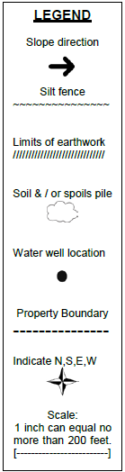
Construction Site Plan
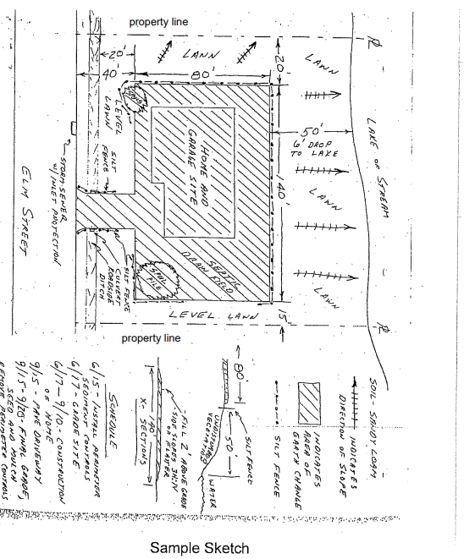

Directions to Site and Instructions for Access:


Arenac Conservation District
4490 W. M-61, Standish MI 48658
PH: 989-846-4565 | Email: arenaccd@gmail.com
This institution is an equal opportunity provider

DESIGNATED AGENT STATEMENT

The State of Michigan requires each Authorized Agent applying for a Soil Erosion and Sediment Control Permit on behalf of another person to include a statement authorizing him/her to secure such a permit.
Please have the landowner complete this "Letter of Authorization" to be submitted with the Application Form.
_________________________is authorized to secure a Soil Erosion Permit in my name for a
(Designated Agent)
project requiring said permit at ____________________________________________________
(Address of Project Location)
located at _____________________________________________________________________.
(Township, City or Village)
I understand that I am responsible for all earth changes related to this project and understand that Act 451, Part 91 may be enforced against me in the event of any violation of that Act.

Print Name of Landowner:______________________________

Signature of Landowner:________________________________

Date:__________________________

