# Rehabilitation of Atrophic Maxilla using Pterygoid Implants

Restoration of a severely atrophic jaw presents a challenge in dentistry. Bone augmentation is usually required in the posterior maxilla to enable placement of a sufficient number and length of implants to support an implant prosthesis due to the poor bone quality of the posterior maxilla.

The recent invention of new surgical techniques and implant systems help circumvent the current restorative problems and provide a solution to erstwhile un-rehabilitated cases. The use of ROOTT pterygoid implants in the pterygo-maxillary region provides posterior bone support without sinus augmentation or supplemental grafts

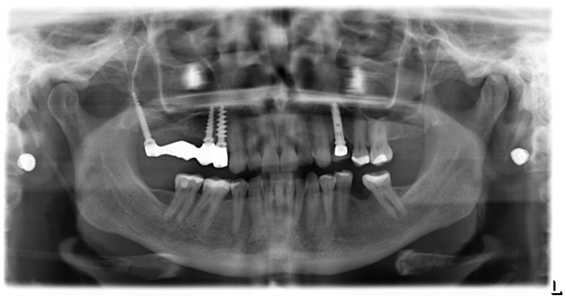

Pterygoid implants provide strong cortical anchorage in the maxilla. It is an alternative treatment option for patients with highly atrophic maxillae without the need for extensive augmentation procedures. The availability of dense cortical bone for engagement of the implant encourages its use. The location of the posterior implant is dictated by the dimensions and quality of the tuberosity.

The mesiodistal angulation of the implant is dictated by the angle of the posterior wall of the sinus and its proximity to the posterior wall of the tuberosity. The bucco-palatal angulation of the implant is dictated by the bone segments to be engaged. Previous studies show that Pterygoid implants have high success rates, similar bone loss levels to those of conventional implants, minimal complications and good acceptance by patients (Balshi TJ, Wolfinger GJ, Balshi SF. Analysis of 356 pterygomaxillary implants in edentulous arches for fixed prosthesis anchorage. Int J Oral Maxillofac Implants. 1999;14(3):398-406.).

Two anatomic locations in which implants are placed in the retromolar area can be distinguished in the literature, these are the pterygoid process and the pterygomaxillary region. Implant lengths and angulations vary between these two locations.

Though the results are promising, case selection is very important and a thorough understanding of the pitfalls of the procedure should be borne in mind. The lack of need for maxillary sinus lift and grafting procedures shorten the treatment time considerably and allow immediate loading of the pterygoid implant (Bidra AS, Huynh-Ba G. Implants in the pterygoid region: a systematic review of the literature. Int J Oral Maxillofac Surg. 2011;40(8):773-781.).