Your Power, Our People,
the Worlds Defense
In More Ways Than One

QUARTERLY 3 REPORT

August 1, 2018

PREPARED FOR:
FACEBOOK, INC

PROJECT COMPLETED BY:

KATHLEEN K. WATERS, MS PSYCHOLOGY

COLONEL BRYAN DENNY (RET.), MA STRATEGIC STUDIES, AND MA MILITARY ART AND SCIENCE

INTRODUCTION
The following review is the third quarter summary from May 1, 2018 to July 31, 2018, resulting from the initial meeting held with Facebook on October 18, 2017. As previous quarterlies showed, this report will not provide numbers and percentages of what accounts were found, deleted and remained due to the change in Facebook response of reported accounts since June 1, 2018. The quarterly will be able to provide the amount of fraudulent accounts found in regard to Bryan’s photos, the photos used, and on how many occasions since starting the Media Partner Support Program (portal). The report will also include data on the Yahoo Boys and like accounts, previous meeting follow-ups, along with Instagram results, anti-scam group updates, education and future targets.

MEDIA PARTNER SUPPORT PROGRAM
On November 1, 2017, the Media Partner Support Program had been implemented with Col. Bryan Denny’s (Ret.) personal account. Since the last quarterly presented on May 1, 2018, the reporting response notification is no longer being offered to the “general” reporters (Implemented on June 1, 2018). Accurate numbers of reported accounts provided by Kathy could not be determined, therefore a show of process improvement or lack of progress could not be furnished.

ACCOUNTS FOUND
As mentioned, Facebook no longer informs reporters of any successful removal of accounts or if accounts are considered “within Community Standards”. Since May 1, 2018 there were 159 accounts found and documented. Monthly reports to the Facebook team ceased due to change in the reporting process.

COMMONLY USED PHOTOS
Last reported by the Facebook team, 22 of Bryan’s photos commonly used by scammers were flagged to help prevent the duplication of accounts and Bryan’s stolen identity. A spreadsheet will be provided of filched photographs used as profile pictures by scammers belonging to Bryan at the end of this quarterly. The photos and metrics are offered to use as a guide to show the most commonly used photos, and which to flag for future fraudulent account creations. Please refer to the 2nd quarterly numbers to help determine which photos are being used more and less than the previous quarter. The documented photos are from May 1, 2018 to July 31, 2018. The identification of the flagged photos continues to be unknown to Kathy and Bryan post several requests to the Facebook team. Not having this information makes it impossible to know which photos are “slipping through the cracks” and which need to be flagged for the ”portal”. Of the 159 accounts found, 144 accounts contained Bryan’s photos as the profile, the other 15 accounts used Bryan’s photos as the background to the accounts.

INSTAGRAM
For the months of May through July, 12 accounts were found on Instagram with Bryan’s picture as the primary account holder; containing a total of 685 followers.

ANTI-SCAM GROUPS
There are currently 152 Anti-Scam Groups that Kathy is a member of, 6 of which were recently placed in archives. Kathy has joined an additional 6 anti-scam groups since the Second Quarter report. Any updates (meetings, goals met or updated education) that are created on the open petition are then posted to each scam group. There has been an update posted approximately every 2 to 3 weeks, and feedback continues to be well received. Kathy has since built her own Facebook page which she posts to on a weekly basis.
YAHOO BOYS
On March 23, 2018, Payton Iheme, Policy Advisor, emailed Bryan and Kathy in regard to the Yahoo Boys and “making some strides against this group”. On July 8, 2018, the Facebook team was sent via email, a list containing approximately 66 “like” accounts of the Yahoo Boys. These accounts were removed rapidly once the list was provided directly to the team. Kathy and Bryan continue to stand by for an update on this matter.

MAY 4th MEETING FINDINGS
The mentioned findings were presented in a letter to the Facebook team on May 22, 2018. Bryan and Kathy are awaiting answers back to the following:
- Multiple Accounts
- Flagged Pictures
- Cropped and Shaded Photos
- Linked Photos
- Group Concerns
- New Dating Sites

MULTIPLE ACCOUNTS
During the May 4, 2018 meeting at Facebook Headquarters, Kathy asked the Facebook Representative why the ability to build multiple accounts remained an option to Facebook users, since this type of action can be found in Facebook’s own Policies at https://www.facebook.com/help/1735443093393986?helpref=hc_global_nav stating, “It's against the Facebook Community Standards to maintain more than one personal account.”
Attached below are photo’s showing the step by step process of how Kathy built an additional account through Facebook. The process showed to be “unpretentious” and created in a matter of minutes.
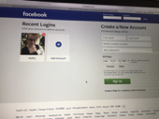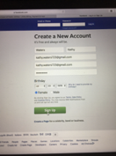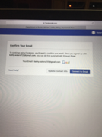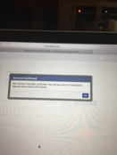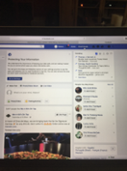
FLAGGED PICTURES
After creating an additional account under the name Waters Kathy (https://www.facebook.com/waters.kathy.7), Kathy opted to use Bryan’s top two utilized photos by scammers to open fraudulent accounts. Kathy built this account on May 6, 2018. To this day, the profile remains active. The Facebook Representative on May 4th 2018, explained when the pictures are entered into the portal, they act as a “fingerprint” to future posts of the same pictures. This is when the portal is to recognize and cease the fake, duplicated accounts.
Kathy used Bryans’ uniform photo as the profile picture and a photo of Bryan in a blue shirt as the background. The pictures utilized were copied directly from Bryans’ account. The images were not shaded nor cropped yet were still not recognized as stolen. According to multiple Facebook team members, untampered photos were the only way the facial recognition program would work effectively. See photos below.

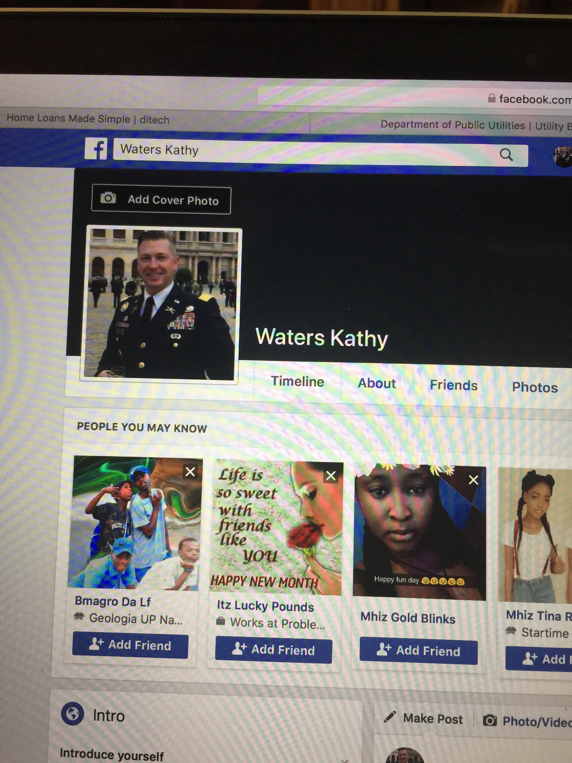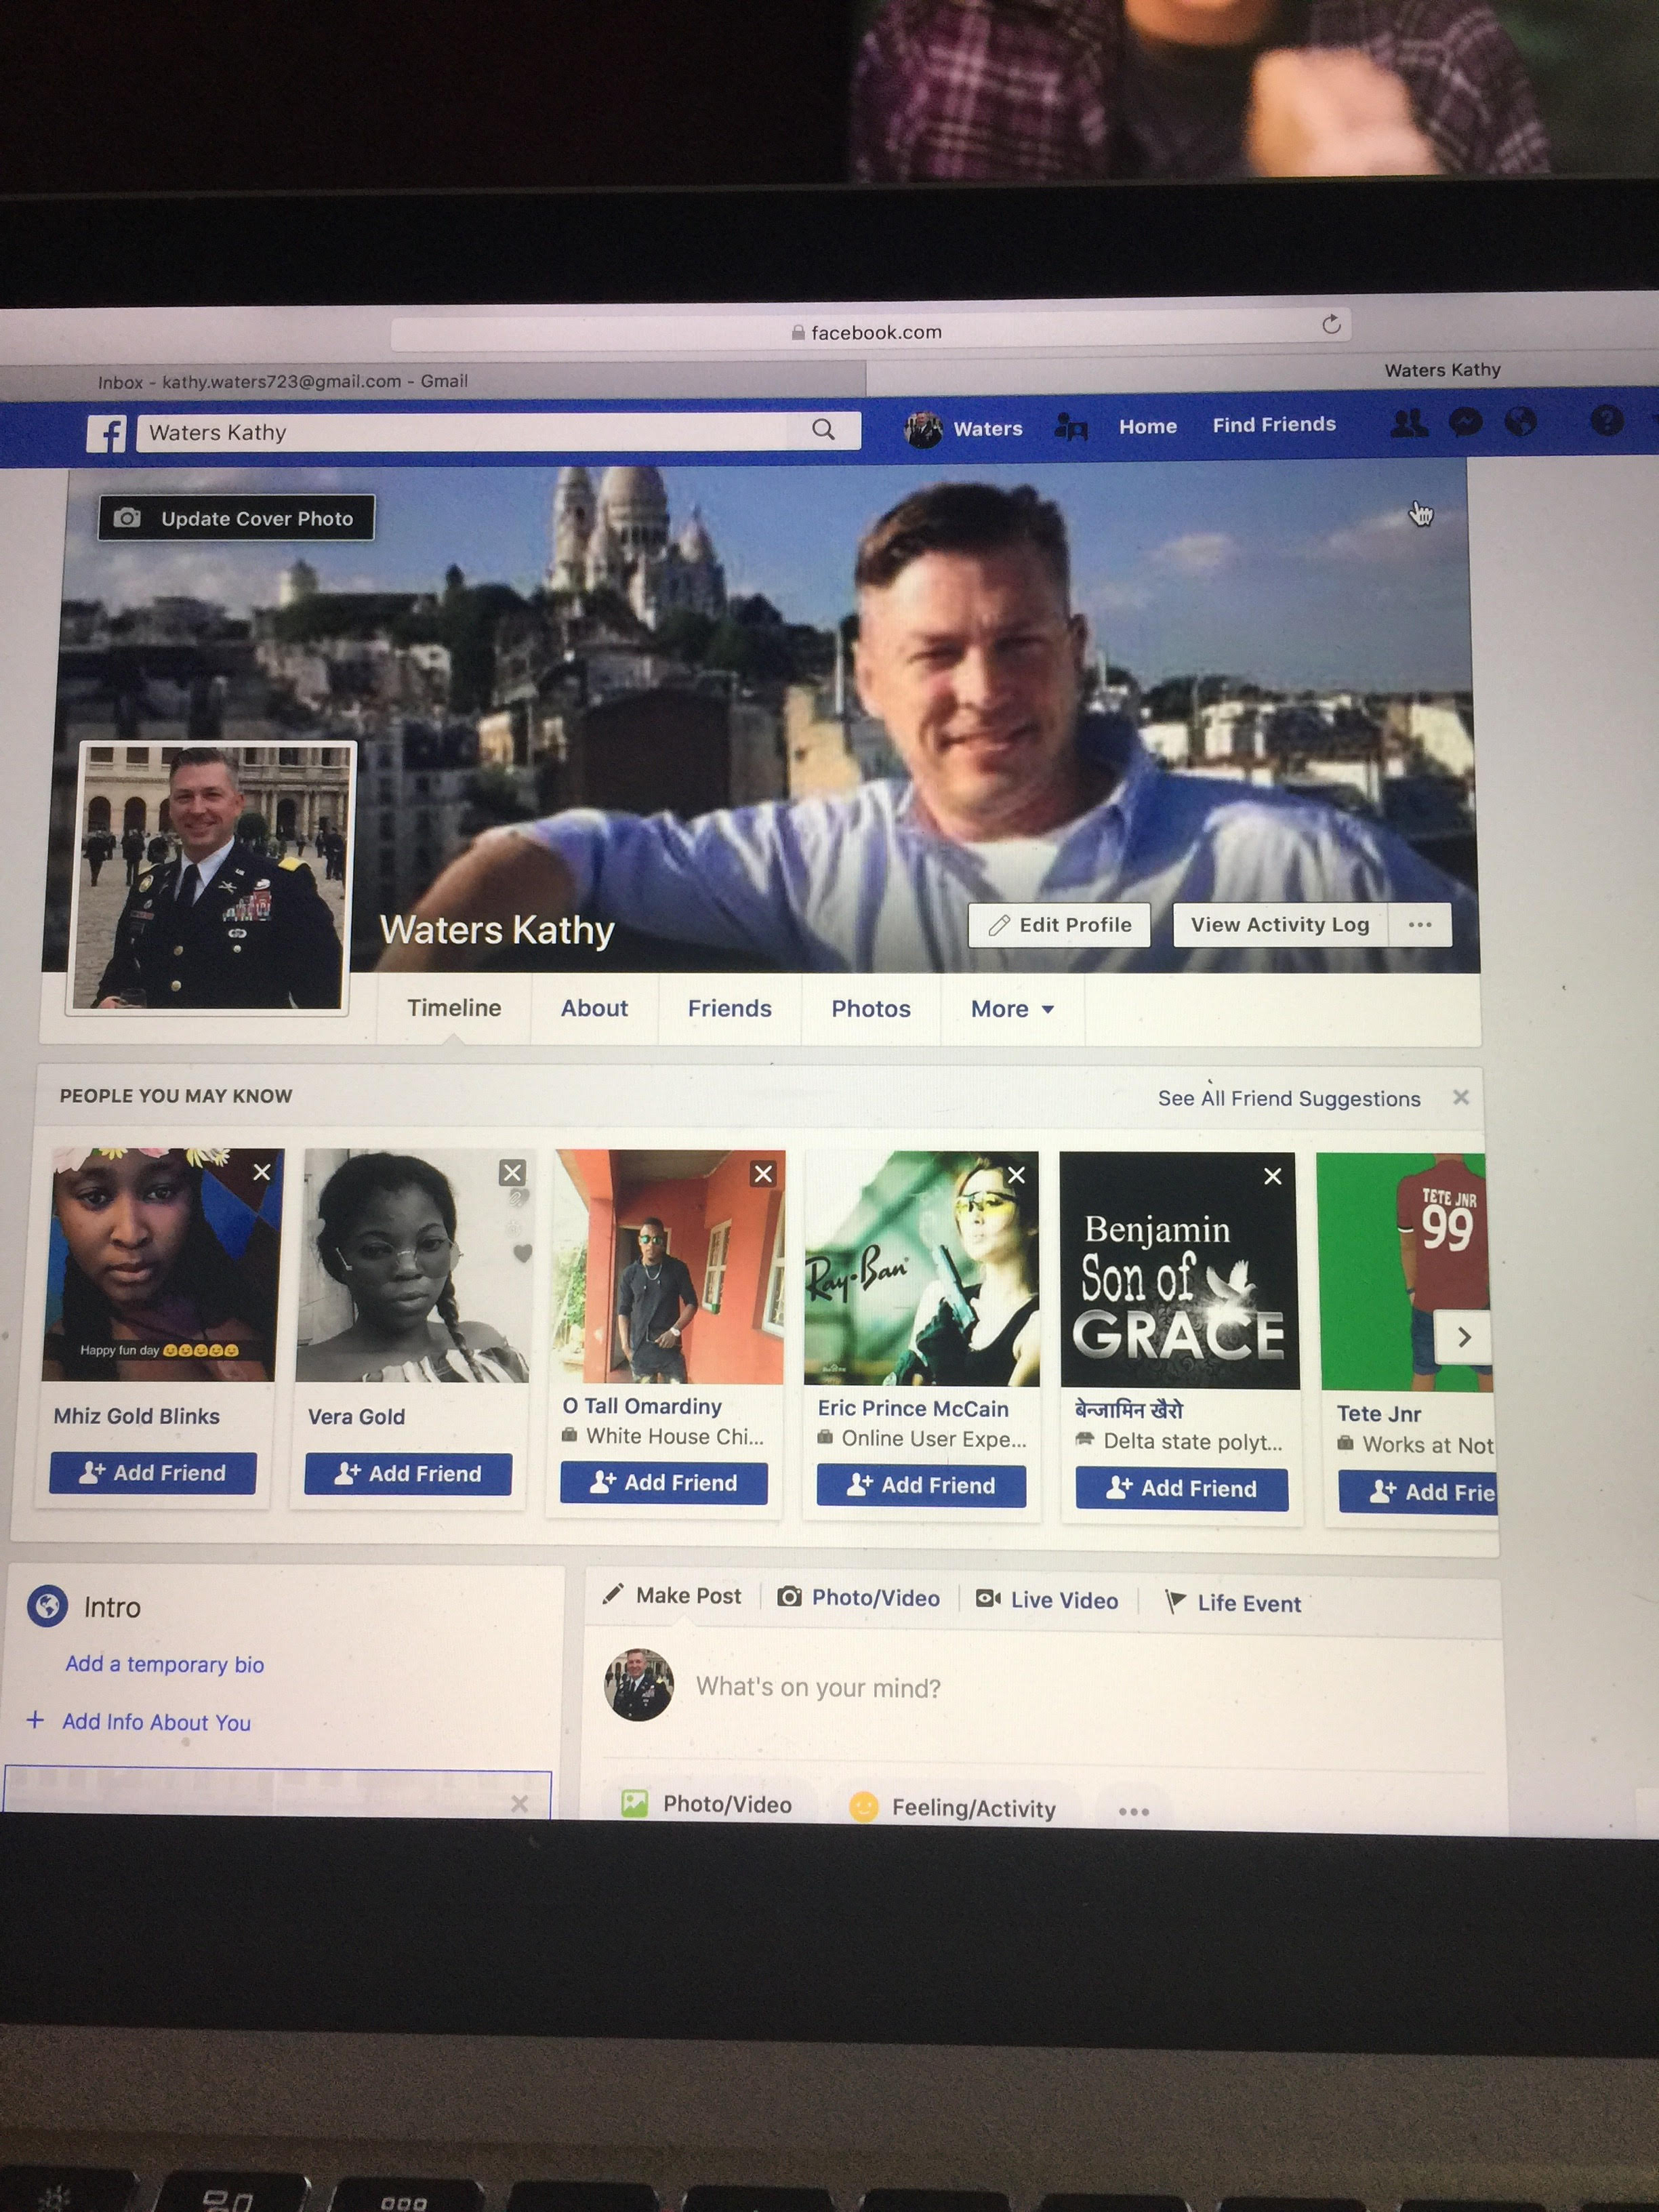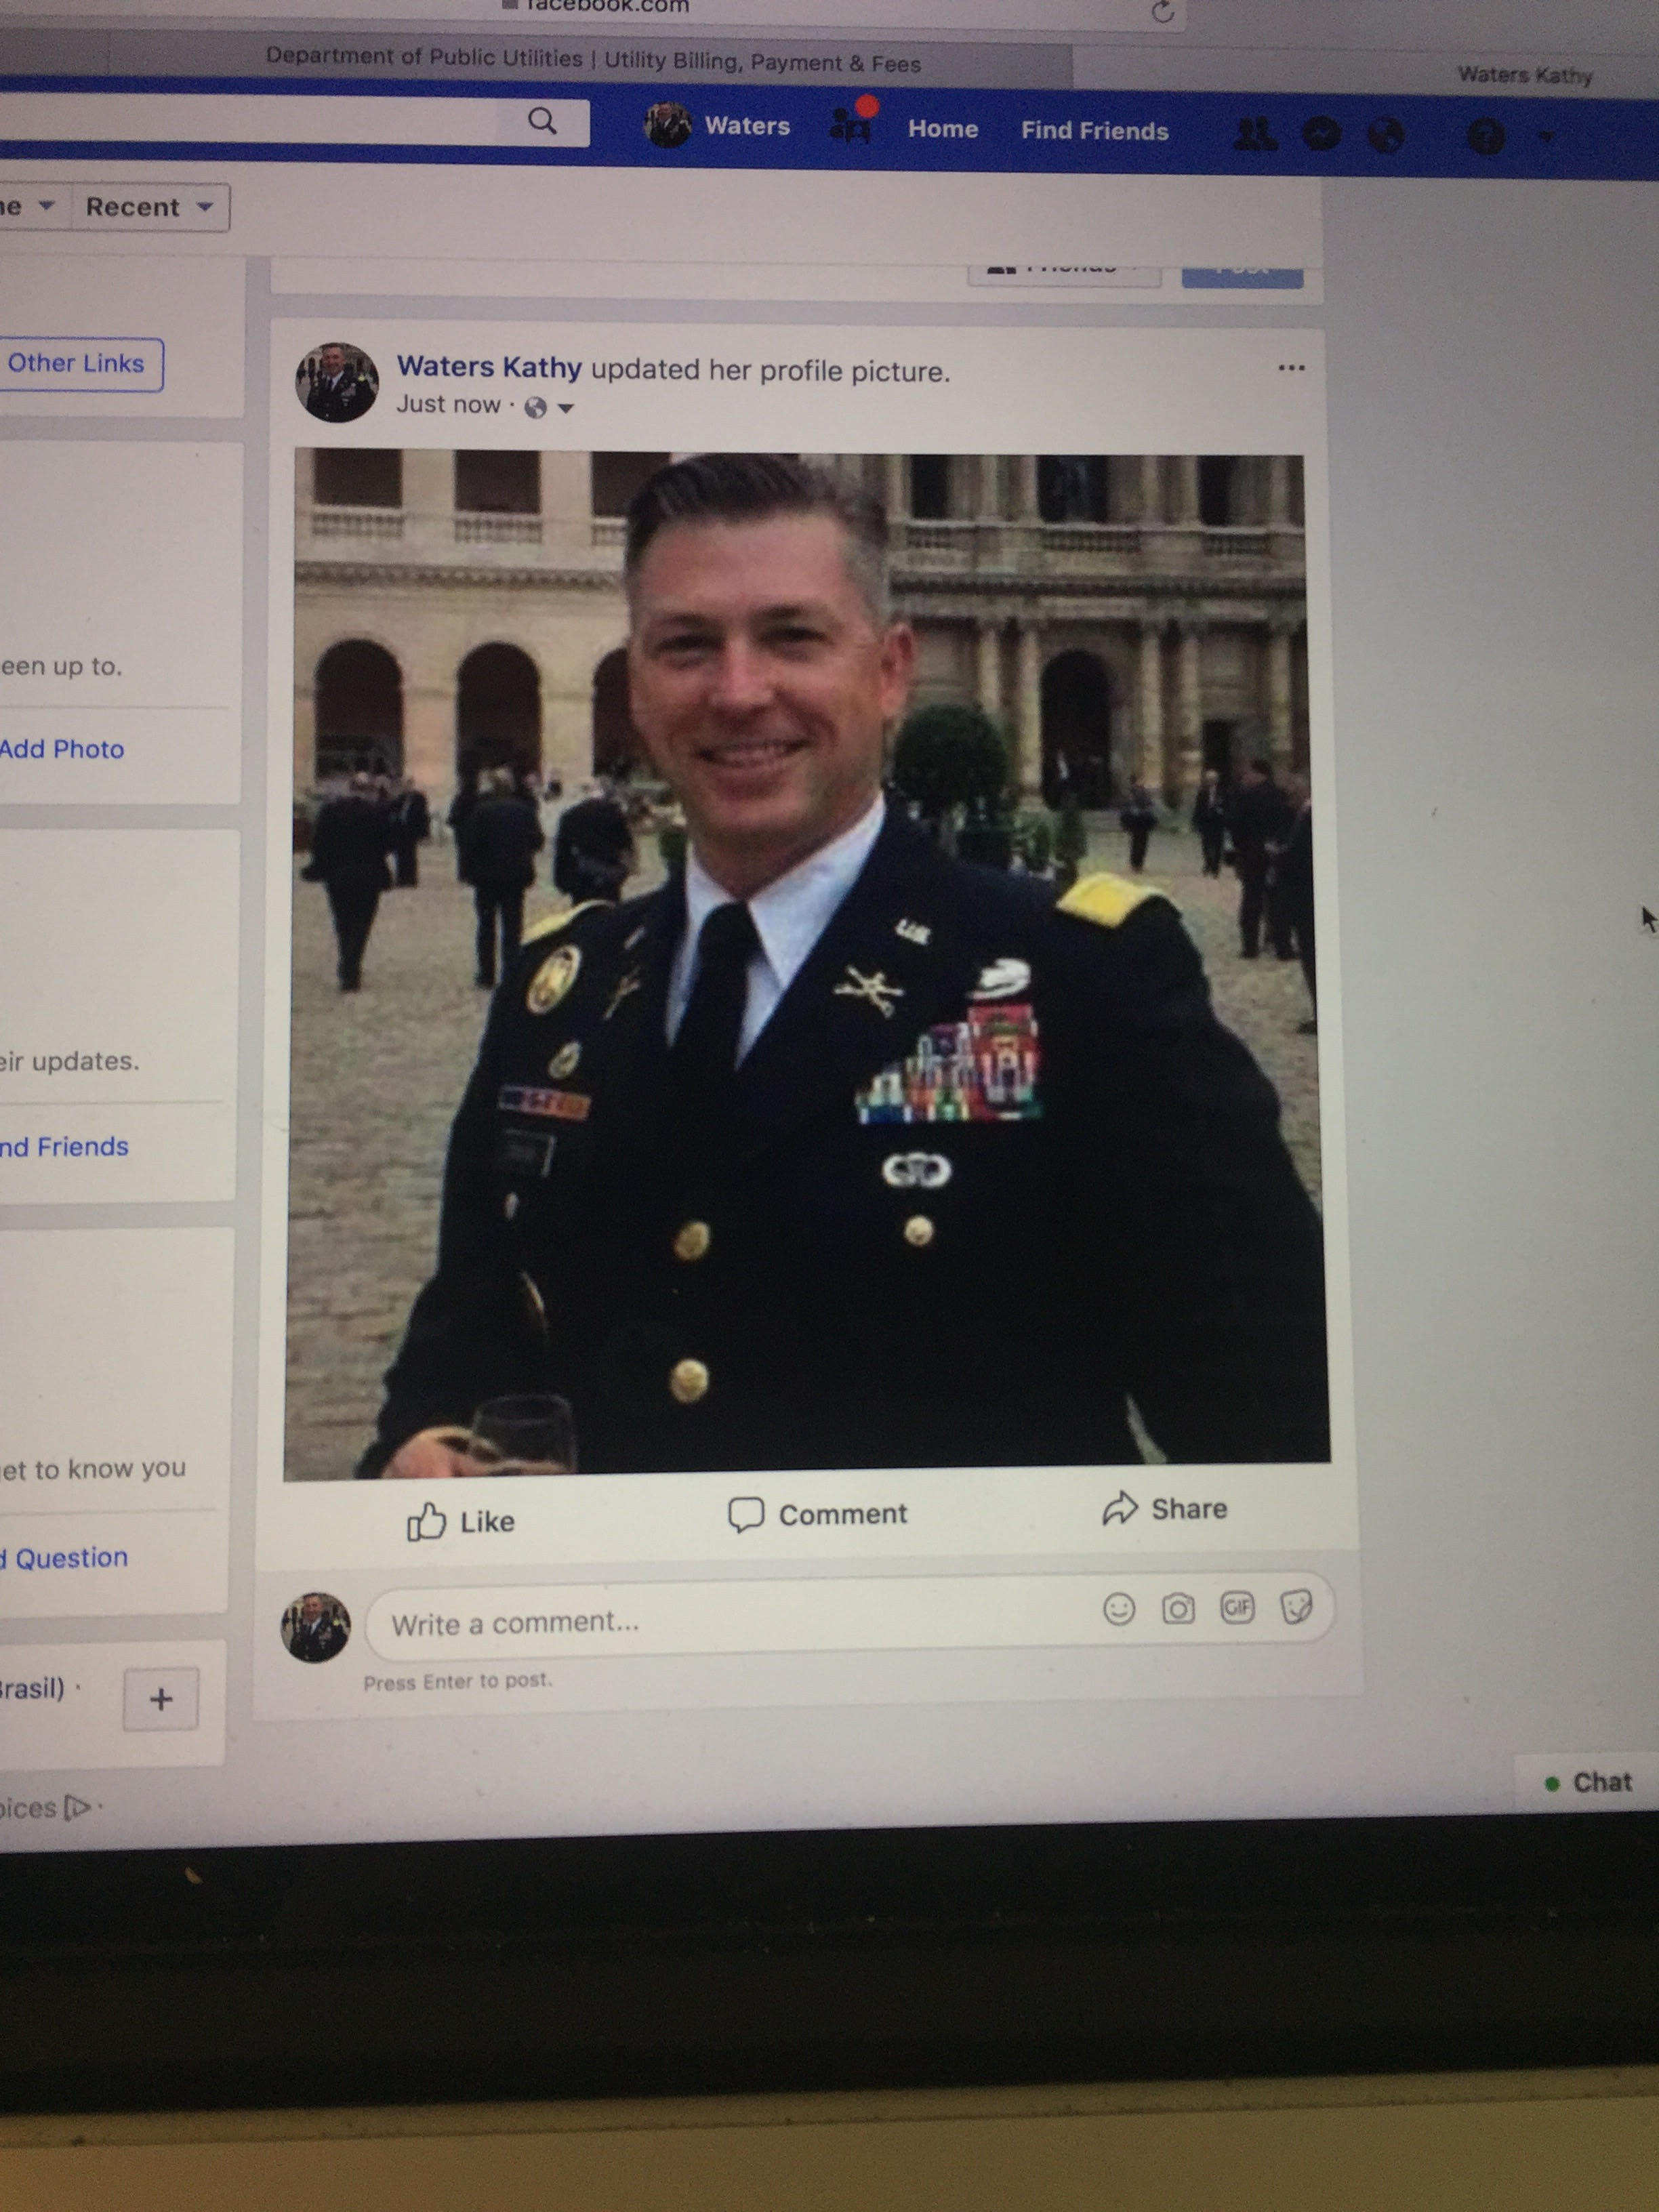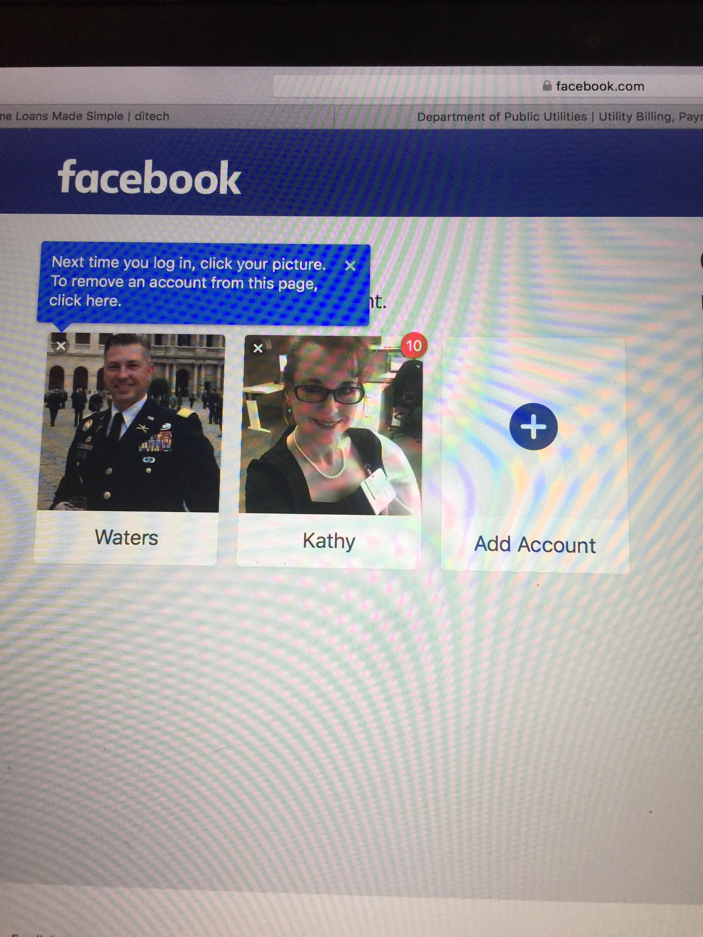

CROPPED AND SHADED PHOTOS
After Bryan and Kathy were informed at the meeting on March 1, 2018, that the facial recognition program is not effective if a photo is cropped or shaded, Kathy proceeded with her own investigation. Kathy copied Bryans’ military photo from his personal Facebook site, and cropped the photo horizontally and laterally, making the picture wider and narrower. Both times Kathy proceeded to post Bryans picture onto Facebook after each crop, Facebook recognized Bryans’ face immediately and tagged his name upon his picture (see pictures below). Kathy also took the same photo and turned it from color to black and white. After attempting to post the photo, Bryans’ face was again recognized by Facebook technology, and his name appeared (tagged) upon his picture (see picture below). Kathy is aware that Bryan is on her friends list, however with the picture being cropped or shaded, and the information told by the Facebook team, Bryans’ picture should not have been familiar to the facial recognition technology.

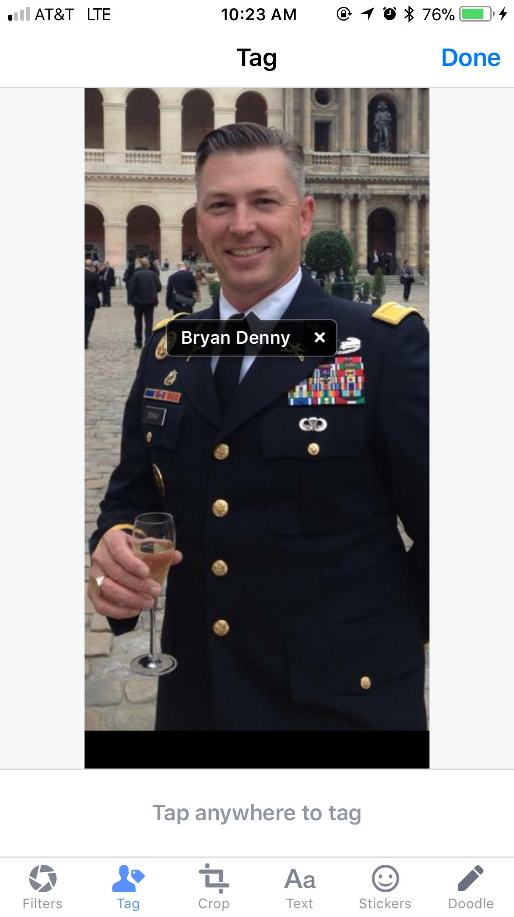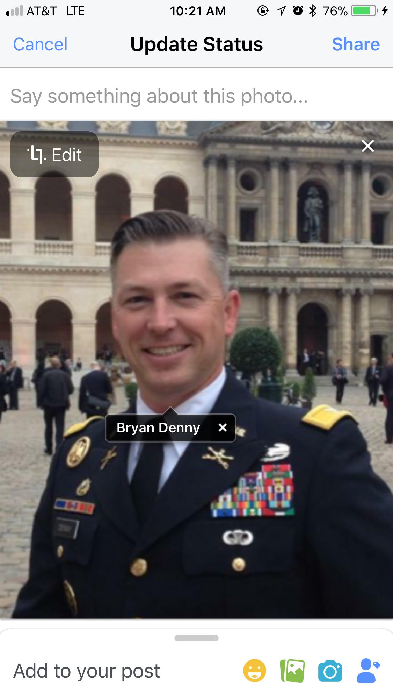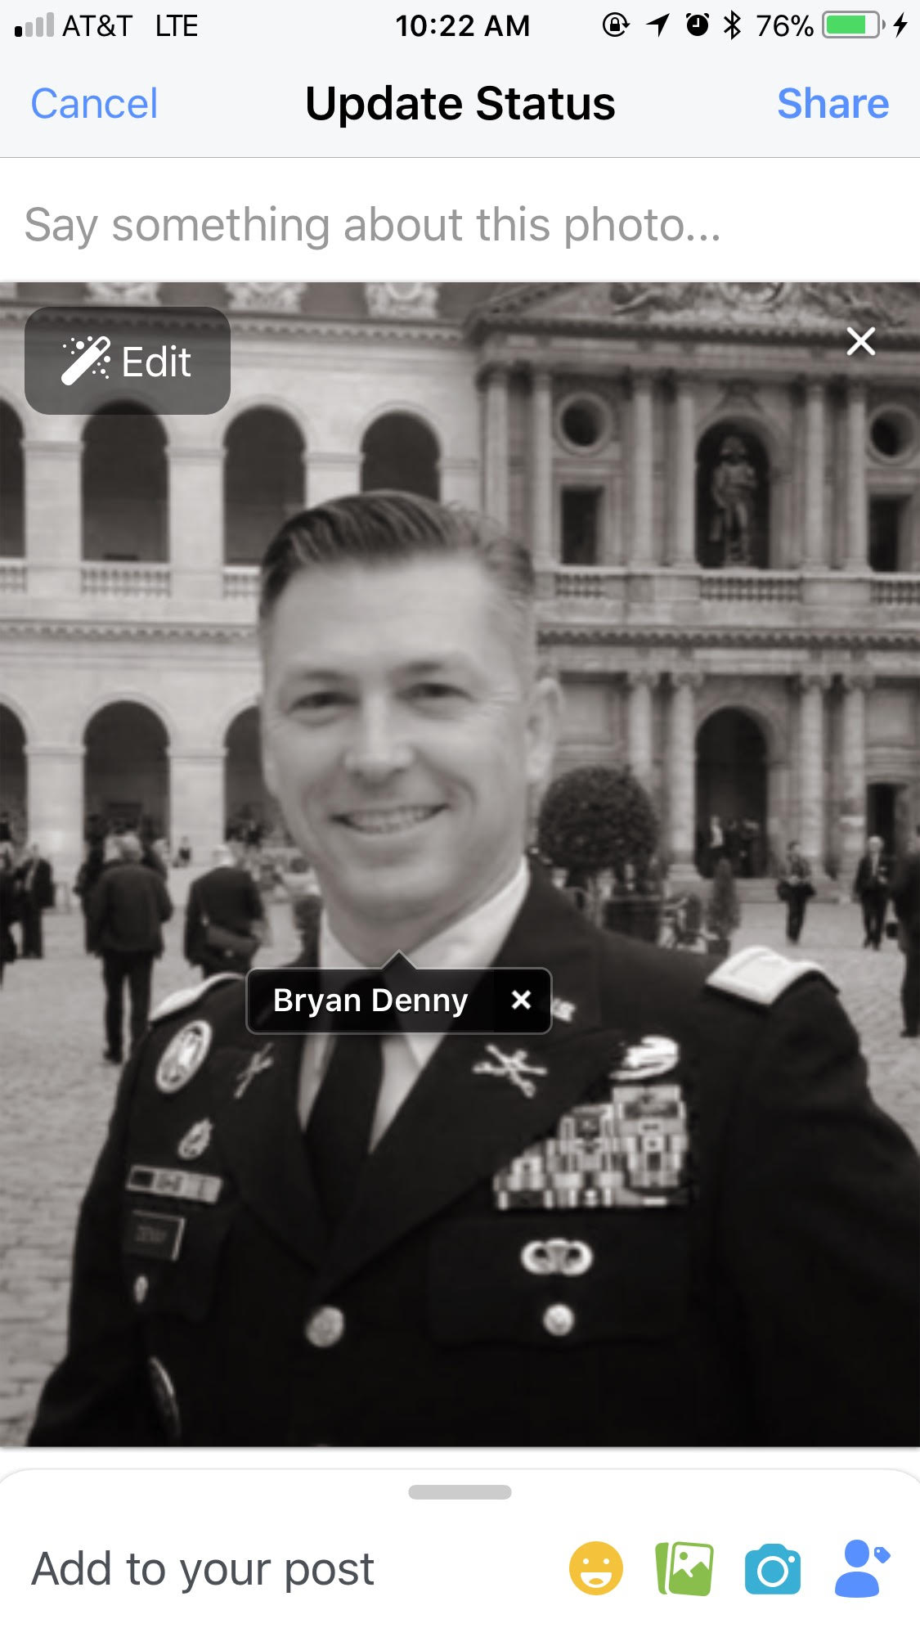

LINKED PHOTO
Upon creation of the account with Bryan’s photo’s, Kathy noticed that the options of: people I may know, city choices, school options, and places of employment under the section of Background Info, were all from Nigeria. Kathy (as the account creator) does not have any ties to Nigeria upon her primary account, therefore the only other item used to link these options were Bryans’ photos. Not only was the account not recognized as a fake by the flagged photos used, but it was also linked to the country that many of the fake account builders reside and that use Bryan’s photos to aid in their scamming activity.

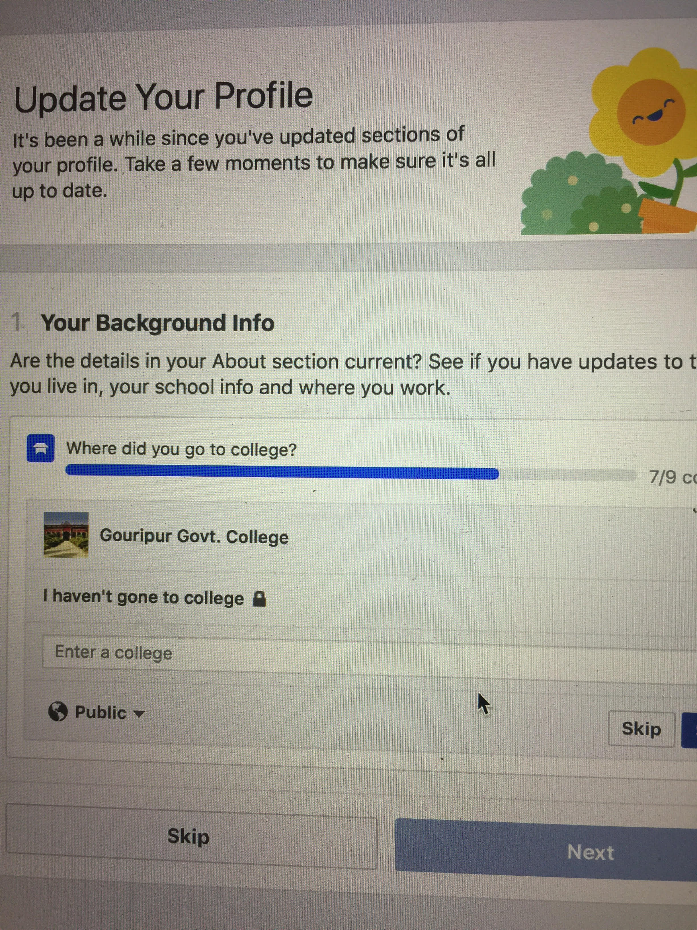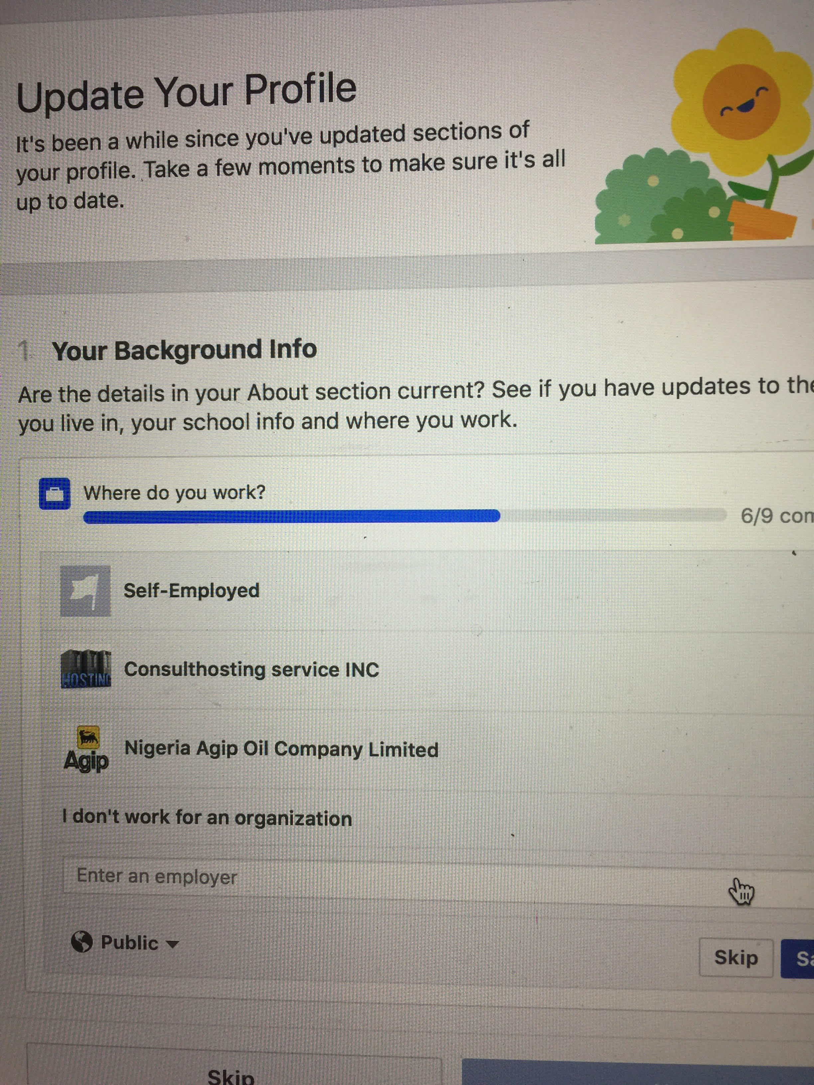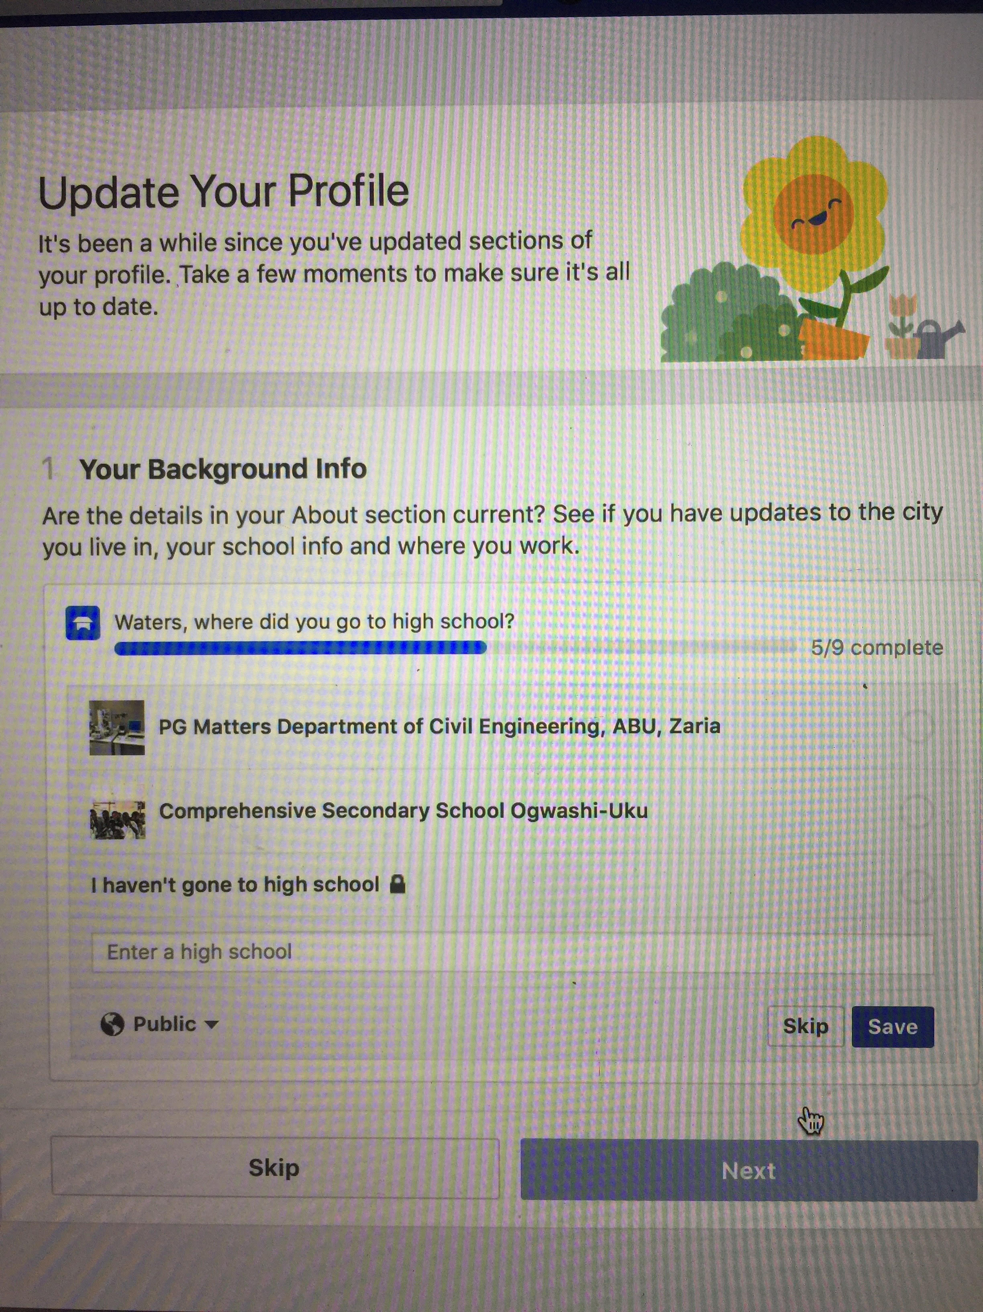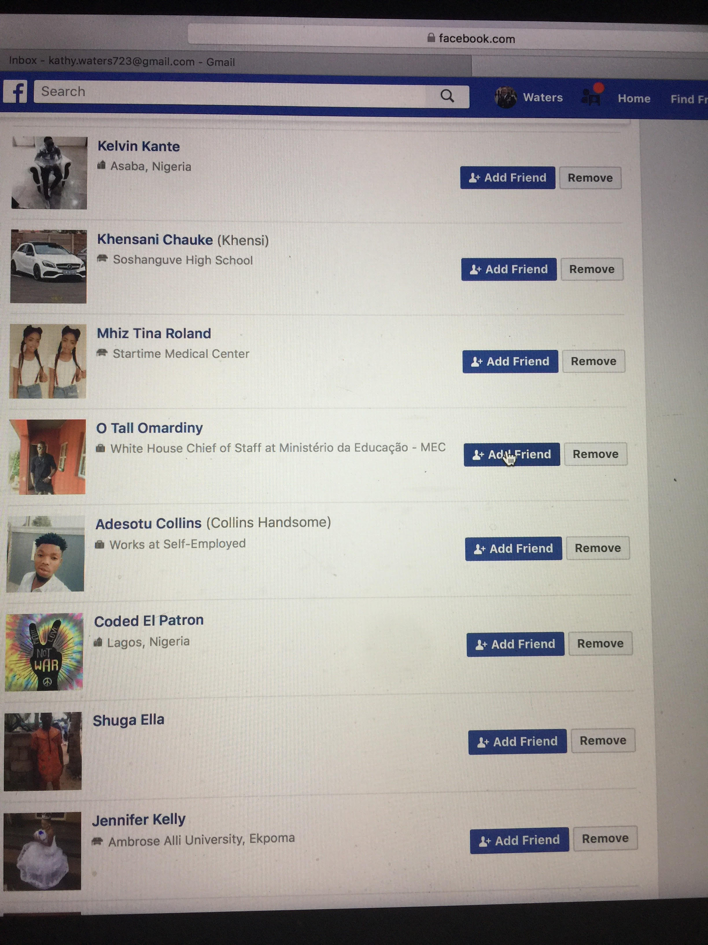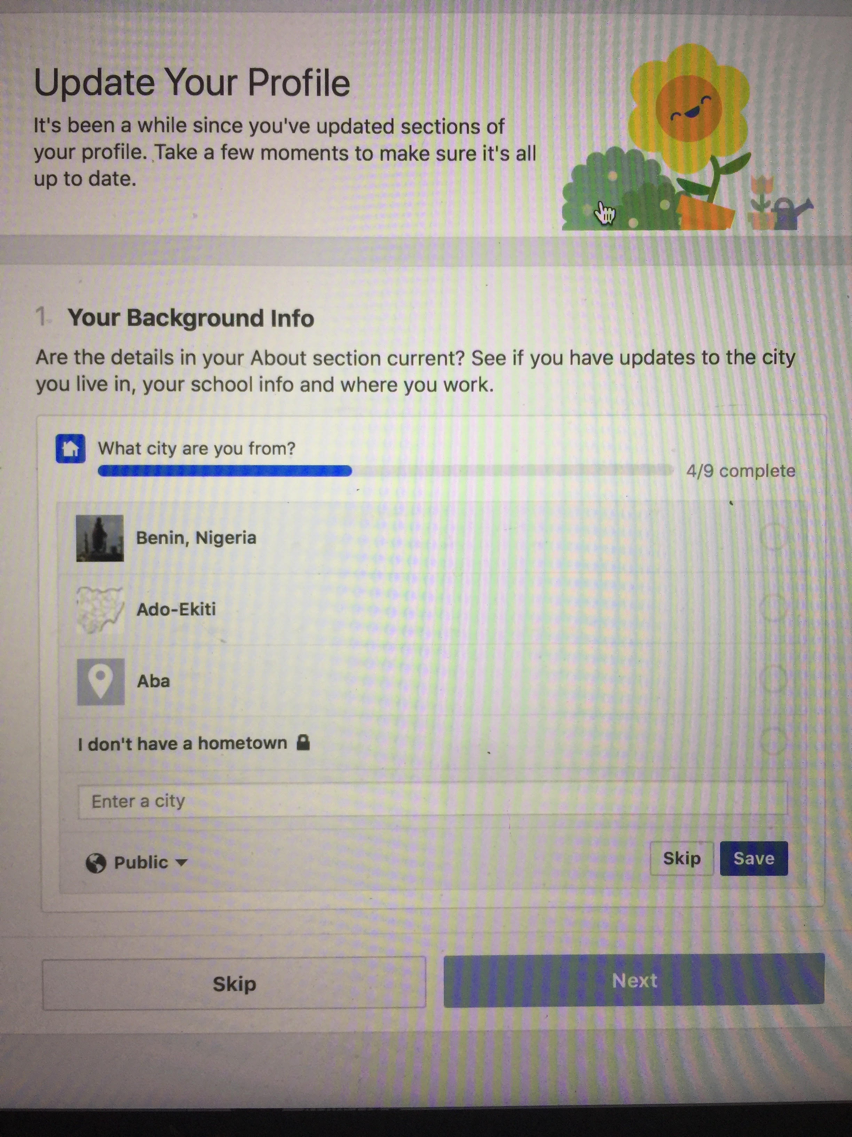

GROUP CONCERNS
The question was also asked to the Facebook Representative why consumers end up in “Facebook jail” or blocked after reporting multiple fake accounts in a short amount of time. The Representative did not think this was the case and said if this happened it would be “a form of discrimination”. On May 17, 2018 at 11:30am Kathy reported fake accounts under the names Walsh, Tucker, and Smith. At 12:08pm and 100 suspected fraudulent accounts later, Kathy was blocked by Facebook with a message stating “Because you filed too many reports in a short time period, you won’t be able to report content for 1 day. Please review our Community Standards and read about Reporting Abuse or Policy Violations before filing any more reports.” See picture below.

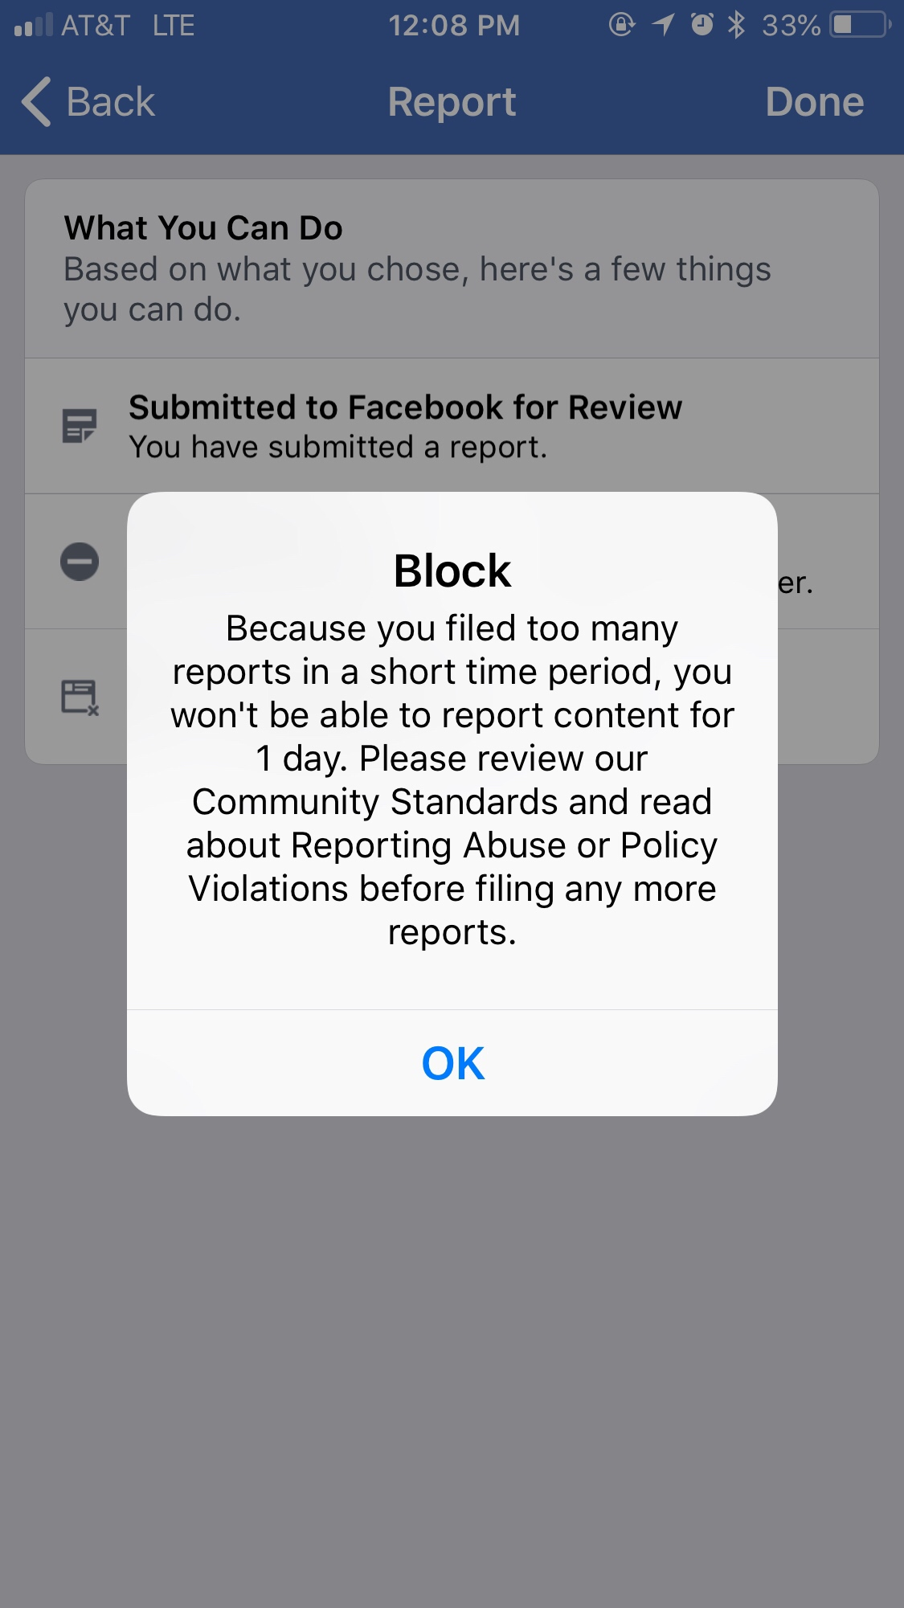

**As a result of the 100 fake accounts found on May 17, 2018, 18 were removed, 80 considered within Community Standards, and 2 unanswered. A 78% failure rate of detecting fraudulent accounts.

NEW DATING SITES
On May 3, 2018, Facebook’s CEO Mark Zuckerberg announced Facebooks upcoming dating site. Kathy asked the Facebook Representative on May 4th, if there would be a new type of security (better protection of identity theft) in place for the new dating site in regard to duplicated and fake accounts. Kathy was informed by the representative that she did not believe there would be a different security system in place, however she was not working on that project and would have to look further into this question. Bryan and Kathy are awaiting the Facebook teams answer.

QUARTERLY TARGETS
VERIFICATION
Verification checkmarks are an option when it comes to those targeted for identity theft. Just like those in the public eye need to be verified, so do the victims whose pictures are stolen and used for criminal activity upon the social media platforms.

PORTAL IMPROVEMENTS
Kathy and Bryan hope to see the amount of fraudulent accounts containing Bryan’s photos decrease. They are aware not all will diminish since every stolen photo is not entered into the portal. Another request of the flagged photos is being presented so that the determination of the portal system faults can be recognized and fixed if applicable.

ACHIEVEMENTS
Since the last quarter, television advertisements, movie ads, and Public Service Announcements have been provided by Facebook. Group education was a target for this quarter and achieved.
CONCLUDING
Bryan and Kathy will continue to share any updates Facebook may have such as forms of education, increase staffing, technology/cyber security upgrades (upon approval of the Facebook Team), and keeping and enhancing the trust and safety of Facebooks consumers.
Bryan and Kathy will also provide any information to Facebook in regard to technology, education and concerns and will continue to remain a partner with Facebook in the goal to better the platform.

Reference
United States. Cong. House and Senate. Committee on Judiciary and Commerce, Science and Transportation. Data Privacy and Protection. Hearings, April 10, 2018, April 11, 2018.

