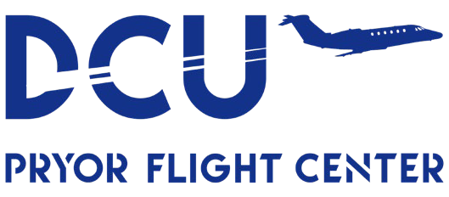

**Pryor Field Airport Authority JOB ANNOUNCEMENT**

**Line Service Technician**

**(Full-Time)**

***Note: Employee must complete NATA Safety First and Forklift training within six months of start date.***

**Hours:** Rotating Schedule; FBO Hours of Operation M-F 7AM-7PM, Sat/Sun 8AM-5PM

**Pay Range:** Based on Experience

**Job Duties:** The purpose of this position is to perform all facets of Line Service operations. This includes fueling aircraft, towing aircraft, routine airport/equipment maintenance, Fuel Quality Control checks, perform safety inspections on airport surfaces and fuel tanks, and other duties as assigned. This position will work under the Airport Director. This position will perform forklift services for cargo operations, dispatch trucking operations, and communicate with Pryor Flight Center customers efficiently and effectively.

**PHYSICAL DEMANDS:** The physical demands described here represent those that must be by an employee in order to successfully perform the daily functions of this job. Reasonable accommodations may be made to enable employees with disabilities to perform the daily functions. During the performance and duties of this position, the employee is frequently required to stand, walk, sit, and use hands to handle or feel objects, tools, or controls; reach with hands and arms; and talk or hear. The employee is occasionally required to climb or balance and stoop, kneel, crouch, or crawl. The employee must occasionally lift and or move up to 30 pounds.

**Requirements:** Applicants must have a minimum of a standard high school diploma or GED. Two years in Fixed Base Operations or equivalent aviation-related field is preferred. This position is outdoors and in all weather conditions. Must possess a valid Driver’s License. This position is subject to drug screening. An ideal applicant will have good communication skills and a high-level work ethic with self-starting skills.

**Benefits:** Retirement Plan (Retirement Systems of Alabama, RSA) and health benefits are offered for full-time employees after a probationary period. Paid Time Off. Holiday paid.

*All applicants are preferred to apply online at [Job Opportunities (flydcu.com).](https://flydcu.com/job-opportunities) For more information, please contact the Airport Director, Adam Fox, at 256-355-5770 or by emailing [afox@flydcu.com.](mailto:afox@flydcu.com.)

*This job posting will run until position(s) are filled.*

Pryor Field Airport Authority is an Equal Opportunity Employer.