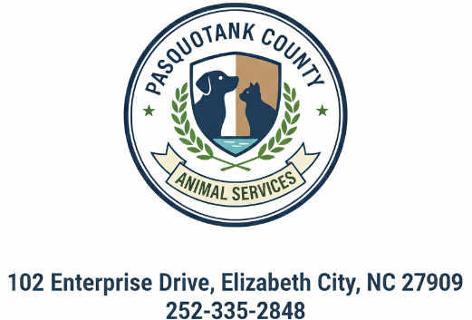

Cat Adoption Contract

Animal Name: ________________________ Breed: _________________________________
Age Estimate: ________________________ Color/Markings: _________________________
Sex(Circle): Male(Neutered) Female(Spayed)
As Adopter, I agree to the following:
- To take the animal(s) I am adopting to my primary veterinarian within 30 days of adopting for a well-check.
- To allow a representative of Pasquotank County Animal Services to visit my premises to insure the terms of this agreement have been kept.
- The animal WILL NOT and MAY NOT be kept strictly outdoors.
- The animal will be provided with adequate fresh food and water, clean, dry shelter when outside and daily exercise.
- To provide a safe collar with rabies and ID tags to be worn at all times.
- To obey all applicable laws governing control and custody of animals.
- To provide all medical care and treatment needed by the animal including but not limited to: Yearly medical checkups, vaccines, and preventative flea medication.
- To adopt the animal only as a personal pet/companion and not as a gift.
- The animal is not to be sold or given away for any reason. If it becomes necessary to find the animal another home, Pasquotank County Animal Services will be contacted and the animal shall be returned to them.
- The animal will be spayed/neutered at the time of adoption. This animal will be altered at one of our partnering veterinarians at the discretion of Pasquotank County Animal Services.
Pasquotank County Animal Services assumes no responsibility nor shall they be held liable for any damages caused by the adopted animal to their property, person or other pets. If any medical problems should occur after adoption, Pasquotank County Animal Shelter is not liable for any medical bills.
As the adopter, I agree to accept full responsibility for the care of this animal releasing the previous owner as well as Pasquotank County Animal Services and its representatives of any liability from this date forward.
I agree to abide by the adoption conditions and realize that I am committed to this animal for his/her life. I have read and fully understand that Pasquotank County Animal Services may repossess this animal at any time if the adoption conditions are violated or animal is mistreated.

This adoption contract is entered into this _______ Day of __________________,
20____, between Pasquotank County Animal Services

Adopter’s Full Name: _________________________________________________
Address: ___________________________________________________________
City, State, Zip: ______________________________________________________
Home Phone:(___) _______________ Cell Phone:(__) _______________________
Email: _____________________________________________________________
Adoption Fee: $______ Cash☐ Check ☐ Card☐
** There may be additional charges at the veterinarian’s office**

Signature of Adopter: _______________________________________________
Shelter Rep. Signature: ______________________________________________

Thank you for adopting and saving a life!
*****Adoption Fees are NON-REFUNDABLE*******
