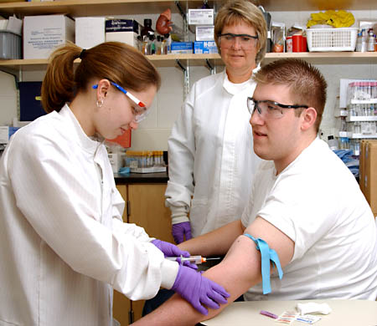 **St. Ferdinand School**

**3131 N. Mason**

**Chicago, ILL 60634**

**Nationalcollegeofphlebotomy@gmail.com**

National College of Phlebotomy

Is approved by the Division of Private Business   
 and Voccational School of the Illinois Board of

Higher Education.

**YOUR SUSSESS STARTS HERE!**

**JOIN NATIONAL COLLETE OF PHLEBOTOMY**

* **Phlebotomy Technician**
* **Urine test manually and on machine**
* **Glucose test**
* **Hemoglobin test**
* **Hematocrit test**
* **Urine test**
* **How to set up for C&S KIT**
* **How to set up a GC TEST**
* **How to do a pregnancy test**
* **Free Certification Exam**
* **WIOA GRANT Accepted**
* **Grants& Scholarships if you qualify**
* **Enroll for Classes Now**
* **Flexible Payment Plan Available**
* **Externship Also Available**