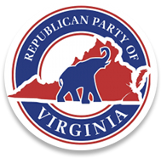

I, Dave Bourne, Chairman of the Augusta County Republican Committee, do hereby call for our monthly unit meeting to be held on Tuesday, March 15, 2022, 7:00 PM, at Common Ground, 15 Angela Court, Fishersville, VA 22939, or alternate time, date, or location if needed.

The agenda will be as follows:

- Welcome & Call to Order.
- Invocation.
- Pledge of Allegiance.
- Reading of the Republican Creed.
- Roll Call & Quorum Declaration.
6. Adoption of Agenda.
7. Executive Board Elections
- Vice Chair – Programs
- Vice Chair – Precinct Organization and Membership
- Vice Chair – Communications
- Secretary
- Treasurer
- Magisterial District Chairs
8. Reading and approval of January 18, 2022, Meeting Minutes
9. Treasurer Report.
10. New Business
11. The transaction of other business as may properly come before the committee.
12. For the good of the committee.
13. Closing Prayer
14. Adjournment

